Data Structure (C Programming) 25/08/2026
Name : Harshad Sanjay Teli.
Roll No : 15
Batch : B1
Prerequisite
Based on Pointers.

Q1. Write a C program to swap two numbers using pointers.
Input:

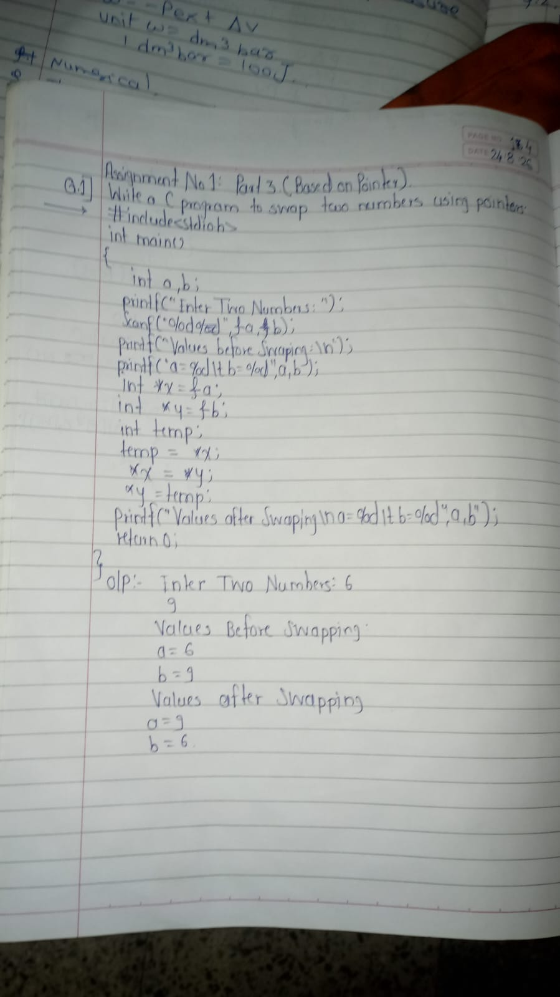

Output:
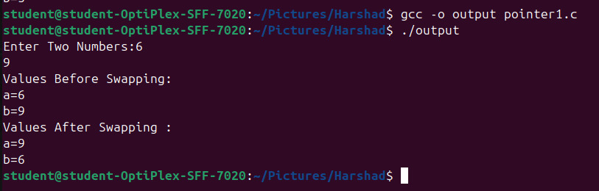

Q2. Write a C program to find the length of a string using pointers (without using strlen).
Input:
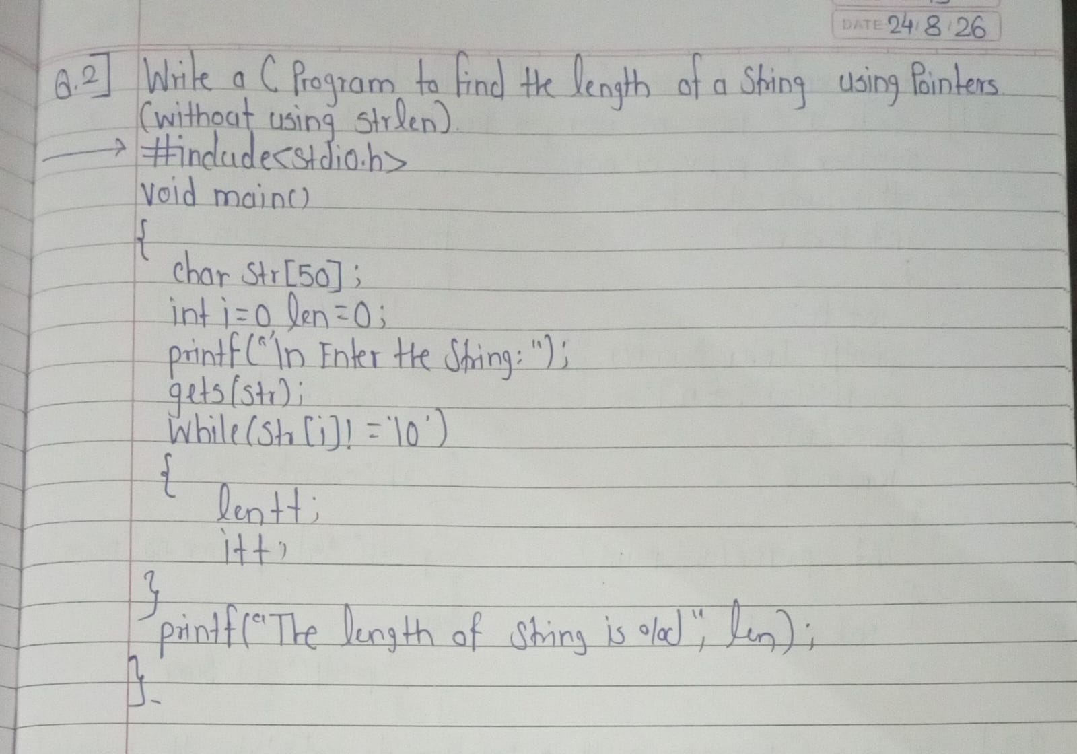
Output:
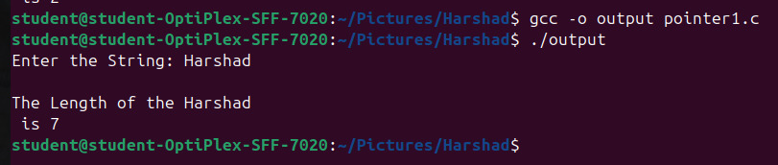

Q3. Write a C program to access and display array elements using pointers.
Input:
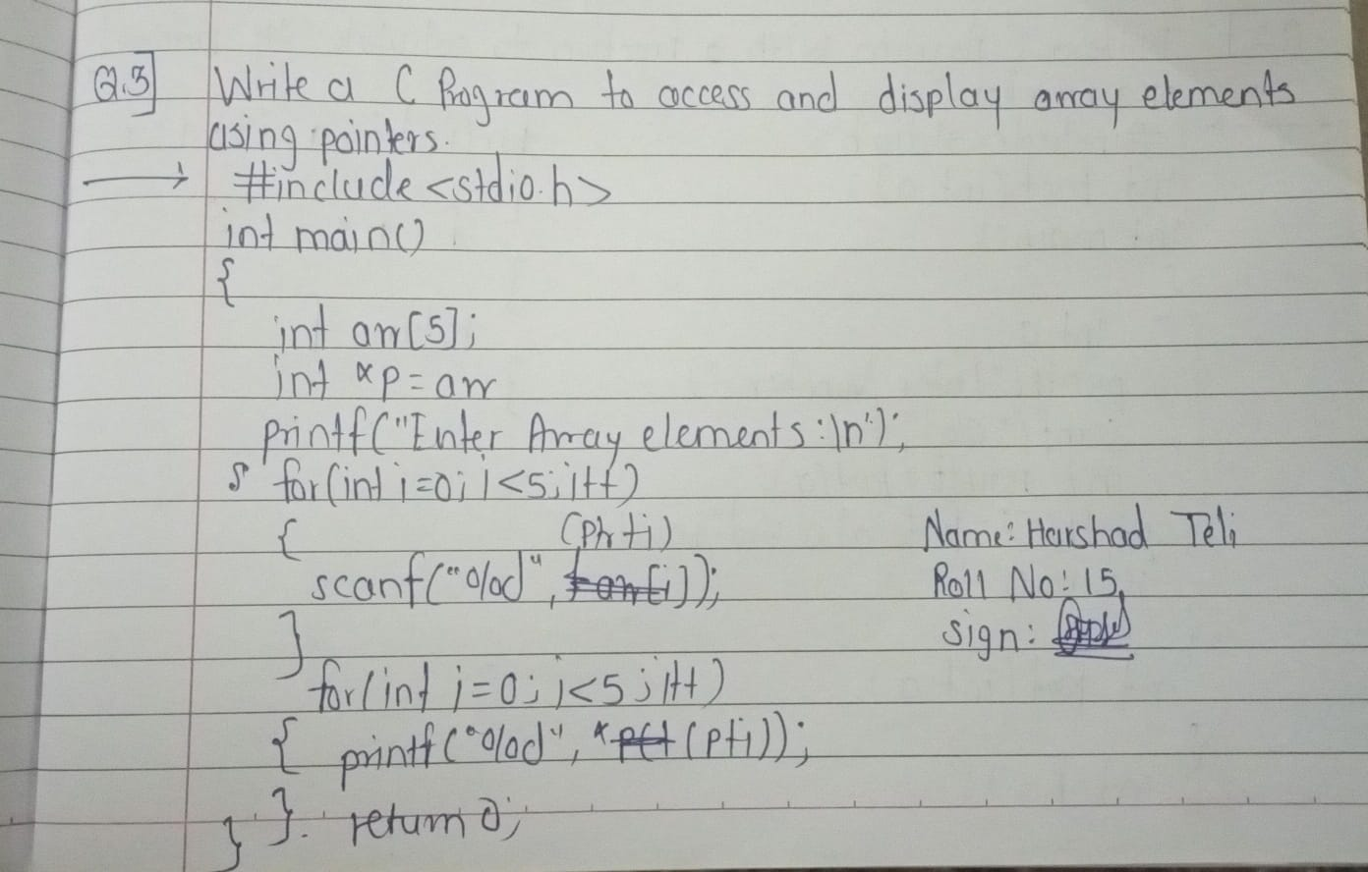
Output:

