Data Structure (C Programming) 25/08/2026
Data Structure (C Programming) 25/08/2026
Name : Harshad Sanjay Teli.
Roll No : 15
Batch : B1
Prerequisite
Based on Structures.

Q1. Write a C program to define a structure Student containing name, roll number, and marks. Accept and display details of 5 students.
Input:

Output:

Q2. Write a C program to add two distances (in feet and inches) using structures.

Input:

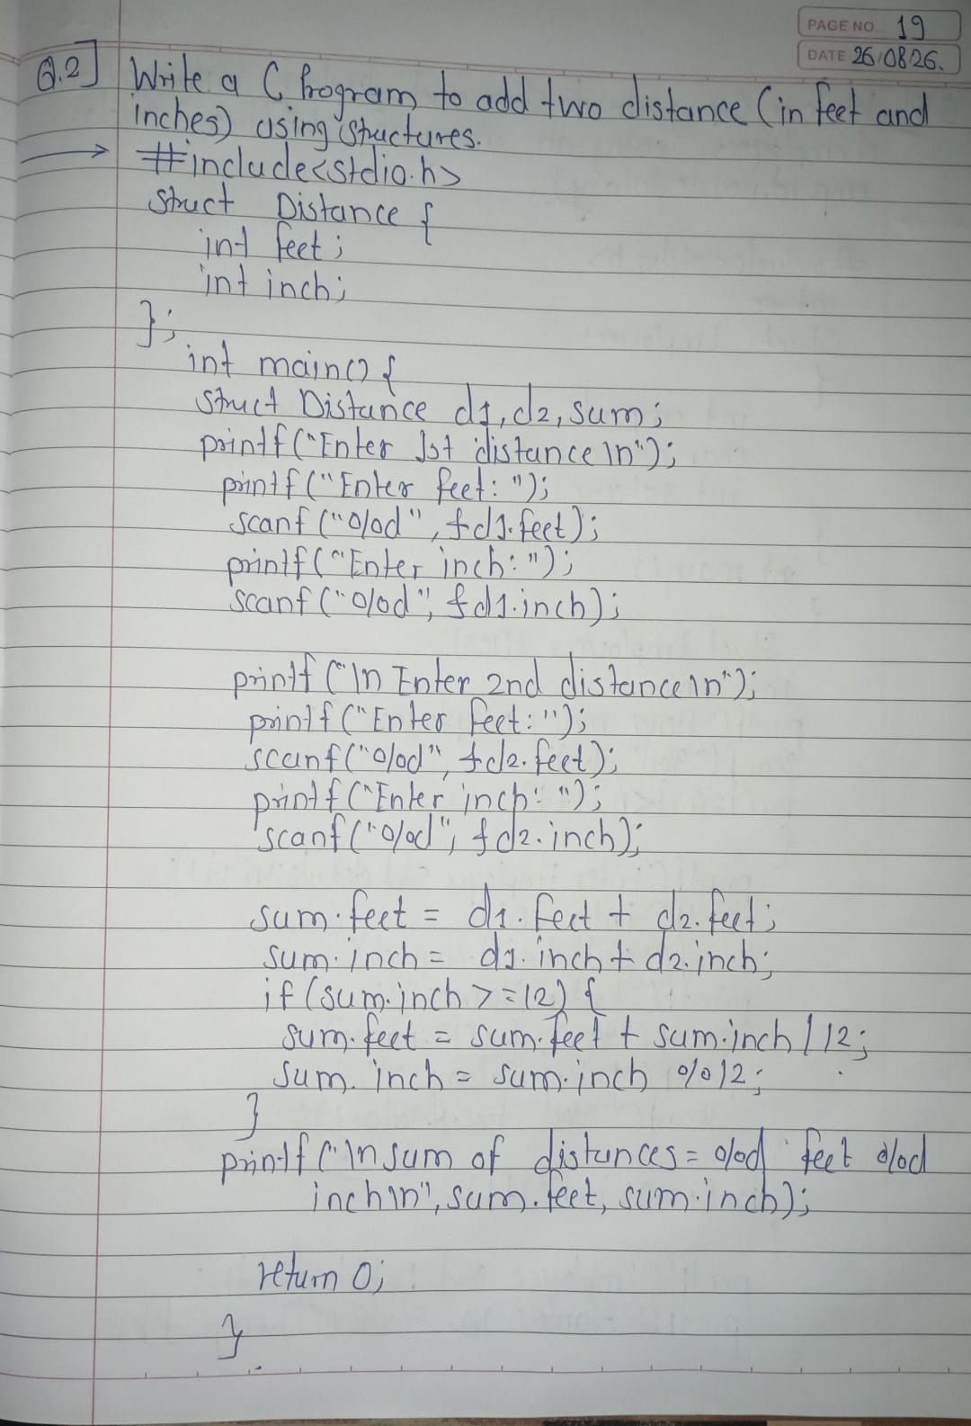

Output:

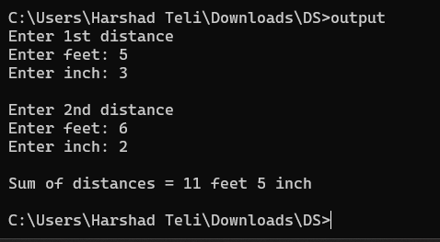

Q3. Write a C program to store and display information of employees using an array of structures (fields: emp_id, name, salary).
Input:
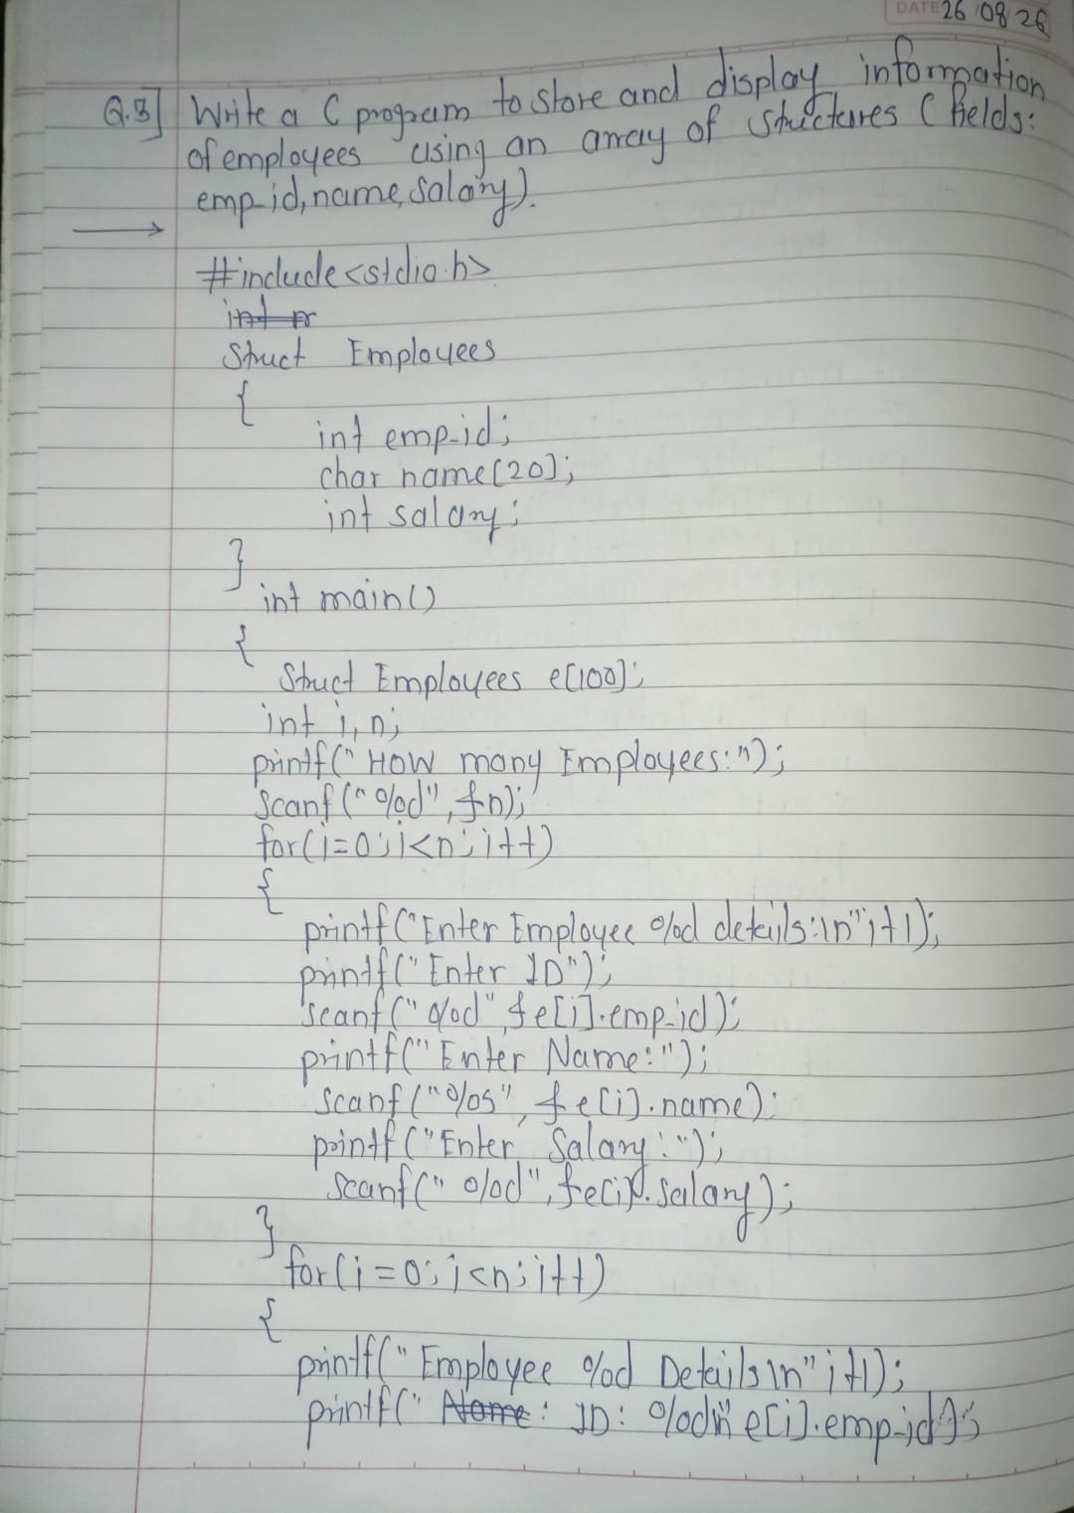
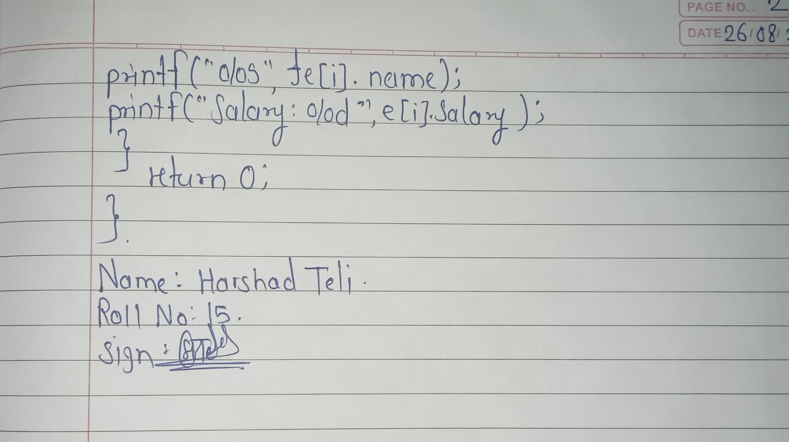
Output:

