Internet Programming
22/10/2026
Name : Harshad Sanjay Teli.
Roll No : 15
Batch : B1
Function and Output Methods

Assignment-9(Function and Output Methods)
- Create a Calculator Using Functions
Write separate functions for:
- Addition
- Subtraction
- Multiplication
- Division
Then call them based on user choice.
Input:
<!DOCTYPE html>
<html lang="en">
<head>
<meta charset="UTF-8">
<meta name="viewport" content="width=device-width, initial-scale=1.0">
<title>Calculator Using Functions</title>
</head>
<body>
<script type="text/javascript">
function addition(a,b){
return a+b;
}
function subtraction(a,b){
return a-b;
}
function multiply(a,b){
return a*b;
}
function divide(a,b){
return a/b;
}
let a = Number(prompt("Enter First Number:"));
let b = Number(prompt("Enter Second Number:"));
let choice = prompt("Enter Choice:+,-,*,/");
if(choice=='+'){
alert(addition(a,b));
}else if(choice=='-'){
alert(substraction(a,b));
}else if(choice=='*'){
alert(multiply(a,b));
}else if(choice=='/'){
alert(divide(a,b))
}
else{
alert("Invalid Choice")
}
</script>
</body>
</html>

Output:
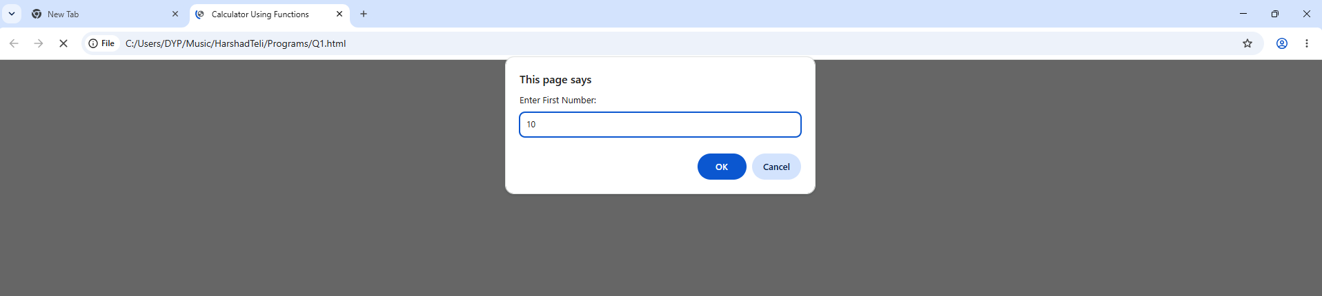
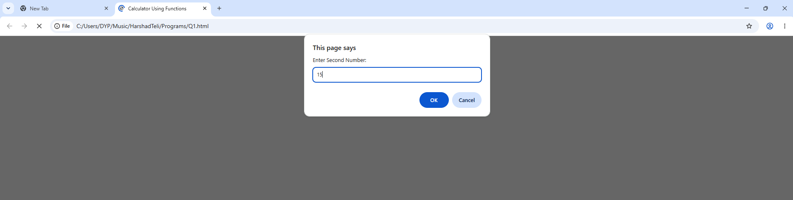
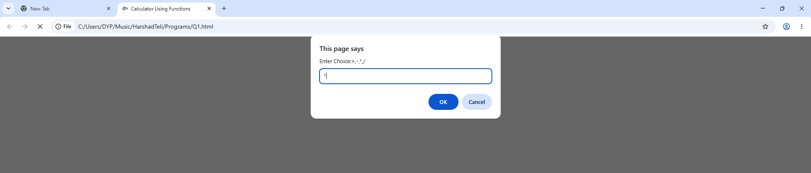
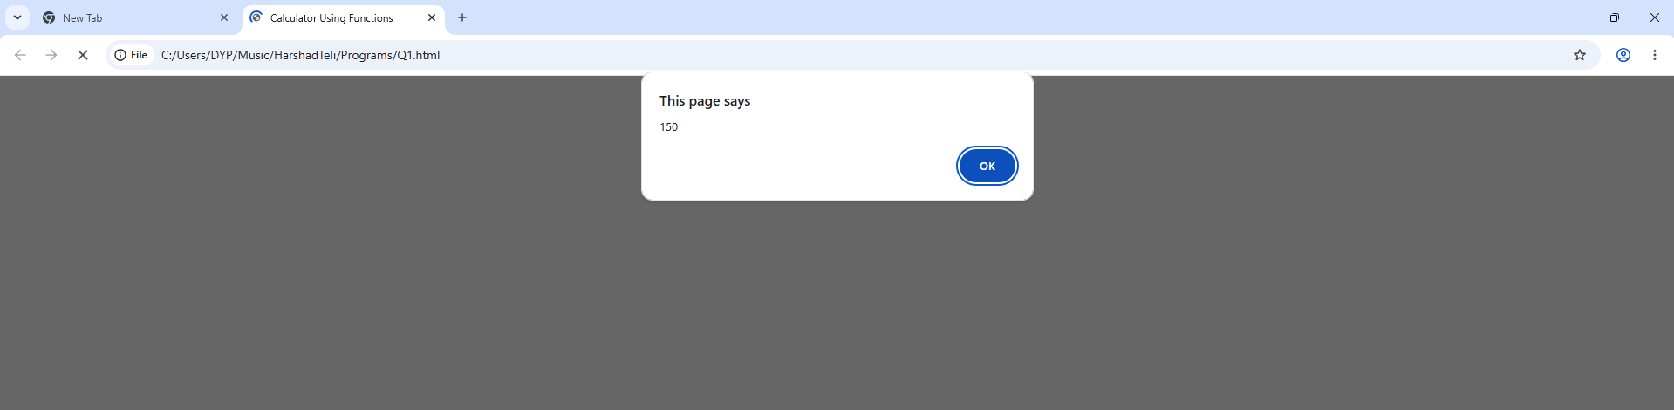
Rewrite the same program using arrow functions.
Input:
<!DOCTYPE html>
<html lang="en">

<head>
<meta charset="UTF-8">
<meta name="viewport" content="width=device-width, initial-scale=1.0">
<title>Calculator using Arrow functions</title>
</head>

<body>
<script type="text/javascript">
let add = (a, b) => a + b;
let sub= (a, b) => a - b;
let mul = (a, b) => a * b;
let div = (a, b) => a / b;
let a = Number(prompt("Enter First Number:"));
let b = Number(prompt("Enter Second Number:"));
let choice = prompt("Enter Choice:+,-,*,/");

if(choice=='+'){
alert(add(a,b));
}else if(choice=='-'){
alert(sub(a,b));
}else if(choice=='*'){
alert(mul(a,b));
}else if(choice=='/'){
alert(div(a,b));
}
else{
alert("Invalid Choice");
}

</script>
</body>

</html>
Output:
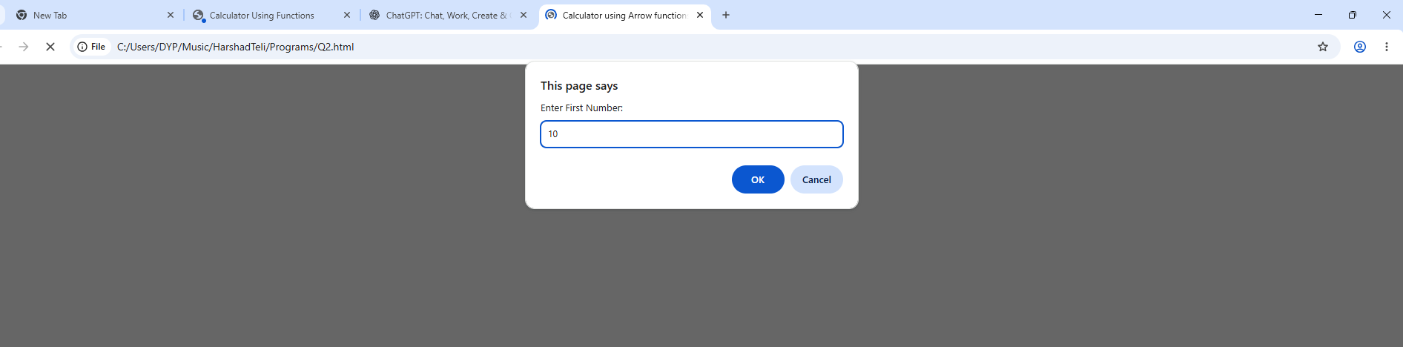
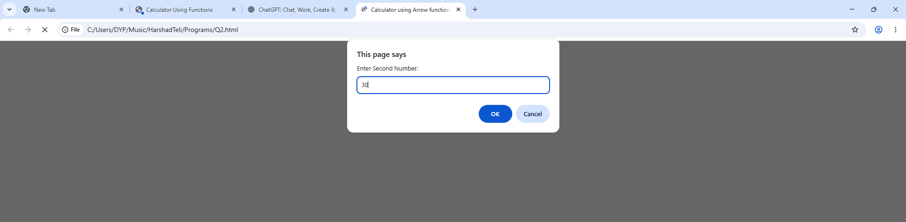
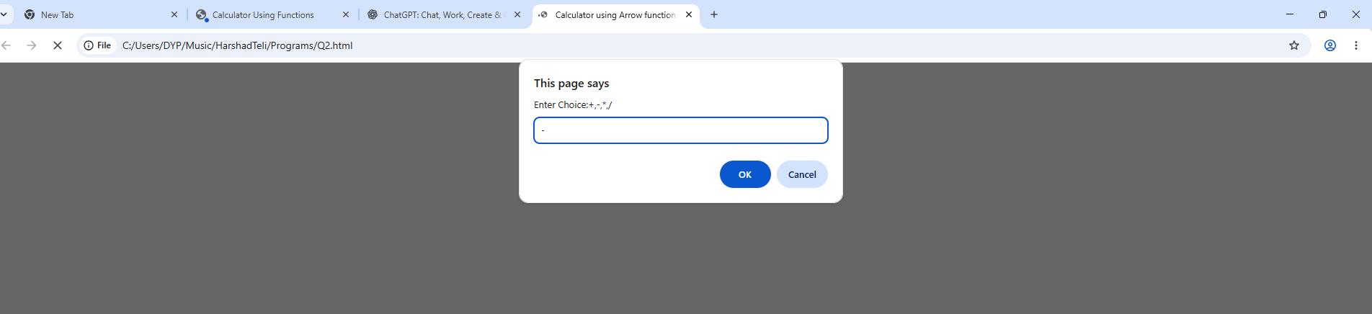
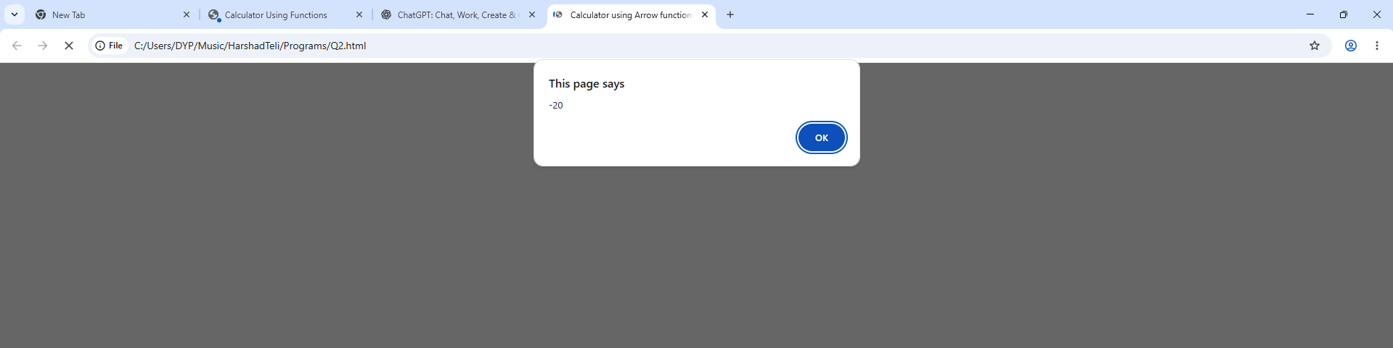

- Array Processing.
Take an array of numbers and write:
- A function to return all even numbers
- A function to return sum of all numbers
- A function to return maximum number something more on array Count How Many Numbers Are Positive, Negative, and Zero.
Input:
<!DOCTYPE html>
<html lang="en">

<head>
<meta charset="UTF-8">
<meta name="viewport" content="width=device-width, initial-scale=1.0">
<title>Array Processing</title>
<style>
body {
background-color: black;
color: whitesmoke;
}
</style>
</head>

<body>

<script type="text/javascript">
let p = 0; n = 0, z = 0;
let arr = [10, -5, 20, 0, -8, 15, 0];
function even() {
let result = [];
for (let i = 0; i < arr.length; i++) {
if (arr[i] % 2 == 0) {
result.push(arr[i]);
}
}
return result;
}
function sum() {
let s = 0;
for (let i = 0; i < arr.length; i++) {
s = s + arr[i];
}
return s;
}
function max() {
let max = arr[0];
for (let i = 0; i < arr.length; i++) {
if (arr[i] > max) {
max = arr[i];
}
}
return max;
}
function count() {

for (let i = 0; i < arr.length; i++) {
if (arr[i] > 0) {
p++;
}
else if (arr[i] < 0) {
n++;
}
else {
z++;
}
}

}
count();
document.write("Even Numbers: " + even() + "<br>");
document.write("Sum of the Array is : " + sum() + "<br>");
document.write("Maximum of the Array is : " + max() + "<br>");
document.write("Total Positive Numbers of the Array is : " + p + "<br>");
document.write("Total Negative Numbers of the Array is : " + n + "<br>");
document.write("Total Zero's in the Array is : " + z + "<br>");
</script>
</body>

</html>
Output:
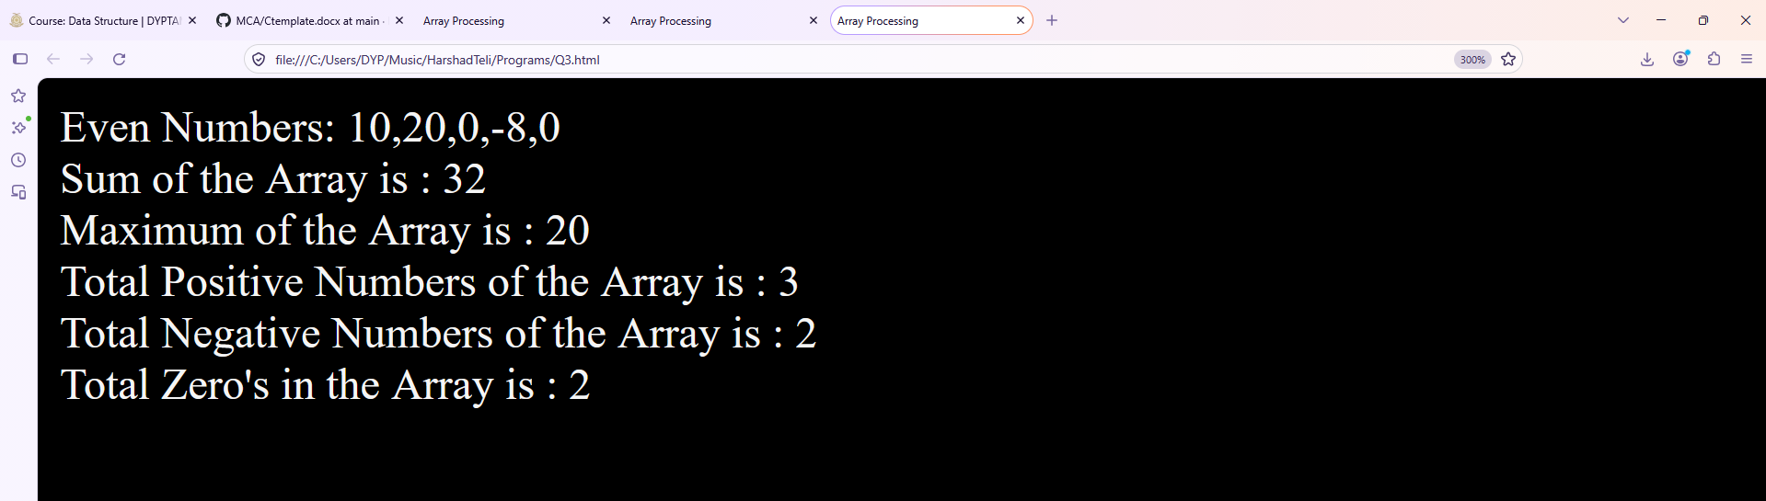

Student Information Form (without HTML form tag)
Using only:
- prompt()
- innerHTML
- alert()
Ask the user:
- Name
- Age
- Course
- College
Then display the details in a <div> in table format using innerHTML.
If age < 18 → show alert “Not eligible”.

Login Authentication
Create a program:
- Ask user for username and password using prompt().
- If username = "admin" AND password = "1234" → display
"Login Successful" using innerHTML.
- Else → show an alert("Invalid Login!").
Use confirm("Do you want to try again?") to repeat the login attempt.

Confirm Navigation
Create a “Go to Google” button.
On clicking:
- Show a confirm("Do you really want to leave this page?")
- If user clicks OK → redirect to Google.
- If Cancel → show innerHTML = "Stayed on the page"`

Dynamic Background Color Chooser
Ask user via prompt():
"Enter background color (red/blue/yellow/green):"
If color is valid → apply it to <body> using style + innerHTML message.
If invalid → show alert "Color not available".

