Internet Programming
Batch No : B1 Assignment No 1 Date: 03/08/2026

Q1)
Input:
<!DOCTYPE html>
<head>
<title>My First Web Page</title>
<meta property="description" content="Practical on the Internet Programming To create the
My First Web Page" />
<meta property="author" content="Harshad Teli, MCA-I DYPSEM,Roll No:15" />
<style>
body{
background-color:black;
color:whitesmoke;
}
body h1{
animation: head 1s linear infinite;
}
@keyframes head{
0%,20%{
color:red;
}20%,40%{
color:pink;
}
40%,60%{
color:green;
}60%,80%{
color:orange;
}80%,100%{
color:indianred;
}
body h3{
color:whitesmoke;
}
</style>
</head>
<body>
<header>
<marquee scrollamount="10">
<h1>Harshad Sanjay Teli</h1>
</marquee>
<h2>College Name: DY Patil Education Society<br>
Class : MCA - I </h2><br>
<p>Hii.. I am Harshad Teli, A passionate Software Developer from the India and also
interested in the learning the New Technology.I am also Solve Real World Problems and much more...</p>
</header>
<div>
<h3>My Hobbies</h3>
<ol>
<li>Drawing</li><li>Gaming</li><li>Eating</li><li>Reading</li>
</ol>
<h3>My Favourite Subjects</h3>
<ul>
<li>AI/ML</li><li>JAVA</li><li>PYTHON<li>C</li><li>C++</li>

</body>
</html>

Output:
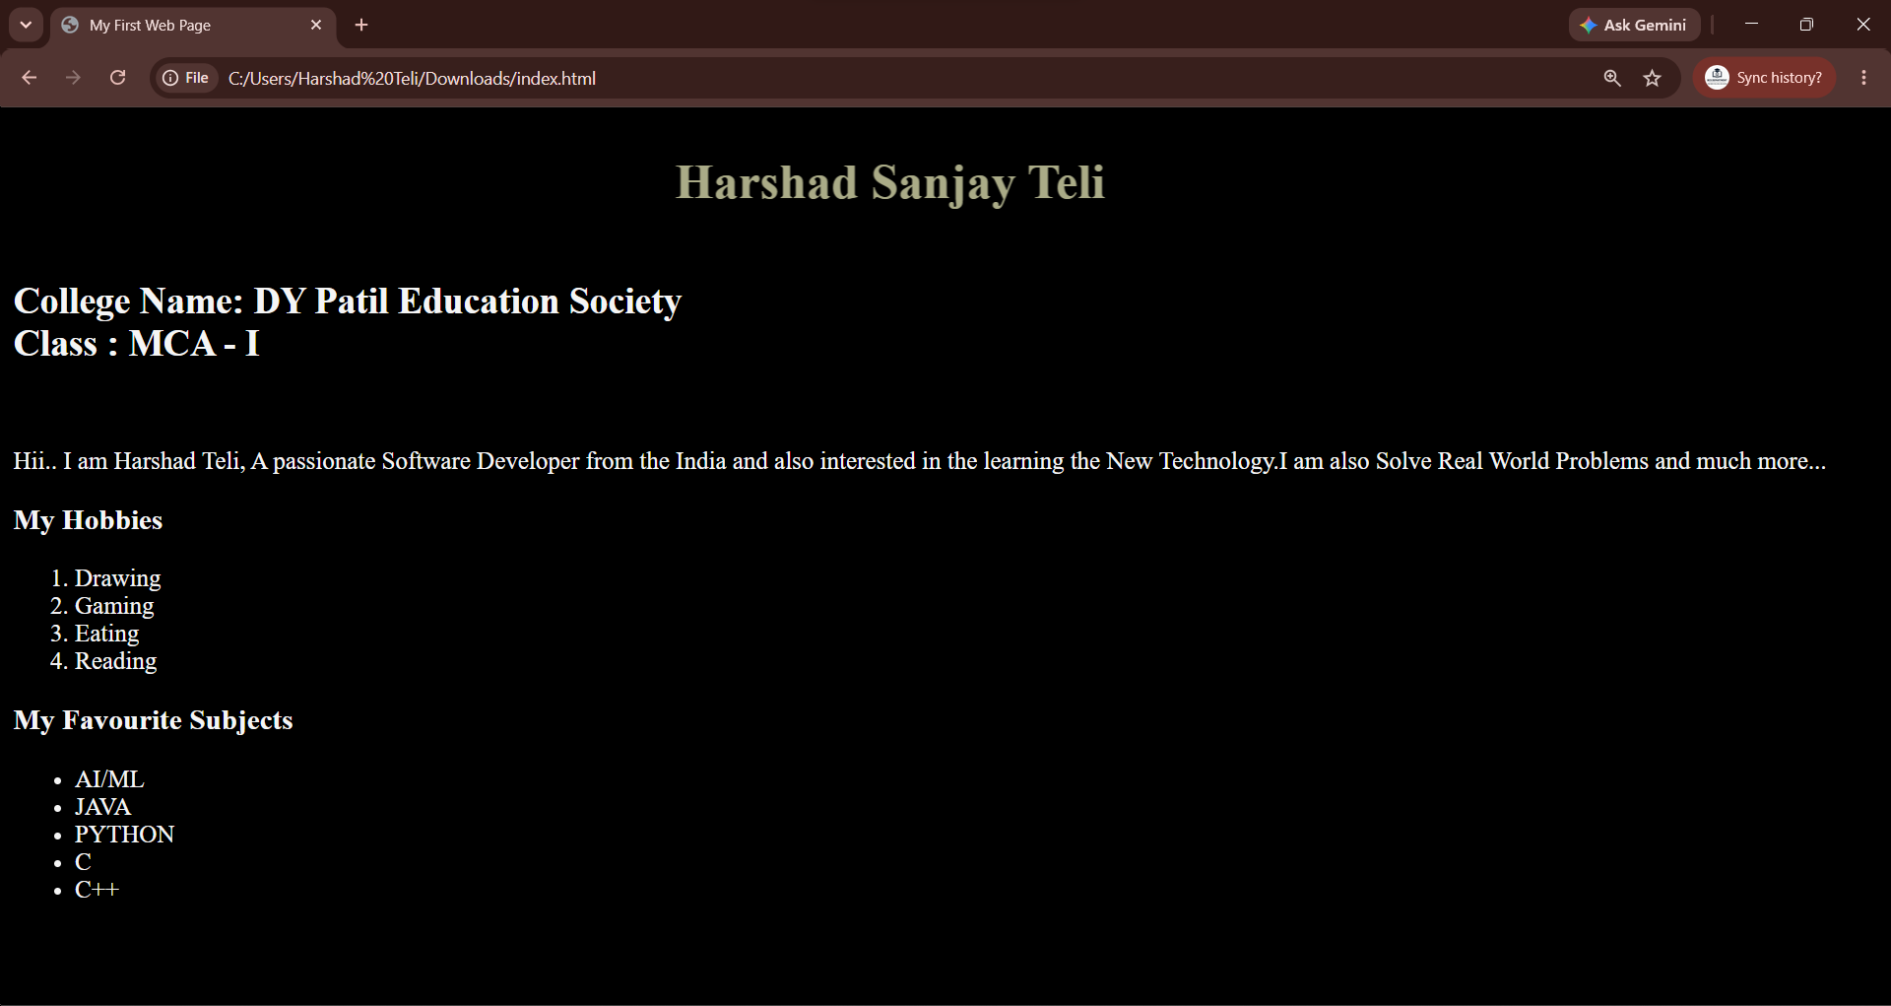
Q2)
Input:
<!DOCTYPE html>
<head>
<title>My Daily Routine</title>
<meta property="description" content="Practical on the Internet Programming To create the
Daily Routine Page " />
<meta property="author" content="Harshad Teli, MCA-I DYPSEM, Roll No:15" />
<style>
body{
background-color:black;
color:whitesmoke;
}
body h1{
animation: head 1s linear infinite;
}
@keyframes head{
0%,20%{
color:red;
}20%,40%{
color:pink;
}
40%,60%{
color:green;
}60%,80%{
color:orange;
}80%,100%{
color:indianred;
}
body h3{
color:whitesmoke;
}
</style>
</head>
<body>
<header>
<marquee scrollamount="10">
<h1>My Daily Routine Web Page</h1>
</marquee>
<h2>My Daily Sequence Tasks </h2><br>
<ol>
<li>Wake Up</li><li>BreakFast</li><li>College</li><li>Study</li><li>Sleep</li>
</ol>
<h2>My Things in the Free Time </h2><br>
<ul>
<li>Sing the Song</li><li>Thing about the new technology</li><li>About the Food</li><li>Extra Activites about the Learning and Study</li>

</header>
</body>
</html>

Output:

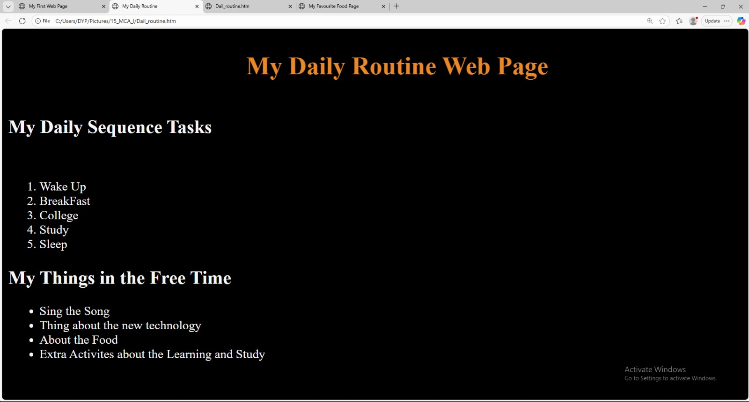

Q3)
Input:
<!DOCTYPE html>
<head>
<title>My Favourite Food Page</title>
<meta property="description" content="Practical on the Internet Programming To create the My Favourite Food Page" />
<meta property="author" content="Harshad Teli, MCA-I DYPSEM,Roll No:15" />
<link rel="shortcut icon" href="https://encrypted-tbn0.gstatic.com/images?q=tbn:ANd9GcRa7YGAbJSuaL9n7BQhXtp6KVngm8YEGjTjyHvOksF5KCbxs_xQLidDMr4&s=10" type="image/x-icon">
<style>
body{
background-color:whitesmoke;
color:black;
}
body h1{
animation: head 1s linear infinite;
}
@keyframes head{
0%,20%{
color:red;
}20%,40%{
color:pink;
}
40%,60%{
color:green;
}60%,80%{
color:orange;
}80%,100%{
color:indianred;
}
body h3{
color:whitesmoke;
}}
</style>
</head>

<body>
<header>
<marquee scrollamount="10">
<h1>My Favourite Food Page</h1>
</marquee>
<h2>My Favourite Dishes</h2>
<hr>
<ul><li>
<img src="https://encrypted-tbn0.gstatic.com/images?q=tbn:ANd9GcRa7YGAbJSuaL9n7BQhXtp6KVngm8YEGjTjyHvOksF5KCbxs_xQLidDMr4&s=10" width="300px"height="auto" alt="Masala_dosa_image"/>
</li><p>Masala Dosa</p>
<li>
<img src="https://encrypted-tbn0.gstatic.com/images?q=tbn:ANd9GcSl9ckBUvpEnHusWX8F6FpOEtXH0TdV-sN8zHeDlZTsUw&s" width="300px"height="auto" alt="Masala_dosa_image"/>
</li><p>Chole Bhature</p>
<li>
<img src="https://encrypted-tbn0.gstatic.com/images?q=tbn:ANd9GcSN2E3WWCI1Z0XcfpKF8Tg5u-QjbwfYZjtA7r14qBnC26LgflUlmzrb3vYe&s=10"width="300px"height="auto" alt="Masala_dosa_image"/>
</li><p>Dal Makhani</p>
</ul>
<h2>Process of the How to Make the Masala Dosa</h2>
<ol>
<li>Soak ingredients: Rinse and soak rice, urad dal, and 1 tsp of fenugreek seeds in separate bowls for 4 to 6 hours or overnight.</li>
<li>Grind separately: Drain and grind the urad dal into a fluffy, smooth paste. Grind the rice into a slightly grainy, smooth batter.</li>
<li> Combine both batters in a large bowl, add salt, mix well, and let it rest in a warm spot for 8 to 12 hours until doubled in size.</li>
<hr>
</header>
</body>
</html>

Output:

