Data Base Management System
30/09/2026
Name : Harshad Sanjay Teli.
Roll No : 15
Batch : B1
Assignment No:5

Table Structure
ProductDetails(ProductID, ProductName, Category, Price, Quantity, SupplierCity)
Perform the following SQL queries:
- Display all products that belong to the Electronics category.
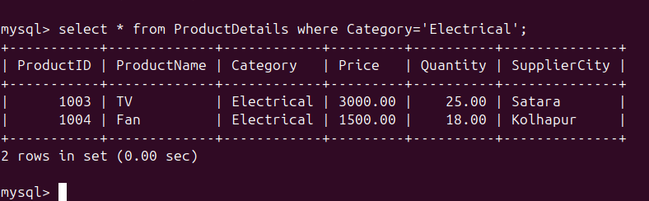
- Display products whose Price is greater than 1000.
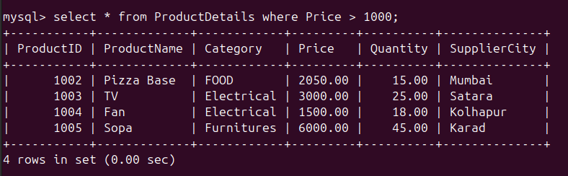
- Display products whose Quantity is less than 20.
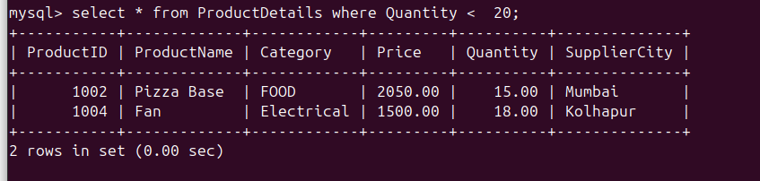
- Display products that belong to Furniture or Kitchen category.
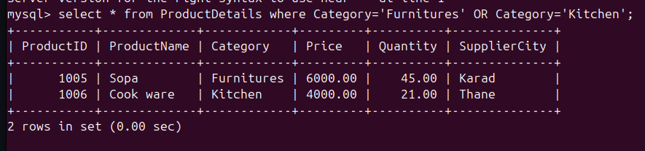
- Display products whose Price is between 500 and 5000.
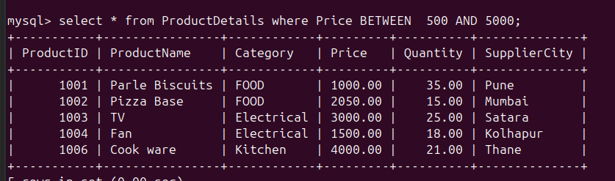
- Display all product records in ascending order of ProductName.
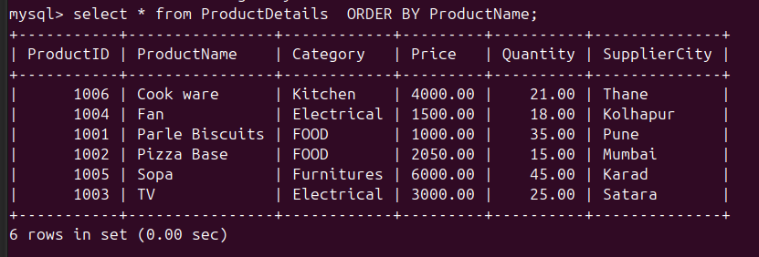
- Display all product records in descending order of Price.

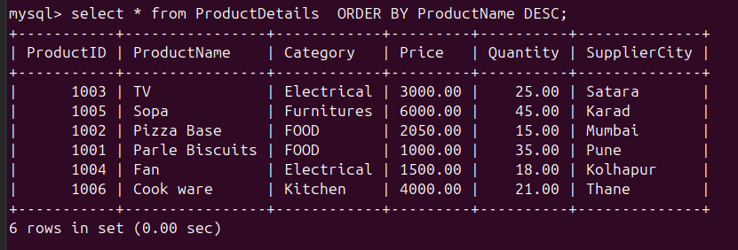
- Find the total number of products in the table.
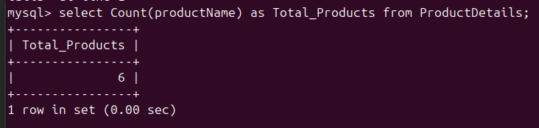
- Find the total quantity of all products.
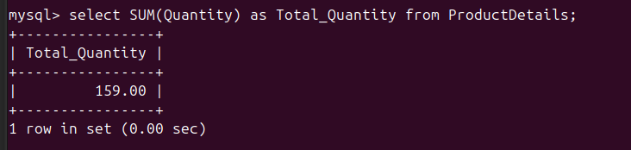
- Find the average price of all products.
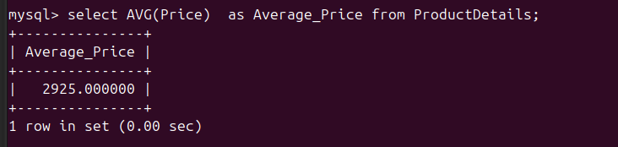
- Find the highest price among all products.
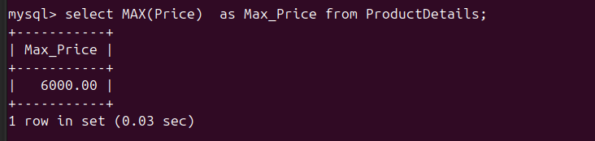
- Find the lowest price among all products.
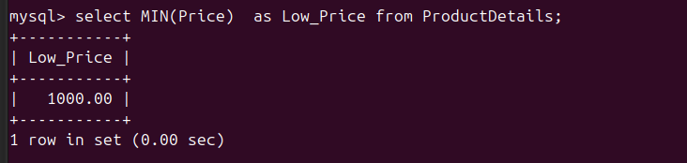
- Find the number of products in each category.
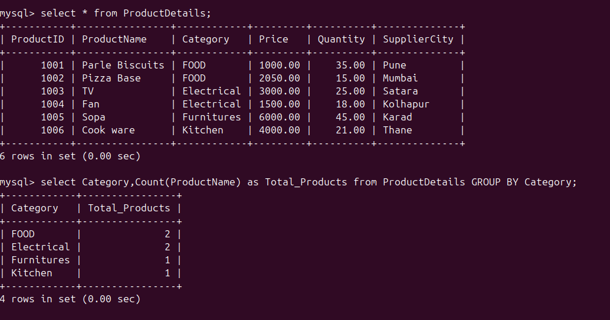
- Find the average price of products in each category.
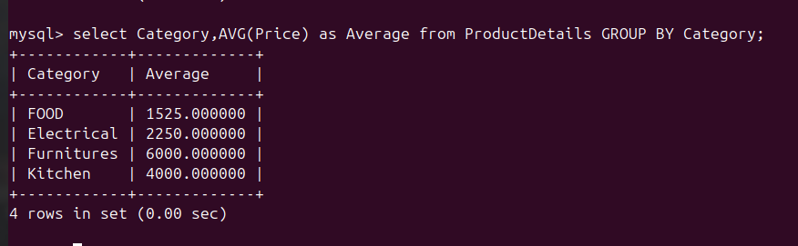
- Find the total quantity of products in each category.
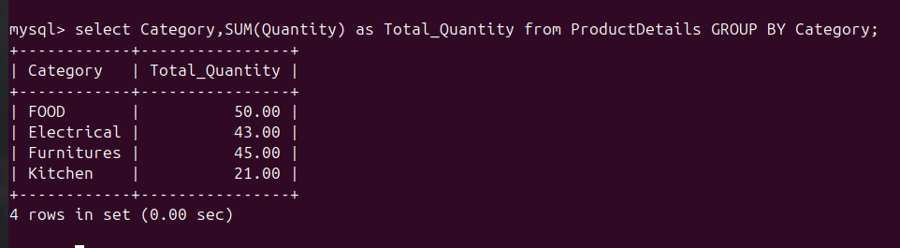

- Display only those categories having more than 2 products.
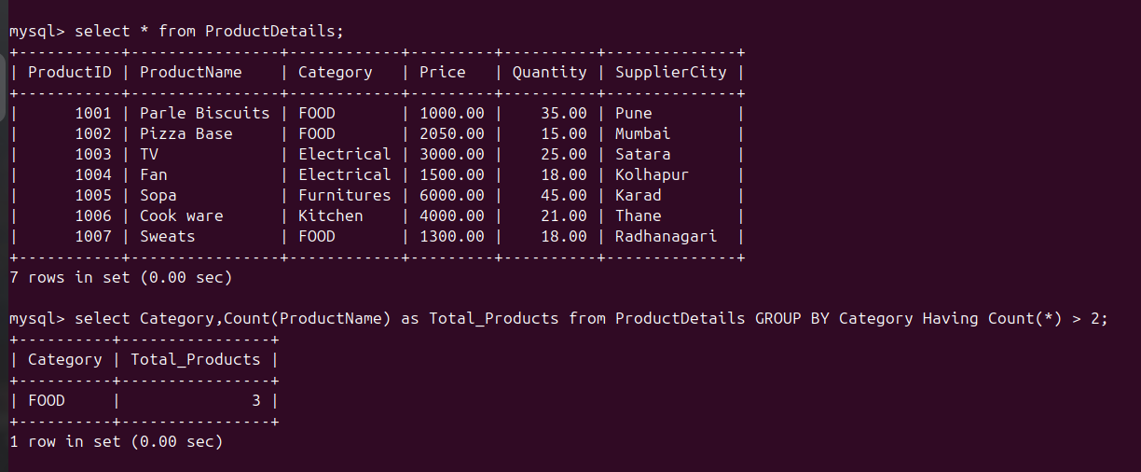
- Display categories where the average price is greater than 2000.
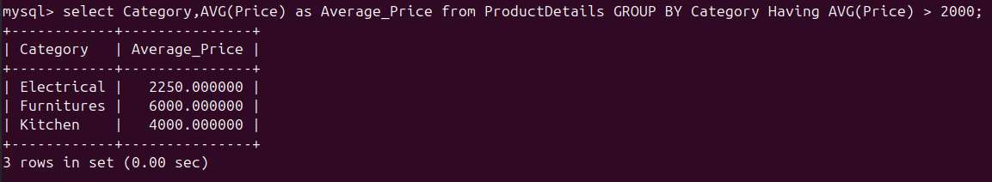
- Display all the different SupplierCity values available in the ProductDetails table.
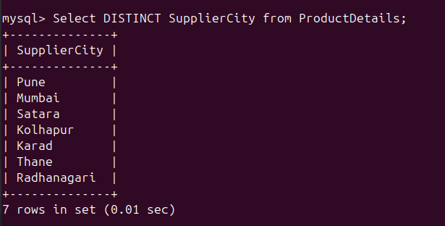
19

- Find the number of products supplied from Pune.
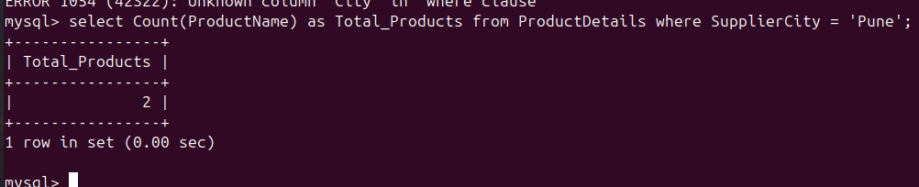
- Display the category-wise product count and average price, showing only categories having more than 1 product, arranged by product count in descending order.
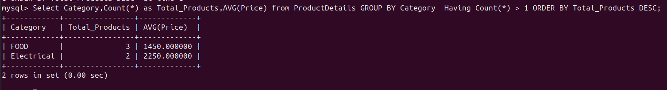

Table Structure
BankTransaction(TransactionID, CustomerName, AccountType, TransactionType, Amount, BranchCity)
Perform the following SQL queries:
- Display all transactions made by customers having Savings accounts.
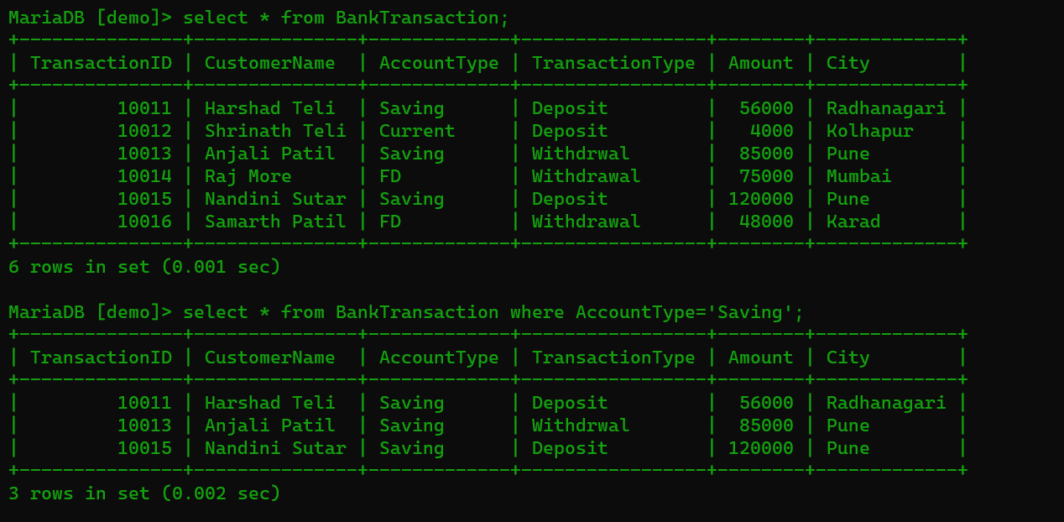
- Display transactions where the Amount is greater than 50,000.
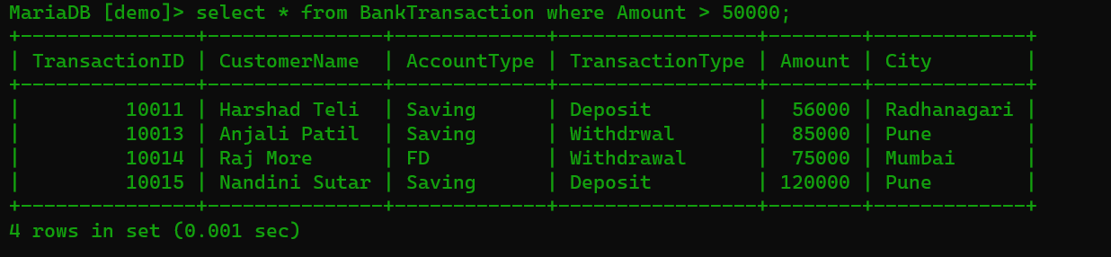

- Display transactions where the Amount is less than 10,000.
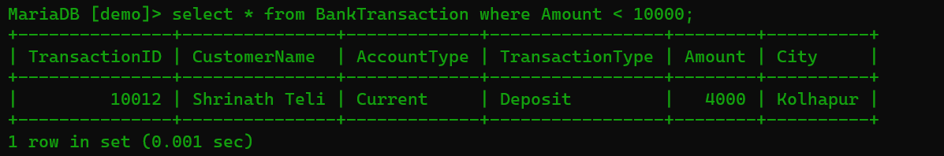

- Display transactions having Deposit or Withdrawal as the TransactionType.
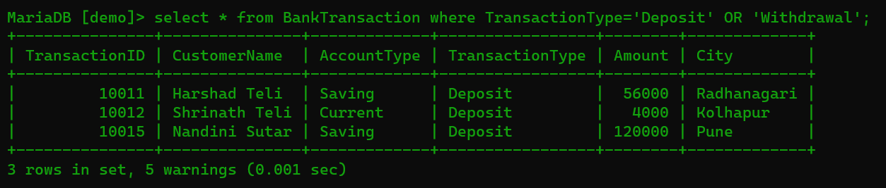

- Display transactions where the Amount is between 10,000 and 75,000.
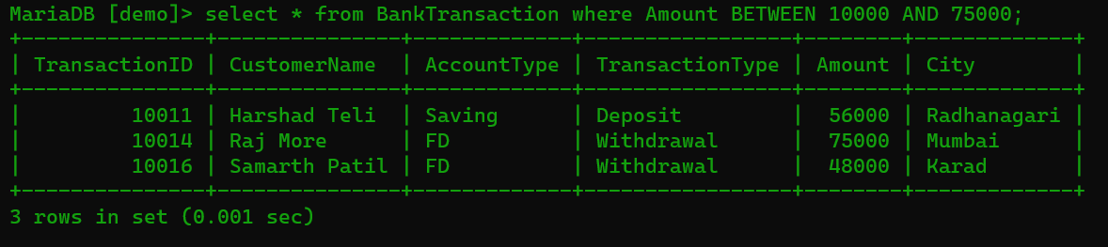
- Display all transaction records in ascending order of CustomerName.
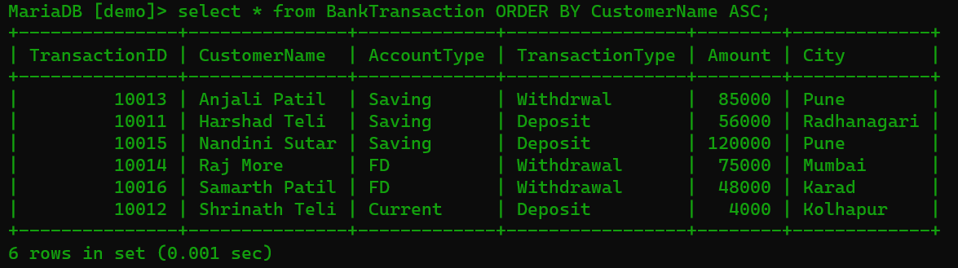
- Display all transaction records in descending order of Amount.
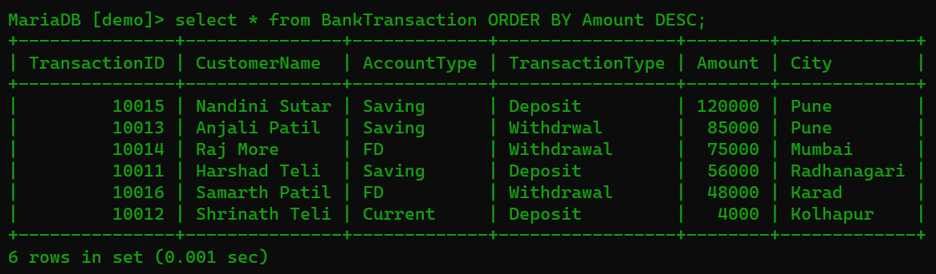
- Find the total number of transactions in the table.
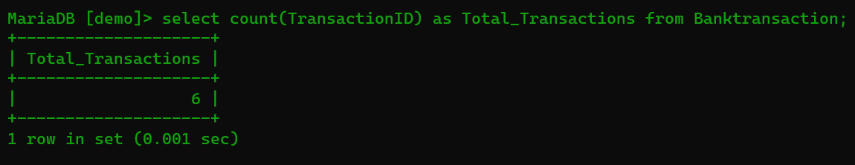
- Find the total transaction amount.
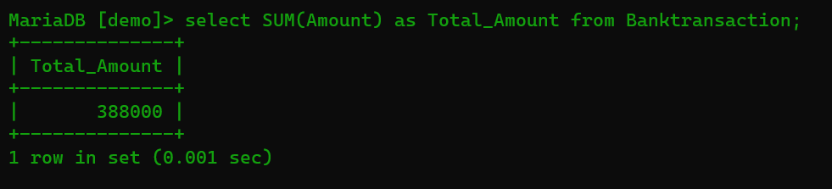
- Find the average transaction amount.
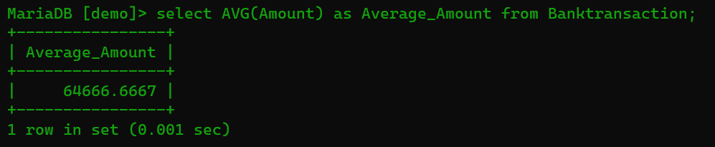
- Find the highest transaction amount.
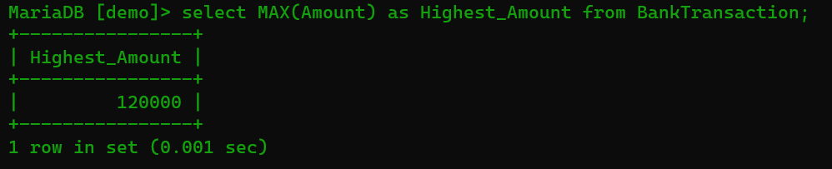
- Find the lowest transaction amount.

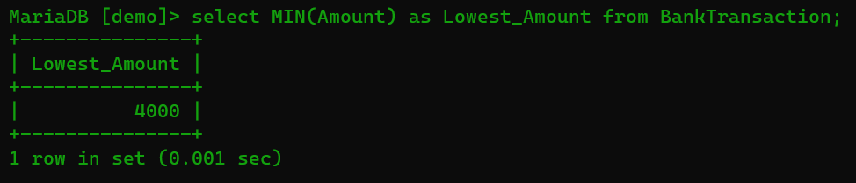
- Find the number of transactions for each AccountType.
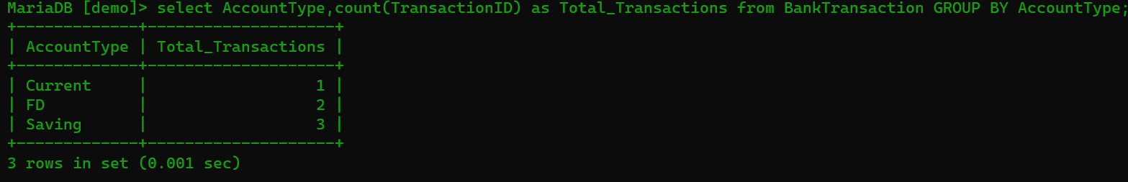
- Find the average transaction amount for each AccountType.
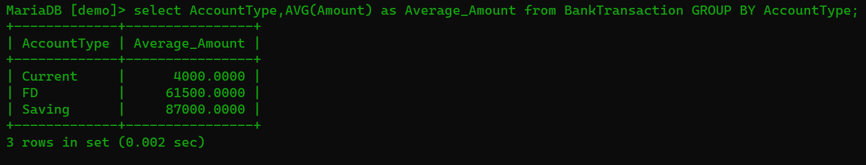
- Find the total transaction amount for each TransactionType.
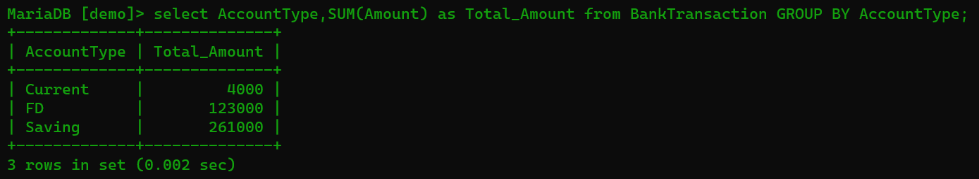
- Display only those AccountTypes having more than 2 transactions.
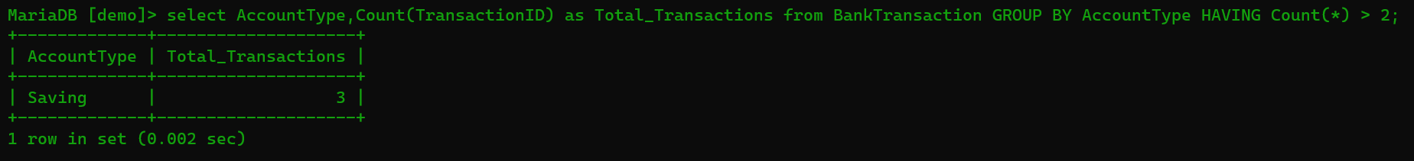
- Display TransactionTypes where the average transaction amount is greater than 25,000.
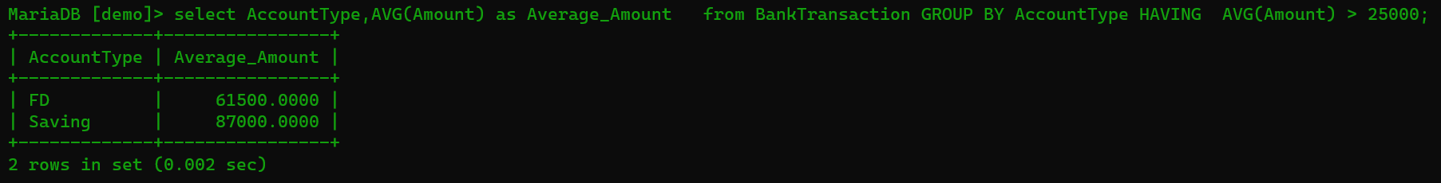
- Display all the different BranchCity values available in the table.

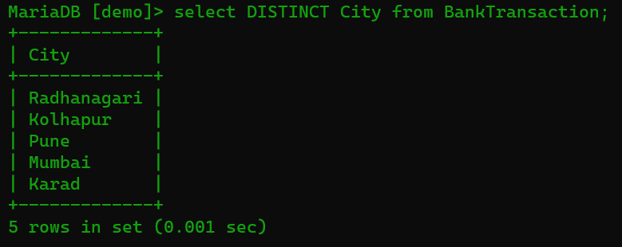

- Find the number of transactions made from Pune branch.
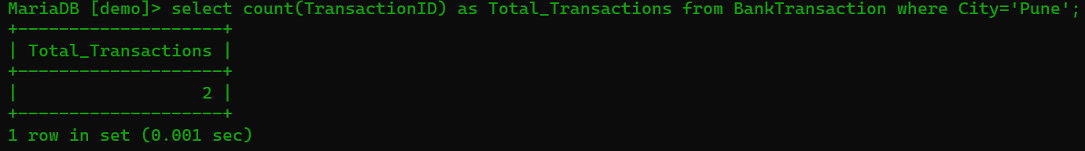
- Display the AccountType-wise transaction count and average transaction amount, showing only account types having more than 1 transaction, arranged by transaction count in descending order.
