Data Base Management System (DBMS) 12/08/2026
Name : Harshad Sanjay Teli.
Roll No : 15
Batch : B1
Assignment No 1 - DDL and DML Commands
Question 1: Employee Management
Table Structure:
Employee(EmpID, EmpName, Department, Salary)
Perform the following SQL operations:
DDL Commands:
a) Create the Employee table with appropriate data types.
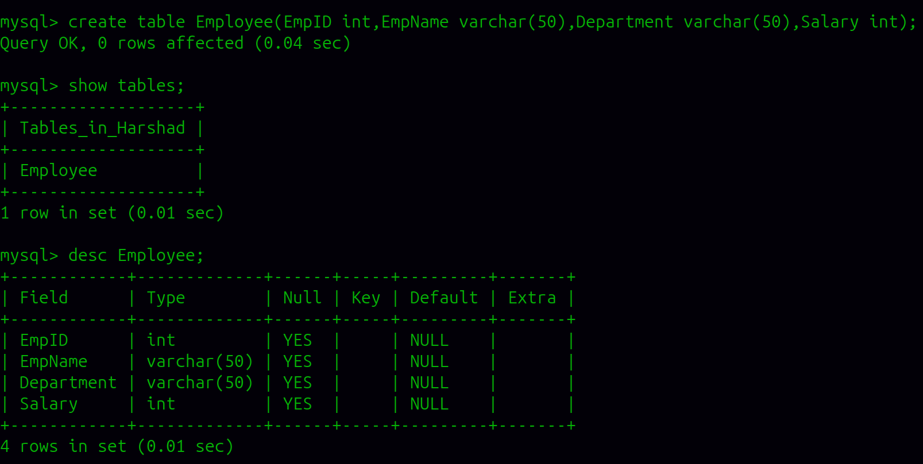

b) Add a new column City.
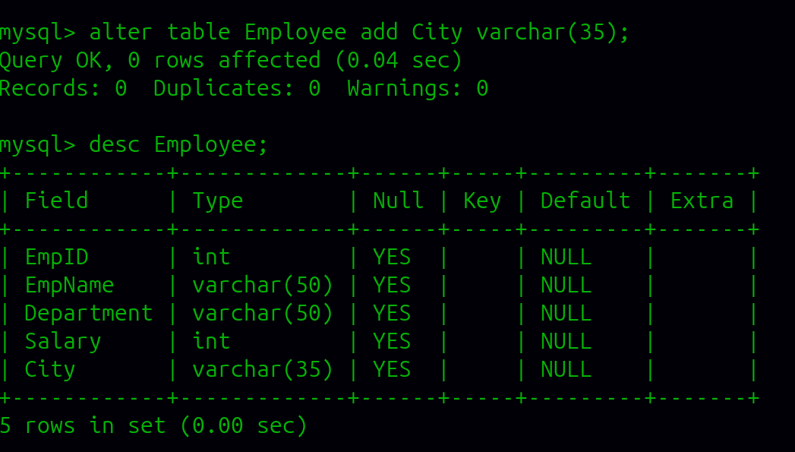
c) Add a new column JoiningDate.
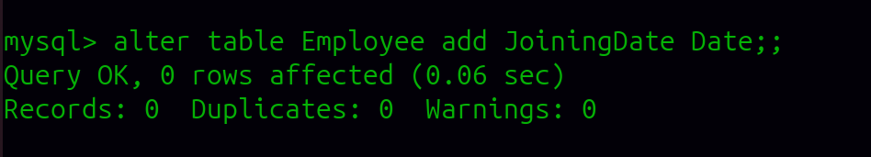
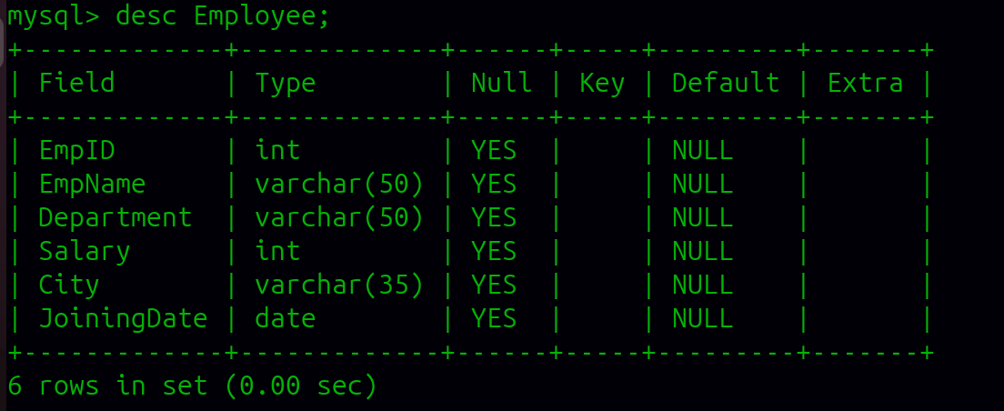
d) Modify the size of the Department column.
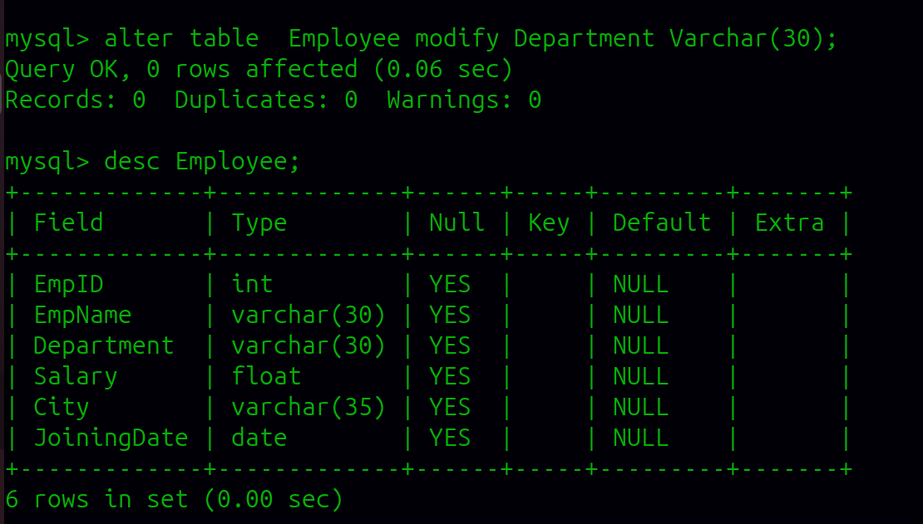
e) Modify the size of the EmpName column.
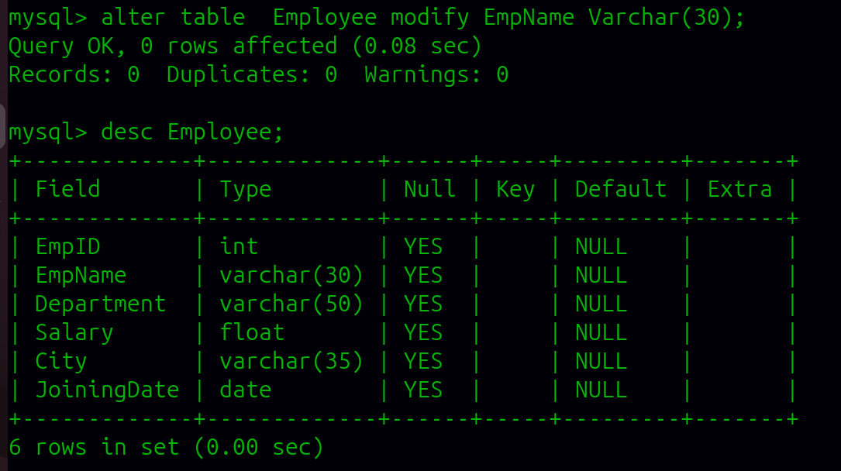

f) Rename the column Salary to MonthlySalary.
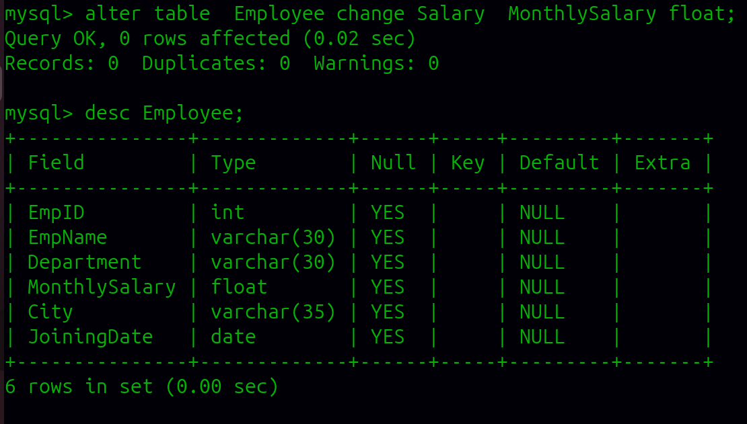
g) Drop the JoiningDate column.
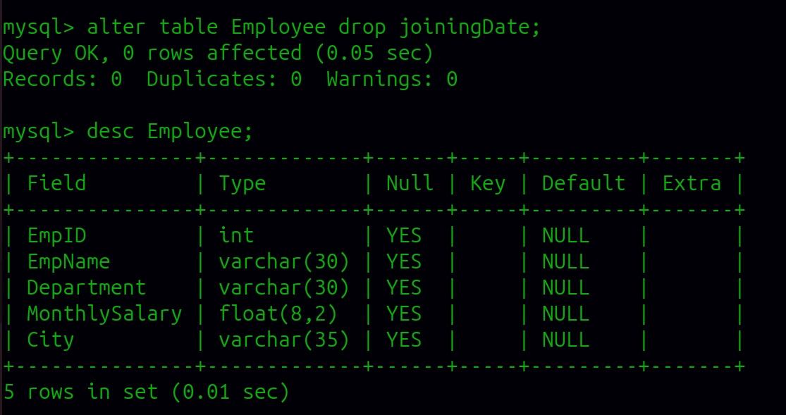

h) Rename the table Employee to EmployeeDetails.
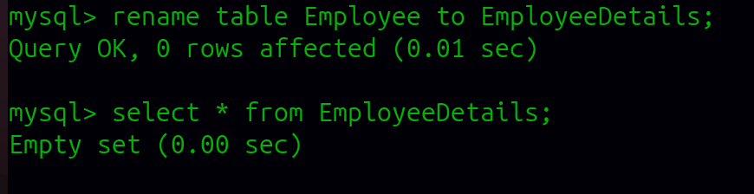
DML Commands:
i) Insert at least 5 employee records into the table.
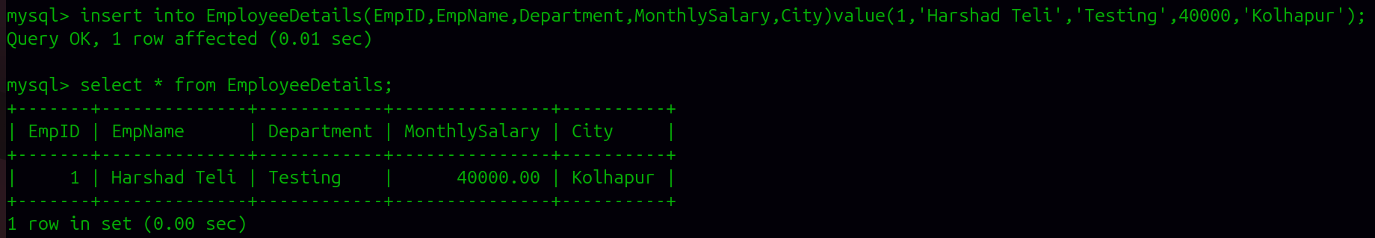
j) Display all records from the table.
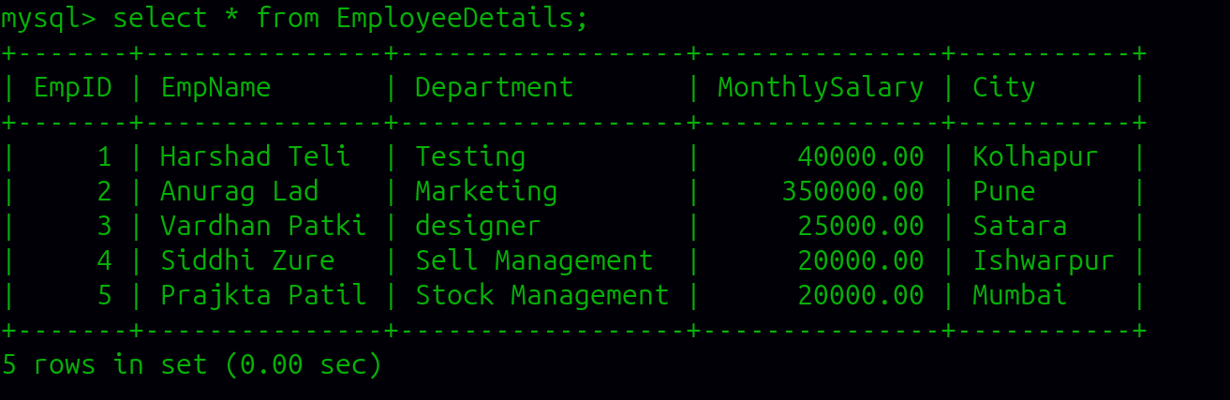

k) Update the City of an employee using EmpID.
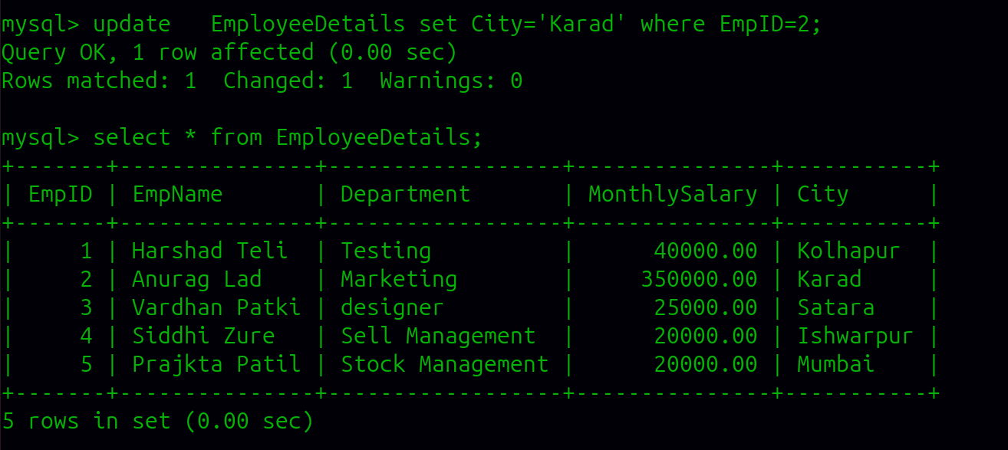
l) Update the MonthlySalary of an employee using EmpID.
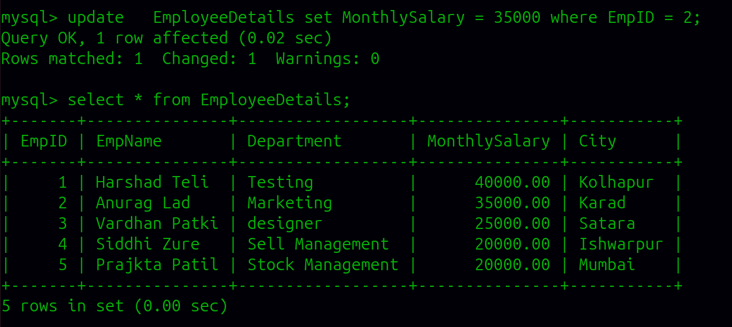

m) Update the Department of an employee using EmpID.
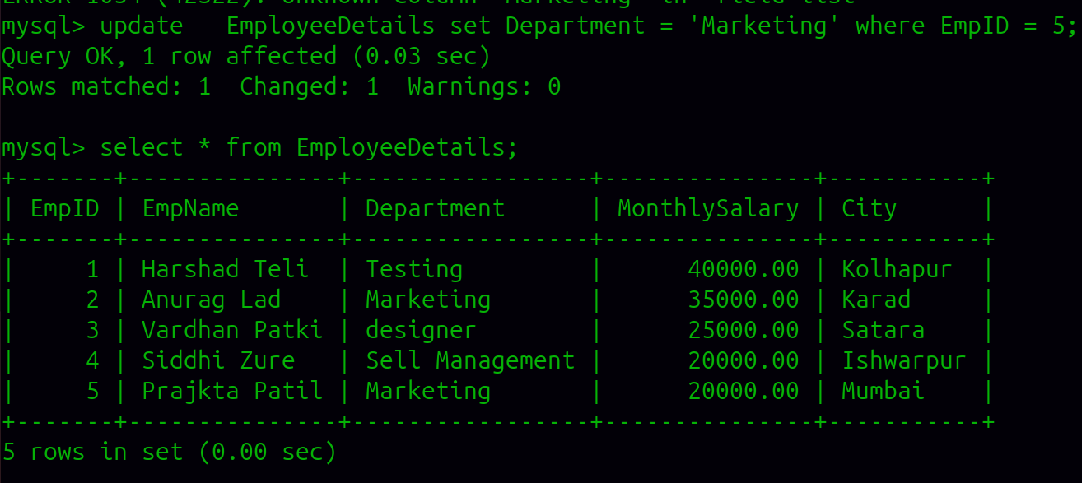
n) Delete one employee record using EmpID.
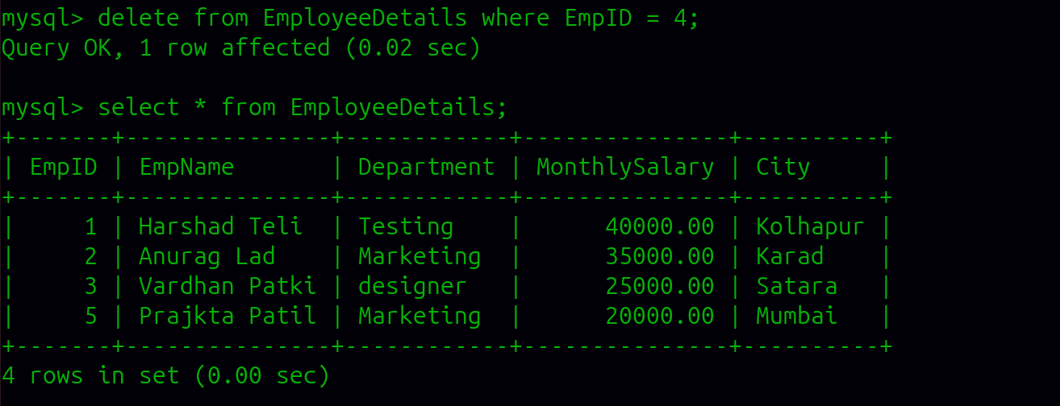
o) Display the records after performing the update and delete operations.
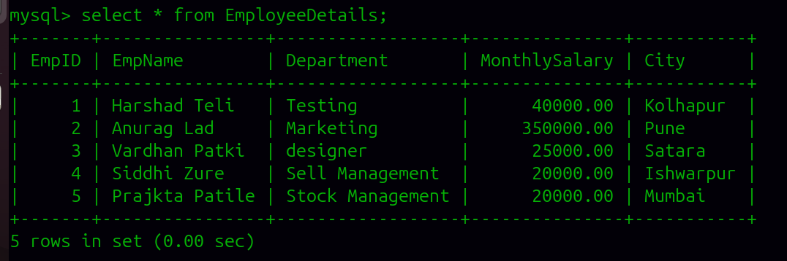
Question 2: Student Management
Table Structure:
Student(StudentID, StudentName, Course, Age)
Perform the following SQL operations:
DDL Commands:
a) Create the Student table with appropriate data types.
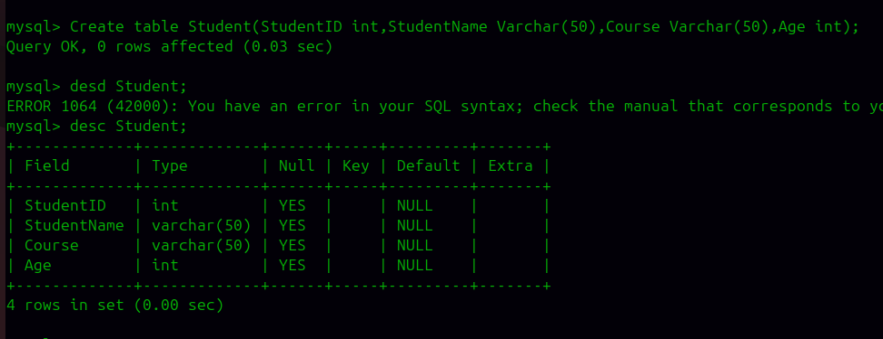
b) Add a new column Email.
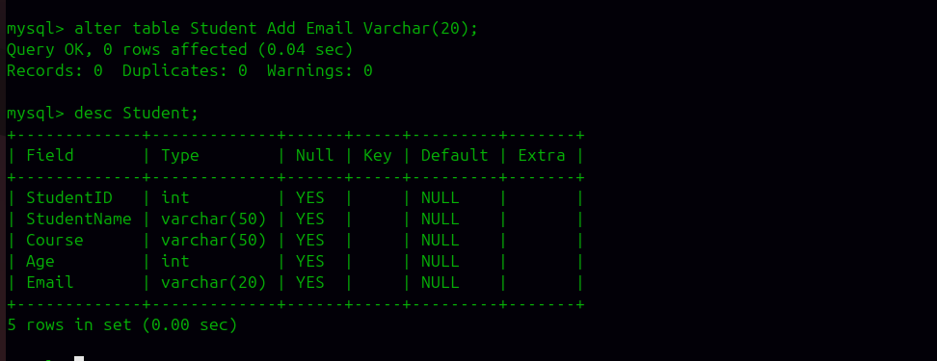

c) Add a new column MobileNo.
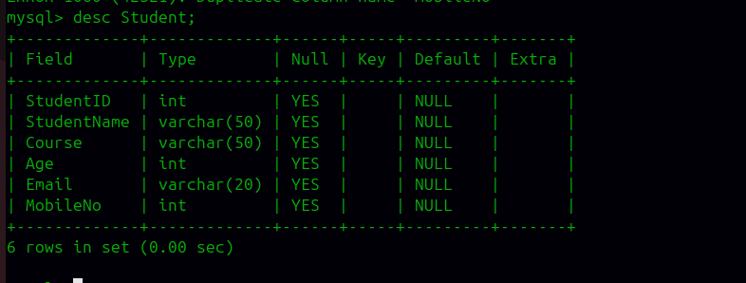
d) Modify the size of the Course column.
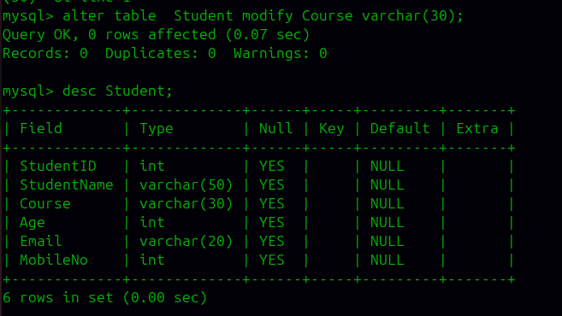

e) Modify the size of the StudentName column.
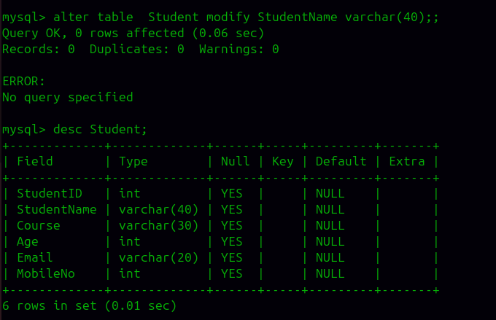
f) Rename the column Age to StudentAge.
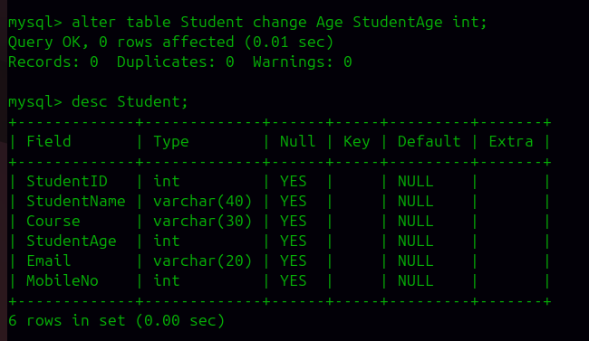

g) Drop the Email column
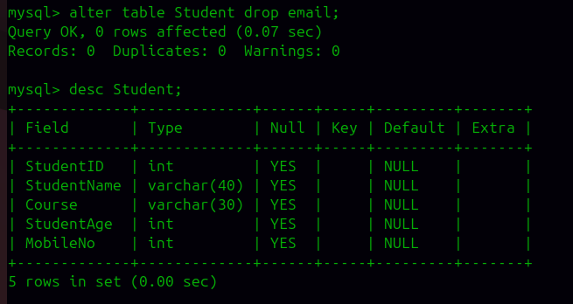
.
h) Rename the table Student to StudentMaster.
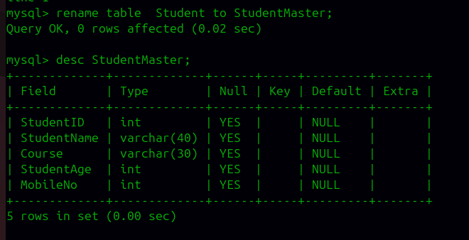

DML Commands:
i) Insert at least 5 student records into the table.
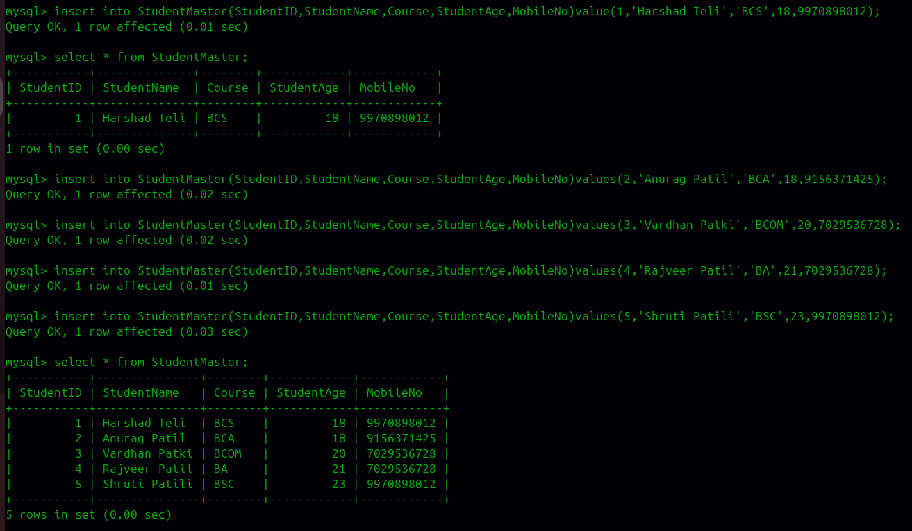
j) Display all records from the table.
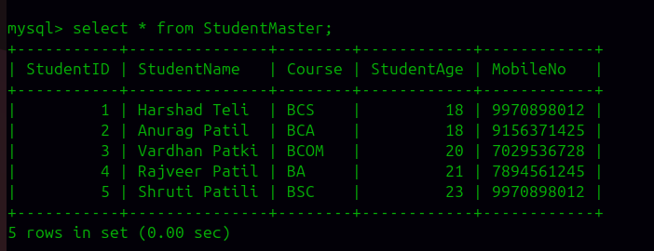

k) Update the Course of a student using StudentID.
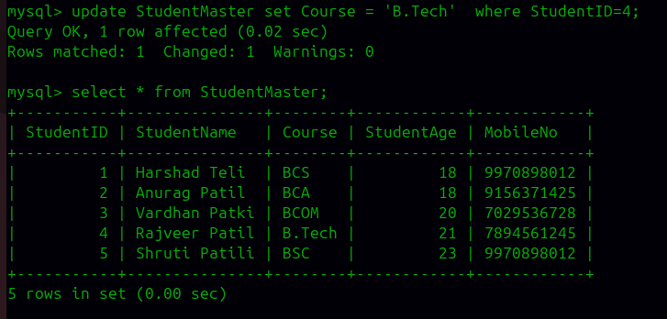
l) Update the StudentAge of a student using StudentID.
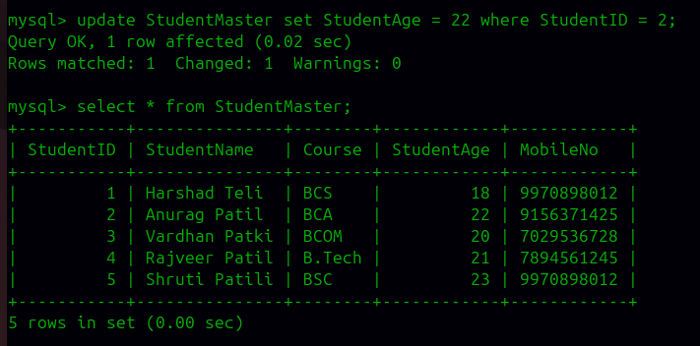

m) Update the MobileNo of a student using StudentID.
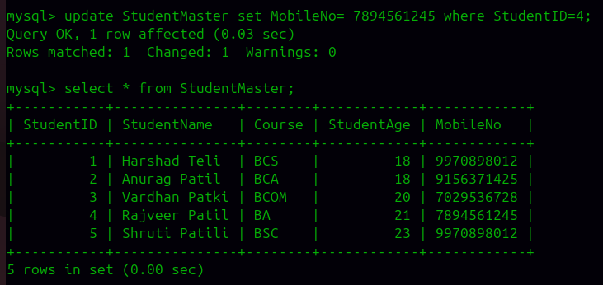
n) Delete one student record using StudentID.
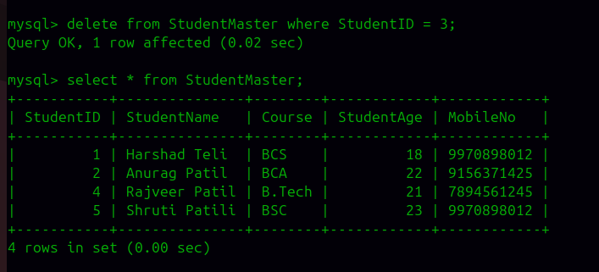
o) Display the records after performing the update and delete operations.
