Internet Programming 17/08/2026
Name : Harshad Sanjay Teli.
Roll No : 15
Batch : B1
Assignment No 3
Frames and Tables

Q1) Create the following table using appropriate HTML tags:
i)
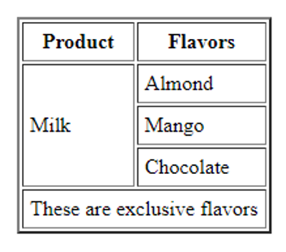

Input:

<!DOCTYPE html>
<html lang="en">
<head>
<meta charset="UTF-8">
<meta name="viewport" content="width=device-width, initial-scale=1.0">
<title>Assignment No 3 : Q1.1</title>

</head>
<body>
<center><h1>
Assignment No 3: Question No 1
</h1></center>
<center>
<table border="n" style="background-color: wheat;font-family: Georgia, 'Times New Roman', Times, serif;color: red;margin-top: 100px;height: 300px; width: 400px;">
<tr>
<th>Product</th>
<th>Flavours</th>
</tr>
<tr>
<td rowspan="3">Milk</td>
<td>Almond</td>
</tr>
<tr>
<td>Mango</td>
</tr>
<tr>
<td>Chocklate</td>
</tr>
<tr>
<td colspan="2">
There are exlcusive Flavours
</td>
</tr>
</table>
</center>
</body>
</html>

Output:

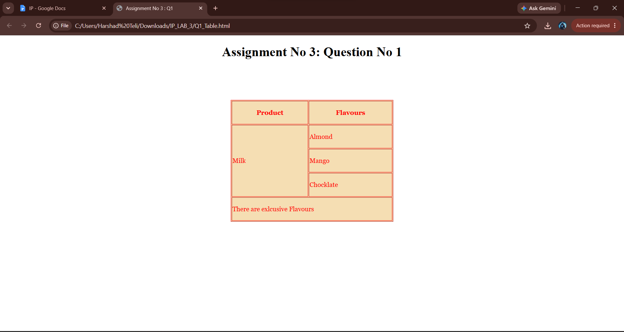

ii)
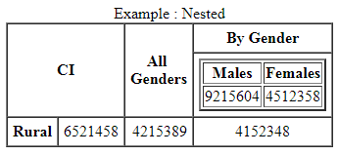
Input:

<!DOCTYPE html>
<html lang="en">
<head>
<meta charset="UTF-8">
<meta name="viewport" content="width=device-width, initial-scale=1.0">
<title>Assignment No 3 : Question 1.2</title>
</head>
<body>
<center><h1>
Assignment No 3: Question No 2 (Nested Table)
</h1></center>
<table border="1">
<caption>Example : Nested</caption>
<tr>
<th colspan="2" rowspan="2">CI</th>
<th rowspan="2">All<br>Genders</th>
<th>By Gender</th>
</tr>
<tr>
<td>
<table border="1">
<tr>
<th>Males</th>
<th>Females</th>
</tr>
<tr>
<td>9215604</td>
<td>4512358</td>
</tr>
</table>
</td>
</tr>
<tr>
<th>Rural</th>
<td>6521458</td>
<td>4215389</td>
<td>4152348</td>
</tr>
</table>
</body>
</html>

Output:

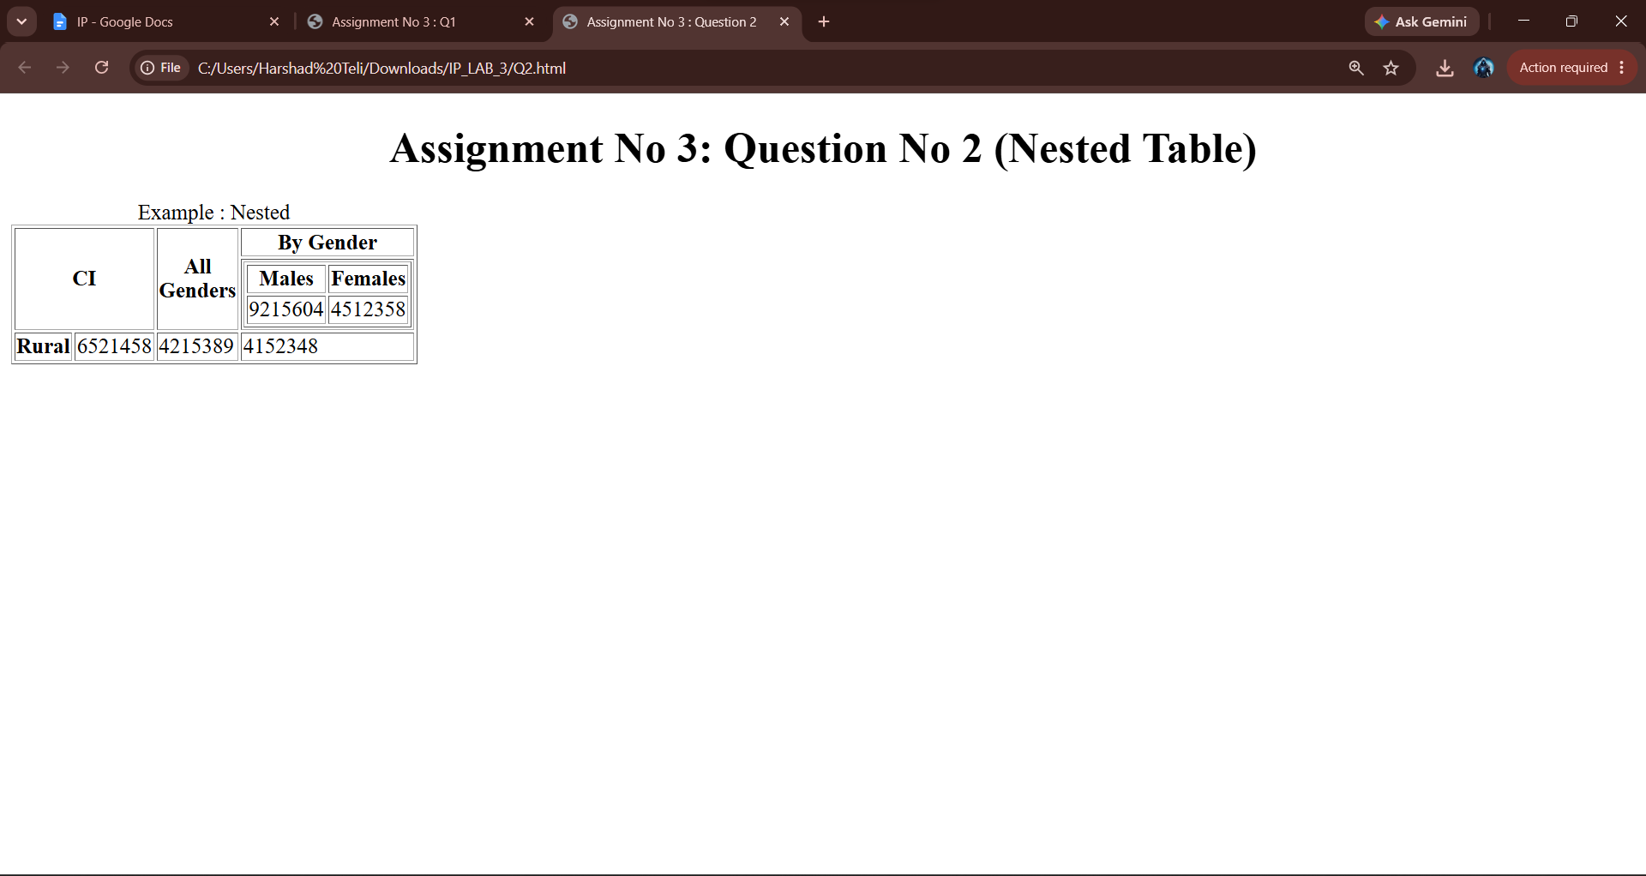

Q2) Anchor tags with the Frames.
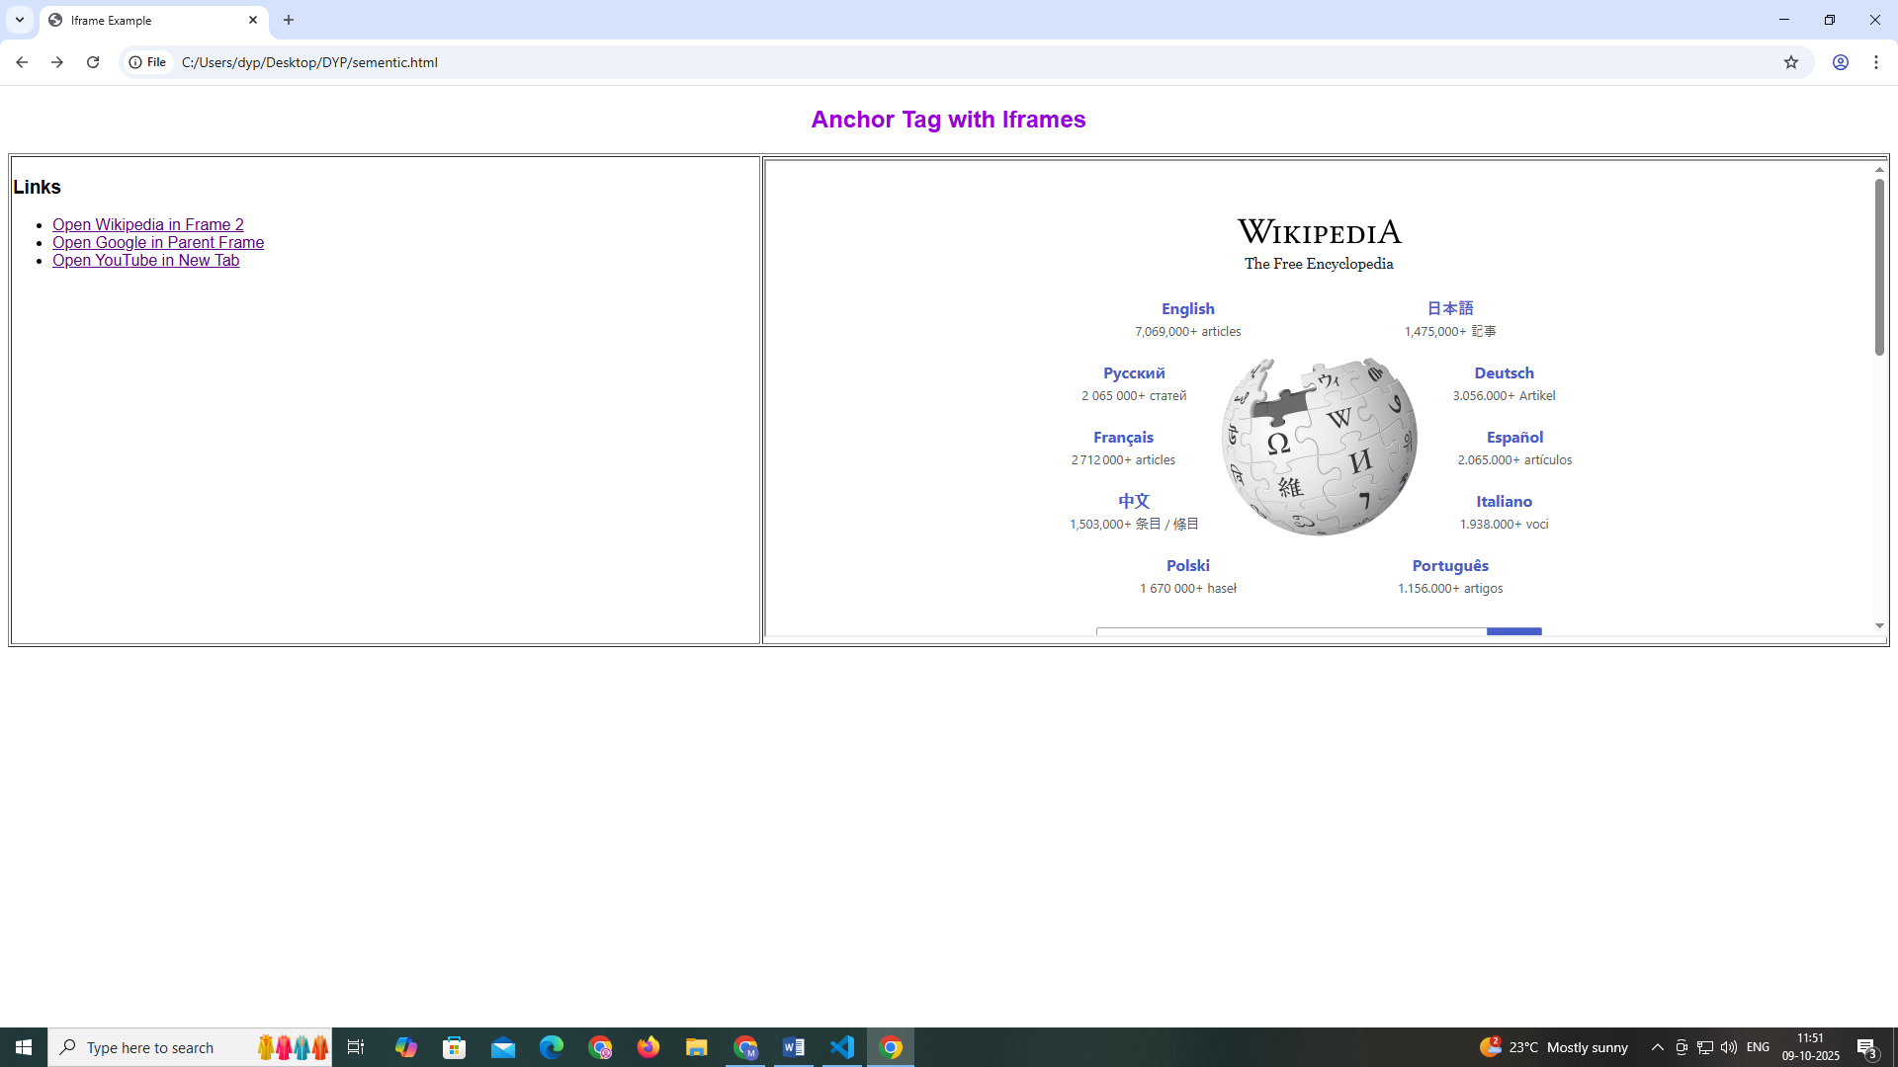

Input:
<!DOCTYPE html>
<html lang="en">
<head>
<meta charset="UTF-8">
<meta name="viewport" content="width=device-width, initial-scale=1.0">
<title>Assigment No 3 : Que No 2</title>
</head>
<body>
<center><h1>
Assignment No 3: Question No 3
</h1></center>
<iframe
name="Links"
width="49%"
height="500"
srcdoc='
<h2>Links</h2><br>
<ul>
<li><a href="https://www.wikipedia.org/" target="Frame2">Open Wikipedia in Frame 2</a></li><br>
<li><a href="https://www.google.com/" target="_Parent">Open Google in Parent Frame</a></li><br>
<li><a href="https://www.youtube.com/" target="_blank">Open Youtube in New Tab</a></li><br>
</ul>'
></iframe>
<iframe
name="Frame2"
width="50%"
height="500"
srcdoc='<h5>To Click on the One of the Options from frame 1</h5>'
>

</iframe>

</body>
</html>

Output:

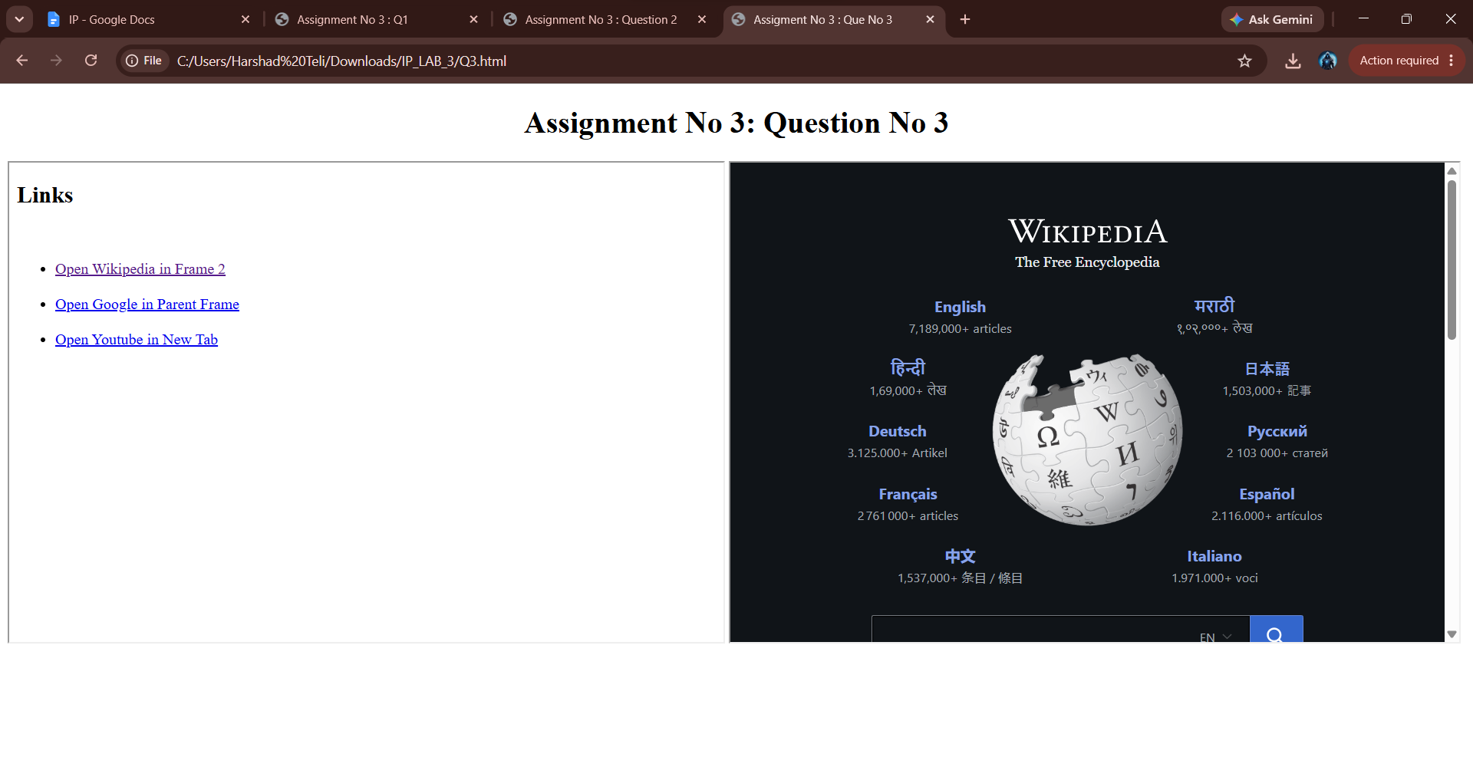

Q3) Computer Science Learning Portal
Create a webpage titled “Computer Science Learning Portal” using HTML iframe.
Create three frames:
Frame 1 – Subjects
- HTML
- CSS
- JavaScript
- Python
Frame 2 – Content
- Display the selected content in this frame.
Use <a> and <iframe> tags. Do not use CSS or tables.
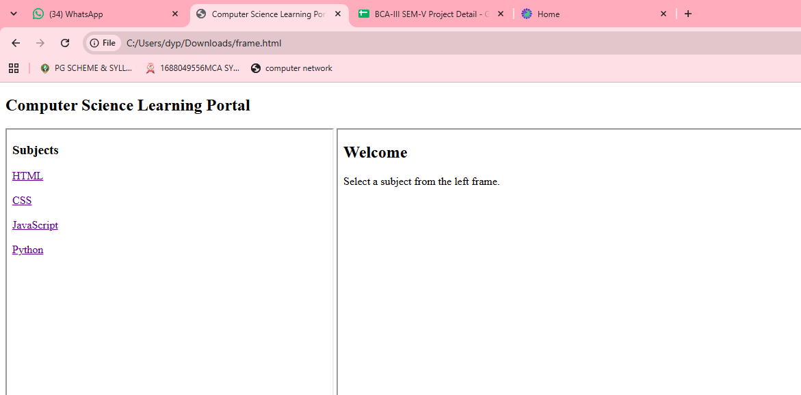
Input:

<!DOCTYPE html>
<html lang="en">

<head>
<meta charset="UTF-8">
<meta name="viewport" content="width=device-width, initial-scale=1.0">
<title>Assignment No 4 : Que No 3</title>
</head>

<body>
<center>
<h1>
Assignment No 3: Question No 4
</h1>
</center>
<iframe name="Frame1_CS" width="49%" height="500px" srcdoc='<h2>Subjects</h2><br>
<ul>
<li><a href="data:text/html,HTML Stands for Hyper Text Markup Language" target="Frame2">HTML</a></li>
<li><a href="data:text/html,CSS is used for the styling the Web page." target="Frame2">CSS</a></li>
<li><a href="data:text/html,JAVASCRIPT handles the logic of the page." target="Frame2">JAVASCRIPT</a></li>
<li><a href="data:text/html,PYTHON is the High Level Language." target="Frame2">PYTHON</a></li>

</ul>'>
</iframe>
<iframe name="Frame2" width="50%" height="500px" srcdoc='<h2>Select a Subject from the Left Frame</h2>'></iframe>
</body>

</html>

Output:

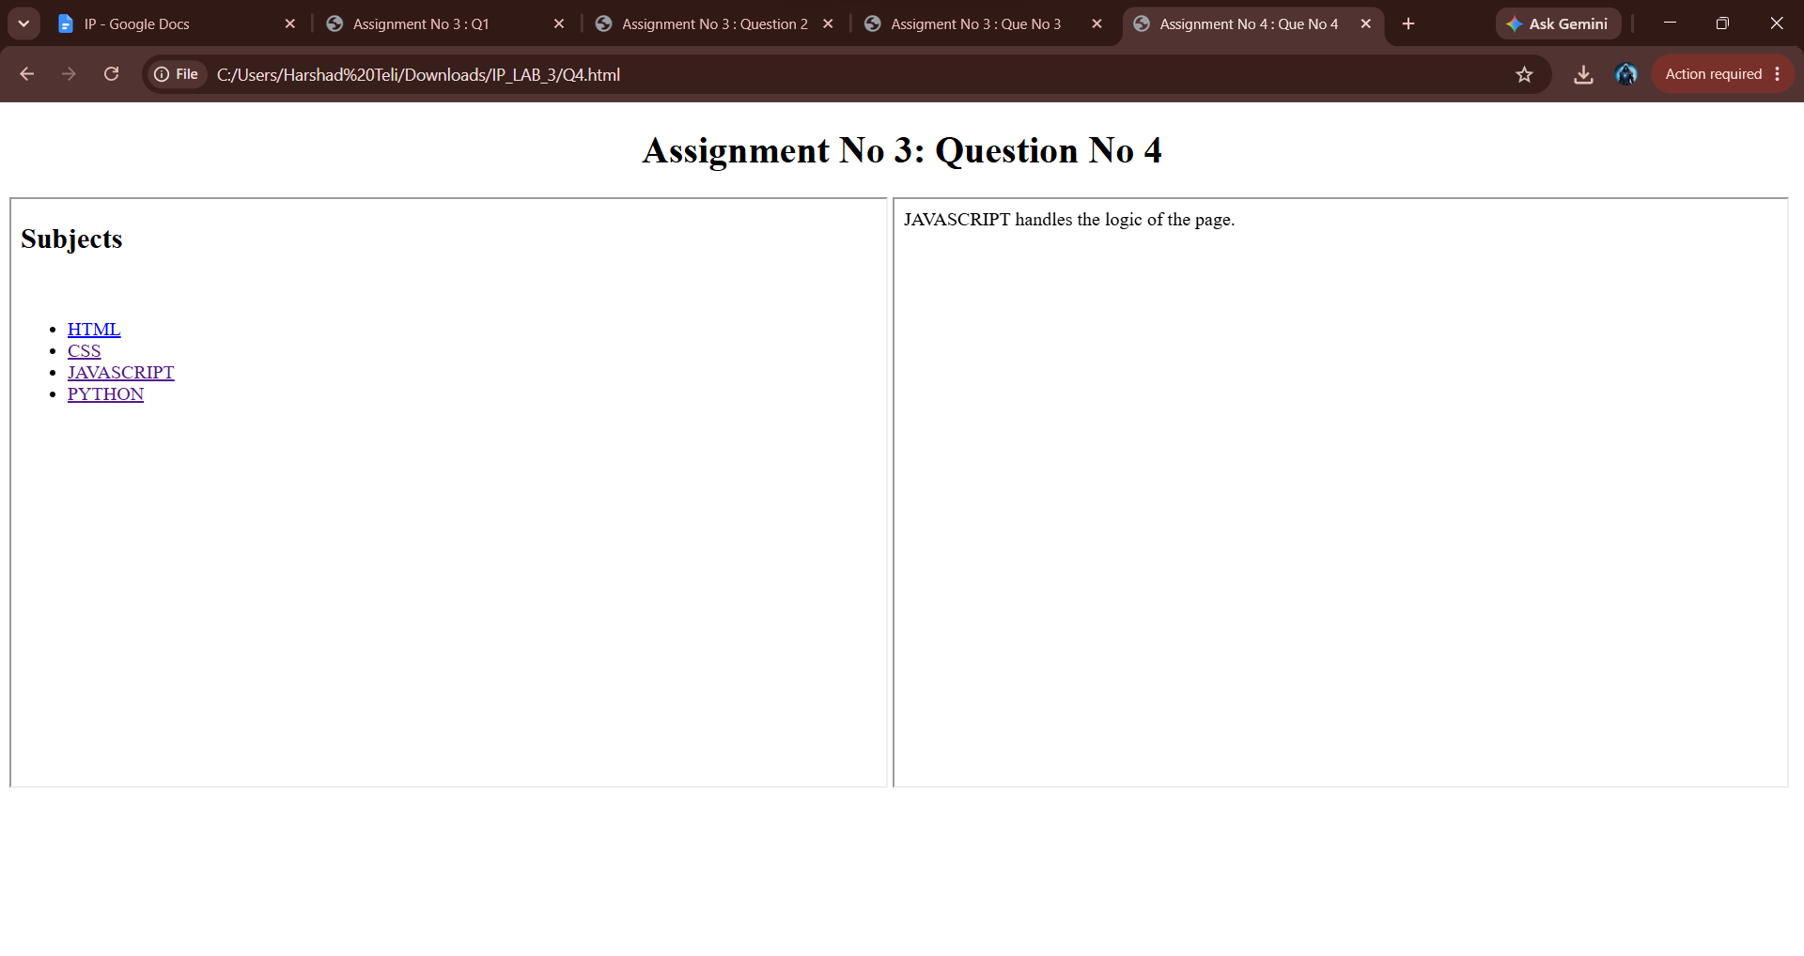

Q4) Online Library
Create an “Online Library” webpage using three iframes.
Frame 1 – Categories
- Programming
- Networking
- Database
- AI
Frame 2 – Books
- Select books related to the category.
Condition: Use only HTML. Do not use CSS or tables.
Input:
<!DOCTYPE html>
<html lang="en">

<head>
<meta charset="UTF-8">
<meta name="viewport" content="width=device-width, initial-scale=1.0">
<title>Assignment No 3 : Que 4</title>
</head>

<body>
<center>
<h1>
Assignment No 3: Question No 4
</h1>
</center>
<h2>Online Library</h2>
<iframe name="Categories" width="49%" height="500px" srcdoc='<h2>Categories</h1><br>
<ul>
<li><a href="data:text/html,Welcome to the Programming World.<br><ul><li>C<li><li>C++</li><li>JAVA</li></ul>" target="Frame2">Programming</a></li><br>
<li><a href="data:text/html,Networking is the easy to understand.<br><ul><li>Computer Networking</li><li>Data Communication and Networking</li></ul>" target="Frame2">Networing</a></li><br>
<li><a href="data:text/html,Database can used for the storing the Data.<br><ul><li>Database Fundamentals</li><li>Database Management System</li></ul>" target="Frame2">Database</a></li><br>
<li><a href="data:text/html,AI is stands for the Artificial Intelligence.<br><ul><li>Artificial Intelligence</li><li>Neural Networks</li></ul>" target="Frame2">AI</a></li><br>

</ul>'>

</iframe>
<iframe name="Frame2" width="49%" height="500px" srcdoc="<h2>Books</h2><br>">

</iframe>
</body>

</html>

Output:
