Assignment-3
- Create the following table using appropriate HTML tags:

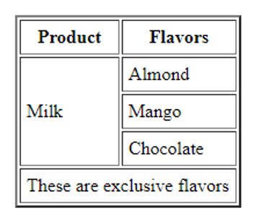

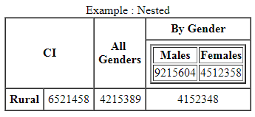

- Anchor tag along with frame.
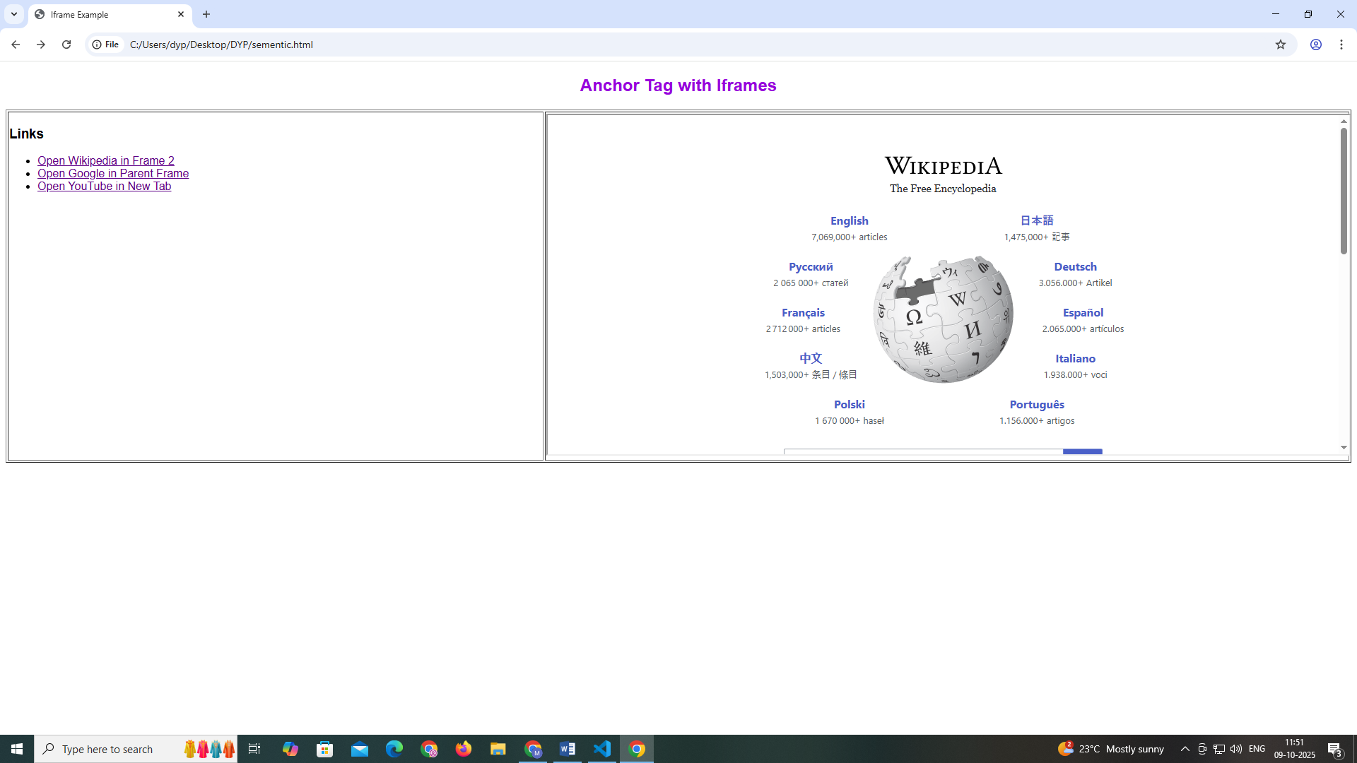

- Computer Science Learning Portal
Create a webpage titled “Computer Science Learning Portal” using HTML iframe.
Create three frames:
Frame 1 – Subjects
- HTML
- CSS
- JavaScript
- Python
Frame 2 – Content
- Display the selected content in this frame.
Use <a> and <iframe> tags. Do not use CSS or tables.
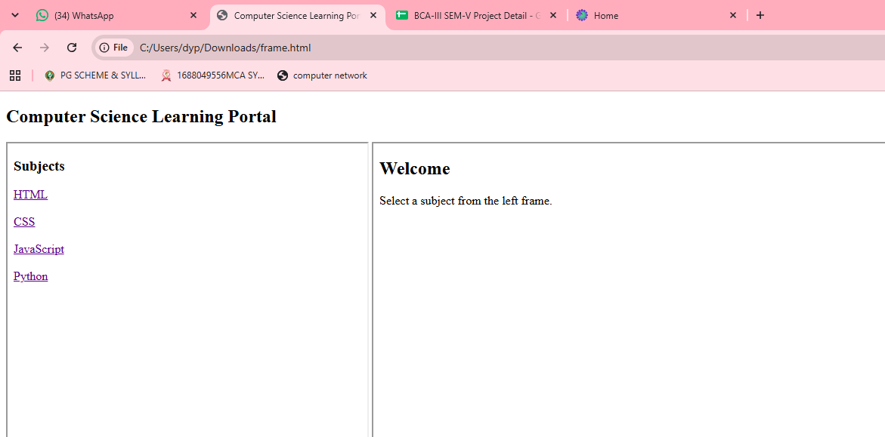
- Online Library
Create an “Online Library” webpage using three iframes.
Frame 1 – Categories
- Programming
- Networking
- Database
- AI
Frame 2 – Books
- Select books related to the category.
Condition: Use only HTML. Do not use CSS or tables.

