Internet Programming 09/08/2026
Name : Harshad Sanjay Teli.
Roll No : 15
Batch : B1
Lab Test 1

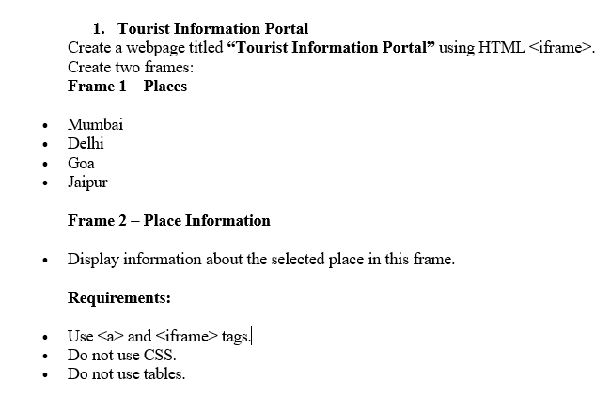
Input:

<!DOCTYPE html>
<html lang="en">

<head>
<meta charset="UTF-8">
<meta name="viewport" content="width=device-width, initial-scale=1.0">
<title>Tourist Information Portal</title>
</head>
<body>
<iframe name="Places" width="49%" height="500px" srcdoc='
<h1>Places</h1>

<ul>
<li><a href="data:text/html,<h1>Welcome To Mumbai</h1><br><table border=`n`><tr><th>Name</th><th>Climate</th></tr><tr><td>Mumbai</td><td>Warm and humid with a primary rainy monsoon season from June to September</td></tr></table>" target="Place">Mumbai</a>
<li><a href="data:text/html,<h1>Welcome To Delihi</h1><br><table border=`n`><tr><th>Name</th><th>Climate</th></tr><tr><td>Delihi</td><td>Delhi has a humid subtropical climate that borders on a hot semi-arid climate, marked by extreme variations between summer and winter temperatures</td></tr></table>" target="Place">Delihi </a></li>
<li><a href="data:text/html,<h1>Welcome To Goa</h1><br><table border=`n`><tr><th>Name</th><th>Climate</th></tr><tr><td>Goa</td><td>Goa features a hot and humid tropical monsoon climate with warm temperatures hovering between 20°C and 35°C all year round, as detailed by the Climate of Goa portal. </td></tr></table>" target="Place">Goa </a></li>
<li><a href="data:text/html,<h1>Welcome To Jaipur</h1><br><table border=`n`><tr><th>Name</th><th>Climate</th></tr><tr><td>Jaipur</td><td>Jaipur features a hot semi-arid climate characterized by long, extremely hot summers, a monsoon season with moderate rainfall, and short, mild winters, as detailed on Wikipedia.</td></tr></table>" target="Place">Jaipur</a></li>
'></iframe>
<iframe name="Place" width="50%" height="500px"
srcdoc='Clik To right any one options'>
</iframe>
</body>
</html>

Output:

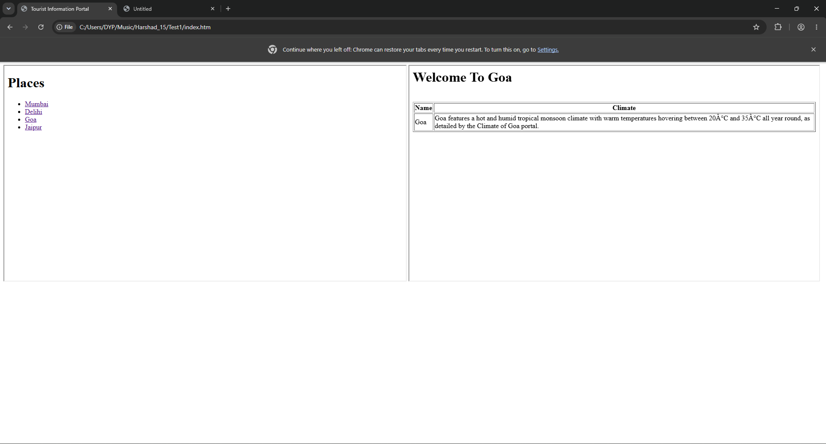

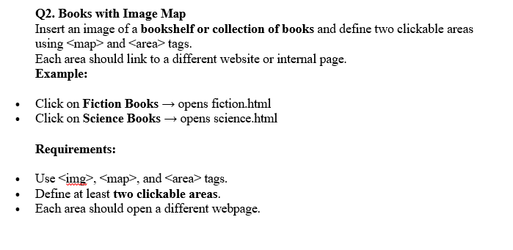
Input:

<!DOCTYPE html>
<html lang="en">
<head>
<meta charset="UTF-8">
<meta name="viewport" content="width=device-width, initial-scale=1.0">
<title> bookshelf or collection of books</title>
<style>
body img area{
cursor: pointer;
}
</style>
</head>
<body>
<center><h1> bookshelf or collection of books</h1></center>
<img src="https://www.hachettebookgroup.com/wp-content/uploads/2020/07/Expand-Your-Mind-with-These-Literary-Science-Fiction-Books-Featured-Image.png" usemap="#BookMap"
width="1500px" height="700px" alt="Book Image">
<map name="BookMap">
<area shape="rect" href="./fictional.html" coords="500,2000,200,100" title="_blank">
<area shape="rect" href="./science.html" coords="800,2000,200,100" title="_blank">
</map>
</body>
</html>
//Fiction Book page
<!DOCTYPE html>
<html lang="en">

<head>
<meta charset="UTF-8">
<meta name="viewport" content="width=device-width, initial-scale=1.0">
<title>Document</title>
</head>

<body>
<h1>The about Aura</h1>
<p>The story follows humanity’s first major attempt at interstellar colonization. A giant generation ship, designed
as a massive Stanford torus (a ring-shaped space habitat), leaves Earth in the year 2545 CE. It is heading
toward the Tau Ceti star system, which is 11.9 light-years away, traveling at a fraction of the speed of light.
</p>
<p>The
narrative begins nearly 160 years into the voyage as the ship is finally decelerating toward its destination.
Over multiple generations, the ship's closed-loop ecological biomes (which mimic various Earth environments)
have begun to break down, face severe resource depletion, and experience technical glitches. The crew must
navigate these compounding crises while preparing to land on a habitable, uncharted moon they name Aurora.</p>
</body>

</html>
//Science Book Page
<!DOCTYPE html>
<html lang="en">

<head>
<meta charset="UTF-8">
<meta name="viewport" content="width=device-width, initial-scale=1.0">
<title>Document</title>
</head>

<body>
<h1>About the Book</h1>
<p> Science Fiction Novels: These are made-up stories grounded in strict, real-world science. Unlike space
fantasies (like Star Wars), these books strictly follow the laws of physics, real mathematics, chemistry, and
biological engineering to tell realistic stories about space exploration and the future (e.g., Kim Stanley
Robinson's Aurora and Andy Weir's The Martian).</p> </body>

</html>

Output:

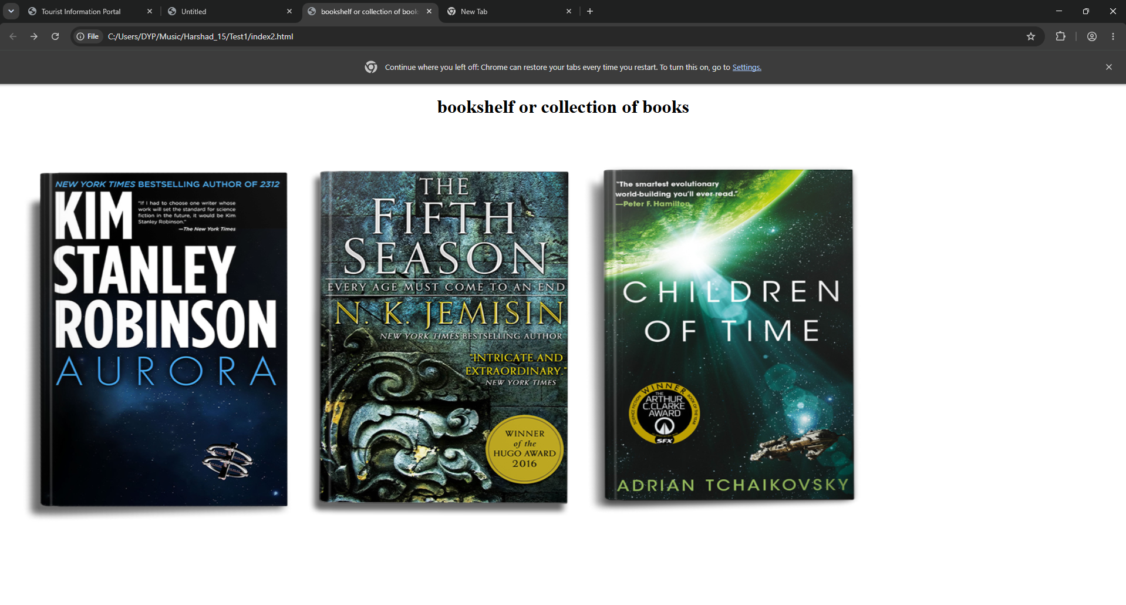
When the click on the first page then show the book info of the fiction book

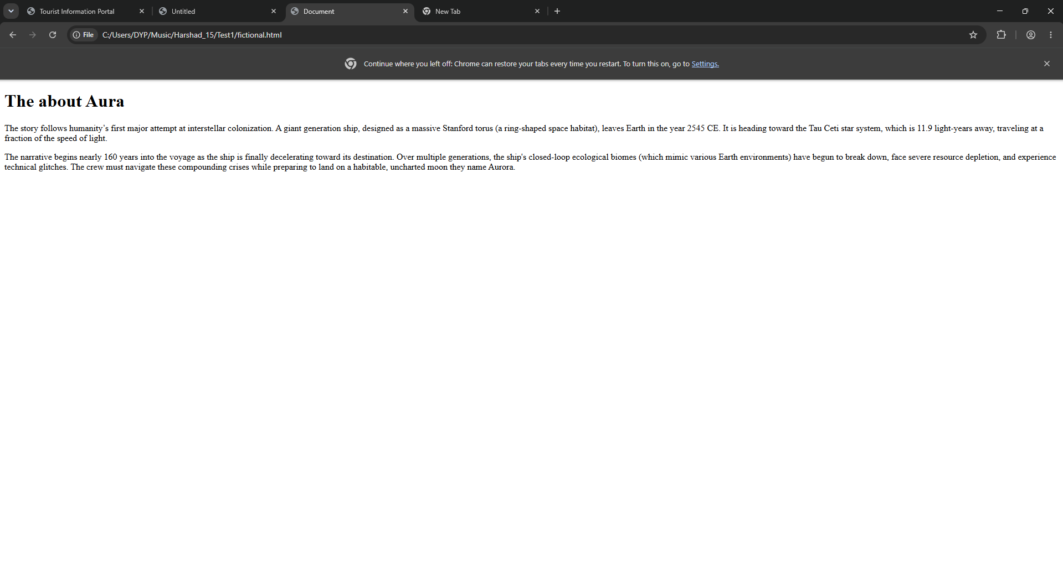

When the click on the Second page then show the book info of the Science book

