Internet Programming
Name: Harshad Sanjay Teli.
Roll No:15
Date:05/11/2026
Assignment-11
- Write a JavaScript program to create a class Employee with the following specifications:
Properties:
- empName
- basicSalary
Constructor:
- Initialize employee name and basic salary using constructor.
Methods:
- calculateSalary()
  - Calculate HRA and DA based on the following conditions:
    - If basicSalary > 50000
      - HRA = 25% of basic salary
      - DA = 20% of basic salary
    - If basicSalary is between 20000 and 50000
      - HRA = 20% of basic salary
      - DA = 15% of basic salary
    - If basicSalary < 20000
      - HRA = 15% of basic salary
      - DA = 10% of basic salary
- displaySalary()
  - Display:
    - Employee Name
    - Basic Salary
    - HRA
    - DA
    - Gross Salary = Basic + HRA + DA

Input:
<!DOCTYPE html>
<html lang="en">
<head>
<meta charset="UTF-8">
<meta name="viewport" content="width=device-width, initial-scale=1.0">
<title>Class Employee</title>
</head>
<body>
<script type="text/javascript">
class Employee{
constructor(empName,basicSalary)
{
this.empName=empName;
this.basicSalary=basicSalary;
}
calculateSalary(){
if(this.basicSalary>50000)
{
this.hra=this.basicSalary*25/100;
this.da=this.basicSalary*20/100;
}
else if(this.basicSalary>=20000)
{
this.hra=this.basicSalary*20/100;
this.da=this.basicSalary*15/100;
}
else{
this.hra=this.basicSalary*15/100;
this.da=this.basicSalary*10/100;
}
this.grosssalary=this.basicSalary+this.hra+this.da;
}
displaySalary()
{
console.log("Employee Name:"+this.empName);
console.log("Basic Salary:"+this.basicSalary);
console.log("HRA:"+this.hra);
console.log("DA:"+this.da);
console.log("Gross Salary:"+this.grosssalary);
}

}
let emp=new Employee("Harshad Teli",45000);
emp.calculateSalary();
emp.displaySalary();
</script>
</body>
</html>
Output:
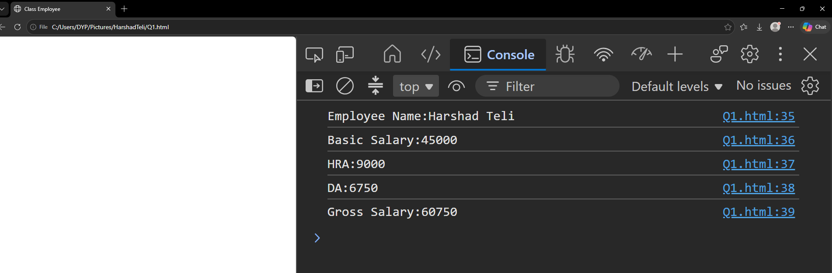

2. Write a JavaScript program to create a class ElectricityBill with the following specifications:

Properties:
- consumerName
- unitsConsumed

Constructor:
- Initialize consumer name and units consumed using constructor.

Methods:
- calculateBill()
  - Calculate electricity bill amount based on the following conditions:
    - If units ≤ 100
      - Rate = ₹1.5 per unit
    - If units between 101 and 300
      - Rate = ₹2.5 per unit
    - If units > 300
      - Rate = ₹4 per unit
  - Calculate total bill amount.
- displayBill()
  - Display:
    - Consumer Name
    - Units Consumed
    - Total Bill Amount
Input:

<!DOCTYPE html>
<html lang="en">
<head>
<meta charset="UTF-8">
<meta name="viewport" content="width=device-width, initial-scale=1.0">
<title>Electricity Bill</title>
</head>
<body>

<script>
class ElectricityBill {

constructor(consumerName, unit) {
this.consumerName = consumerName;
this.unit = unit;
this.total = 0;
}

calculateAmount() {

if (this.unit <= 100) {
this.total = this.unit * 1.5;
}
else if (this.unit <= 300) {
this.total = this.unit * 2.5;
}
else {
this.total = this.unit * 4;
}

}

displayBill() {
console.log("Consumer Name: " + this.consumerName);
console.log("Units Consumed: " + this.unit);
console.log("Total Amount: Rs. " + this.total);
}
}

let user = new ElectricityBill("Harshad Teli", 45000);

user.calculateAmount();
user.displayBill();

</script>

</body>
</html>

Output:
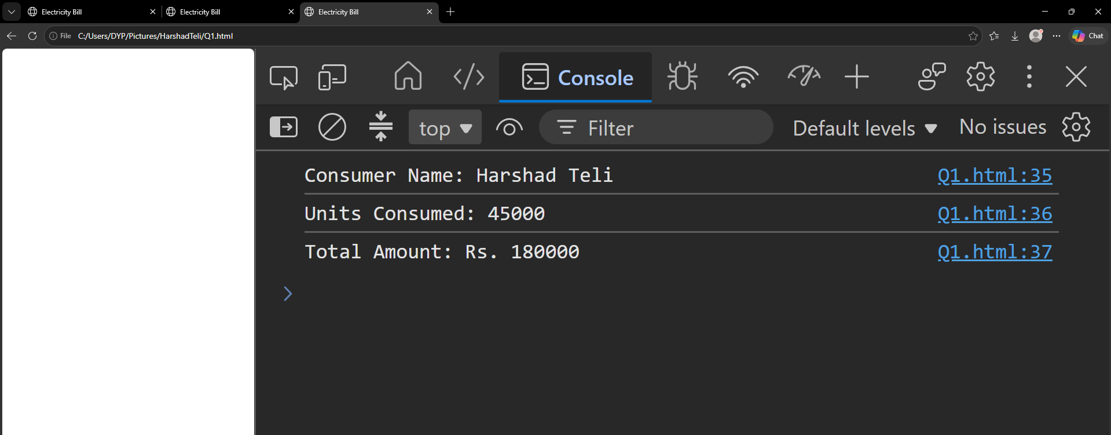

- Create a Password Strength Checker using jQuery with the following requirements:

Input Field:
- Password

Functionality (Using jQuery Events):
- As the user types the password, check its strength in real time using the keyup() event.

Password Strength Rules:
- Weak Password
  - Less than 6 characters
- Medium Password
  - Minimum 6 characters
  - Contains letters and numbers
- Strong Password
  - Minimum 8 characters
  - Contains:
    - Uppercase letter
    - Lowercase letter
    - Number
    - Special character
Input:
<html>
<head>
<title>Password Checker</title>
<script src="https://code.jquery.com/jquery-3.7.1.min.js"></script>
</head>
<body>

<h2>Password Strength Checker</h2>

Enter Password:
<input type="password" id="pass">

<p id="result"></p>

<script>
$(document).ready(function()
{
$("#pass").keyup(function()
{
var p = $("#pass").val();

if(p.length < 6)
{
$("#result").text("Weak Password");
}
else if(p.length >= 8 &&
/[A-Z]/.test(p) &&
/[a-z]/.test(p) &&
/[0-9]/.test(p) &&
/[^A-Za-z0-9]/.test(p))
{
$("#result").text("Strong Password");
}
else if(/[a-zA-Z]/.test(p) && /[0-9]/.test(p))
{
$("#result").text("Medium Password");
}
else
{
$("#result").text("Weak Password");
}
});
});
</script>

</body>
</html>

Output:
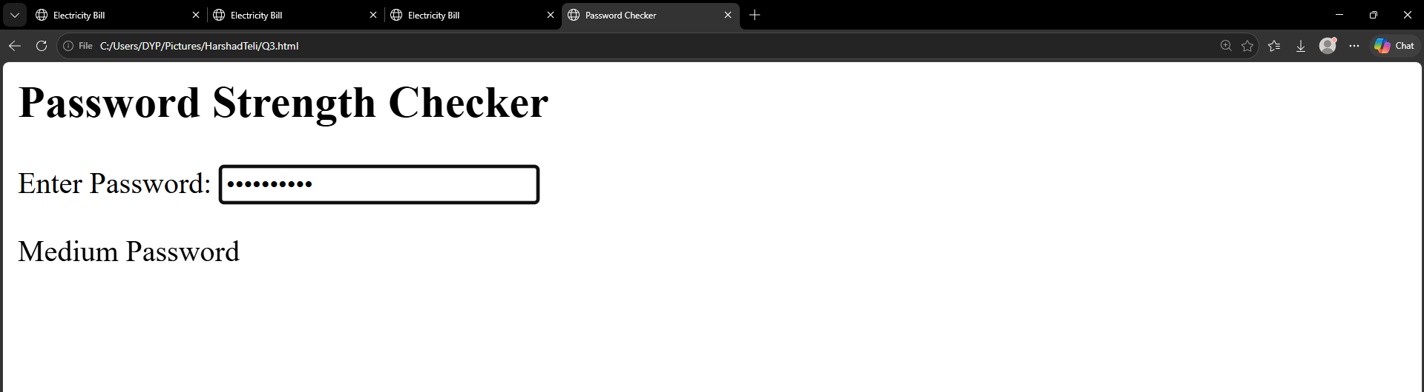

- Create a class LoginSystem:
- Validates username & password
- Locks account after 3 failed attempts
- Displays remaining attempts dynamically
Input:
<html>
<head>
<title>Login System</title>
</head>
<body>

<h2>Login System</h2>

Username:
<input type="text" id="username"><br><br>

Password:
<input type="password" id="password"><br><br>

<button onclick="login()">Login</button>

<p id="result"></p>

<script>

class LoginSystem
{
constructor()
{
this.username = "admin";
this.password = "12345";
this.attempts = 3;
}

checkLogin(u, p)
{
if(this.attempts == 0)
{
return "Account Locked!";
}

if(u == this.username && p == this.password)
{
return "Login Successful!";
}
else
{
this.attempts--;

if(this.attempts == 0)
{
return "Account Locked!";
}

return "Wrong Username or Password! Remaining Attempts: " + this.attempts;
}
}
}

let obj = new LoginSystem();

function login()
{
let u = document.getElementById("username").value;
let p = document.getElementById("password").value;

let msg = obj.checkLogin(u, p);

document.getElementById("result").innerHTML = msg;
}

</script>

</body>
</html>
Output:
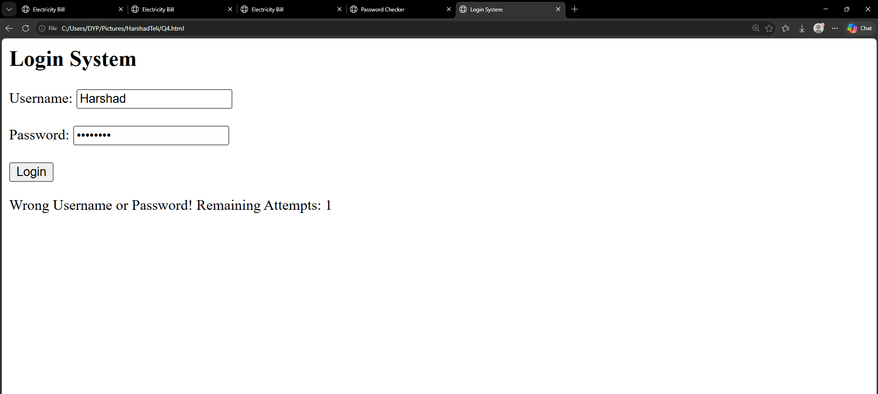

Real-World Billing System
Create classes:
Customer → Bill → DiscountedBill

Requirements:
- Bill amount calculation
- Discount based on customer type
- Display final payable amount
Input:
<html>
<head>
<title>Billing System</title>
</head>
<body>

<h2>Real-World Billing System</h2>

<script>

class Customer
{
constructor(name, type)
{
this.name = name;
this.type = type;
}
}

class Bill extends Customer
{
constructor(name, type, amount)
{
super(name, type);
this.amount = amount;
}

calculateBill()
{
return this.amount;
}
}

class DiscountedBill extends Bill
{
calculateDiscount()
{
if(this.type == "Regular")
{
this.discount = 5;
}
else if(this.type == "Premium")
{
this.discount = 10;
}
else
{
this.discount = 0;
}

this.finalAmount = this.amount - (this.amount * this.discount / 100);
}

displayBill()
{
document.write("Customer Name: " + this.name + "<br>");
document.write("Customer Type: " + this.type + "<br>");
document.write("Bill Amount: Rs. " + this.amount + "<br>");
document.write("Discount: " + this.discount + "%<br>");
document.write("Final Payable Amount: Rs. " + this.finalAmount);
}
}

// Create Object
let obj = new DiscountedBill("Harshad", "Premium", 1000);

obj.calculateBill();
obj.calculateDiscount();
obj.displayBill();

</script>

</body>
</html>
Output:


