SRS Documentation of Brigs Nucleus

**1.Introduction:**

1.1 Purpose:

The purpose of this document is to build an online system for Asset maintenance and audit of Brigs Nucleus. We develop Web application and User App.

1.2 Document Conventions:

AM- Automative Maintenance.

PM- Preventive Maintenance.

ERD-Entity Relationship Diagram.

1.3 Project Scope:

The purpose of the online Brigs Nucleus System is to ease management of assets and easy to use application for users to maintenance and audit of assets.

This system provides one Super Admin and that admin manages different organizations. Each Organization have admin and that admin creates users, assets, asset category, department, manufacturer, supplier etc.

The User Application provides three modules i.e. Assetmate, Documate, Taskmate. In assetmate user scan the asset, after scanning he will get all details about the asset.

**2. System Description:**

The Brigs Nucleus System stores the following information-

Asset details:

It includes information of asset maintenance and audit. It creates new asset, view asset details, edit asset.

User details:

It includes user details and show department name related to that user.

Organization description:

Organization includes unique id for each organization, name of organization, location of organization.

Spare part details:

It includes spare part name, serial number, brand name, price of spare part, quantity.

**3. Functional Requirement:**

3.1 User Interface:

Front End-Angular, React native

Back End-PHP

3.2 Hardware Requirement:

* Windows 10, MAC.
* A browser which supports CGI, HTML & JavaScript

3.3 System Feature of User Application:

1. **Forget Password**

User can change password by using OTP.

1. **Login Screen**

Login by using email-id and password.

1. **Home Screen**
2. Assetmate

Scan Code / Enter Code

View details like-

* + - * View document
      * Done checklist
      * Start new checklist
      * Spear parts belongs to asset
      * Date of last checklist done
      * Raise complaint/breakdown
      * Attend complaint/breakdown

1. Documate

Scan code/ Enter code

List of document

Download

Open

1. Taskmate

Assigned task list

-View details

-View task status

New task

1. Manage Complaints/ Breakdowns

List of complaint/breakdowns

View details

Assign to selected user

View status

1. Alerts

List of alerts

View details

Redirect on related screen.

* 1. System Feature of Admin Panel:

1. **Brigs – Super User Panel**
2. Organization :

Organization includes

* Organization ID(Unique id)
* Organization name
* Email id
* Mobile number
* Location
* State

1. User level hierarchy

Super user defines levels hierarchy that is L0 to L6, for e.g.

L0 => Admin

L1 => Manager

L2 => Supervisor

L3 => User

1. Super User Rights(Access)

Super User can Active/Deactivate any part of the system related to Organization.

* Super user has access of viewing the following reports like :

1. Asset List with details
2. Document List with details
3. All schedules
4. Checklist format
5. Asset level history
6. Maintenance reports on each assets
7. Spare part maintenance reports.
8. Asset wise breakdown AM/PM time cost reports.
9. User wise complaints raise reports
10. **Organization Level Admin Panel**
11. Login :

Login Module includes

* Credentials given by super admin
* Reset password

1. Admin Rights (Access) :

* Setup & Modify asset and documents
* Delete audit records
* Assign user hierarchy
* Send emails to specific users of all asset related reports
* Admin can only view the organization

1. User

* Download the asset related all reports
* User can update schedules against asset (audit, maintenance etc.)
* User can reschedule a task by drag and drop on a calendar
* User can reset the password

1. Department

* Manage department

1. Manufacturer

* Manage Manufacturer

1. Supplier

* Manage Supplier

1. User

* Manage User

1. User role

* Admin can assign the user roles

1. Asset category

* Manage asset category

1. Asset

* Manage asset

1. Spare Parts

* Manage Spare Parts

1. Checklist

* Manage Checklist

1. Alert System

* Email for reminding an audit to specific person
* Audit report can be emailed to specific persons
* Escalation ( Work not done) alerts

3.5 Entity Relationship Diagram:

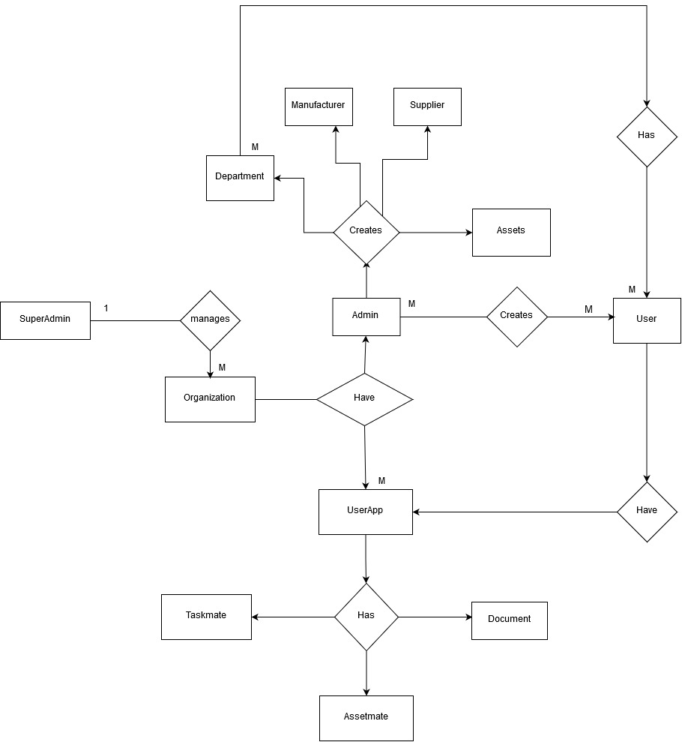

ERD for Brigs Nucleus System

3.6 Flowchart Diagram for User Application:

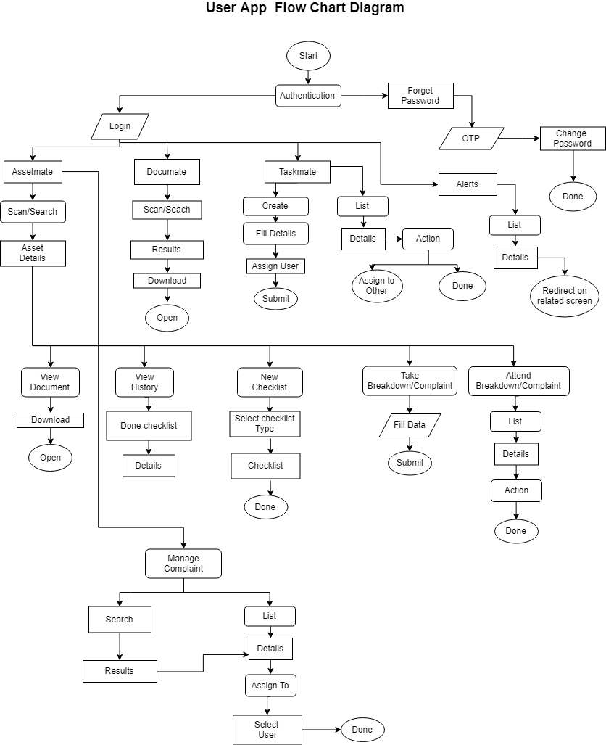

Flowchart Diagram for User Application