CHAPTER 1
INTRODUCTION

1.1 Chapter Overview
This chapter lays the groundwork for the rest of the thesis. It begins with what has actually happened in the AI-generated text space over the last three years, then narrows that situation into a formal problem statement split into a general dimension and a discipline-specific dimension. From there, the chapter states the single research question this project is built to answer, together with four supporting sub-questions, and explains the motivation that led the researcher toward this particular gap rather than any of the other directions available within AI-text forensics. The research aim and four research objectives follow, written in the identify-analyse-design-evaluate format expected at undergraduate level. A rich picture then sets out how the proposed solution actually moves data through collection, rewriting, feature extraction, classification, and feature-survival analysis, before the chapter closes with the hardware and software resources committed to the project, the boundaries placed on its scope, and a short summary that carries the reader into Chapter 2.

1.2 Problem Background
By the start of 2026, four large language models had become the default writing assistants for university students almost everywhere: ChatGPT from OpenAI, Claude from Anthropic, Gemini from Google, and Grok from xAI. Each one is reachable through a free or low-cost interface, and each is capable of producing a polished, submission-ready paragraph in under ten seconds. Universities responded the way most institutions respond to a new risk — they bought or built detection software. NSBM, like most universities, now routes submitted coursework through an AI-detection layer before a human marker opens the file.
Almost every detector built so far answers one question: is this text AI-generated, or is it not? That binary framing made sense in 2023, when ChatGPT was effectively the only model anyone needed to worry about. It makes far less sense now. A plagiarism office that flags a submission simply as “AI-generated,” with nothing further attached, cannot tell whether a student used Grok once for a single paragraph or relied on ChatGPT across six consecutive assignments. Repeat-offence cases, appeals, and formal misconduct hearings all depend on more than a flag. They depend on evidence that traces back to a specific tool, ideally across multiple submissions from the same student over time.
Two further developments make the binary approach even harder to defend. The first is that Grok, despite sitting alongside the other three as one of the most-used commercial models by late 2025, does not appear in a single major detection or attribution benchmark — not RAID (Dugan et al., 2024), not M4 (Wang et al., 2024), not DAIGT. The second is that students rarely submit raw model output anymore. A common workflow by late 2025 involves generating a first draft with one model, then feeding that draft into a second prompt — something like “rewrite this so it sounds like me” — before submission. That second step, LLM-based rewriting, restructures sentences, swaps vocabulary, and reorganises paragraphs in ways a simple synonym-substitution tool never could. Whether the forensic fingerprint left by the first model survives that second step has never actually been measured. That is the situation this study walks into.

1.3 Problem Statement
The shortfall described above is not a vague sense that detection “could be better.” It is measurable, and the numbers are not encouraging. Krishna et al. (2023) showed that DetectGPT’s accuracy at a fixed 1% false-positive rate fell from 70.3% to 4.6% after a single round of DIPPER paraphrasing — a drop of more than sixty-five percentage points from one editing step. Dugan et al. (2024) tested eleven detectors across eleven adversarial conditions in the RAID benchmark and found that five detectors lost an average of 40.6% accuracy under homoglyph substitution alone, with paraphrasing attacks ranking among the most damaging conditions tested across the board. Zhang et al. (2025) reported that targeted adversarial paraphrasing strips 30 to 50 percentage points from detection accuracy across several classifier architectures. None of these figures even describe attribution — they describe whether a system can tell AI-written text from human-written text at all, and that narrower task already collapses under light editing pressure.
The Grok problem compounds the picture rather than sitting separately from it. Ye et al. (2025) tested classifiers trained on ChatGPT, Claude, and Gemini against Grok-generated text and found zero agreement — a model trained without Grok in its distribution could not classify Grok output any better than chance. Cao et al. (2025) documented a related homogenising effect across commercial LLMs, in which overlapping training corpora and similar RLHF tuning pipelines are pushing model outputs toward a shared stylistic centre, making attribution harder with every new model generation rather than easier. Put together: detection is fragile, attribution is a harder problem than detection to begin with, Grok is invisible to the field, and nobody has checked what happens to attribution specifically once a second model rewrites the first model’s output.

1.3.1 General Problem
At a general level, this leaves every institution relying on AI-detection software holding a tool that gives a partial answer to the wrong question. Knowing that a submission is “AI-generated,” with no further detail, offers little support to an academic integrity panel trying to establish a pattern of behaviour, distinguish a single lapse from repeated misuse, or defend a decision under appeal. The arms race between detection and evasion keeps pushing universities toward more expensive tooling while delivering systems that lose most of their power the moment a student adds one extra step — a rewrite — to their workflow. Institutional confidence in AI-detection infrastructure is currently being built on evidence that does not reflect how students actually use these tools in 2025 and 2026.

1.3.2 Specific Problem
Within the narrower discipline of computational stylometry and AI-text forensics, the shortfall breaks down into four concrete gaps:
- Gap 1 — Grok is absent from every public attribution benchmark, including RAID and M4, despite occupying a usage share comparable to the other three commercial models by late 2025.
- Gap 2 — every rewriting-robustness study published so far measures binary detection degradation. None measures attribution degradation: whether a four-class classifier can still name which model wrote a text once that text has been rewritten.
- Gap 3 — the rewriting tools used in the existing literature, principally DIPPER and similar T5-based paraphrasers, operate through word-level synonym substitution. They do not reflect how a student actually rewrites AI output in 2025, which typically means prompting a second instruction-following LLM to rewrite the text “in my own voice.”
- Gap 4 — no published study has examined which individual stylometric or semantic features survive rewriting and which collapse first, information that would be directly useful for designing the next generation of attribution tools.
Taken together, these four gaps mark out a research space the existing literature has not entered: inter-model attribution, across four commercial models including Grok, measured before and after realistic LLM-based rewriting, with a feature-level account of what survives and what does not. Closing that combined gap, rather than any one piece of it in isolation, is what this study sets out to do.

1.4 Research Question
This study is organised around a single overarching research question, expressed in Wh-form, from which four supporting sub-questions are derived.
Main Research Question: How do LLM stylometric fingerprints survive rewriting pressure, and which attribution features resist erasure across ChatGPT, Claude, Gemini, and Grok under LLM-based rewriting at light and heavy intensity levels?
Four sub-questions operationalise this main question into testable parts:
RQ1: What is the baseline inter-model attribution accuracy across ChatGPT, Claude, Gemini, and Grok, using a combined stylometric and SentenceTransformer semantic feature set reduced via PCA to approximately 83 dimensions, evaluated through 5-fold stratified cross-validation?
RQ2: How does LLM-based rewriting affect attribution accuracy at light (~40% word-level edit) and heavy (~65% word-level edit) intensity levels, and at what point does attribution accuracy fall below the 25% chance baseline for a four-class problem?
RQ3: Which of the eight stylometric features retain the most discriminative power under rewriting pressure, as measured through SHAP TreeExplainer survival analysis, and does aggregate semantic signal survive rewriting at a rate comparable to stylometric signal?
RQ4: Does a combined stylometric-semantic feature set outperform either feature type used alone, holding XGBoost constant as the classifier so that the feature-type effect is isolated from any classifier-architecture effect?

1.5 Research Motivation
The starting point for this project was not one dramatic discovery but an accumulation of small irritations while working through the AI-detection literature during the early proposal stage. Krishna et al.’s (2023) DIPPER paper was the first to genuinely unsettle the researcher’s assumptions: a single paraphrasing pass collapsing DetectGPT from 70.3% accuracy to 4.6% is not a minor robustness gap — it reads more like evidence that the entire detection paradigm rests on much shakier ground than most institutions appear to assume. Reading the RAID paper (Dugan et al., 2024) shortly afterward reinforced the same impression at a larger scale, across eleven detectors and eleven attack types.
What kept nagging at the researcher, though, was a far simpler observation: Grok was nowhere in either paper, nor in M4 (Wang et al., 2024), nor in any other benchmark turned up during the literature search. By the second half of 2025, Grok had become a default option inside X for hundreds of millions of users, yet not one academic attribution study had included it. That absence felt less like an oversight and more like a structural blind spot that any forensic tool built today would simply inherit.
A second, more technical observation followed naturally from the first. Every rewriting study the researcher could locate measured whether a paraphrased text could still be flagged as AI-generated at all. None asked whether the more specific, more forensically useful signal — which model wrote it — survives the same pressure. Once that distinction became clear, in discussion with the project supervisor, Prof. Chaminda, the direction of the study more or less set itself. An estimated total API cost of roughly $0.40 made the project realistic to execute single-handedly within the available timeline, which made committing to the direction considerably easier.

1.6 Research Aim
The aim of this study is to empirically measure the extent to which inter-model attribution accuracy survives LLM-based rewriting pressure across four major commercial language models — ChatGPT, Claude, Gemini, and Grok — and to identify which specific stylometric and semantic features remain discriminative once that rewriting has taken place.
Meeting this aim means producing three concrete deliverables by the end of the project: a measured attribution-accuracy curve across the original, lightly rewritten, and heavily rewritten conditions; a ranked account of which of the eight stylometric features, and which semantic signal block, survive that curve best; and a working attribution pipeline that later researchers can extend to additional models, rewriting tools, or languages without redesigning the underlying methodology.

1.7 Research Objectives
Four research-specific objectives operationalise the aim above, following the identify-analyse-design-evaluate structure expected at undergraduate level.

1.7.1 To Identify
To identify the stylometric and semantic features that differentiate AI-generated text across ChatGPT, Claude, Gemini, and Grok under three edit conditions — original, lightly rewritten, and heavily rewritten.

1.7.2 To Analyze
To analyze how LLM-based rewriting at light (~40%) and heavy (~65%) intensity levels degrades inter-model attribution accuracy across the four model classes, relative to the 25% chance baseline for a four-class problem.

1.7.3 To Design and Develop
To design and develop a PCA-corrected soft-voting ensemble attribution classifier combining eight stylometric features with all-MiniLM-L6-v2 SentenceTransformer embeddings, trained exclusively on original samples and evaluated out-of-distribution on rewritten text without retraining.

1.7.4 To Evaluate
To evaluate which specific stylometric features, and whether aggregate semantic signal, resist LLM-based rewriting pressure, using SHAP TreeExplainer survival analysis at both the light and heavy edit intensity levels.

1.8 Rich Picture of the Proposed Solution
Figure 1.1 sets out the complete workflow this study implements, from raw data collection through to the feature-survival findings that answer RQ1 through RQ4. The picture is organised around one structural decision that defines the whole project: the dataset forks into two parallel paths immediately after collection — one that stays untouched and one that passes through LLM-based rewriting — and the gap between what each path produces at the evaluation stage is the actual measurement this thesis reports.
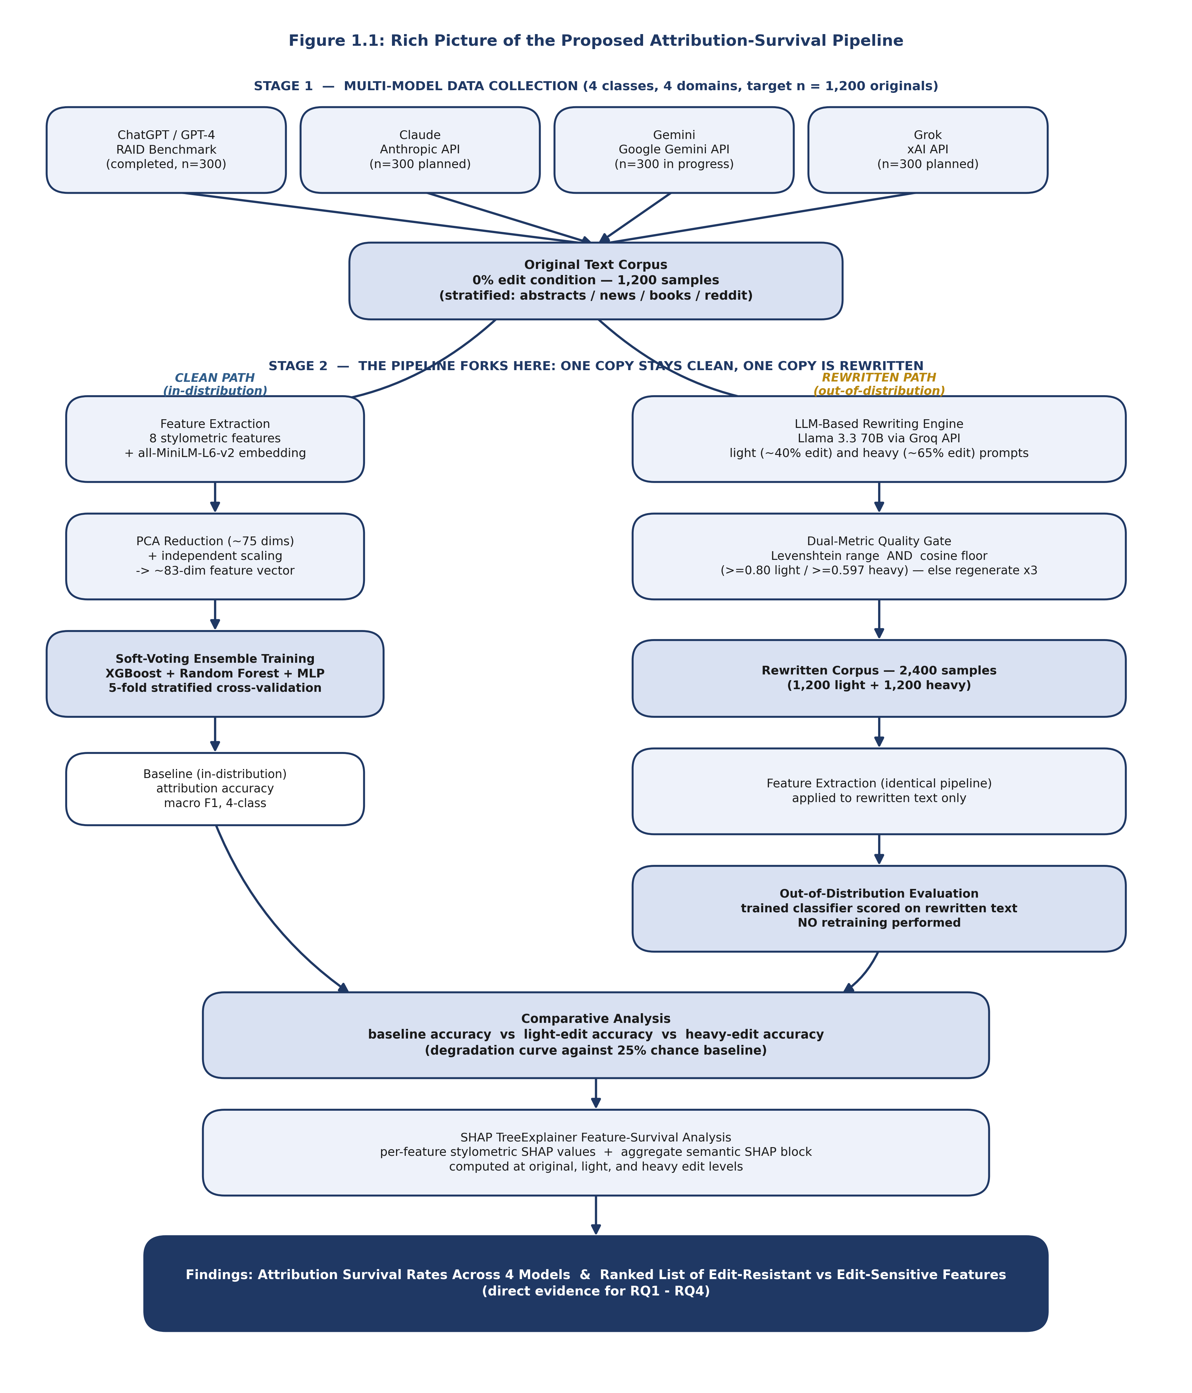
Figure 1.1: Rich picture of the proposed attribution-survival pipeline
The pipeline begins with four parallel data-collection streams (Stage 1 in Figure 1.1). ChatGPT and GPT-4 samples come from the RAID benchmark and have already been extracted — 300 samples each, filtered to attack='none' and decoding='greedy' conditions. Claude, Gemini, and Grok samples are collected directly from their respective provider APIs, since none of the three appears in any existing public benchmark in the format this study requires. All four streams merge into a single, domain-stratified corpus of 1,200 original samples — 300 per model, split evenly across academic abstracts, news reporting, creative book-style prose, and informal Reddit-style text.
From that point, the pipeline forks. On the clean path, the original samples pass straight through feature extraction — eight hand-engineered stylometric features plus a 384-dimensional all-MiniLM-L6-v2 sentence embedding — followed by PCA reduction to roughly 75 components and independent feature scaling, producing an approximately 83-dimensional vector per sample. That vector trains the primary classifier: a soft-voting ensemble of XGBoost, Random Forest, and a multi-layer perceptron, evaluated through 5-fold stratified cross-validation. This produces the baseline, in-distribution attribution accuracy that anchors every later comparison.
On the rewritten path, the same 1,200 original samples are passed through Llama 3.3 70B via the Groq API under two separate instruction prompts — a light rewrite targeting roughly 40% word-level change, and a heavy rewrite targeting roughly 65% change. Every rewritten sample must clear a dual quality gate before being accepted: a Levenshtein-distance band confirming that enough surface-level editing has actually occurred, and a cosine-similarity floor (≥0.80 light, ≥0.597 heavy) confirming that the rewrite has not drifted away from the original meaning. Samples that fail are regenerated up to three times before being replaced from a 50-sample reserve pool. The result is a 2,400-sample rewritten corpus, which passes through the identical feature-extraction pipeline used on the clean path and is then scored by the already-trained classifier with no retraining — the standard out-of-distribution evaluation protocol.
The two paths converge at the comparison stage. Baseline accuracy, light-edit accuracy, and heavy-edit accuracy are placed side by side against the 25% chance baseline, producing the central degradation curve this study reports. SHAP TreeExplainer is then applied to the XGBoost component of the ensemble at all three edit levels, generating individual SHAP values for each of the eight stylometric features and a single aggregate SHAP value for the semantic block as a whole. That feature-survival ranking, together with the degradation curve, forms the direct evidence used to answer RQ1 through RQ4.

1.9 Resource Requirements
The technical design of this study was shaped from the outset by the resources realistically available to a self-funded undergraduate researcher. Every tool listed below is either already owned, freely available, or accessible at negligible per-sample cost, which kept the entire data-collection budget under one US dollar.

1.9.1 Hardware
Resource | Specification | Role in the Study
GPU | 4 GB VRAM | Runs all-MiniLM-L6-v2 for semantic embedding extraction only; the model itself is roughly 80 MB, so 4 GB is more than sufficient.
RAM | 24 GB | Holds the full feature matrices, the 3,600-sample dataset, and the soft-voting ensemble during training and cross-validation without swapping.
CPU | 6 cores / 12 threads | Parallelises stylometric feature extraction, the 5-fold cross-validation loop, and SHAP value computation across folds.
Storage | Standard SSD, < 200 MB required | The entire dataset of 3,600 samples, together with extracted embeddings and intermediate feature files, occupies well under 200 MB.

1.9.2 Software
Category | Tool / Library | Purpose
Data collection | HuggingFace datasets (RAID) | Extraction of ChatGPT and GPT-4 samples using the liamdugan/raid identifier.
Data collection | Anthropic API, Google Gemini API, xAI API | Direct generation of Claude, Gemini, and Grok samples, since none appear in RAID.
Rewriting | Groq API (Llama 3.3 70B) | LLM-based rewriting of all 2,400 light and heavy edit samples.
Feature extraction | spaCy (en_core_web_sm), NLTK, textstat | Sentence parsing, tokenisation, hedging-word counts, TTR, and Flesch-Kincaid readability.
Feature extraction | SentenceTransformers (all-MiniLM-L6-v2) | 384-dimensional semantic embeddings, reused from the quality-gate pipeline.
Machine learning | scikit-learn, XGBoost, SHAP | Random Forest, MLP, PCA, StandardScaler, the soft-voting ensemble, and TreeExplainer-based feature survival analysis.
Analysis & reporting | pandas, NumPy, Matplotlib, Seaborn | Data wrangling, descriptive statistics, and all result visualisations.
Total direct project cost is estimated at approximately $0.40 — around $0.20 for Claude sample generation via the Anthropic API and $0.20 for Grok sample generation via the xAI API. RAID extraction, the Google Gemini free tier, the Groq API, and every Python library listed above carry no cost to the researcher.

1.10 Project Scope
Table 1.1 sets out the explicit boundaries of this study. Several of these boundaries were tightened deliberately, not because the excluded work is unimportant, but because each one represents a distinct experimental design problem that a single undergraduate project, working to a September 2026 submission deadline, cannot also absorb.
In Scope | Out of Scope
Four commercial LLMs as generation sources: ChatGPT, Claude, Gemini, and Grok. | Any LLM beyond these four (e.g., LLaMA, Mistral, DeepSeek) used as a generation source for attribution.
LLM-based rewriting via Llama 3.3 70B at light (~40%) and heavy (~65%) word-level edit intensity. | Commercial AI-humanisation tools such as StealthWriter or Undetectable.ai, and statistical evasion techniques such as perplexity injection.
English-language text across four domains: academic abstracts, news, creative/book prose, and informal Reddit-style writing. | Cross-lingual or multilingual attribution.
A combined feature representation: 8 stylometric features plus PCA-reduced SentenceTransformer embeddings. | End-to-end deep-learning attribution classifiers (e.g., a fine-tuned transformer) as an alternative to the ensemble design.
A soft-voting ensemble (XGBoost, Random Forest, MLP) trained on original samples and evaluated out-of-distribution on rewritten samples. | Retraining or fine-tuning the classifier directly on rewritten samples.
SHAP TreeExplainer feature-survival analysis on the XGBoost component, at the individual stylometric level and the aggregate semantic level. | Real-time deployment, productisation, or integration into an institutional plagiarism-detection system.
RAID benchmark extraction for ChatGPT/GPT-4; direct API collection for Claude, Gemini, and Grok. | Stylometric behaviour of GPT-4o or later model revisions, which are not represented in the RAID benchmark snapshot used here.
Each excluded item is excluded for a specific, statable reason rather than by default. Commercial humanisation tools were left out because they apply additional statistical manipulation — perplexity injection and burstiness modification — that would require a different quality-gate design entirely; testing their effect on attribution is a natural next study, not a gap in this one. Cross-lingual attribution was left out because the RAID benchmark, the primary ChatGPT data source, is English-only, and introducing a second language would multiply the data-collection burden well beyond what the timeline allows. The GPT-4o boundary is acknowledged directly rather than glossed over: RAID's ChatGPT samples reflect GPT-3.5 and GPT-4 generation configurations from 2023–2024, and stylometric fingerprints may have shifted in later model revisions. That is treated here as a documented dataset boundary, not a methodological flaw to be hidden.

1.11 Chapter Summary
This chapter opened with what is actually happening on university campuses in 2025 and 2026 — four major commercial LLMs in everyday use, detection tools built around a binary question that no longer matches student behaviour, and a rewriting step that may be quietly erasing whatever forensic signal those tools still capture. From that background, the chapter built a problem statement grounded in measured figures rather than assumption, named four specific research gaps, and set a single Wh-form research question with four supporting sub-questions. It explained the motivation behind choosing this particular gap, stated the research aim, and broke that aim into four research-specific objectives. The rich picture in Section 1.8 then walked through exactly how data moves from four collection sources, through a fork into clean and rewritten paths, into a shared classifier, and out the other side as a degradation curve and a feature-survival ranking. The chapter closed with the concrete hardware and software resources committed to the project and an explicit statement of what this study does, and does not, attempt to cover. Chapter 2 now turns to the existing literature that this problem statement was built against.

