

**Compiler Design Lab**

**SUBMITTED BY: SUBMITTED TO:**

Name: Harsh Agrawal Dr. Ajay Prasad

SAP ID: 500107136

Enrollment No: R2142220326

Course- B.Tech. (CSE)

Batch: 4 (AI/ML) (Non- Hons)

**Assignment 5**

**1.WAP to simulate FIRST and FOLLOW of a grammar in C**

Code-

#include <ctype.h>

#include <stdio.h>

#include <string.h>

void followfirst(char, int, int);

void follow(char c);

void findfirst(char, int, int);

int count, n = 0;

char calc_first[10][100];

char calc_follow[10][100];

int m = 0;

char production[10][10];

char f[10], first[10];

int k;

char ck;

int e;

int main(int argc, char** argv){

int jm = 0;

int km = 0;

int i, choice;

char c, ch;

FILE *file = fopen("grammar.txt", "r");

if (!file){

printf("Error: Unable to open grammar.txt\n");

return 1;

}

count = 0;

while (fgets(production[count], sizeof(production[count]), file)){

production[count][strlen(production[count]) - 1] = '\0';

count++;

}

fclose(file);

int kay;

char done[count];

int ptr = -1;

for (k = 0; k < count; k++){

for (kay = 0; kay < 100; kay++){

calc_first[k][kay] = '!';

}

}

int point1 = 0, point2, xxx;

for (k = 0; k < count; k++){

c = production[k][0];

point2 = 0;

xxx = 0;

for (kay = 0; kay <= ptr; kay++)

if (c == done[kay])

xxx = 1;

if (xxx == 1)

continue;

findfirst(c, 0, 0);

ptr += 1;

done[ptr] = c;

printf("\n First(%c) = { ", c);

calc_first[point1][point2++] = c;

for (i = 0 + jm; i < n; i++) {

int lark = 0, chk = 0;

for (lark = 0; lark < point2; lark++) {

if (first[i] == calc_first[point1][lark]) {

chk = 1;

break;

}

}

if (chk == 0) {

printf("%c, ", first[i]);

calc_first[point1][point2++] = first[i];

}

}

printf("}\n");

jm = n;

point1++;

}

printf("\n\n");

char donee[count];

ptr = -1;

for (k = 0; k < count; k++) {

for (kay = 0; kay < 100; kay++) {

calc_follow[k][kay] = '!';

}

}

point1 = 0;

int land = 0;

for (e = 0; e < count; e++) {

ck = production[e][0];

point2 = 0;

xxx = 0;

for (kay = 0; kay <= ptr; kay++)

if (ck == donee[kay])

xxx = 1;

if (xxx == 1)

continue;

land += 1;

follow(ck);

ptr += 1;

donee[ptr] = ck;

printf(" Follow(%c) = { ", ck);

calc_follow[point1][point2++] = ck;

for (i = 0 + km; i < m; i++) {

int lark = 0, chk = 0;

for (lark = 0; lark < point2; lark++) {

if (f[i] == calc_follow[point1][lark]) {

chk = 1;

break;

}

}

if (chk == 0) {

printf("%c, ", f[i]);

calc_follow[point1][point2++] = f[i];

}

}

printf(" }\n\n");

km = m;

point1++;

}

}

void follow(char c)

{

int i, j;

if (production[0][0] == c) {

f[m++] = '$';

}

for (i = 0; i < 10; i++) {

for (j = 2; j < 10; j++) {

if (production[i][j] == c) {

if (production[i][j + 1] != '\0') {

followfirst(production[i][j + 1], i,(j + 2));

}

if (production[i][j + 1] == '\0'&& c != production[i][0]) {

follow(production[i][0]);

}

}

}

}

}

void findfirst(char c, int q1, int q2)

{

int j;

if (!(isupper(c))) {

first[n++] = c;

}

for (j = 0; j < count; j++) {

if (production[j][0] == c) {

if (production[j][2] == '#') {

if (production[q1][q2] == '\0')

first[n++] = '#';

else if (production[q1][q2] != '\0'&& (q1 != 0 || q2 != 0)) {

findfirst(production[q1][q2], q1,(q2 + 1));

}

else

first[n++] = '#';

}

else if (!isupper(production[j][2])) {

first[n++] = production[j][2];

}

else {

findfirst(production[j][2], j, 3);

}

}

}

}

void followfirst(char c, int c1, int c2)

{

int k;

if (!(isupper(c)))

f[m++] = c;

else {

int i = 0, j = 1;

for (i = 0; i < count; i++) {

if (calc_first[i][0] == c)

break;

}

while (calc_first[i][j] != '!') {

if (calc_first[i][j] != '#') {

f[m++] = calc_first[i][j];

}

else {

if (production[c1][c2] == '\0') {

follow(production[c1][0]);

}

else {

followfirst(production[c1][c2], c1,c2 + 1);

}

}

j++;

}

}

}

Grammer.txt file-

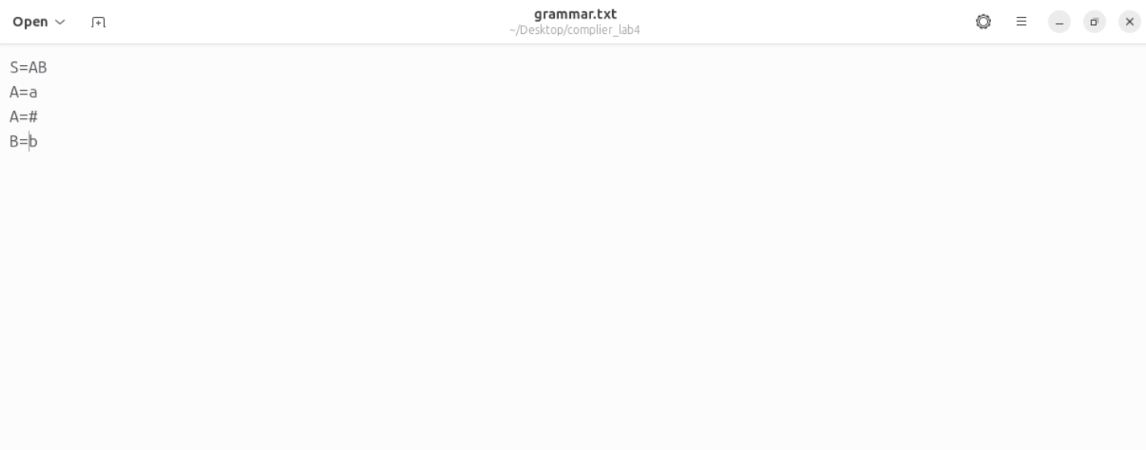

Output-

