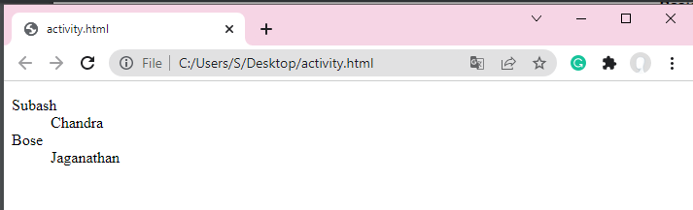

<dl>

<dt>Subash</dt>

<dd>Chandra</dd>

<dt>Bose</dt>

<dd>Jaganathan</dd>

</dl>

<https://www1.udel.edu/it/help/web-development/HTML103.pdf>

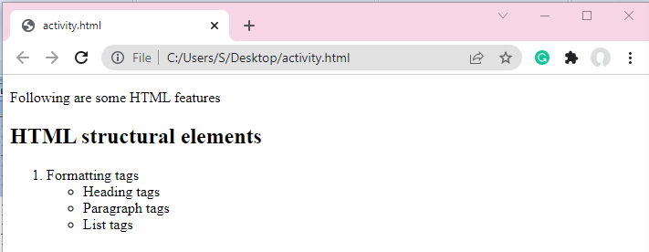

<!DOCTYPE html>

<html>

<body>

<p>

Following are some HTML features

</p>

<h2>HTML structural elements</h2>

<ol>

<li>Formatting tags</li>

<ul>

<li>Heading tags</li>

<li>Paragraph tags</li>

<li>List tags</li>

</ul>

</ol>

</body>

</html>

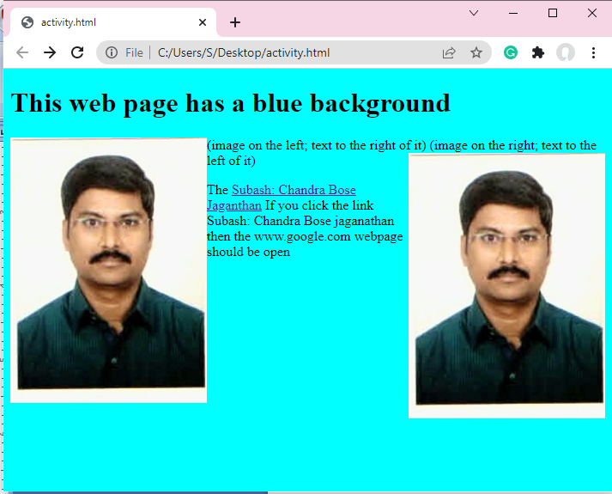

<!DOCTYPE html>

<html>

<body>

<BODY STYLE="BACKGROUND-COLOR:AQUA;">

<H1>This web page has a blue background</H1>

<img align="left" src="Bose.jpg" alt="spider in a web" />

(image on the left; text to the right of it)

<img align="right" src="Bose.jpg" alt="spider in a web" />

(image on the right; text to the left of it)

<p>

The <a href="https://www.google.com//">

Subash: Chandra Bose Jaganthan</a> If you click the link Subash: Chandra Bose jaganathan then the www.google.com webpage should be open</p>

</body>

</html>

https://www.academia.edu/39822444/HTML_EXERCISESss