Predicting Customer Churn in a Telecom Company

A Predictive Analytics Case Study Using IBM SPSS Modeler
Educational project report prepared with a synthetic practice dataset. The structure follows the requested 10-section format and includes visuals, model evaluation, and GitHub-ready project files.

Item | Details
Dataset | 1,200 synthetic customer records
Target | Churn (Yes / No)
Split | 75% training / 25% testing
Models | Logistic Regression, Decision Tree, Random Forest
Best by ROC AUC | Random Forest (AUC 0.752)

Title – Project Topic
Predicting Customer Churn in a Telecom Company. The project demonstrates how predictive analytics can estimate which customers may stop using a telecom service, allowing a business to prioritize retention efforts.

Introduction
Customer churn happens when a customer stops using a company's service. In a competitive telecom market, retaining existing customers can be important for revenue and long-term relationships. Customers may leave because of pricing, contract flexibility, service experience, payment issues, or competing offers. Predictive analytics uses patterns in historical records to estimate future outcomes.
This case study demonstrates a classification workflow suitable for recreation in IBM SPSS Modeler. A Python reference implementation is included to make the sample metrics reproducible; it is not presented as an actual execution inside IBM SPSS Modeler.

Problem Statement
A fictional telecom provider wants to identify customers who may churn so that the retention team can prioritize appropriate outreach. The question is whether tenure, monthly charges, contract type, data usage, support calls, and payment behavior can help distinguish customers likely to leave from those likely to stay. The output is a predicted class and estimated risk score, not a guarantee about an individual customer.

Data Discussion
The dataset contains 1,200 synthetic customer records and 12 fields. It was generated for educational use and does not contain real customer information. The target field is Churn; CustomerID is an identifier and should not be used as a predictor. Missing values were intentionally inserted into a few predictor fields to provide practice with data cleaning.

Field | Description
CustomerID | Synthetic identifier; exclude from predictors
TenureMonths | Months with the provider
MonthlyCharges | Approximate monthly bill
TotalDataUsageGB | Estimated data usage in gigabytes
ContractType | Month-to-month, one-year, or two-year plan
InternetService | Fiber, DSL, or no internet
PaymentMethod | Payment method
CustomerServiceCalls | Number of support calls

Field | Description
LatePayments | Count of late payments
AutoPay | Automatic payment enabled: Yes/No
StreamingService | Streaming service enabled: Yes/No
Churn | Target label: Yes/No

Generated class distribution: 883 No and 317 Yes; synthetic churn share 26.4%. These patterns are properties of the simulated data and must not be treated as evidence about a real telecom business.

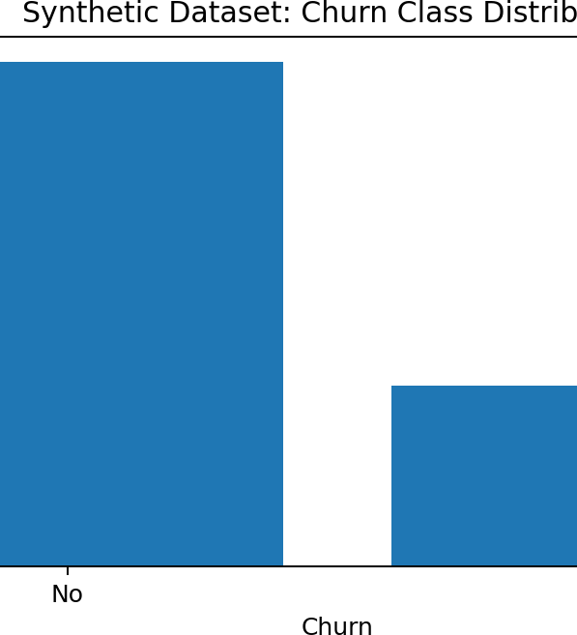

Method, Tools & Technologies Used
Method: supervised binary classification. Logistic Regression provides a baseline, Decision Tree offers rule-like splits, and Random Forest combines multiple trees. Workflow application: IBM SPSS Modeler for visual preparation, modeling, evaluation, and scoring. Reference implementation: Python, pandas, NumPy, scikit-learn, and Matplotlib generated the sample metrics and charts in this package.
Evaluation measures: accuracy, precision, recall, F1 score, ROC AUC, and a confusion matrix. Accuracy alone may be misleading when the business cost of missed churn differs from the cost of unnecessary outreach.

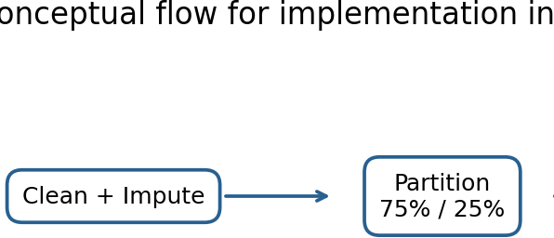
Workflow

The workflow is: import CSV → define field types and target → inspect and impute missing values → partition training/testing data → train candidate models → evaluate held-out performance → score customer records. In SPSS Modeler, these stages can be represented by source, Type, Data Audit/Filler, Partition, modeling, evaluation, and scoring nodes.

Procedure
  - Generated a fictional dataset with customer tenure, charges, usage, contract, service, payment, support, and churn fields.
  - Imported the CSV and excluded CustomerID from predictors.
  - Imputed numeric missing values using the median and categorical missing values using the most frequent category; encoded categorical predictors for the reference implementation.

  - Split records into 75% training and 25% test data using stratification and a fixed random seed.
  - Trained Logistic Regression, Decision Tree, and Random Forest models using the same split and input fields.
  - Compared held-out predictions using accuracy, precision, recall, F1 score, ROC AUC, and a confusion matrix.
  - Exported sample predictions with predicted churn class and estimated probability.
For authentic application evidence, open the actual IBM SPSS Modeler stream and capture your own screenshots of the stream, target/type settings, model results, and scored output. The workflow illustration in this repository is conceptual, not an actual application screenshot.

Results / Predictive Model
The following scores come from the included Python reference run on held-out synthetic test data. Results may differ in SPSS Modeler depending on version, algorithm settings, and preprocessing.
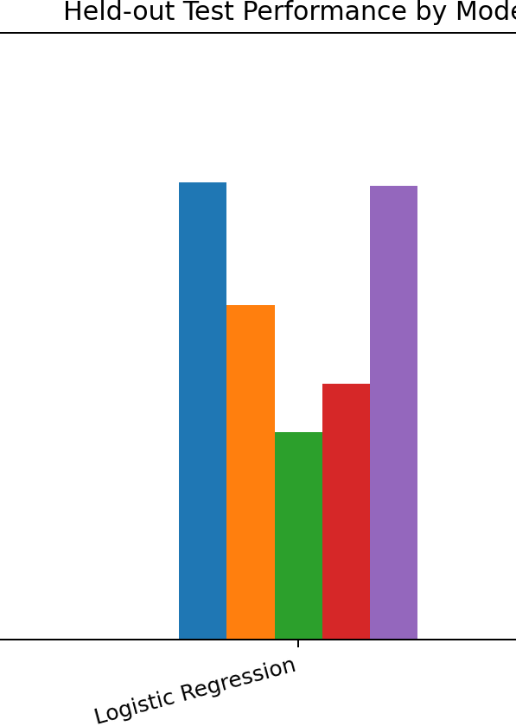
Model | Accuracy | Precision | Recall | F1 | ROC AUC
Random Forest | 0.730 | 0.485 | 0.405 | 0.441 | 0.752
Logistic Regression | 0.753 | 0.551 | 0.342 | 0.422 | 0.748
Decision Tree | 0.727 | 0.463 | 0.241 | 0.317 | 0.730

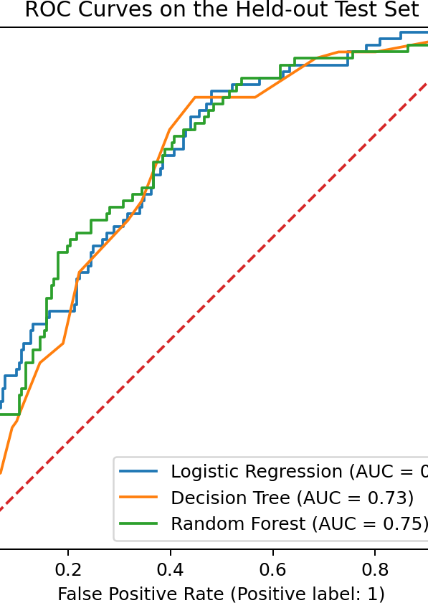

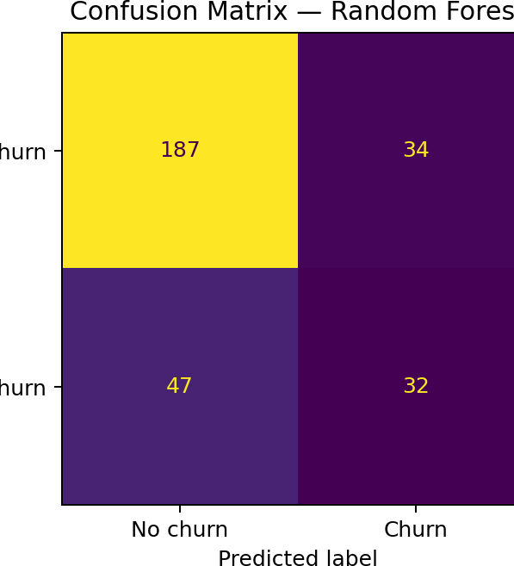

For the selected Random Forest reference model, the confusion matrix contains 187 true negatives, 34 false positives, 47 false negatives, and 32 true positives. False negatives are churners the model missed; false positives are customers flagged as at-risk who did not churn in the test set.

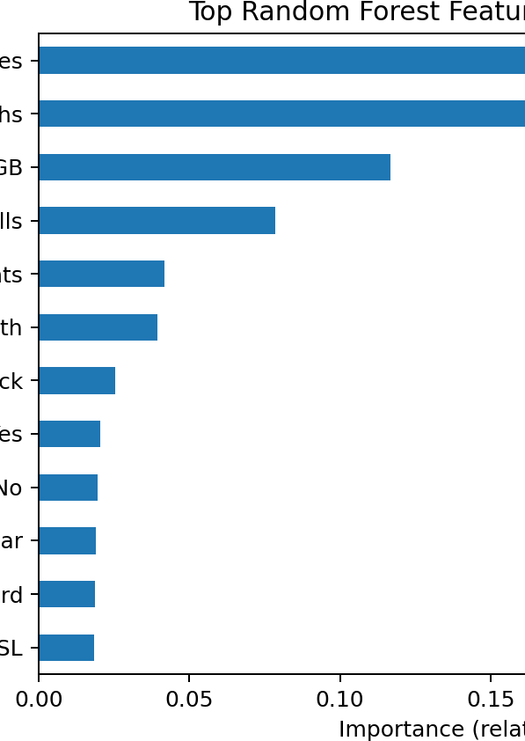

Feature importance is model-specific and does not prove causation. The strongest features should be checked against real, representative data before decisions are made.

Insights (Observations)
- The highest ROC AUC in this run was achieved by Random Forest (0.752). Consider the full metric profile when selecting a model.
- Contract, tenure, charges, payment behavior, and service interactions may appear influential because the synthetic target was generated partly from plausible relationships. This is a simulation outcome, not a real-world finding.
- The confusion matrix shows the trade-off between missing potential churners and contacting customers who would have stayed. The decision threshold should reflect business costs and available retention capacity.
- Feature importance can guide further investigation, but should not be interpreted as proof that a feature causes churn.

Recommendations / Suggestions
  - Use risk scores as decision support and review customer context before outreach.
  - Offer appropriate plan reviews, transparent pricing options, or service follow-up to customers who want help.
  - Investigate repeated support calls and late payments as possible friction signals without blaming the customer.
  - Choose the classification threshold based on the relative cost of missed churn and unnecessary outreach.
  - Validate on recent, representative real data before deployment and monitor performance over time.
  - Protect customer privacy, restrict access to risk scores, and avoid unfair or inappropriate use of customer attributes.
  - Review drift and retrain only after new data is quality-checked and the updated model is compared with the baseline.

