**Team 1: GreenDisk Videos and Video Games**

**Organization Overview**

GreenDisk Videos and Video Games is a provider of “wholesome entertainment,” delivering highly edited (for violence, language, nudity, and moral issues) mainstream movies, religious films, and games with morally wholesome content to its users through a computer, an Android and an iPhone app, or a Roku channel, for $7.99 a month. Its headquarters are in Burbank, CA, with all customer-facing IT operations based in Palo Alto, CA.

GreenDisk’s 1,500 employees serve upwards of 2,000,000 subscribers; the company has budgets in excess of $100 million dollars and complies with various regulations. To meet the needs of all these constituencies, GreenDisk has all the business processes and IT systems found in a typical service corporation such as HR, payroll, finance, marketing and customer relations, and billing, in addition to typical services such as email and calendar. Quite naturally, GreenDisk has a large IT department, which is dedicated to ensuring that sensitive customer data, such as credit card numbers, birthdates, and other information, is kept absolutely secure while providing a highly customized user experience.

Hoping to capitalize on the current political situation, GreenDisk is pursuing a joint venture with a Hollywood megachurch to produce “L.A. Miracle,” a TV show about miracles in the lives of Los Angeles, CA, citizens. The recently hired producer and his staff of writers have a strong record of attracting donations from viewers, but while this project creates great opportunities for local actors to achieve more visibility, the IT department has been advised that it should upgrade its systems for handling pre-production, production, and post-production assets. Two years ago, one of the main streaming servers was hacked with a redirect to an adult video provider, and sensitive customer information was stolen for all new customer accounts set up right before the redirect was planted.

In addition to its regular and new business activities, GreenDisk also supports two major community outreach efforts:

1. An annual Young Filmmaker’s Talent Competition, in which high school and college students are invited to use the company’s IT resources and mentoring from executives to produce a short film, with which they compete for a $10,000 scholarship to a local filmmaker school.
2. An annual donation drive for, and job fair at, a local homeless shelter, complete with providing resume services and mock interviews.

**Organization Structure**

An extract from the company’s organizational structure is shown below. Your work in this course will be limited to these units of the business. The Chief Executive Officer is responsible for the overarching business strategy and goals. The Executive Vice President of Finance is responsible for all marketing and finance activities. General Counsel manages legal affairs and compliance, and the Chief Operating Officer is responsible for all activities in support of the company’s business.

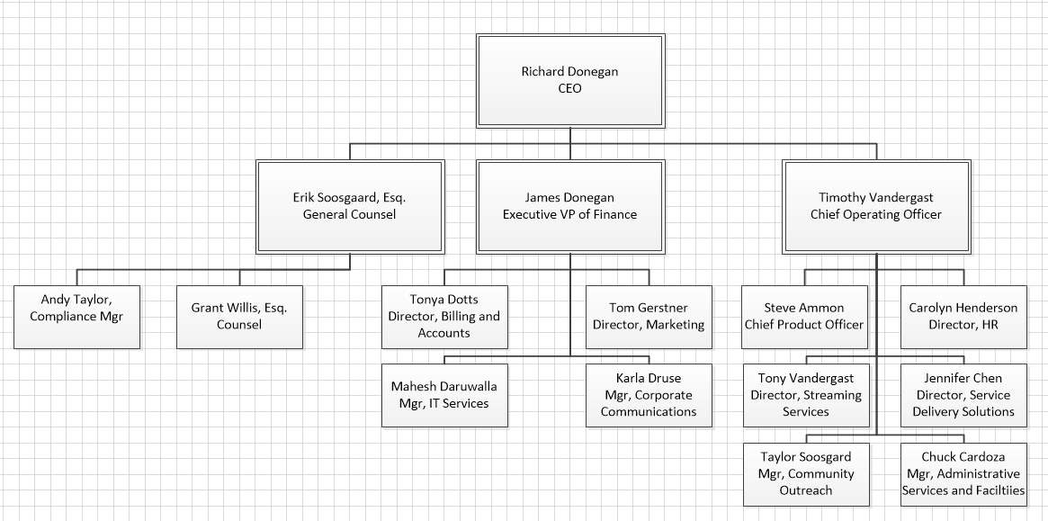

The company’s business and finance services are largely centralized. The administrative services component handles purchasing, physical building maintenance, and safety. HR deals with payroll, hiring procedures, and benefits. IT Services owns the Enterprise Business Systems, including HR systems, and payroll and financial systems, but Service Delivery Solutions owns all customer-focused hardware and software.

Some ancillary IT services are operated as a mix of centralized services and local support. These services include desktop support and management, file share management, print management, account provisioning, and server management. To save costs, the management of some of these services is led by administrative assistants whose primary responsibility is to support departmental administrative needs. Generally speaking, technical staff is over-worked, under paid, but is well-trained and qualified. They do their best to meet stakeholder expectations on a limited budget. The information security department split between IT Services and Service Delivery Solutions.