HarshAgrawal_HW6.R

Asus

2021-11-15

# Course : CS 513  
# First Name : Harsh  
# Last Name : Agrawal  
# CWID : 10475285  
  
rm(list=ls())  
  
library(C50)  
  
setwd("C:/Users/Asus/Desktop/Github/MSCS/CS-513/HW6")  
  
db = read.csv('breast-cancer-wisconsin.csv',header=TRUE, sep=",")  
summary(db)

## Sample F1 F2 F3   
## Min. : 61634 Min. : 1.000 Min. : 1.000 Min. : 1.000   
## 1st Qu.: 870688 1st Qu.: 2.000 1st Qu.: 1.000 1st Qu.: 1.000   
## Median : 1171710 Median : 4.000 Median : 1.000 Median : 1.000   
## Mean : 1071704 Mean : 4.418 Mean : 3.134 Mean : 3.207   
## 3rd Qu.: 1238298 3rd Qu.: 6.000 3rd Qu.: 5.000 3rd Qu.: 5.000   
## Max. :13454352 Max. :10.000 Max. :10.000 Max. :10.000   
## F4 F5 F6 F7   
## Min. : 1.000 Min. : 1.000 Length:699 Min. : 1.000   
## 1st Qu.: 1.000 1st Qu.: 2.000 Class :character 1st Qu.: 2.000   
## Median : 1.000 Median : 2.000 Mode :character Median : 3.000   
## Mean : 2.807 Mean : 3.216 Mean : 3.438   
## 3rd Qu.: 4.000 3rd Qu.: 4.000 3rd Qu.: 5.000   
## Max. :10.000 Max. :10.000 Max. :10.000   
## F8 F9 Class   
## Min. : 1.000 Min. : 1.000 Min. :2.00   
## 1st Qu.: 1.000 1st Qu.: 1.000 1st Qu.:2.00   
## Median : 1.000 Median : 1.000 Median :2.00   
## Mean : 2.867 Mean : 1.589 Mean :2.69   
## 3rd Qu.: 4.000 3rd Qu.: 1.000 3rd Qu.:4.00   
## Max. :10.000 Max. :10.000 Max. :4.00

db<-na.omit(db)  
  
db$Class <- factor(db$Class, levels = c(2, 4), labels = c("benign", "malignant"))  
  
View(db)  
  
train_index <- sample(nrow(db),as.integer(.70*nrow(db)))  
train_data<-db[train_index,]  
test_data<-db[-train_index,]  
  
c50<-C5.0(Class~.,train_data[,-1])  
summary(c50)

##   
## Call:  
## C5.0.formula(formula = Class ~ ., data = train_data[, -1])  
##   
##   
## C5.0 [Release 2.07 GPL Edition] Mon Nov 15 00:03:07 2021  
## -------------------------------  
##   
## Class specified by attribute `outcome'  
##   
## Read 489 cases (10 attributes) from undefined.data  
##   
## Decision tree:  
##   
## F2 <= 2:  
## :...F1 <= 5: benign (278/2)  
## : F1 > 5:  
## : :...F8 <= 2: benign (9/1)  
## : F8 > 2: malignant (6)  
## F2 > 2:  
## :...F3 <= 3:  
## :...F7 <= 3: benign (15/2)  
## : F7 > 3: malignant (16/3)  
## F3 > 3:  
## :...F1 > 6: malignant (95)  
## F1 <= 6:  
## :...F7 > 4: malignant (48/1)  
## F7 <= 4:  
## :...F4 > 3: malignant (10/2)  
## F4 <= 3:  
## :...F8 <= 8: benign (9/1)  
## F8 > 8: malignant (3)  
##   
##   
## Evaluation on training data (489 cases):  
##   
## Decision Tree   
## ----------------   
## Size Errors   
##   
## 10 12( 2.5%) <<  
##   
##   
## (a) (b) <-classified as  
## ---- ----  
## 305 6 (a): class benign  
## 6 172 (b): class malignant  
##   
##   
## Attribute usage:  
##   
## 100.00% F2  
## 93.66% F1  
## 40.08% F3  
## 20.65% F7  
## 5.52% F8  
## 4.50% F4  
##   
##   
## Time: 0.0 secs

plot(c50)

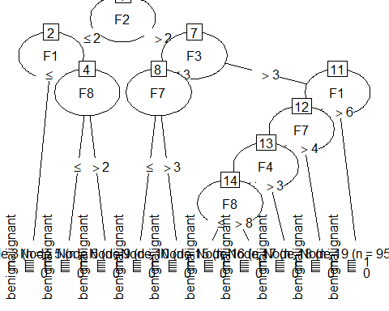

pred<-predict(c50,test_data[,-1],type="class")   
conf_matrix<-table(test_data[,11],pred)  
conf_matrix

## pred  
## benign malignant  
## benign 142 5  
## malignant 7 56

inc<-sum(test_data[,11]!=pred)  
accuracy<- 1 - inc/length(test_data[,11])  
accuracy

## [1] 0.9428571

rm(list=ls())  
  
# Random Forest  
library('randomForest')

## randomForest 4.6-14

## Type rfNews() to see new features/changes/bug fixes.

setwd("C:/Users/Asus/Desktop/Github/MSCS/CS-513/HW6")  
  
db = read.csv('breast-cancer-wisconsin.csv',header=TRUE, sep=",")  
summary(db)

## Sample F1 F2 F3   
## Min. : 61634 Min. : 1.000 Min. : 1.000 Min. : 1.000   
## 1st Qu.: 870688 1st Qu.: 2.000 1st Qu.: 1.000 1st Qu.: 1.000   
## Median : 1171710 Median : 4.000 Median : 1.000 Median : 1.000   
## Mean : 1071704 Mean : 4.418 Mean : 3.134 Mean : 3.207   
## 3rd Qu.: 1238298 3rd Qu.: 6.000 3rd Qu.: 5.000 3rd Qu.: 5.000   
## Max. :13454352 Max. :10.000 Max. :10.000 Max. :10.000   
## F4 F5 F6 F7   
## Min. : 1.000 Min. : 1.000 Length:699 Min. : 1.000   
## 1st Qu.: 1.000 1st Qu.: 2.000 Class :character 1st Qu.: 2.000   
## Median : 1.000 Median : 2.000 Mode :character Median : 3.000   
## Mean : 2.807 Mean : 3.216 Mean : 3.438   
## 3rd Qu.: 4.000 3rd Qu.: 4.000 3rd Qu.: 5.000   
## Max. :10.000 Max. :10.000 Max. :10.000   
## F8 F9 Class   
## Min. : 1.000 Min. : 1.000 Min. :2.00   
## 1st Qu.: 1.000 1st Qu.: 1.000 1st Qu.:2.00   
## Median : 1.000 Median : 1.000 Median :2.00   
## Mean : 2.867 Mean : 1.589 Mean :2.69   
## 3rd Qu.: 4.000 3rd Qu.: 1.000 3rd Qu.:4.00   
## Max. :10.000 Max. :10.000 Max. :4.00

db<-na.omit(db)  
  
db$Class <- factor(db$Class, levels = c(2, 4), labels = c("benign", "malignant"))  
db = db[-1]  
  
View(db)  
  
train_index <- sample(nrow(db),as.integer(.70*nrow(db)))  
train_data<-db[train_index,]  
test_data<-db[-train_index,]  
  
rf<-randomForest(Class~.,data = train_data, importance = TRUE, ntree=1000)  
varImpPlot(rf)

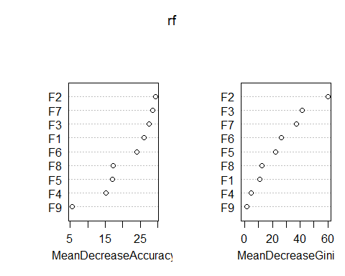

importance(rf)

## benign malignant MeanDecreaseAccuracy MeanDecreaseGini  
## F1 16.985768 27.3382953 26.016587 11.060658  
## F2 20.113069 23.3821169 29.339351 60.020764  
## F3 11.000507 24.9943595 27.490966 41.476595  
## F4 9.501326 11.9761281 15.137191 4.473377  
## F5 12.974604 10.6928908 17.076794 22.289537  
## F6 11.424254 23.7728339 24.016485 26.568185  
## F7 17.784815 25.8751499 28.541621 37.485781  
## F8 17.073066 4.1804225 17.265850 12.286474  
## F9 5.991248 0.1703767 5.594091 1.361032

#Hence F2 is the most important feature followed by F3 and then F7 in the order shown in the graph. F9 is the least important feature.  
  
pred <-predict( rf ,test_data , type="class" )  
inc <- sum(test_data[,10] != pred)  
accuracy <- 1 - inc/length(test_data[,10])  
accuracy

## [1] 0.952381

rm(list=ls())