**CS-513 Midterm Exam**

**Question 1**

To check if a function is a proper distance function, it must satisfy three conditions.

1. Distance is always non negative
2. Distance is always commutative, i.e. distance from A to B is same as distance from B to A
3. Triangle inequality, i.e. distance from A to C must be less than or equal to distance from A to B and B to C.

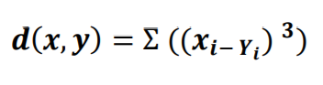

In the given case, finding the distance between two points A(1,1) and B(4,4) will result in:

AB = ( ( 1 - 4 )3 + ( 1 - 4 )3 ) = -18

Since this result violates the first condition, given function is **not a proper distance function**.

The distance between x(0, 0, 0) and y(0, 1, 0)

By given distance (incorrect) formula : D(x,y) = ( ( 0 - 0 )3 + ( 0 – 1 )3 + ( 0 – 0 )3 ) = -1

By proper distance formula **: D(x,y) = √( ( 0 - 0 )2 + ( 0 - 1 )2 + ( 0 – 0 )2 ) = 1**