WordLens – NLP based text visualization dashboard

Submitted in partial fulfillment of the requirements of the degree
BACHELOR OF ENGINEERING INCOMPUTER ENGINEERING

By

Bhumika Bhatia 24132197 Khushi Rijhwani 2313201 Lalit Bajaj 2341202
Harsh Ahuja 2413207

Supervisor
Dr. Ujwala Bharambe

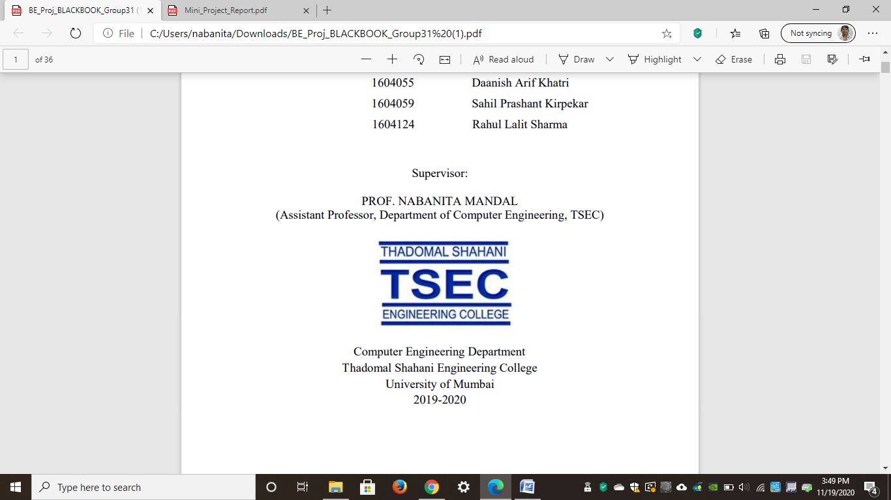

Computer Engineering Department
Thadomal Shahani Engineering College
Bandra(W), Mumbai - 400 050
University of Mumbai
(AY 2025-26)

CERTIFICATE

This is to certify that the Mini Project entitled “WordLens – NLP based text visualization dashboard” is a bonafide work of Bhumika Bhatia 24132197, Khushi Rijhwani 2313201, Lalit Bajaj 2341202, Harsh Ahuja 2413207 submitted to the University of Mumbai in partial fulfillment of the requirement for the award of the degree of “Bachelor of Engineering” in “Computer Engineering”.

Prof. Dr. Ujwala Bharambe
Supervisor

Dr. Tanuja Sarode Dr. G. T. Thampi
(Head of Department) (Principal)

Mini Project Approval

This Mini Project entitled “WordLens – NLP based text visualization dashboard”

By Name of students (Roll No.) is approved for the degree of Bachelor of Engineering in Computer Engineering.

Examiners

1………………………………………
(Internal Examiner Name & Sign)

2…………………………………………
(External Examiner name & Sign)

Date: Place:

Contents

Abstract ii

Acknowledgments iii

List of Abbreviations iv

List of Figures v

List of Tables vi

List of Symbols vii

Introduction 1
  - Introduction
  - Motivation
  - Problem Statement & Objectives
  - Organization of the Report

Literature Survey 11

  - Survey of Existing System
  - Limitation Existing system or research gap
  - Mini Project Contribution

Proposed System 18

  - Introduction
  - Architecture/ Framework
  - Algorithm and Process Design
  - Details of Hardware & Software
  - Experiment and Results
  - Conclusion and Futurework.

References 32

Acknowledgement

We would like to express our gratitude and thanks to Dr. Ujwala Bharambe for her valuable guidance and help. We are indebted for her guidance and constant supervision as well as for providing necessary information regarding the project. We would like to express our greatest appreciation to our principal Dr. G.T. Thampi and head of the department Dr. Tanuja Sarode for their encouragement and tremendous support. We take this opportunity to express our gratitude to the people who have been instrumental in the successful completion of theproject.

Bhumika Bhatia 24132197
Khushi Rijhwani 2313201
Lalit Bajaj 2341202
Harsh Ahuja 2413207

Chapter 1
Introduction
This chapter explains the aim, objectives and scope of the proposed system.

Introduction
In today’s digital era, a massive amount of data is generated in textual form through blogs, social media, articles, and online platforms. However, extracting meaningful insights from such unstructured data remains a challenging task. Traditional analysis methods are often insufficient to process large-scale text efficiently and present it in an understandable format.
Natural Language Processing (NLP) plays a crucial role in addressing this challenge by enabling machines to understand, process, and analyze human language. By combining NLP techniques with data visualization, it becomes possible to transform complex textual data into intuitive and meaningful graphical representations.
The WordLens Dashboard is designed to simplify text analysis by providing an interactive platform that integrates multiple NLP techniques into a single system. It allows users to input data in various formats such as raw text, URLs, and structured files, ensuring flexibility and ease of use. The system processes the input data through several preprocessing stages to enhance its quality and consistency
Once processed, the platform generates a variety of visual outputs including word clouds, keyword frequency charts, sentiment analysis graphs, and topic modeling results. These visualizations help users quickly identify patterns, trends, and relationships within the data. The dashboard also supports advanced analysis techniques such as TF-IDF scoring, n-gram analysis, and co-occurrence mapping to provide deeper insights.
The primary objective of this project is to bridge the gap between raw textual data and human understanding by presenting complex information in a simplified and visually appealing manner. By doing so, the system enhances decision-making and enables users to gain valuable insights from textual datasets efficiently.

Motivation
In the modern digital world, an enormous amount of information is generated daily in the form of textual data through sources such as blogs, news articles, social media, and research publications. Despite its abundance, this data often remains underutilized because it is unstructured and difficult to analyze using traditional methods. Extracting meaningful insights from such large volumes of text requires advanced tools and techniques.
The motivation behind developing the NLP-Based Text Visualization Dashboard (WordLens) stems from the need to simplify and enhance the process of text analysis. While there are individual tools available for tasks such as sentiment analysis, keyword extraction, or topic modeling, they are often scattered, complex to use, or lack integration. This creates a gap for users who need a unified, user-friendly platform to perform comprehensive text analysis in one place.
Another key motivation is to make text analysis more accessible and visually intuitive. Raw textual outputs or statistical data can be difficult to interpret, especially for non-technical users. By transforming text into interactive visualizations such as word clouds, frequency graphs, and sentiment timelines, the system enables users to quickly understand patterns, trends, and relationships within the data.
Additionally, the project is motivated by the growing importance of data-driven decision-making. Businesses, researchers, and content creators increasingly rely on insights derived from textual data to understand user opinions, identify trends, and improve strategies. A tool like WordLens can significantly assist in these tasks by providing quick and reliable analysis.
Finally, this project aims to demonstrate the practical application of Natural Language Processing (NLP) in solving real-world problems. By combining multiple NLP techniques into a single interactive dashboard, the system highlights how complex data processing can be made efficient, accessible, and meaningful.

Problem Statement & Objectives
In the current digital landscape, a vast amount of data is generated in textual form from sources such as social media, blogs, news articles, and research documents. However, this data is typically unstructured, making it difficult to process, analyze, and extract meaningful insights using conventional tools.
Existing text analysis solutions often focus on specific tasks such as sentiment analysis or keyword extraction, but lack integration into a single, unified system. Additionally, many of these tools require technical expertise and do not provide intuitive visual representations, making them less accessible to non-technical users.
Furthermore, analyzing data from multiple sources (such as combining text from URLs, files, and raw input) is often time-consuming and inefficient due to the absence of a centralized platform. This creates a need for a system that can handle diverse input formats, perform comprehensive text processing, and present the results in a clear and interactive manner.
Therefore, there is a requirement for a user-friendly and integrated solution that leverages Natural Language Processing (NLP) techniques to transform raw textual data into meaningful visual insights, enabling better understanding, comparison, and decision-making.
🔹 Primary Objectives:
- To develop a web-based platform for analyzing unstructured textual data using NLP techniques.
- To support multiple input formats such as raw text, URLs, and structured files (CSV/Excel).
- To preprocess textual data through cleaning, normalization, tokenization, and stopword removal
- To generate visual representations such as word clouds and frequency charts for better understanding.
- To implement keyword extraction and TF-IDF scoring to identify important terms.
- To perform n-gram analysis (uni-grams, bi-grams, tri-grams) to capture contextual patterns.
- To bridge the gap between raw textual data and human understanding by presenting complex information in a simple, visual, and interactive format.

  - Organization of the Report
This report consists of three chapters. The first chapter deals with introduction of the topic, problem statement, motivation behind the topic and objectives. The second chapter is the Literature Survey. It includes all the research work done related to this topic. All information related to study of existing systems as well as learning of new tools is mentioned in this chapter. The third chapter is about the proposed system which is used in this project. The block diagram, techniques used, hardware and software used screenshots of the project are presented in this chapter. All the documents related to development of this project are mentioned in References

Chapter 2
Literature Survey
This chapter explains the concepts used in this project, study of existing system and contribution of this project

2.1 Survey of Existing System

Several tools and platforms have been developed to analyze and visualize textual data using Natural Language Processing (NLP). These systems provide useful features such as word frequency analysis, sentiment detection, and topic modeling. Some of the commonly used existing systems are described below:

1. Voyant Tools

Voyant Tools is a web-based text analysis platform widely used in academic research and education. It allows users to upload text or input URLs and provides multiple visualization options such as word clouds, frequency graphs, and trend analysis over time.

2. Google Cloud Natural Language API

This is a cloud-based NLP service that provides powerful text analysis capabilities such as sentiment analysis, entity recognition, and syntax analysis. It is widely used in industry for large-scale applications.

3. MATLAB Text Analytics Toolbox

MATLAB provides a powerful toolbox for text preprocessing,visualization, and modeling. It supports techniques like tokenization, topic modeling (LDA), and sentiment analysis along with visualizations such as word clouds and plots.

2.2 Limitation of existing system
Limited Input Flexibility
Many tools support only a single type of input, such as raw text or uploaded files. They often do not allow combining data from multiple sources like URLs, CSV files, and manual input in a single analysis.
Complex User Interface
Advanced tools like cloud-based NLP services or programming libraries require technical knowledge and setup. This makes them less accessible to beginners or non-technical users.
No Customization Options
Many existing tools do not allow customization such as adding user-defined stopwords, adjusting analysis parameters, or selecting specific visualization types
Dependency on External Services
Some platforms rely heavily on external APIs or cloud services, which may require internet connectivity, subscription costs, or API limits.

2.3 Mini Project Contribution
The NLP-Based Text Visualization Dashboard (WordLens) has been developed to address several limitations identified in existing text analysis systems. The primary contribution of this project lies in creating a unified, interactive, and user-friendly platform that integrates multiple Natural Language Processing (NLP) techniques into a single system.
One of the major contributions of this project is the integration of diverse functionalities such as text preprocessing, keyword extraction, sentiment analysis, topic modeling, and visualization within a single dashboard. Unlike existing systems that require users to switch between multiple tools, this platform provides an all-in-one solution, thereby improving efficiency and usability.
The system also introduces multi-source input capability, allowing users to analyze text from raw input, URLs, and structured files such as CSV and Excel. Additionally, it supports combining text data from multiple URLs into a single dataset, which is not commonly available in many existing tools.
Furthermore, the dashboard is designed with a simple and intuitive user interface, making it accessible to both technical and non-technical users. This improves user experience and ensures that complex NLP operations can be performed with minimal effort.

Chapter 3
Proposed System
This chapter consists of detailed description about the methodology used, the hardware and software components, the tools used and also the screenshots of the project

3.1 Introduction

The proposed system is developed as a web-based application that integrates multiple Natural Language Processing (NLP) techniques for analyzing and visualizing textual data.

Programming Language Used:

Python is used as the core programming language due to its strong support for NLP and data analysis libraries.

Technologies and Frameworks:

Flask / Streamlit – for building the web-based interface

HTML, CSS, JavaScript – for frontend design and user interaction

Libraries Used:

NLTK / spaCy – for text preprocessing (tokenization, stopword removal)

Scikit-learn – for TF-IDF and machine learning models

Gensim – for topic modeling (LDA)

Pandas & NumPy – for data handling and processing

Matplotlib / Seaborn / Plotly – for data visualization

WordCloud – for generating word clouds

Tools Used:

Jupyter Notebook / VS Code – for development

Web browser – for running the dashboard

.

3.2 Architecture
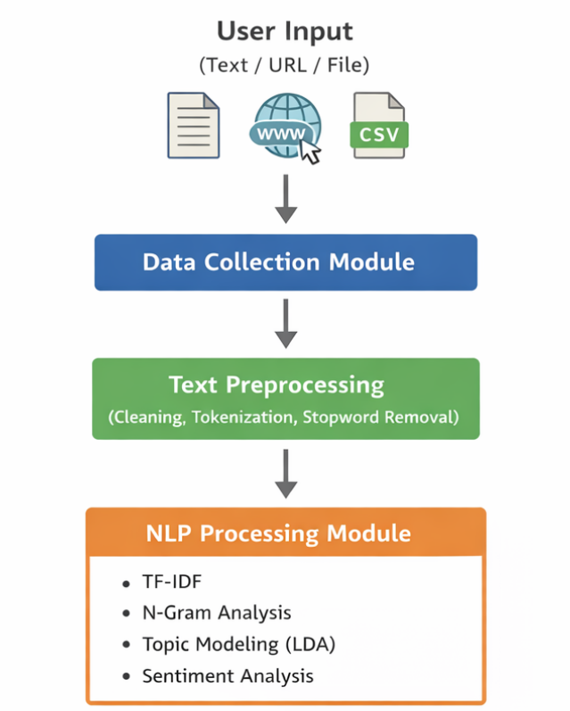
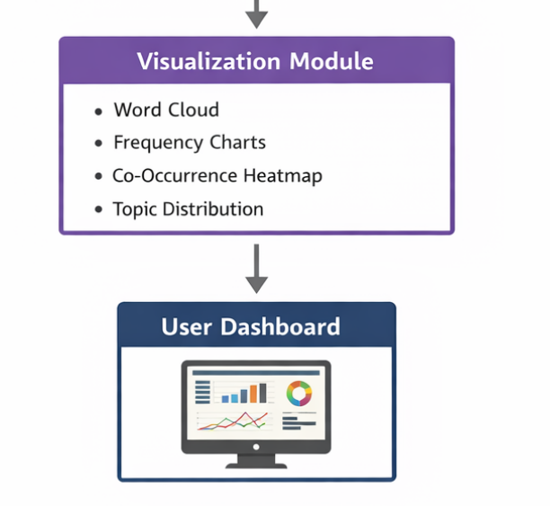

3.3 Algorithm and Process Design

🔹 Step 1: Data Input
The system accepts input in multiple formats, including:
- Raw text entered by the user
- URLs (single or multiple)
- Files such as CSV, Excel, and PDF
This flexibility allows users to analyze data from different sources within a single platform.

🔹 Step 2: Data Extraction and Collection
- If URLs are provided, the system extracts textual content using web scraping techniques.
- For file inputs, the system reads and extracts text from selected columns.
- All extracted text is combined into a single dataset for unified analysis.

🔹 Step 3: Text Preprocessing
The collected text undergoes several preprocessing steps:
- Conversion to lowercase
- Removal of URLs, HTML tags, punctuation, and numbers
- Tokenization (splitting text into words)
- Stopword removal (default + custom stopwords)
- Lemmatization to reduce words to their base form
This step ensures that the text is clean, consistent, and ready for analysis.

🔹 Step 4: Feature Extraction (TF-IDF)
- The system uses TF-IDF (Term Frequency–Inverse Document Frequency) to identify important words.
- Words that are frequent in a document but rare across others are given higher importance.
This helps in highlighting meaningful keywords instead of just frequent terms.

🔹 Step 5: N-gram Analysis
- The system generates:
  - Unigrams (single words)
  - Bigrams (two-word combinations)
  - Trigrams (three-word combinations)
This step captures contextual patterns and commonly used phrases in the text.

🔹 Step 6: Co-occurrence Analysis
- A co-occurrence matrix is created based on the proximity of words.
- Relationships between words are visualized using:
  - Heatmaps
  - Network graphs
This helps identify how terms are connected within the text.

🔹 Step 7: Topic Modeling (LDA Algorithm)
- The system applies Latent Dirichlet Allocation (LDA) to identify hidden topics.
- Each topic is represented by a group of important keywords.
This helps in understanding the main themes present in the dataset.

🔹 Step 8: Sentiment Analysis
- Sentiment analysis is performed using polarity scoring.
- Each text segment is classified as:
  - Positive
  - Negative
  - Neutral
A sentiment timeline is generated to show how sentiment changes across the text.

🔹 Step 9: Visualization Generation
The processed data is converted into visual formats such as:
- Word clouds (for frequency visualization)
- Frequency charts
- N-gram graphs
- Co-occurrence heatmaps
- Topic distribution charts
- Sentiment graphs
These visualizations make the analysis easy to understand.

🔹 Step 10: Output Display
All results are displayed on an interactive dashboard, allowing users to:
- Explore insights
- Compare patterns
- Analyze trends effectively

3.4 Details of Hardware & Software

Hardware Requirements
The system was developed and tested on the following hardware configuration:
- Processor: Intel Core i5 (or equivalent)
- RAM: 8 GB (minimum 4 GB required)
- Storage: 256 GB SSD / HDD
- System Type: 64-bit Operating System

Software Requirements
- Operating System: Windows 10 / 11 (or Linux/MacOS)
- Programming Language: Python
- Framework: Flask (for web application)
- Frontend Technologies: HTML, CSS, JavaScript

Libraries and Tools Used
- NLTK / spaCy – Text preprocessing
- Scikit-learn – TF-IDF and feature extraction
- Gensim – Topic modeling (LDA)
- VADER Sentiment – Sentiment analysis
- Pandas, NumPy – Data handling
- Matplotlib / Seaborn / Plotly – Visualization
- BeautifulSoup, Requests – Web scraping
- pdfplumber, openpyxl, xlrd – File handling

3.5 Results

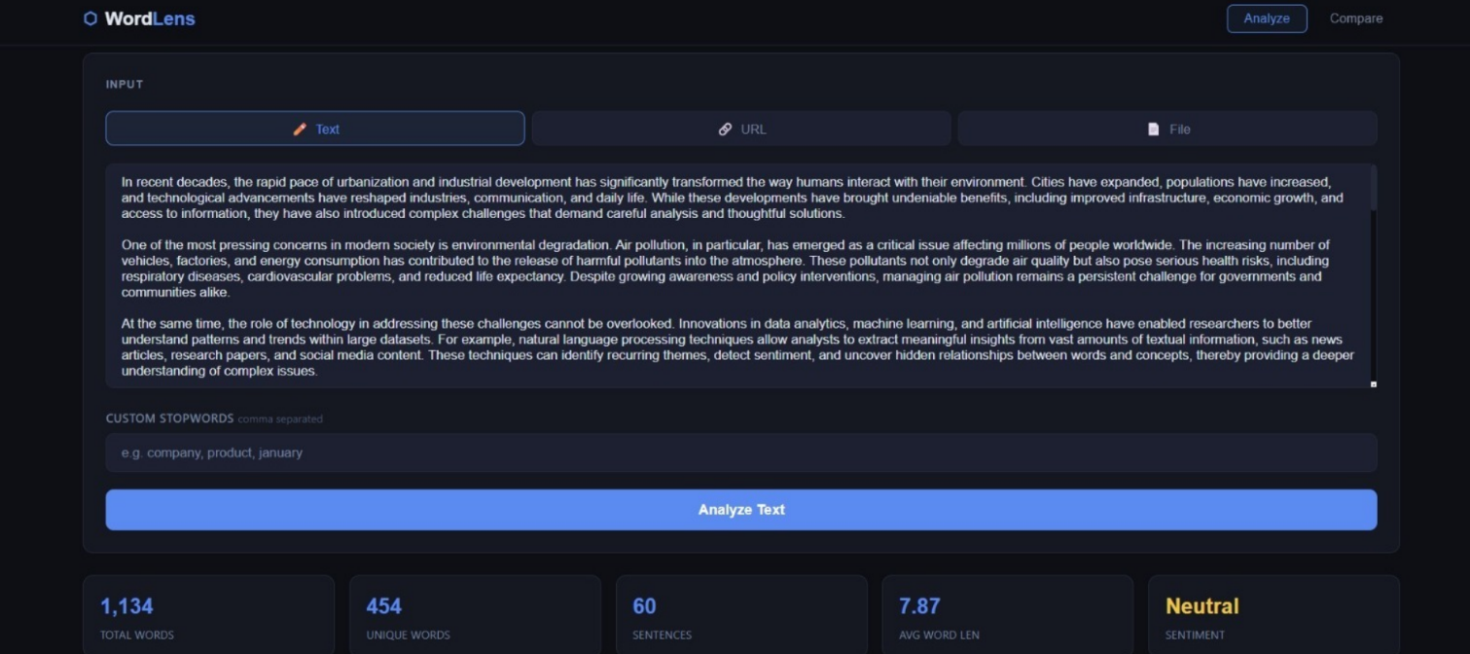
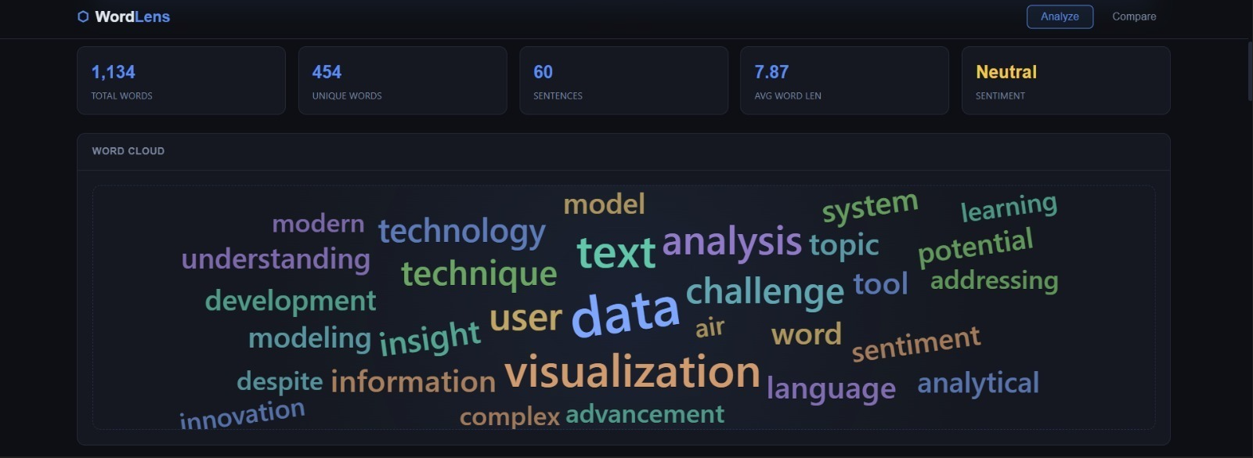
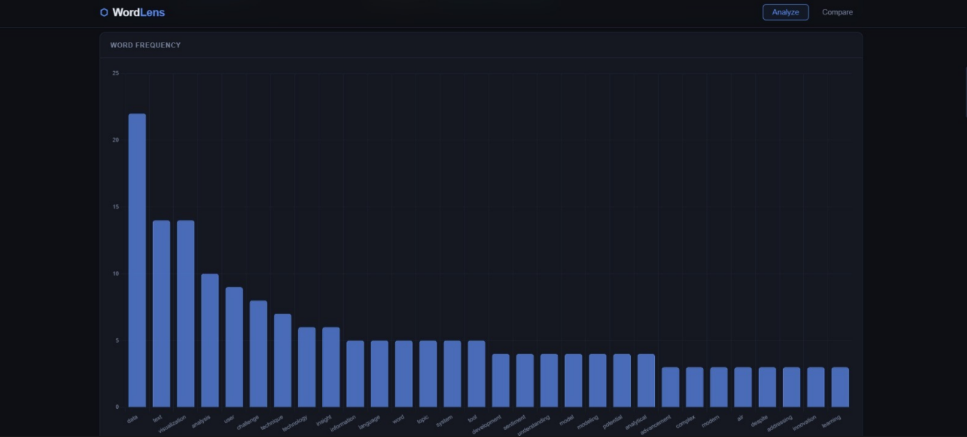
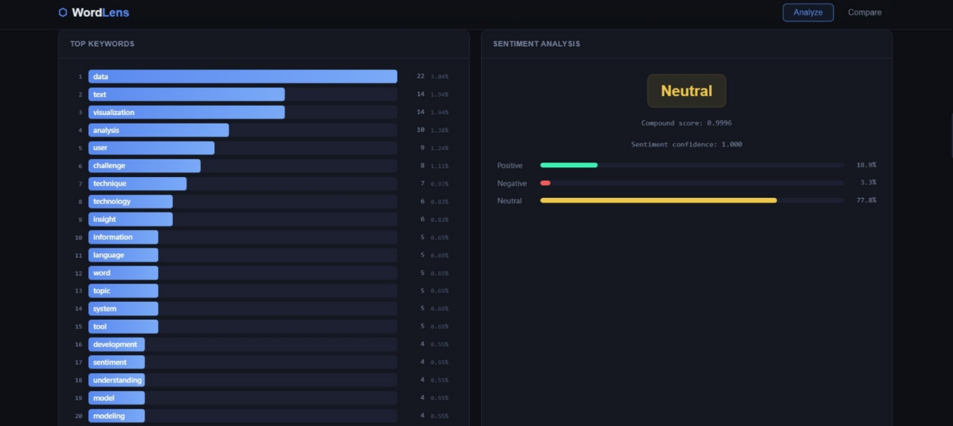
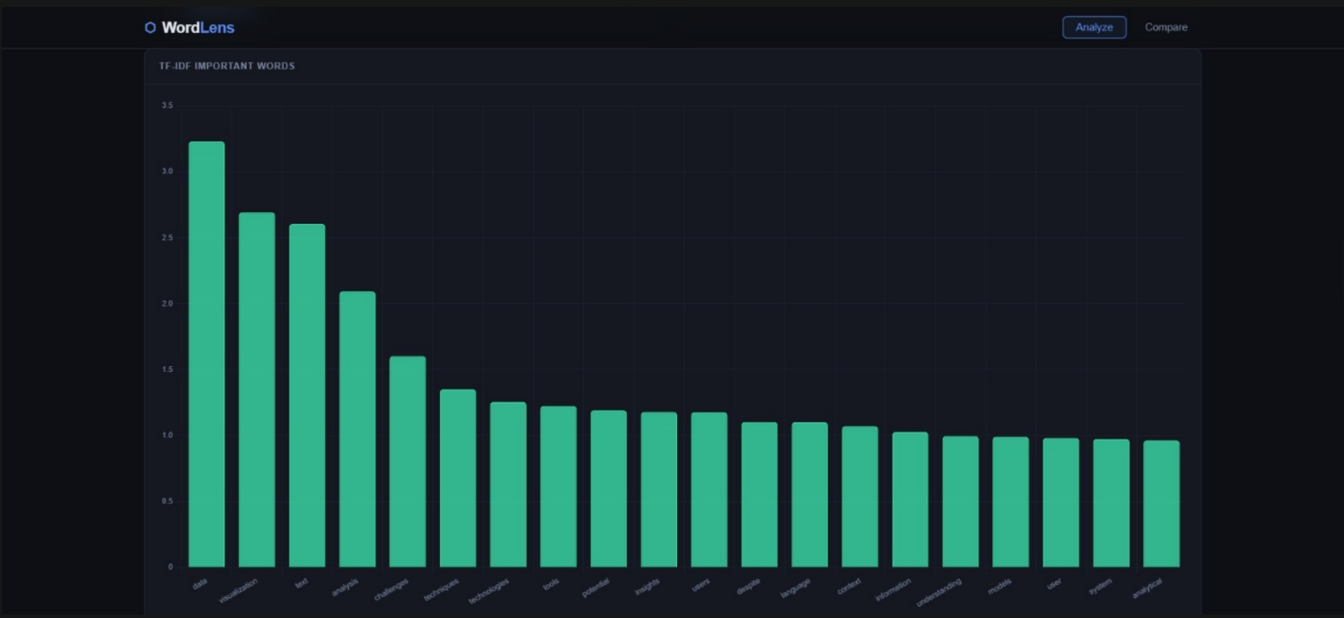
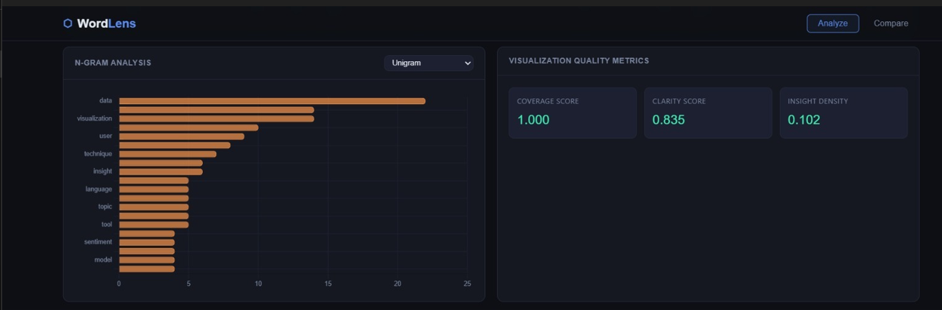
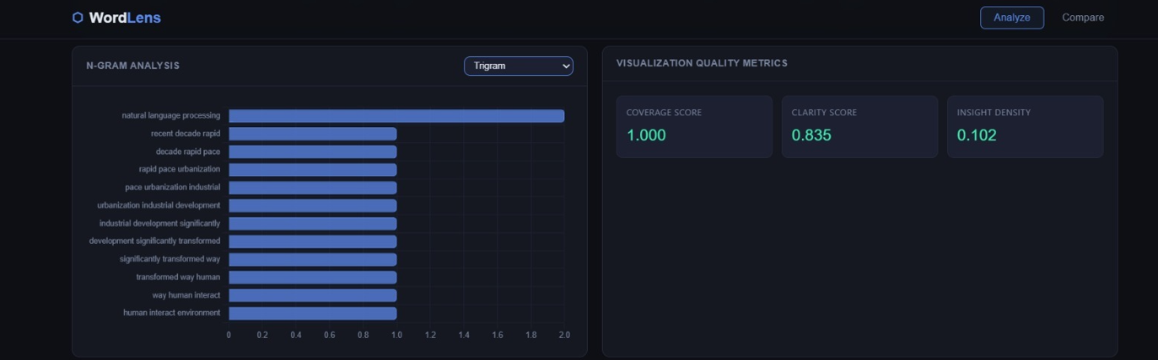
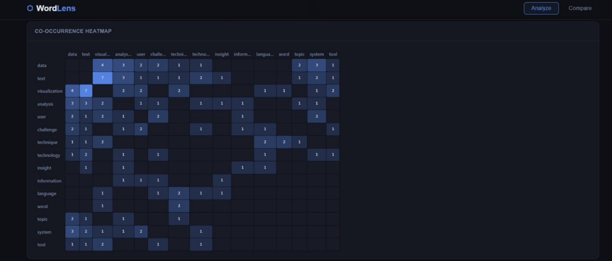
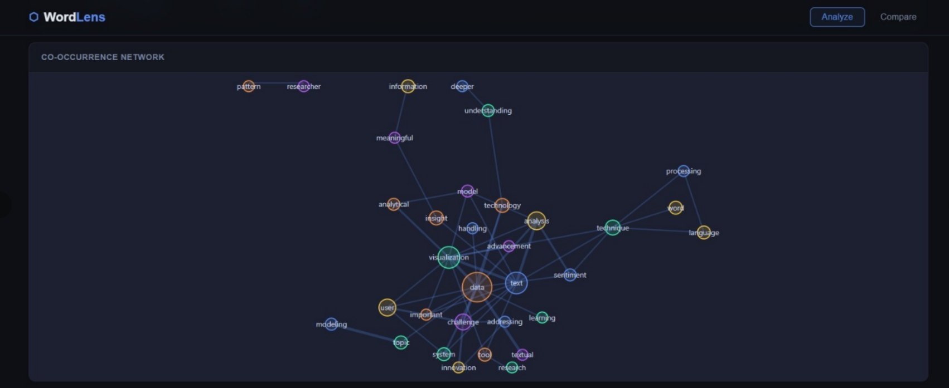
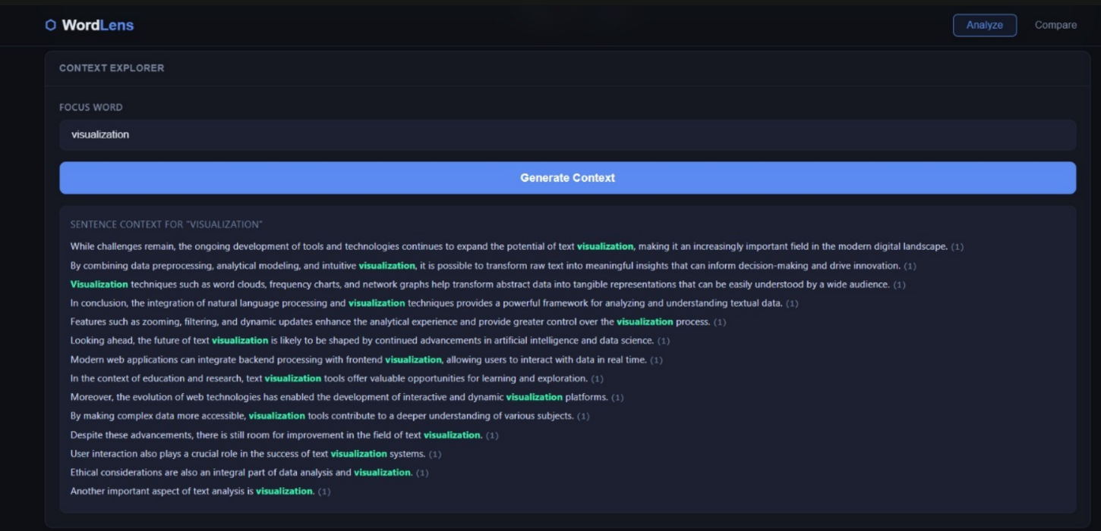
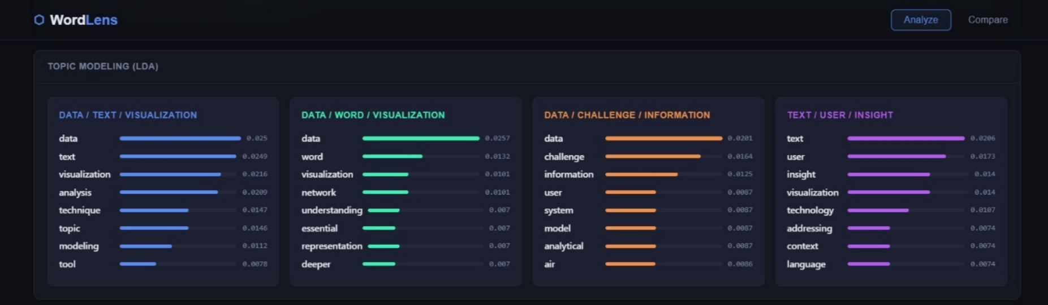
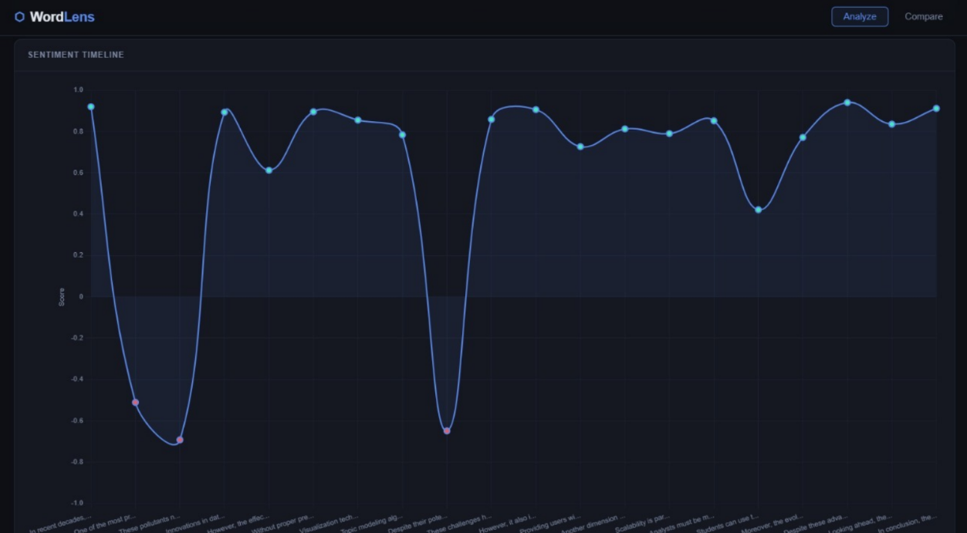

  - Conclusion and Future Work

The NLP-Based Text Visualization Dashboard (WordLens) successfully demonstrates how unstructured textual data can be transformed into meaningful visual insights using Natural Language Processing techniques. The system integrates multiple functionalities such as preprocessing, keyword extraction, sentiment analysis, and topic modeling into a single platform. By presenting results through interactive visualizations, it simplifies the process of understanding complex text data. The project effectively bridges the gap between raw data and user interpretation, making text analysis more accessible and efficient.
In the future, the system can be enhanced by incorporating advanced deep learning models such as BERT for more accurate text understanding. Additional features like real-time data analysis, multilingual support, and voice-to-text input can further improve usability. The dashboard can also be extended into a fully deployed web application with user authentication and cloud integration. These improvements will make the system more scalable, intelligent, and applicable to a wider range of real-world scenarios.

References
cikit-learn Developers, “TF-IDF Vectorizer Documentation,” [Online]. Available: https://scikit-learn.org
Gensim Documentation, “Topic Modeling using LDA,” [Online]. Available: https://radimrehurek.com/gensim
NLTK Project, “Natural Language Toolkit Documentation,” [Online]. Available: https://www.nltk.org
Voyant Tools, “Text Analysis Web Tool,” [Online]. Available: https://voyant-tools.org
InfraNodus, “Text Network Visualization Tool,” [Online]. Available: https://infranodus.com
Flask Documentation, “Flask Web Framework,” [Online]. Available: https://flask.palletsprojects.com

Note: Mention page numbers in bottom right corner of every page. Start the report from introduction. Make a separate document for the pages before introduction because they will be numbered in Roman Number. Contents will be page i, abstract will be page ii, acknowledgements will be page iii, list of figures will be page iv

No need for list of abbreviations, list of tables and list of symbols

Note: Try to write the whole report in your own words. Avoid copying from the internet.

Note: Font should be Times New Roman, Font size for headings will be 16, sub headings: 14, body: 12. Line spacing: 1.5

