Summary of Key Findings
Customer segmentation and ANN churn prediction
Prepared by Mitul (Cluster Analyst) | Team 10 – ACS WILDA Internship, Customer Churn Analysis

Summary of Key Findings

1. Churn is concentrated in new, high-spend customers
Stage 2 K-Means clustering (k = 4, silhouette 0.476) split customers by tenure and monthly charges. Churn rates differ sharply between the segments, and the ANN’s predictions on the unseen test set follow the same pattern.
Segment | Share of test customers | Actual churn | ANN avg. predicted prob. | Share of all churners | Flagged high-risk | Churners caught (recall)
New, High-Spend (At-Risk) | 31.5% | 50.0% | 69.3% | 59.4% | 64.4% | 77.9%
New, Low-Spend | 24.6% | 23.3% | 44.8% | 21.7% | 25.6% | 48.1%
Loyal, High-Spend | 29.0% | 14.7% | 30.2% | 16.0% | 1.2% | 6.7%
Loyal, Low-Spend (Stable) | 14.9% | 5.2% | 10.6% | 2.9% | 0% | 0%

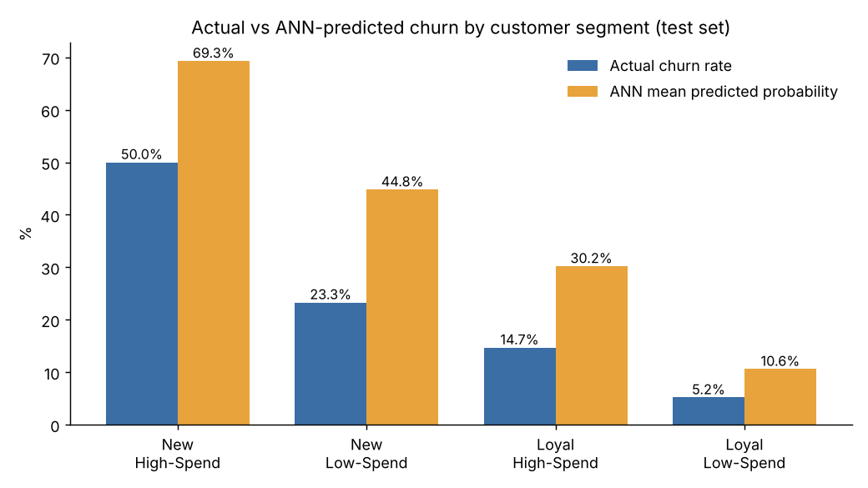
Figure: Actual churn rate vs ANN mean predicted probability, by segment (test set)
- New, High-Spend customers make up under a third of the base but nearly 60% of all churners. Half of them churn. The ANN flags 64% of this segment as high risk and catches 78% of its churners, so this is where the model is most useful.
- The model ranks the segments in the right order. Average predicted probability falls from 69% to 11% across the segments, in the same order as actual churn. The absolute probabilities are higher than actual rates because of class weighting (see Limitations), so they should be read as a risk ranking, not a literal percentage.
- Loyal, High-Spend customers are a blind spot. They account for 16% of churners, but because their long tenure pulls their scores down, the model catches only 4 of 60 (6.7%). These customers need a different approach than model-driven outreach.
- Loyal, Low-Spend customers are very stable (5% churn). The model correctly gives 95% of them a low risk score.

2. The ANN gives a usable risk ranking
Grouping test customers by predicted probability gives three tiers with very different real churn rates. This makes the model practical for prioritising retention effort.
Risk tier (ANN probability) | Customers (test) | Actual churn rate
High (66% and above) | 380 | 56.8%
Medium (30% to 66%) | 506 | 25.1%
Low (below 30%) | 523 | 5.9%

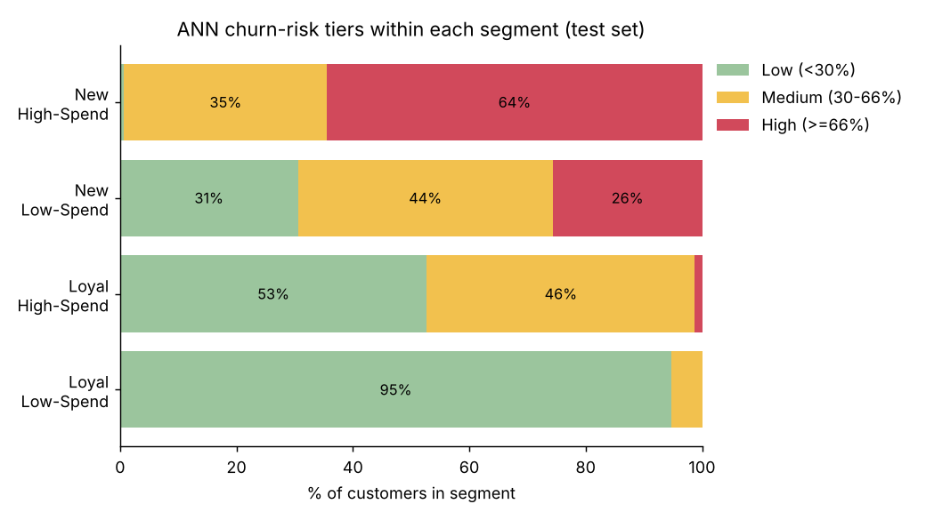
Figure: Share of each segment in each ANN risk tier (test set)

3. Model performance in one line
On 1,409 unseen customers the ANN reached ROC AUC 0.805, accuracy 77.2%, recall 57.8% and precision 56.8%, with stable 5-fold cross-validated AUC of 0.824 ± 0.005. A customer in the high-risk tier is about ten times more likely to churn than one in the low-risk tier (56.8% vs 5.9%).

4. Tenure and monthly charges drive churn; most other attributes matter little
Tenure and monthly charges together account for about 94% of the ANN’s predictive power. Senior citizens and customers without dependents are at moderately higher risk. Contract type, internet service type, phone lines and gender make little difference in this dataset. Details are in the Factors section.

