Factors Contributing to Churn and Retention
Based on the ANN model’s predictions
Prepared by Ashrafun (Business Analyst) | Team 10 – ACS WILDA Internship, Customer Churn Analysis

Factors Contributing to Churn and Retention
Three methods were used so that the conclusions do not rest on one technique: (1) permutation importance, which measures how much the ANN’s test AUC drops when one attribute is randomly shuffled; (2) effect profiles (partial dependence), which show the ANN’s average predicted risk as one attribute is changed and everything else is held as it is; and (3) observed churn rates in the raw data, as a check on the model.

What the ANN relies on
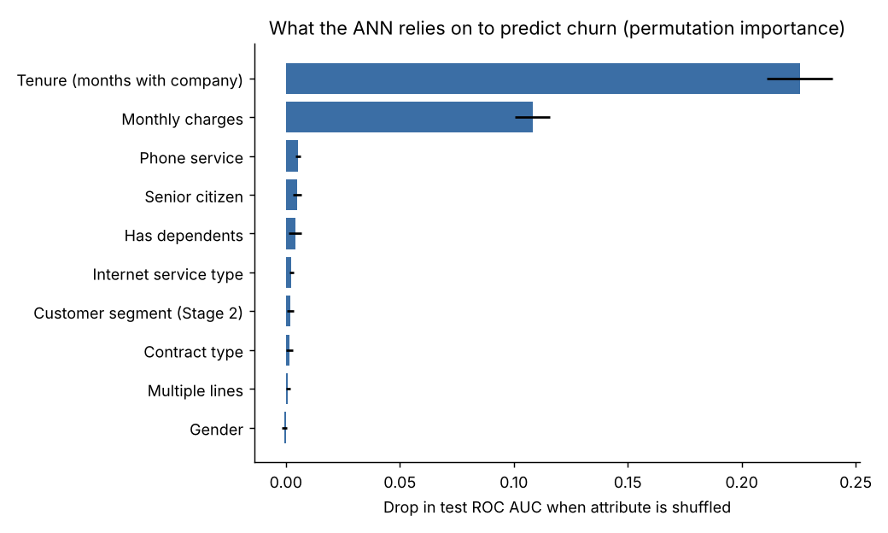
Figure: Permutation importance (drop in test ROC AUC when the attribute is shuffled, 20 repeats)
Attribute | AUC drop when shuffled | Share of importance
Tenure | 0.226 | 63.5%
Monthly charges | 0.108 | 30.5%
Phone service | 0.005 | 1.5%
Senior citizen | 0.005 | 1.4%
Has dependents | 0.004 | 1.1%
Internet service type | 0.002 | 0.7%
Customer segment (Stage 2) | 0.002 | 0.5%
Contract type | 0.002 | 0.5%
Multiple lines | 0.001 | 0.3%
Gender | ≈ 0 | 0%

The segment flags add little on their own because they are built from tenure and charges, which the model already sees directly.

Churn drivers
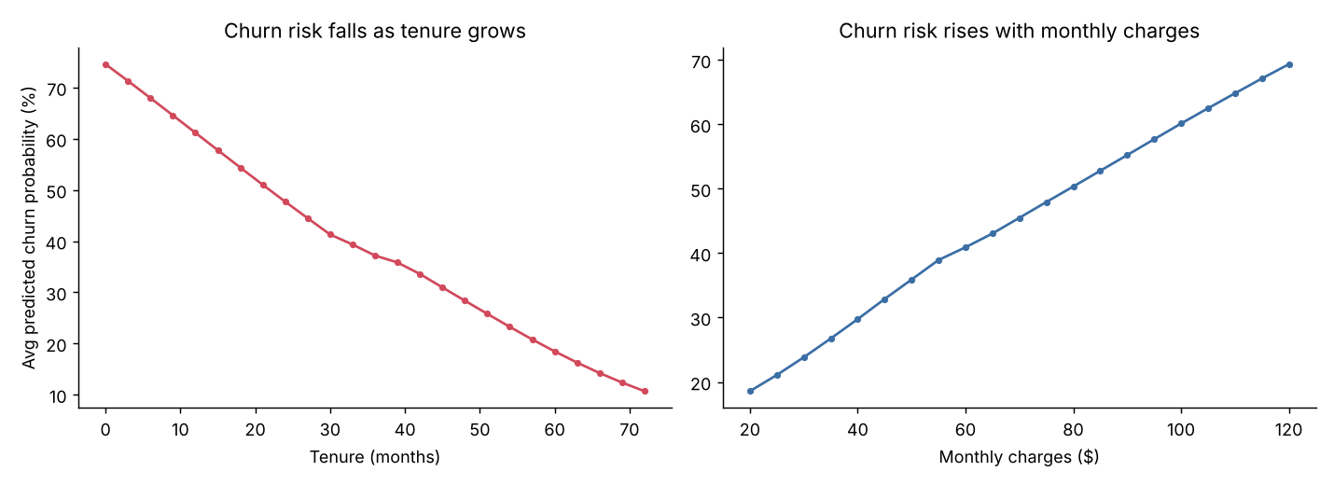
Figure: ANN average predicted churn probability as tenure and monthly charges change
- Short tenure (strongest driver). Predicted risk falls steadily from about 75% at month 0 to 48% at 2 years and 11% at 6 years. In the raw data, 52.9% of customers in their first 6 months churn, compared with 9.5% of customers past 4 years. The first year is the critical window.
- High monthly charges. Predicted risk rises from about 19% at $20/month to 50% at $80 and 69% at $120. Observed churn is 10.1% for customers paying under $30 and 33–37% for those paying $70 or more.
- Senior citizens. Being a senior raises predicted risk by about 8 points with everything else held equal. Observed churn is 41.7% for seniors vs 23.6% for non-seniors.

Retention drivers
- Long tenure. The longer a customer stays, the less likely they are to leave; loyalty builds on itself.
- Lower monthly charges. Customers on lower-cost plans are much more stable.
- Having dependents. Lowers predicted risk by about 7 points. Observed churn is 15.5% with dependents vs 31.3% without, which is consistent with household accounts being harder to move.

Attributes with little or no effect
In this dataset, contract type barely changes churn (observed: month-to-month 27.3%, one-year 25.8%, two-year 25.4%; the ANN gives only a 5-point difference). The same applies to internet service type (DSL 27.4% vs fibre 25.4%), multiple lines and gender. The contract result is unusual, because in most telecom data long contracts strongly reduce churn. It should be checked against the company’s full customer records before anyone acts on it (see Limitations).
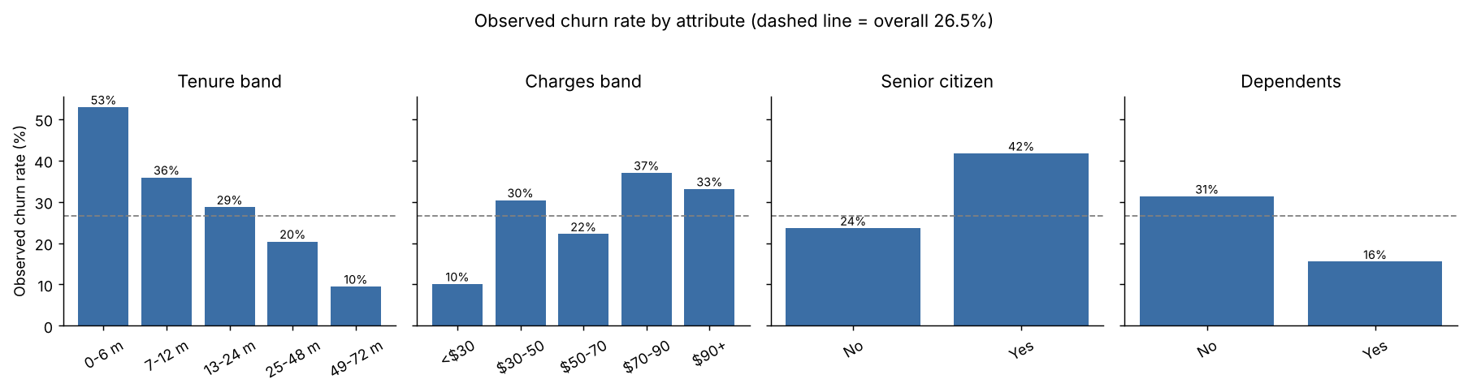
Figure: Observed churn rate by attribute in the full dataset (dashed line = 26.5% overall)

