Final Report: Customer Churn Prediction with an Artificial Neural Network
ACS WILDA Internship – Telecommunications Customer Churn Analysis, Stage 3
Team 10 | Compiled by Bhavin (Project Manager)
Team member | Role | Stage 3 contribution
Bhavin | Project Manager | Coordination, limitations, report compilation, video
Harsha Jumrani | Data Analyst – Predictive Modelling | ANN architecture, training and evaluation
Mitul | Cluster Analyst | Segment-level analysis of predictions; key findings
Pruthal | Data Engineer | Model data pipeline, leakage fix, train/val/test sets
Ashrafun | Business Analyst | Churn and retention factors; retention recommendations

Executive Summary
- An ANN (14 inputs → 64 → 32 → 1) was trained on 7,043 telecom customers to predict churn.
- On 1,409 unseen test customers it achieved ROC AUC 0.805, accuracy 77.2%, recall 57.8%, precision 56.8%; 5-fold cross-validated AUC was 0.824 ± 0.005.
- Customers the model rates high-risk churn at 56.8%, compared with 5.9% for low-risk customers.
- Short tenure and high monthly charges explain about 94% of the model’s predictive power. Senior citizens and customers without dependents are also at higher risk. Contract type has little effect in this data.
- The New, High-Spend segment is 31% of customers but about 59% of churners.
- Top recommendations: first-year onboarding, plan-fit and loyalty offers for new high-spend customers, and tiered, model-driven outreach measured against a control group.

Data and Approach
The dataset (Dataset_ATS_v2.csv) contains 7,043 customers and 10 variables: gender, senior citizen, dependents, tenure, phone service, multiple lines, internet service, contract, monthly charges and churn (26.5% churned). Stage 2 prepared and encoded the data and grouped customers into four K-Means segments. Stage 3 builds on that work.
The ANN is trained on files produced by prepare_model_data.py. The script starts from the Stage 2 output Clustering_Analysis/clustered_dataset.csv (7,043 customers with encoded variables and the K-Means segment) and produces model-ready training, validation and test sets.

Steps
- Load and check. 7,043 rows, 0 missing values. 302 exact duplicate rows were already flagged in Stage 2; they are kept because the data has no customer ID to prove they are true duplicates (see Limitations).
- Select features. 14 inputs: tenure and monthly charges (scaled), 8 binary/one-hot fields (senior citizen, gender, dependents, phone service, multiple lines, internet service type, one-year contract, two-year contract) and the 4 one-hot Stage 2 segment flags.
- Recreate the Stage 2 test set. The same stratified 80/20 split (random_state = 42) is applied, so the 1,409-customer test set is identical to Data_Preparation/test_set.csv. The script checks this automatically.
- Create a validation set. 15% of the training data is held back (stratified) for early stopping and threshold tuning. The test set is only used once, for the final evaluation.
- Fix scaling leakage. In Stage 2 the StandardScaler was fitted on all 7,043 rows, including the test rows. In Stage 3 it is re-fitted on the training rows only and then applied to validation and test.
- Save outputs. model_train.csv, model_val.csv, model_test.csv, scaler.joblib, feature_columns.json and split_summary.json.

Resulting data sets
Set | Customers | Share | Churn rate | Used for
Training | 4,788 | 68% | 26.6% | Fitting network weights
Validation | 846 | 12% | 26.5% | Early stopping, architecture choice, decision threshold
Test | 1,409 | 20% | 26.5% | Final, one-time performance evaluation

Feature list
Feature | Type | Source
tenure_scaled | Numeric (z-score) | tenure, scaler fitted on training rows
MonthlyCharges_scaled | Numeric (z-score) | MonthlyCharges, scaler fitted on training rows
SeniorCitizen | Binary 0/1 | Raw
gender_enc | Binary 0/1 (Male = 1) | Label-encoded, Stage 2
Dependents_enc | Binary 0/1 | Label-encoded, Stage 2
PhoneService_enc | Binary 0/1 | Label-encoded, Stage 2
MultipleLines_enc | Binary 0/1 | Label-encoded, Stage 2
InternetService_enc | Binary 0/1 (Fiber optic = 1) | Label-encoded, Stage 2
Contract_One year, Contract_Two year | One-hot (Month-to-month = baseline) | Stage 2
Segment_0 to Segment_3 | One-hot | Stage 2 K-Means segment

ANN Architecture
The model is a fully connected feed-forward neural network (multilayer perceptron) built with TensorFlow/Keras. It takes 14 customer features as input and outputs a single churn probability between 0 and 1.
Layer | Units | Activation | Details | Parameters
Input (customer_features) | 14 | – | Scaled numeric + binary + segment flags | 0
Hidden layer 1 (hidden_1) | 64 | ReLU | He-normal initialisation, L2 = 0.0001 | 960
Dropout 1 | – | – | Rate 0.3 (training only) | 0
Hidden layer 2 (hidden_2) | 32 | ReLU | He-normal initialisation, L2 = 0.0001 | 2,080
Dropout 2 | – | – | Rate 0.3 (training only) | 0
Output (churn_probability) | 1 | Sigmoid | Probability that the customer churns | 33
Total |  |  |  | 3,073

Why these choices
- ReLU hidden layers learn non-linear patterns (for example, risk falling quickly in the first year and then levelling off) and train quickly without vanishing gradients.
- Sigmoid output with binary cross-entropy loss is the standard set-up for a yes/no target and gives a probability that can be ranked and thresholded.
- Dropout (0.3) and a small L2 penalty reduce overfitting. With only 14 inputs and about 4,800 training rows, an unregularised network starts to memorise the training data within a few epochs.
- He-normal initialisation suits ReLU layers and gives stable early training.

How the architecture was optimised
Four candidate architectures were trained with the same settings and compared on the validation set only (the test set was not used for this choice). The best validation ROC AUC was selected. If a simpler model came within 0.002 AUC of the best, the simpler one would have been preferred.
Candidate | Parameters | Epochs (early stop) | Validation ROC AUC | Validation PR AUC
A: 1 hidden layer (16) | 257 | 60 | 0.811 | 0.617
B: 2 hidden layers (32-16) | 1,025 | 25 | 0.808 | 0.599
C: 2 hidden layers (64-32) – selected | 3,073 | 28 | 0.814 | 0.621
D: 3 hidden layers (64-32-16) | 3,585 | 47 | 0.813 | 0.614

All four candidates score within 0.006 AUC of each other. Adding more depth does not help, which tells us that the limit on performance comes from the information in the 10 original variables, not from model capacity.

Training the Model
Setting | Value | Reason
Optimiser | Adam, learning rate 0.001 | Adaptive and robust; standard choice for tabular ANNs
Loss | Binary cross-entropy | Matches sigmoid output and yes/no target
Batch size / max epochs | 32 / 200 | Small batches give useful gradient noise; early stopping decides the real length
Class weights | No churn 0.68, Churn 1.88 | Only 26.5% of customers churn. Weighting stops the model from just predicting “no churn”
Early stopping | Monitor validation AUC, patience 20, restore best weights | Stops before overfitting; keeps the best epoch
Learning-rate schedule | ReduceLROnPlateau (x0.5 after 8 flat epochs, min 1e-5) | Finer steps once progress slows
Reproducibility | Seed 42, deterministic TensorFlow ops | Same results every run on the same versions

Training stopped after 28 epochs. Validation AUC peaked early (around epoch 8–10) and early stopping restored those weights. After that point training AUC kept rising while validation AUC stayed flat, which is the usual sign of overfitting starting.
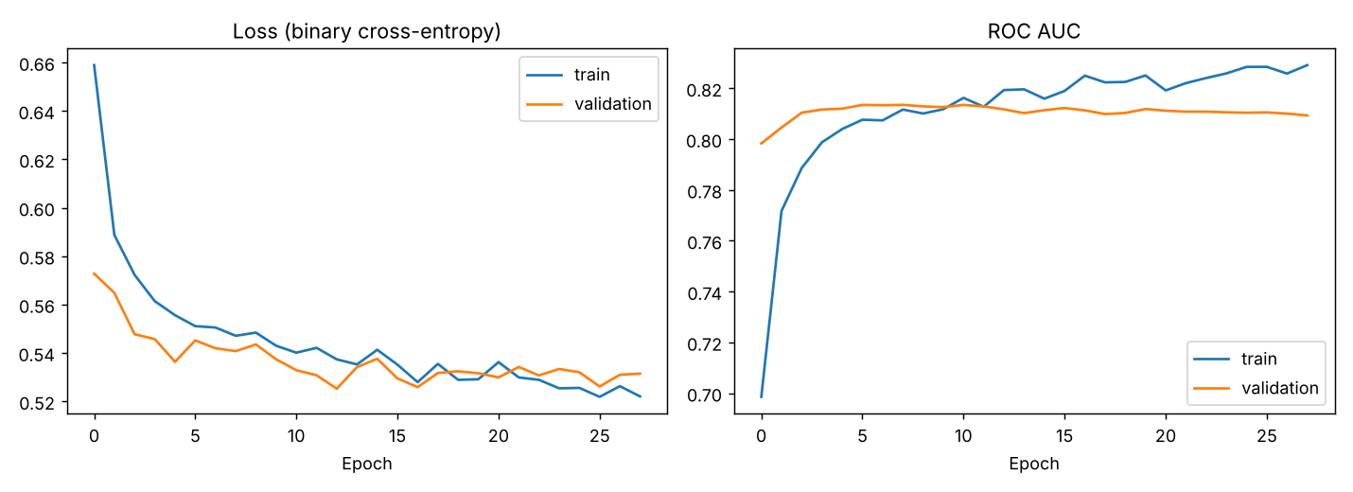
Figure: Training and validation loss and ROC AUC by epoch

Choosing the decision threshold
The network outputs a probability. To turn it into a churn / no-churn prediction we need a cut-off. Because class weights push probabilities upward, the default 0.5 flags too many customers. The threshold that maximised F1 on the validation set was 0.66, and this is used as the main operating point. Results at 0.5 are also reported, because a retention team that values catching churners above all may prefer it.

Model Performance
All results below are on the 1,409-customer test set, which the model never saw during training, architecture selection or threshold tuning.
Metric | ANN (t = 0.66) | ANN (t = 0.50) | Logistic regression | Always “No churn”
Accuracy | 77.2% | 71.8% | 78.6% | 73.5%
Precision (of flagged, % who churn) | 56.8% | 47.9% | 61.9% | –
Recall (of churners, % caught) | 57.8% | 73.8% | 50.8% | 0%
F1 score | 0.573 | 0.581 | 0.558 | 0
Specificity | 84.2% | 71.0% | 88.7% | 100%
ROC AUC | 0.805 | 0.805 | 0.805 | 0.5
PR AUC (average precision) | 0.603 | 0.603 | 0.606 | 0.265

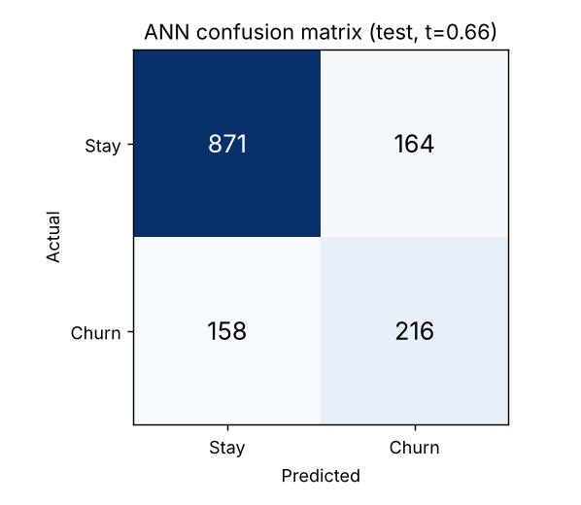
Figure: Confusion matrix on the test set at threshold 0.66
At the 0.66 threshold the model catches 216 of 374 churners (57.8%). Of the 380 customers it flags, 216 actually churn, so a retention team working from this list would be reaching a real churner more than half the time. That compares with 26.5% if it contacted customers at random. There were 164 false alarms and 158 missed churners.
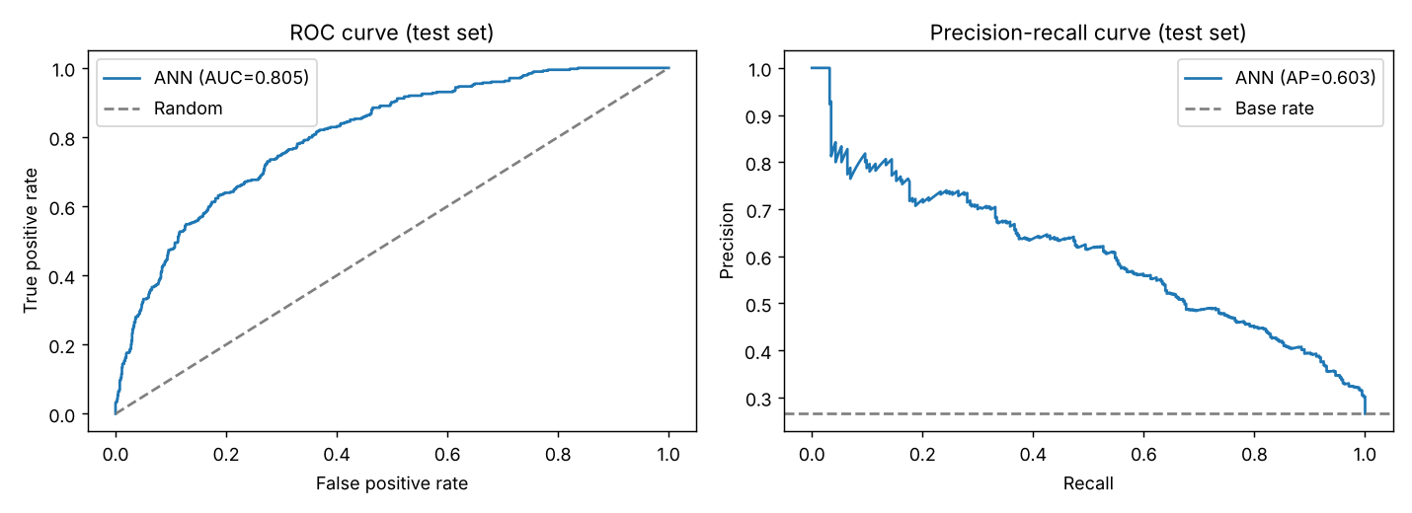
Figure: ROC and precision-recall curves on the test set

Robustness
To check that the result is not a lucky split, the selected architecture was retrained with 5-fold stratified cross-validation on the training + validation data. ROC AUC was 0.824 ± 0.005 across folds (folds: 0.822, 0.821, 0.818, 0.827, 0.831), F1 was 0.576 ± 0.023 and recall was 55.0% ± 4.4%. The small spread shows the model is stable. The test AUC (0.805) is close to the cross-validated figure, so there is no sign of the model being tuned to one particular split.

How to read these results
- The ANN ranks customers by risk well (AUC 0.805, so it puts a random churner above a random non-churner about 80% of the time) and is far more useful than the 73.5% “always no churn” baseline, which catches no churners at all.
- A plain logistic regression reaches the same AUC. This is an honest and important finding: with only 10 customer variables, and churn driven mostly by two of them (tenure and charges), there is little non-linear structure for a neural network to exploit. The ANN’s advantage is that it can take on richer data (usage, support calls, billing history) without redesign. See Limitations.
- Accuracy alone is misleading for this problem because of class imbalance. Recall, precision, F1 and AUC are the metrics to judge the model on.

Summary of Key Findings

1. Churn is concentrated in new, high-spend customers
Stage 2 K-Means clustering (k = 4, silhouette 0.476) split customers by tenure and monthly charges. Churn rates differ sharply between the segments, and the ANN’s predictions on the unseen test set follow the same pattern.
Segment | Share of test customers | Actual churn | ANN avg. predicted prob. | Share of all churners | Flagged high-risk | Churners caught (recall)
New, High-Spend (At-Risk) | 31.5% | 50.0% | 69.3% | 59.4% | 64.4% | 77.9%
New, Low-Spend | 24.6% | 23.3% | 44.8% | 21.7% | 25.6% | 48.1%
Loyal, High-Spend | 29.0% | 14.7% | 30.2% | 16.0% | 1.2% | 6.7%
Loyal, Low-Spend (Stable) | 14.9% | 5.2% | 10.6% | 2.9% | 0% | 0%

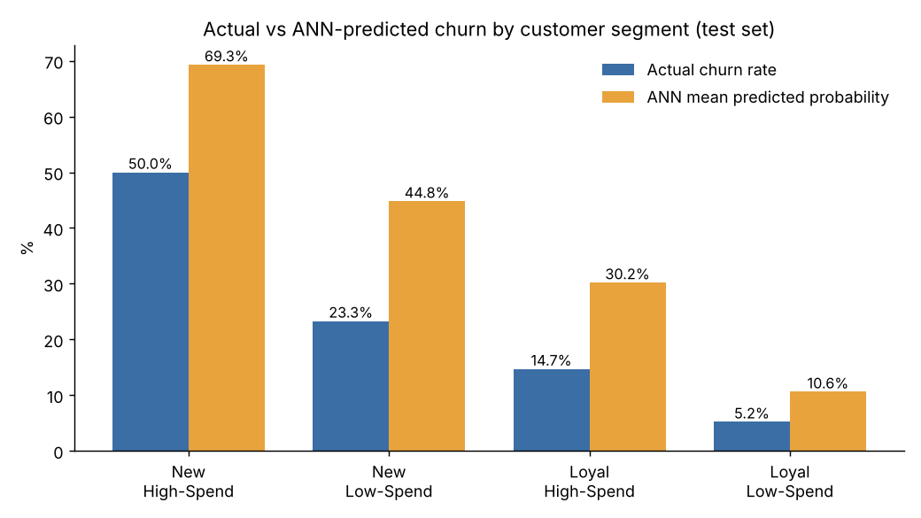
Figure: Actual churn rate vs ANN mean predicted probability, by segment (test set)
- New, High-Spend customers make up under a third of the base but nearly 60% of all churners. Half of them churn. The ANN flags 64% of this segment as high risk and catches 78% of its churners, so this is where the model is most useful.
- The model ranks the segments in the right order. Average predicted probability falls from 69% to 11% across the segments, in the same order as actual churn. The absolute probabilities are higher than actual rates because of class weighting (see Limitations), so they should be read as a risk ranking, not a literal percentage.
- Loyal, High-Spend customers are a blind spot. They account for 16% of churners, but because their long tenure pulls their scores down, the model catches only 4 of 60 (6.7%). These customers need a different approach than model-driven outreach.
- Loyal, Low-Spend customers are very stable (5% churn). The model correctly gives 95% of them a low risk score.

2. The ANN gives a usable risk ranking
Grouping test customers by predicted probability gives three tiers with very different real churn rates. This makes the model practical for prioritising retention effort.
Risk tier (ANN probability) | Customers (test) | Actual churn rate
High (66% and above) | 380 | 56.8%
Medium (30% to 66%) | 506 | 25.1%
Low (below 30%) | 523 | 5.9%

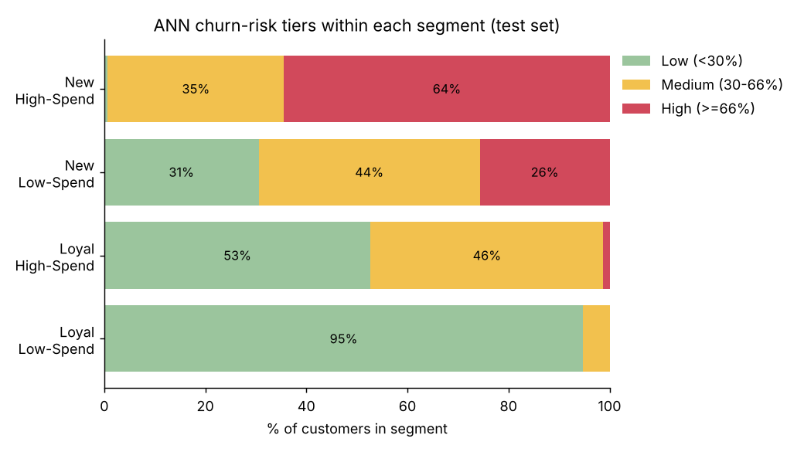
Figure: Share of each segment in each ANN risk tier (test set)

3. Model performance in one line
On 1,409 unseen customers the ANN reached ROC AUC 0.805, accuracy 77.2%, recall 57.8% and precision 56.8%, with stable 5-fold cross-validated AUC of 0.824 ± 0.005. A customer in the high-risk tier is about ten times more likely to churn than one in the low-risk tier (56.8% vs 5.9%).

4. Tenure and monthly charges drive churn; most other attributes matter little
Tenure and monthly charges together account for about 94% of the ANN’s predictive power. Senior citizens and customers without dependents are at moderately higher risk. Contract type, internet service type, phone lines and gender make little difference in this dataset. Details are in the Factors section.

Factors Contributing to Churn and Retention
Three methods were used so that the conclusions do not rest on one technique: (1) permutation importance, which measures how much the ANN’s test AUC drops when one attribute is randomly shuffled; (2) effect profiles (partial dependence), which show the ANN’s average predicted risk as one attribute is changed and everything else is held as it is; and (3) observed churn rates in the raw data, as a check on the model.

What the ANN relies on
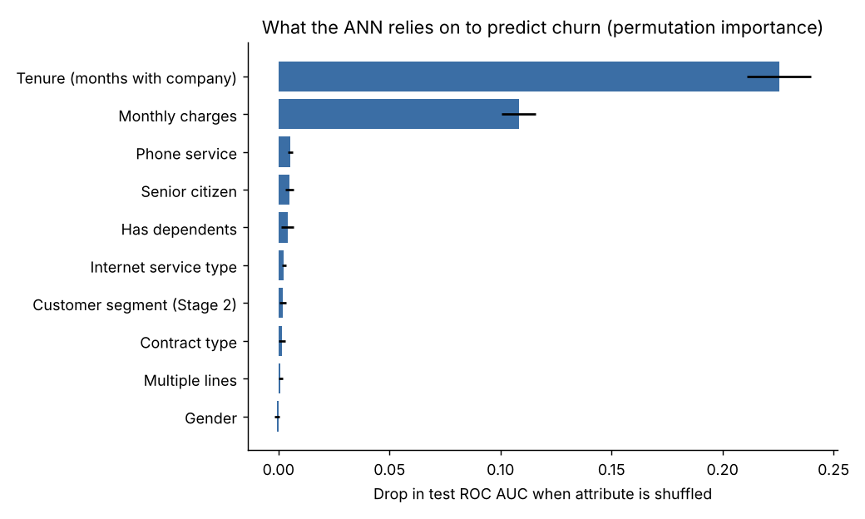
Figure: Permutation importance (drop in test ROC AUC when the attribute is shuffled, 20 repeats)
Attribute | AUC drop when shuffled | Share of importance
Tenure | 0.226 | 63.5%
Monthly charges | 0.108 | 30.5%
Phone service | 0.005 | 1.5%
Senior citizen | 0.005 | 1.4%
Has dependents | 0.004 | 1.1%
Internet service type | 0.002 | 0.7%
Customer segment (Stage 2) | 0.002 | 0.5%
Contract type | 0.002 | 0.5%
Multiple lines | 0.001 | 0.3%
Gender | ≈ 0 | 0%

The segment flags add little on their own because they are built from tenure and charges, which the model already sees directly.

Churn drivers
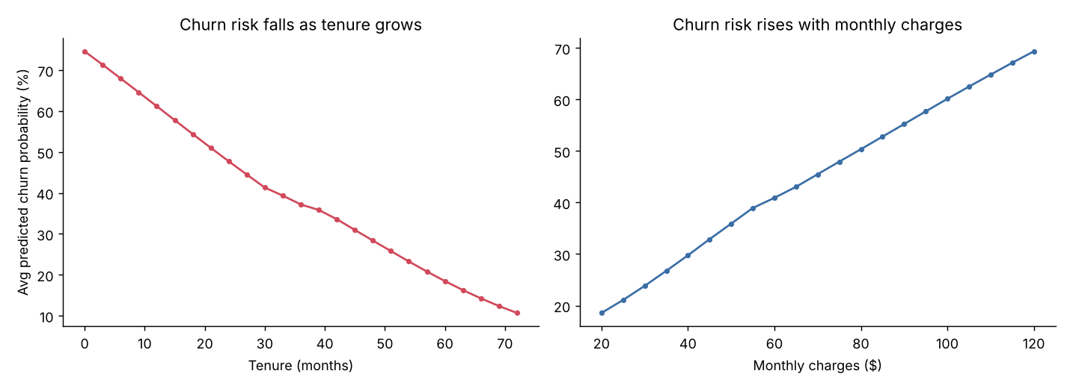
Figure: ANN average predicted churn probability as tenure and monthly charges change
- Short tenure (strongest driver). Predicted risk falls steadily from about 75% at month 0 to 48% at 2 years and 11% at 6 years. In the raw data, 52.9% of customers in their first 6 months churn, compared with 9.5% of customers past 4 years. The first year is the critical window.
- High monthly charges. Predicted risk rises from about 19% at $20/month to 50% at $80 and 69% at $120. Observed churn is 10.1% for customers paying under $30 and 33–37% for those paying $70 or more.
- Senior citizens. Being a senior raises predicted risk by about 8 points with everything else held equal. Observed churn is 41.7% for seniors vs 23.6% for non-seniors.

Retention drivers
- Long tenure. The longer a customer stays, the less likely they are to leave; loyalty builds on itself.
- Lower monthly charges. Customers on lower-cost plans are much more stable.
- Having dependents. Lowers predicted risk by about 7 points. Observed churn is 15.5% with dependents vs 31.3% without, which is consistent with household accounts being harder to move.

Attributes with little or no effect
In this dataset, contract type barely changes churn (observed: month-to-month 27.3%, one-year 25.8%, two-year 25.4%; the ANN gives only a 5-point difference). The same applies to internet service type (DSL 27.4% vs fibre 25.4%), multiple lines and gender. The contract result is unusual, because in most telecom data long contracts strongly reduce churn. It should be checked against the company’s full customer records before anyone acts on it (see Limitations).
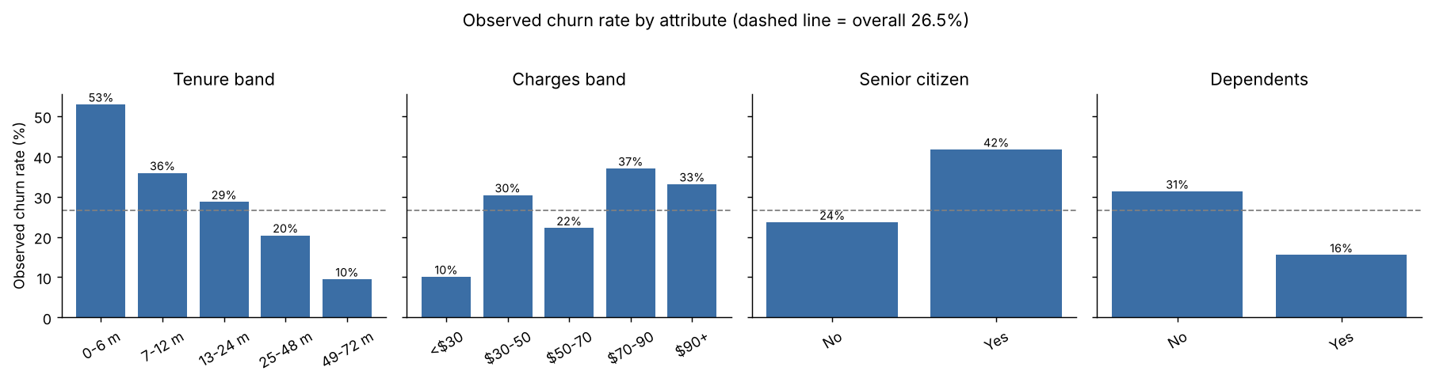
Figure: Observed churn rate by attribute in the full dataset (dashed line = 26.5% overall)

Recommendations for Targeted Retention Strategies
The recommendations follow from the segment analysis and the churn factors. They are ordered by expected impact. Each one names who to target, what to do and how to measure it.
# | Strategy | Target group | Why (evidence) | KPI
1 | First-year onboarding programme | All customers in months 0–12 | 52.9% churn in first 6 months; tenure is 63% of model importance | Churn rate in months 0–12
2 | Plan-fit review and early loyalty offer | New, High-Spend segment | 31% of customers, ~59% of churners, 50% churn | Segment churn rate; offer take-up
3 | Model-driven risk outreach | ANN high-risk tier (≥ 66%) | 56.8% of this tier churns vs 5.9% in low tier | Save rate vs control group
4 | Price-sensitivity programme | Customers paying $70+/month | 33–37% churn; risk rises steadily with charges | Churn and ARPU in $70+ band
5 | Senior customer support | Senior citizens | 41.7% churn vs 23.6% | Senior churn rate; satisfaction
6 | Household bundles | Customers without dependents | 31.3% churn vs 15.5% with dependents | Bundle uptake; churn
7 | Relationship check-ins | Loyal, High-Spend segment | 16% of churners but model catches only 7% | Segment churn rate
8 | Maintain, don’t over-contact | Loyal, Low-Spend segment | 5% churn; already stable | Cost per retained customer

1. First-year onboarding programme
- Welcome call in week 1, then check-ins at 30, 60 and 90 days to fix setup, billing or service problems early.
- A month-3 and month-6 review that confirms the plan still fits and points out features the customer is not using.
- Track churn by month of tenure so the team can see if the early-life curve is flattening.

2. New, High-Spend segment: plan fit and early loyalty
- Proactively review whether these customers are on the right plan. Moving an over-provisioned customer to a cheaper plan that fits keeps the relationship; losing them loses all the revenue.
- Offer a time-limited loyalty discount or bonus (for example, data or a device credit) around months 3–6, when risk is highest.
- Make this segment the first priority for the retention team’s capacity.

3. Put the ANN into the retention workflow
- Score all active customers monthly and assign the three risk tiers.
- High tier (≥ 66%): personal outreach from a retention specialist with a tailored offer. Medium tier (30–66%): lower-cost automated contact (email/SMS offers, satisfaction survey). Low tier (< 30%): business as usual.
- Keep a random control group in each tier that receives no contact, so the real effect of each action can be measured.
- If missed churners are more costly than wasted offers, lower the threshold to 0.5 (recall rises from 58% to 74%, precision falls from 57% to 48%).

4. Price-sensitive, high-charge customers
- Run a bill review for customers paying $70+ per month, especially those in their first two years.
- Offer price-lock guarantees or bundle discounts rather than straight price cuts, so revenue is protected.
- Be careful with upselling low-spend customers: higher charges are linked with higher churn, so upsells should add clear value.

5–8. Smaller, targeted programmes
- Senior citizens: a dedicated support line, simpler plan options and in-store or phone setup help.
- Customers without dependents: household or multi-service bundles, which raise the value of staying.
- Loyal, High-Spend: the model under-detects churn here, so use account-manager check-ins, anniversary rewards and priority service rather than relying on model scores.
- Loyal, Low-Spend: keep service quality steady and avoid unnecessary contact; these customers are already stable.

A note on contracts
Pushing customers onto longer contracts is a common retention tactic, but in this dataset contract type has almost no link to churn. We recommend a small pilot with a control group before investing heavily in contract-upgrade campaigns.

Limitations, Challenges and Proposed Solutions
# | Limitation / challenge | Impact | Proposed solution
1 | Few features. Only 10 customer variables; no usage, support-ticket, billing-history, payment-method or complaint data. | Caps performance at about 0.81 AUC; ANN performs no better than logistic regression. | Add behavioural and service data (support calls, payment method, total charges, usage trends). Retrain and re-compare ANN vs simpler models.
2 | Class imbalance (26.5% churn). | Without correction the model predicts “no churn” for almost everyone. | Used balanced class weights and tuned the threshold on validation data. Could also try SMOTE or focal loss.
3 | Probabilities are not calibrated. Class weighting raises scores (mean predicted 43% vs 26.5% actual). | Scores rank customers well but should not be read as literal probabilities. | Apply Platt or isotonic calibration on the validation set before using scores for financial forecasts.
4 | Precision–recall trade-off. Catching more churners means more false alarms. | The “right” threshold depends on business costs. | Set the threshold from offer cost vs customer lifetime value; 0.66 (balanced) and 0.5 (high recall) are both documented.
5 | Unusual contract result. Contract type barely affects churn, unlike most telecom data. | Possible that the dataset is simplified or synthetic; conclusions may not transfer. | Validate on the company’s full customer records before acting on contract-related findings.
6 | Duplicate rows (302 exact duplicates) kept, as there is no customer ID. | Some identical rows may sit in both train and test, slightly flattering results. | Request a customer ID; de-duplicate and re-evaluate.
7 | Data leakage from Stage 2. The scaler and K-Means were fitted on all rows. | Small optimistic bias. | Scaler now re-fitted on training rows only (fixed in Stage 3). K-Means should also be refitted on training rows; impact is minimal since segment adds ~0.5% importance.
8 | Blind spot in Loyal, High-Spend. 16% of churners but only 6.7% caught. | Model-led outreach misses these customers. | Segment-specific thresholds or a separate model; add usage/satisfaction data; use relationship-based retention meanwhile.
9 | ANN is a “black box”. | Harder to explain individual predictions to the business. | Used permutation importance and effect profiles. SHAP values could explain individual customers.
10 | Static snapshot. No dates, so no time-based validation or drift tracking. | Model may degrade as prices and products change. | Retrain quarterly; monitor AUC and churn rate by tier; validate on a later time period.
11 | Reproducibility across environments. TensorFlow results can vary slightly by version and hardware. | Teammates may see small metric differences. | Seeds fixed, deterministic ops enabled, versions pinned in requirements.txt; trained model file is committed.

Project challenges
- Keeping stages consistent. Stage 3 depends on Stage 2 outputs. We rebuilt the exact Stage 2 test split and added an automatic check so all members work from the same data.
- Choosing what “good” means. Accuracy looked acceptable but hid the fact that a naive model catches no churners. The team agreed to judge the model on AUC, recall, precision and F1.
- Avoiding test-set leakage. Architecture and threshold choices were made on a separate validation set so the test result is a fair estimate.
- Turning model output into actions. Raw probabilities were hard to act on, so we converted them into three risk tiers linked to specific retention actions.

Conclusion
The ANN predicts churn with ROC AUC 0.805 on unseen customers and splits the base into risk tiers whose real churn rates range from 5.9% to 56.8%. Churn is driven mainly by short tenure and high monthly charges and is concentrated in the New, High-Spend segment, which holds nearly 60% of churners. The most valuable actions are a first-year onboarding programme, plan-fit reviews and early loyalty offers for new high-spend customers, and model-driven outreach to the high-risk tier with a control group to measure impact. The model’s main limits come from the small set of available variables, so adding usage and service data is the clearest next step.

Appendix: Repository Files
Folder | Owner | Key files
Predictive_Modeling | Pruthal | prepare_model_data.py, model_train/val/test.csv, scaler.joblib, Model_Data_Pipeline.docx
Predictive_Modeling | Harsha | train_ann.py, churn_ann_model.keras, ANN_Architecture.docx, evaluation_metrics.json, test_predictions.csv, charts
Predictive_Modeling | Mitul | segment_churn_analysis.py, segment_prediction_summary.csv, risk-tier charts
Predictive_Modeling | Ashrafun | churn_factors_analysis.py, feature_importance.csv, effect and churn-rate charts
Final_Report | All (compiled by Bhavin) | Final_Report.docx and the four section documents
Video | Bhavin (all present) | Video_Script_and_Plan.docx

