ANN Model Architecture, Training and Evaluation
Stage 3 – Predictive Modeling
Prepared by Harsha Jumrani (Data Analyst – Predictive Modelling) | Team 10 – ACS WILDA Internship, Customer Churn Analysis

ANN Architecture
The model is a fully connected feed-forward neural network (multilayer perceptron) built with TensorFlow/Keras. It takes 14 customer features as input and outputs a single churn probability between 0 and 1.
Layer | Units | Activation | Details | Parameters
Input (customer_features) | 14 | – | Scaled numeric + binary + segment flags | 0
Hidden layer 1 (hidden_1) | 64 | ReLU | He-normal initialisation, L2 = 0.0001 | 960
Dropout 1 | – | – | Rate 0.3 (training only) | 0
Hidden layer 2 (hidden_2) | 32 | ReLU | He-normal initialisation, L2 = 0.0001 | 2,080
Dropout 2 | – | – | Rate 0.3 (training only) | 0
Output (churn_probability) | 1 | Sigmoid | Probability that the customer churns | 33
Total |  |  |  | 3,073

Why these choices
- ReLU hidden layers learn non-linear patterns (for example, risk falling quickly in the first year and then levelling off) and train quickly without vanishing gradients.
- Sigmoid output with binary cross-entropy loss is the standard set-up for a yes/no target and gives a probability that can be ranked and thresholded.
- Dropout (0.3) and a small L2 penalty reduce overfitting. With only 14 inputs and about 4,800 training rows, an unregularised network starts to memorise the training data within a few epochs.
- He-normal initialisation suits ReLU layers and gives stable early training.

How the architecture was optimised
Four candidate architectures were trained with the same settings and compared on the validation set only (the test set was not used for this choice). The best validation ROC AUC was selected. If a simpler model came within 0.002 AUC of the best, the simpler one would have been preferred.
Candidate | Parameters | Epochs (early stop) | Validation ROC AUC | Validation PR AUC
A: 1 hidden layer (16) | 257 | 60 | 0.811 | 0.617
B: 2 hidden layers (32-16) | 1,025 | 25 | 0.808 | 0.599
C: 2 hidden layers (64-32) – selected | 3,073 | 28 | 0.814 | 0.621
D: 3 hidden layers (64-32-16) | 3,585 | 47 | 0.813 | 0.614

All four candidates score within 0.006 AUC of each other. Adding more depth does not help, which tells us that the limit on performance comes from the information in the 10 original variables, not from model capacity.

Training the Model
Setting | Value | Reason
Optimiser | Adam, learning rate 0.001 | Adaptive and robust; standard choice for tabular ANNs
Loss | Binary cross-entropy | Matches sigmoid output and yes/no target
Batch size / max epochs | 32 / 200 | Small batches give useful gradient noise; early stopping decides the real length
Class weights | No churn 0.68, Churn 1.88 | Only 26.5% of customers churn. Weighting stops the model from just predicting “no churn”
Early stopping | Monitor validation AUC, patience 20, restore best weights | Stops before overfitting; keeps the best epoch
Learning-rate schedule | ReduceLROnPlateau (x0.5 after 8 flat epochs, min 1e-5) | Finer steps once progress slows
Reproducibility | Seed 42, deterministic TensorFlow ops | Same results every run on the same versions

Training stopped after 28 epochs. Validation AUC peaked early (around epoch 8–10) and early stopping restored those weights. After that point training AUC kept rising while validation AUC stayed flat, which is the usual sign of overfitting starting.
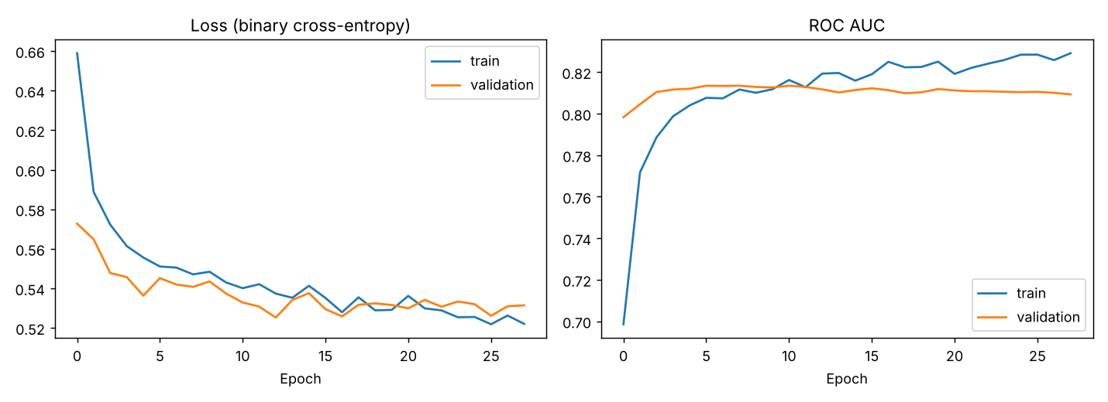
Figure: Training and validation loss and ROC AUC by epoch

Choosing the decision threshold
The network outputs a probability. To turn it into a churn / no-churn prediction we need a cut-off. Because class weights push probabilities upward, the default 0.5 flags too many customers. The threshold that maximised F1 on the validation set was 0.66, and this is used as the main operating point. Results at 0.5 are also reported, because a retention team that values catching churners above all may prefer it.

Model Performance
All results below are on the 1,409-customer test set, which the model never saw during training, architecture selection or threshold tuning.
Metric | ANN (t = 0.66) | ANN (t = 0.50) | Logistic regression | Always “No churn”
Accuracy | 77.2% | 71.8% | 78.6% | 73.5%
Precision (of flagged, % who churn) | 56.8% | 47.9% | 61.9% | –
Recall (of churners, % caught) | 57.8% | 73.8% | 50.8% | 0%
F1 score | 0.573 | 0.581 | 0.558 | 0
Specificity | 84.2% | 71.0% | 88.7% | 100%
ROC AUC | 0.805 | 0.805 | 0.805 | 0.5
PR AUC (average precision) | 0.603 | 0.603 | 0.606 | 0.265

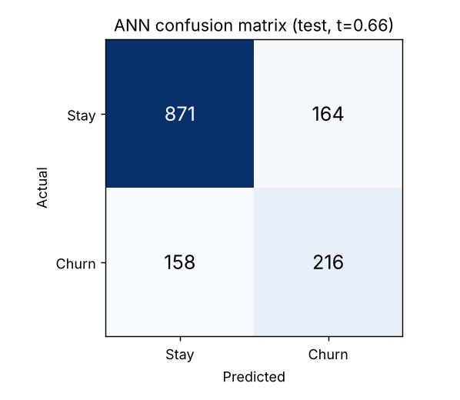
Figure: Confusion matrix on the test set at threshold 0.66
At the 0.66 threshold the model catches 216 of 374 churners (57.8%). Of the 380 customers it flags, 216 actually churn, so a retention team working from this list would be reaching a real churner more than half the time. That compares with 26.5% if it contacted customers at random. There were 164 false alarms and 158 missed churners.
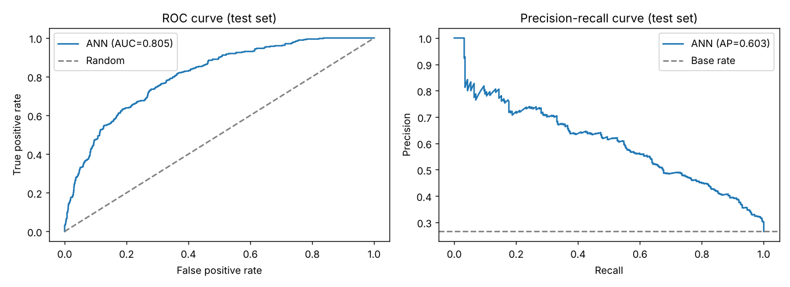
Figure: ROC and precision-recall curves on the test set

Robustness
To check that the result is not a lucky split, the selected architecture was retrained with 5-fold stratified cross-validation on the training + validation data. ROC AUC was 0.824 ± 0.005 across folds (folds: 0.822, 0.821, 0.818, 0.827, 0.831), F1 was 0.576 ± 0.023 and recall was 55.0% ± 4.4%. The small spread shows the model is stable. The test AUC (0.805) is close to the cross-validated figure, so there is no sign of the model being tuned to one particular split.

How to read these results
- The ANN ranks customers by risk well (AUC 0.805, so it puts a random churner above a random non-churner about 80% of the time) and is far more useful than the 73.5% “always no churn” baseline, which catches no churners at all.
- A plain logistic regression reaches the same AUC. This is an honest and important finding: with only 10 customer variables, and churn driven mostly by two of them (tenure and charges), there is little non-linear structure for a neural network to exploit. The ANN’s advantage is that it can take on richer data (usage, support calls, billing history) without redesign. See Limitations.
- Accuracy alone is misleading for this problem because of class imbalance. Recall, precision, F1 and AUC are the metrics to judge the model on.

