Authenticated VAPT Scanner for IDOR and Privilege Escalation Detection

Abstract
New security risks, particularly those pertaining to access control, have been brought about by the growing number of web applications.
Insecure Direct Object Reference (IDOR) is a prevalent vulnerability that allows attackers to access resources that belong to other users
by changing object identifiers in requests. An authenticated Vulnerability Assessment and Penetration Testing (VAPT) scanner that
automatically finds IDOR vulnerabilities is presented in this project. In order to find possible access control problems, the scanner
records authenticated requests, modifies object identifiers, sends the application modified requests, and examines server responses.
The tool shows how security analysts can find broken access control vulnerabilities in web applications with the help of automated testing.

Introduction
Web applications are crucial to contemporary digital services like social media, online banking, and e-commerce. Sensitive data,
such as user credentials, financial records, and personal information, are often handled by these applications. Ensuring the security
of web applications has become crucial for organizations and developers as their usage grows.
Broken Access Control, one of the most serious vulnerabilities in the OWASP Top 10, is one of the main security threats in web applications.
When an application does not appropriately limit what authenticated users are permitted to access, it is said to have broken access control.
Insecure Direct Object Reference (IDOR) is a typical illustration of this vulnerability. When an application exposes internal object
identifiers, like user IDs or file references, without first confirming that the user making the request has authorization to access
that resource, this is known as IDOR.
In these situations, attackers can change parameters in a request to gain access to other users' data. Manually identifying these
vulnerabilities can be challenging and time-consuming, particularly in large applications with numerous endpoints.
The goal of this project is to create an Authenticated VAPT Scanner that can automatically identify possible IDOR vulnerabilities.
In order to identify possible access control problems, the scanner records authenticated requests, changes object identifiers, sends
the modified requests to the target application, and examines the responses. The system helps security testers find vulnerabilities
more quickly by automating this process.

System Architecture
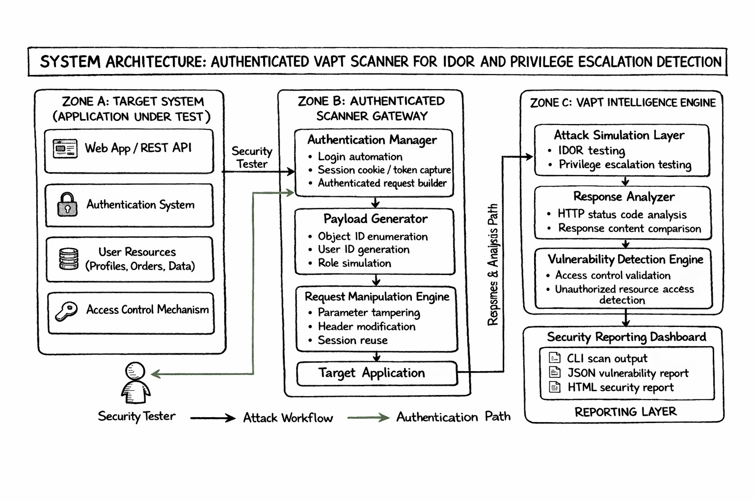

Methodology / Logical Steps
7. Methodology /steps

To identify possible Insecure Direct Object Reference (IDOR) vulnerabilities in web applications, the suggested system employs an organized methodology. By obtaining legitimate session data, altering request parameters, submitting automated requests to the target application, and examining the answers to spot potential access control problems, the scanner carries out authenticated testing. The following steps outline the system's general methodology.

Step 1: Set Up the Target Application
Choosing a web application to be vulnerability tested is the first step. Vulnerable lab environments from the PortSwigger Web Security Academy are utilized in this project. These labs use purposefully weak access control implementations to mimic real-world web applications.

Step 2: Session capture and authentication
The user uses legitimate login credentials to access the target web application in order to conduct authenticated testing. Burp Suite serves as an intercepting proxy and captures the authenticated request that the browser generates. The session cookie is extracted from the request that was captured. The scanner sends authenticated requests to the application using this session cookie.
Step 3: Make an Identification Request
The pertinent request containing the object identifier parameter is found after authentication. For instance, a parameter like /my-account?id=wiener might be included in an account page request.
The user identifier that the application uses to retrieve account information is represented by this parameter.Step 3: Monitoring Application Activity – Navigate through the application while the proxy records HTTP requests.
Step 4: Generation of Payloads
In this step, the scanner modifies the object identifier to create multiple payloads. By substituting alternative values for the original identifier, the payload generator generates various test cases. Examples consist of:
id=administrator; id=wiener; id=carlos
These altered values mimic possible attack situations in which a hacker tries to access resources that belong to other users.
Step 5: Transmission and Manipulation of Requests
With the modified parameters and the captured session cookie, the scanner creates HTTP requests. The HTTP request library in Python is then used to automatically send these requests to the target web application. The scanner makes sure that every request is made using the same authenticated session.
Step 6: Gathering Reactions
The server responds to each request made to the application. Important response information is gathered by the scanner, including:
HTTP status code
Length of response
Redirecting actions
These answers are kept for later examination.
Step 7: Response Analysis
The responses received for various object identifiers are compared by the response analyzer. A possible access control problem might be indicated if the response behavior changes when the identifier is changed. For instance:

id=carlos → HTTP 302 (redirected) id=wiener → HTTP 200 (authorized access)

In order to identify unusual authorization behavior, these variations in responses are examined.
Step 8: Vulnerability Detection
The vulnerability detection module ascertains whether a potential IDOR vulnerability exists based on the response comparison. The request is marked as a Potential IDOR vulnerability by the system if unauthorized access patterns are detected.
Step 9: Creating Reports
Lastly, a report summarizing the results is produced by the scanner. Included in the report are:
Object identifiers that have been tested
Response codes for HTTP
Status of vulnerability
Results of detection Security testers can use this output to determine whether the tested application has any potential access control flaws.

