PROJECT DOCUMENTATION REPORT
Smart Internship Skill Intelligence System
1. Title and Project Overview
Project Title: Smart Internship Skill Intelligence System (Full-Stack Web Application)
Student Name: Harsha K
Registration Number: 922525148033
Department: AIML
Project Repository: https://github.com/harshakolandasamy/Smart-Internship-Skill-Intelligence
Overview:
The Smart Internship Skill Intelligence System is a complete full-stack CRUD web application developed in accordance with standard operating procedures. The project separates the user interface from the backend server logic and communicates through RESTful APIs. It allows students to manage their profiles, handle multiple technical skills, explore matched internship opportunities, update details, and remove records with immediate persistence in a relational database.
2. Problem Statement
Traditional internship and placement record-keeping is often inefficient, prone to manual entry errors, and lacks fast multi-skill matching capabilities. Monolithic architectures may also combine business logic and user interface into a single layer, making scalability more difficult. This project addresses these issues through a responsive, separated client-server application that provides data access, validation, dynamic skill handling, and automated data persistence.
3. Objectives
- Design and deploy a decoupled full-stack architecture using modern frontend UI components and Python Django REST Framework.
- Provide complete CRUD (Create, Read, Update, Delete) functionality for Student Profiles, Skills, and Internships with dynamic frontend feedback.
- Persist data reliably in an SQLite relational database using Django ORM.
- Implement client-side validation to maintain data integrity.
- Provide an intuitive multi-skill matching and recommendation mechanism.
- Validate REST API endpoints using standard HTTP response testing.
4. Technology Stack
Layer | Technology | Purpose
Frontend | React.js / Vite / Modern UI Cards | Dynamic client-side interface and interactive dashboards
Frontend Styling | Custom CSS / Modern UI Cards | Theme styling, responsive layouts, and card-based data presentation
Backend Framework | Python, Django 6.x / Django REST Framework (DRF) | Server-side routing, serializers, and REST API controllers
Cross-Origin Handler | django-cors-headers | Handles Cross-Origin Resource Sharing (CORS)
Database | SQLite3 | Persistent relational data storage via Django ORM
Testing & Tools | Web Browser / REST Client / VS Code | API inspection, runtime execution, and debugging
5. System Architecture
The application follows a decoupled client-server web architecture:
User Browser (Client) ↔ REST API Endpoints (Django) ↔ Django ORM ↔ SQLite Database
- Client Layer: Renders the user interface, validates user inputs, and sends asynchronous HTTP requests (GET, POST, PUT, DELETE) with JSON data.
- REST API Layer: Receives HTTP requests, validates data through serializers, executes business logic, and returns JSON responses with suitable HTTP status codes.
- Database Layer: Django ORM maps model classes to SQLite database tables and stores the data.
6. Database Design and Schema
The primary entities managed by the system are Student, Skill, and Internship.
Entity 1: Student (students_student)
- id (Integer, Primary Key, Auto-Increment): Unique identifier for each student.
- name (Varchar(150), Not Null): Full name of the student.
- email (Varchar(200), Not Null, Unique): Contact email address.
- department (Varchar(100), Not Null): Branch or department name.
- cgpa (Float, Not Null): Academic performance score.
Entity 2: Skill (skills_skill)
- id (Integer, Primary Key, Auto-Increment): Unique identifier.
- student_id (ForeignKey, Not Null): Relational link to the student.
- skill_name (Varchar(255), Not Null): Technical skill such as Python, React, or SQL.
Entity 3: Internship (internships_internship)
- id (Integer, Primary Key, Auto-Increment): Unique identifier.
- company_name (Varchar(150), Not Null): Recruiting company or MNC name.
- role (Varchar(150), Not Null): Internship job role.
- required_skills (Text, Not Null): Comma-separated required competencies.
7. User Interface Screenshots
Home Screen (Dashboard and Interactive Cards)
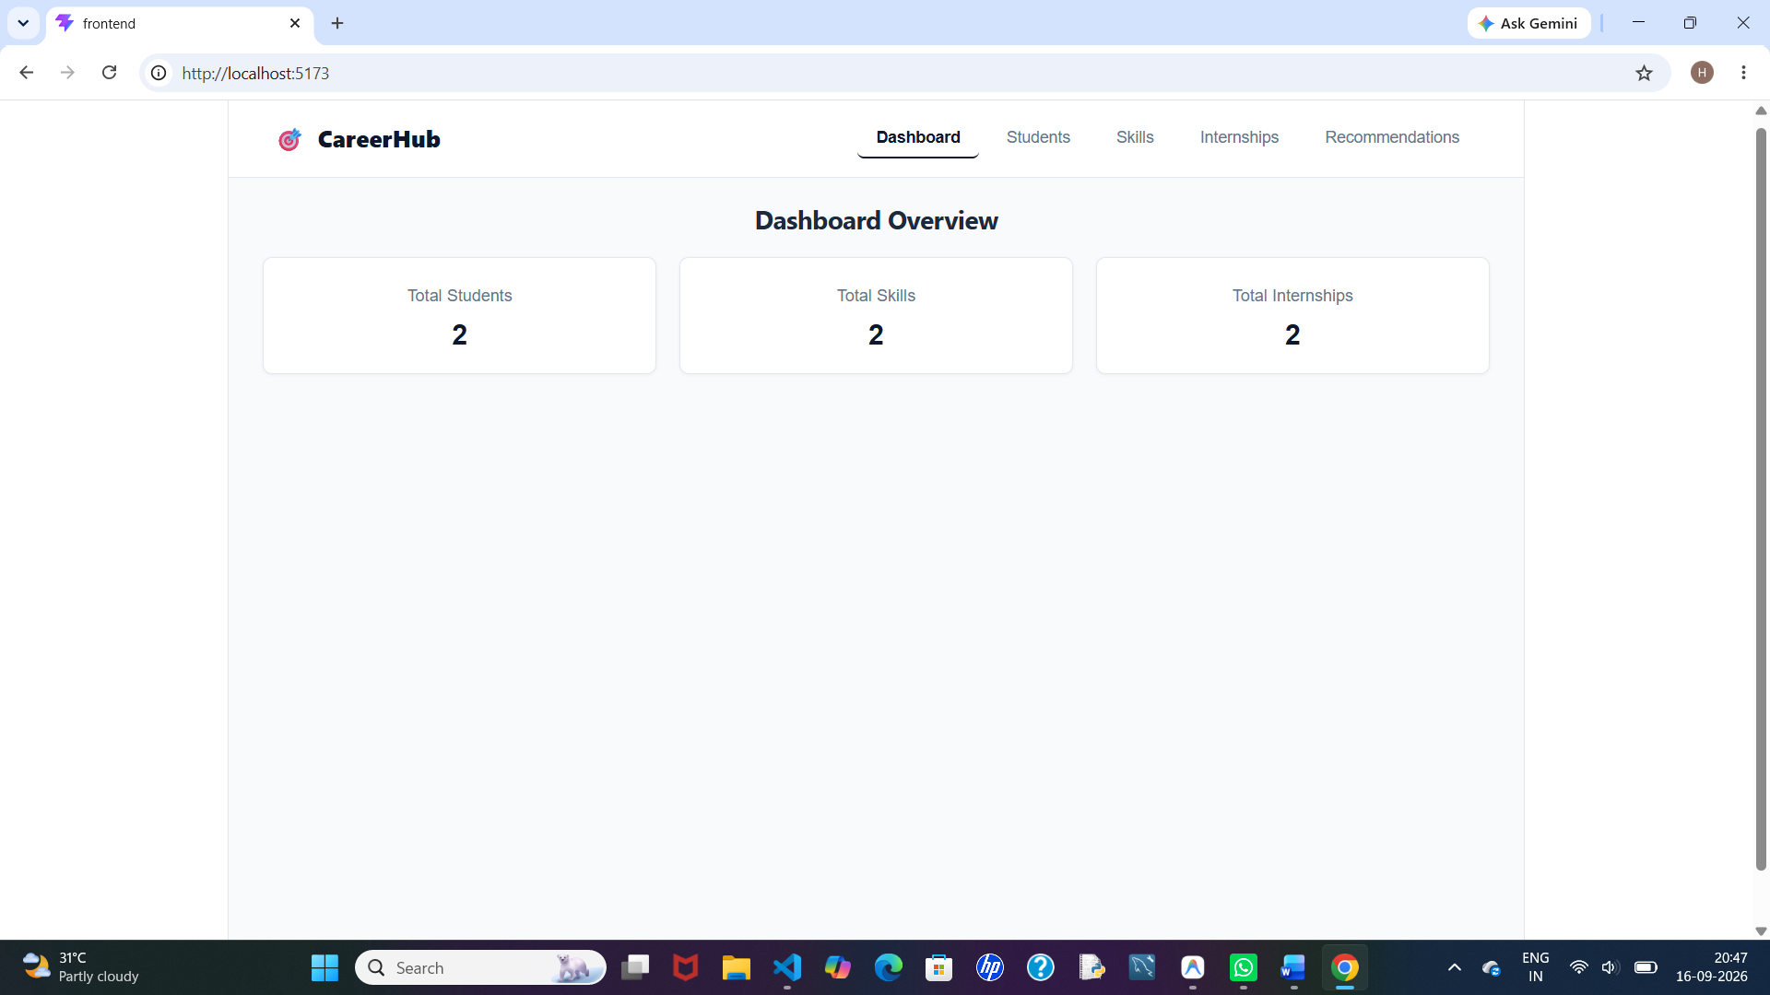
Create Record (Add New Student/Skill/Internship Modal)
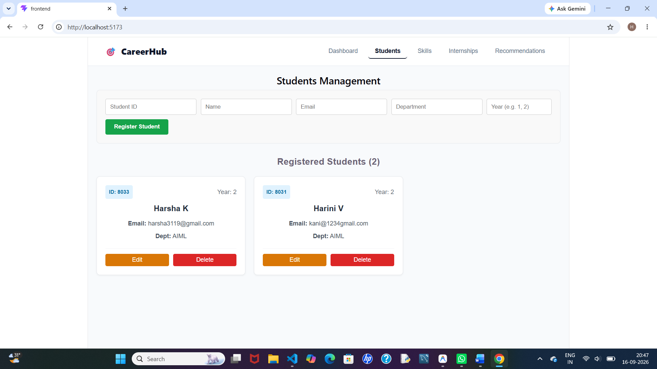

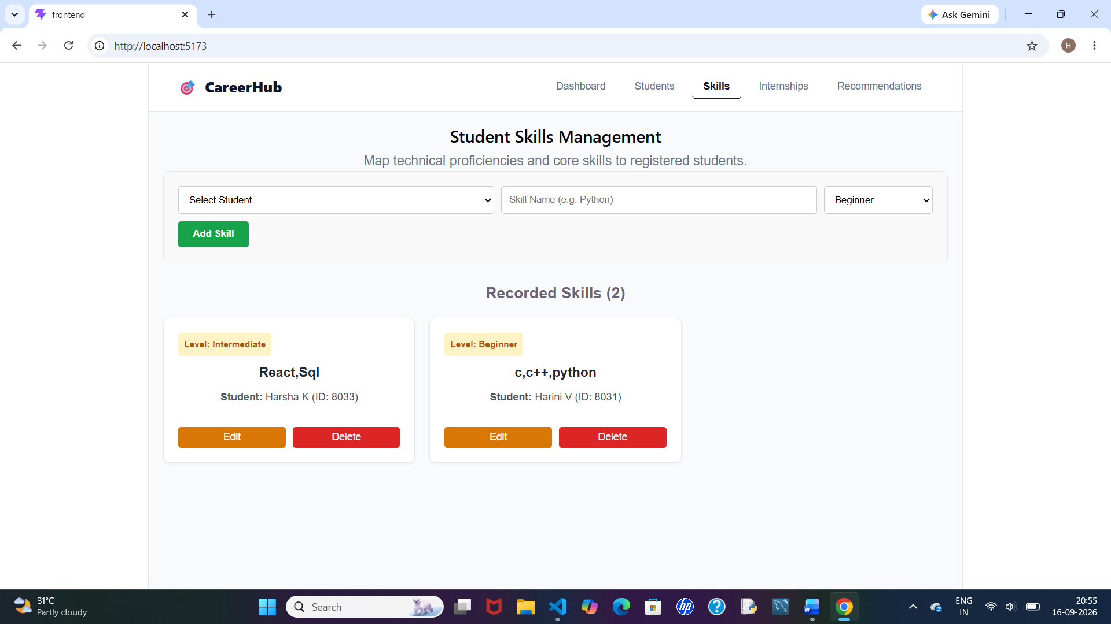

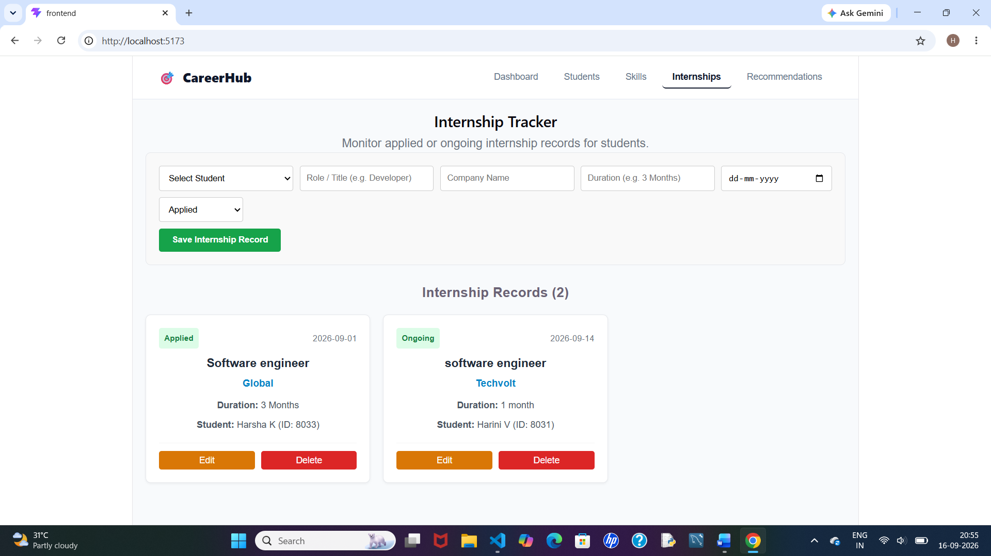
Dynamic Recommendation and Search Filtering
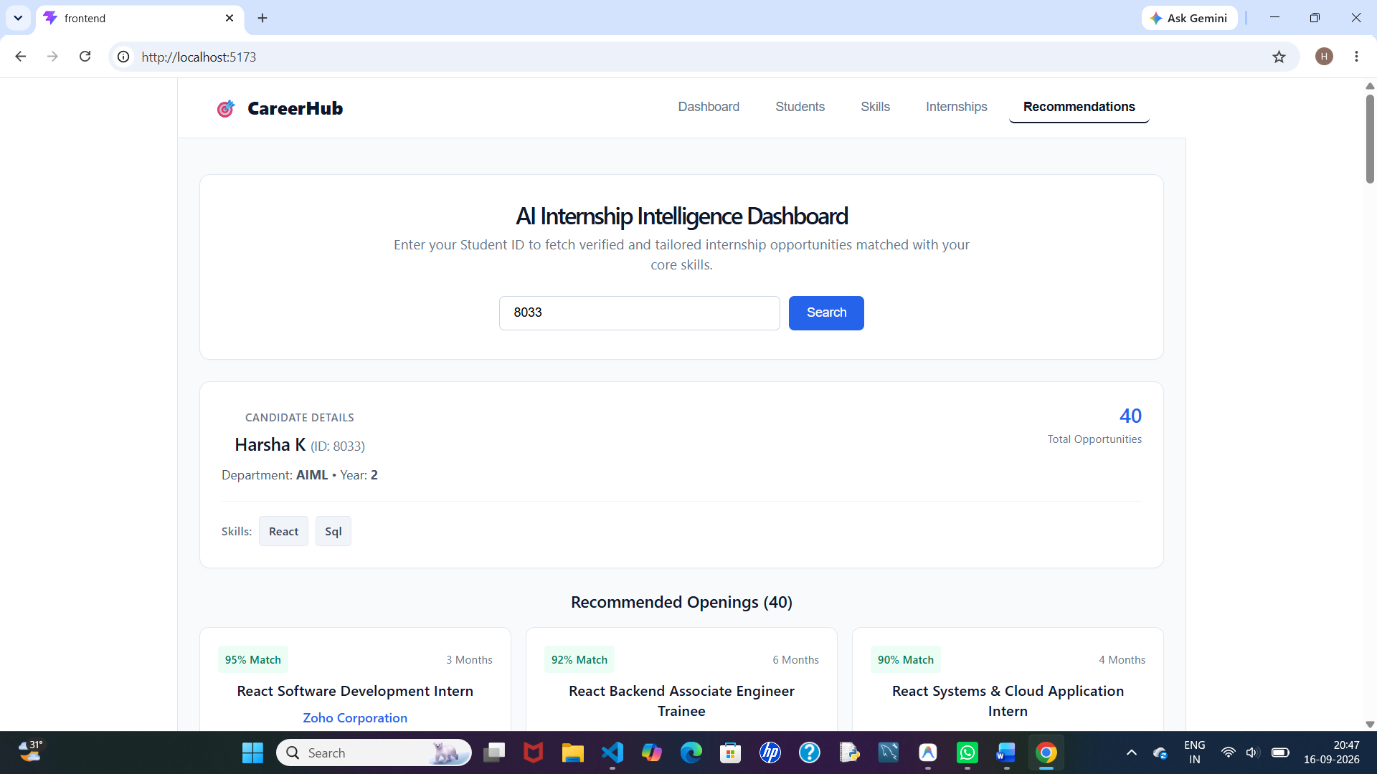

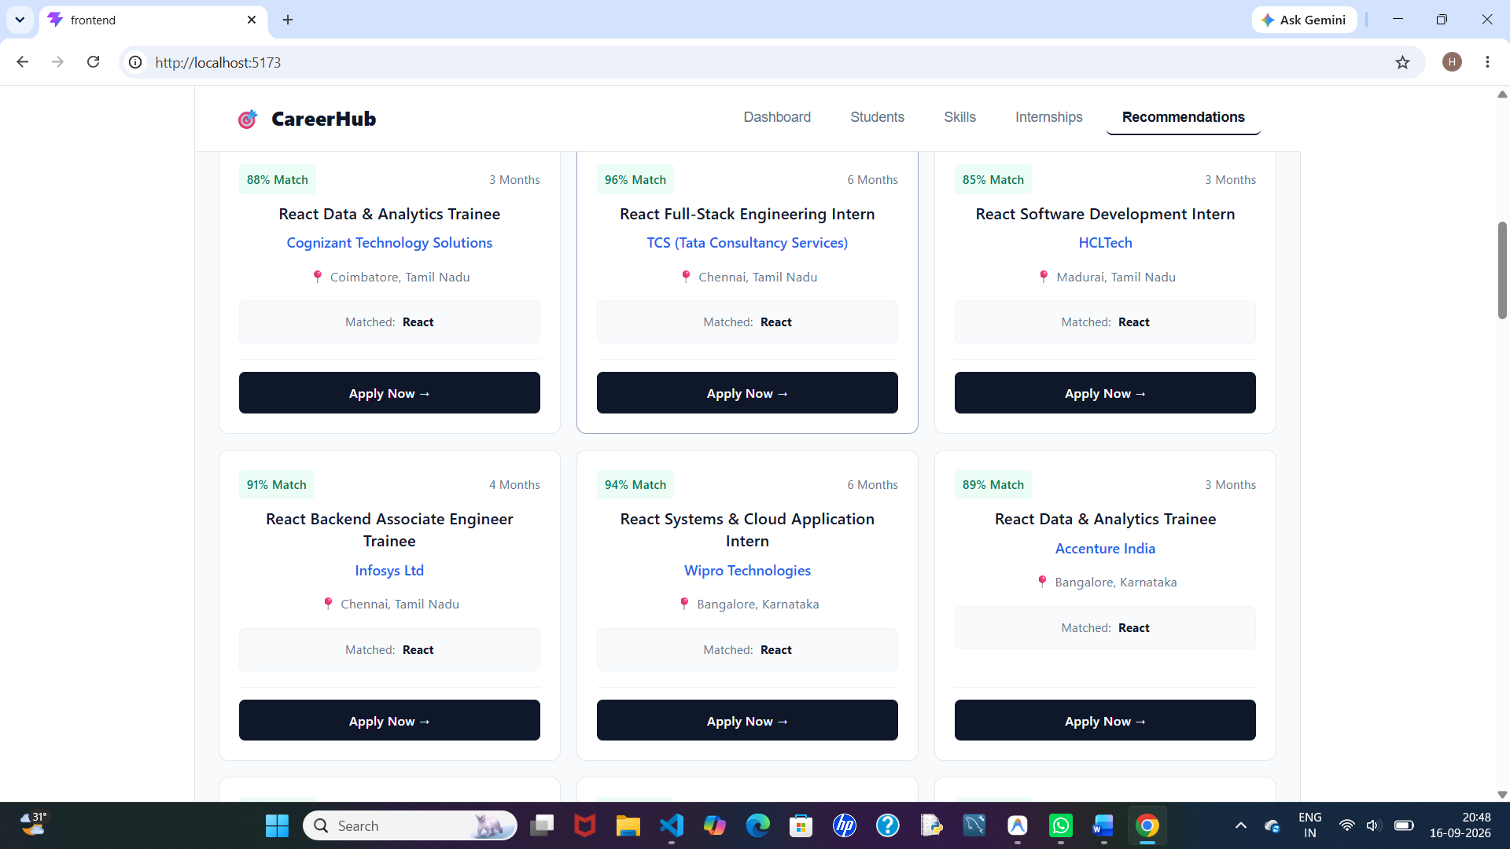

8. REST API Endpoint Documentation
Operation | HTTP Method | Endpoint URI | Request Body | Expected Result
Read All | GET | /api/students/ | None | Retrieves all student records
Read One | GET | /api/students/{id}/ | None | Retrieves a specific student
Create | POST | /api/students/ | JSON object | Creates a new record in SQLite DB
Update | PUT | /api/students/{id}/ | JSON object | Updates an existing student
Delete | DELETE | /api/students/{id}/ | None | Removes the student record
Recommend | GET | /api/recommend-internships/{id}/ | None | Returns multi-skill internship matches
9. CRUD Implementation Details
- Create (POST): Users enter details in the form. The frontend converts the data into JSON and sends a POST request to the API. The server saves the record and the interface updates.
- Read (GET): When the application loads, GET requests retrieve records. The returned JSON data is displayed through dynamic UI cards.
- Update (PUT): Clicking the Edit button loads the selected record into the form. Submitting the form sends a PUT request to update the backend record.
- Delete (DELETE): Clicking Delete asks for confirmation. After confirmation, a DELETE request removes the record from SQLite.
10. Testing Results and Verification
Test Case | Tested Action | Input Data | Expected Output | Status
TC-01 | Load Dashboard | Page Load | Fetch all records via GET endpoints | PASSED
TC-02 | Add Record | Valid Data | Save to DB and return 201 Created | PASSED
TC-03 | Missing Fields | Empty Form | Client-side validation stops submission | PASSED
TC-04 | Update Record | Edited Data | Database record updated and 200 OK | PASSED
TC-05 | Delete Record | Click Delete and Confirm | Record removed and 204 No Content | PASSED
API Response Verification (Django REST Framework)
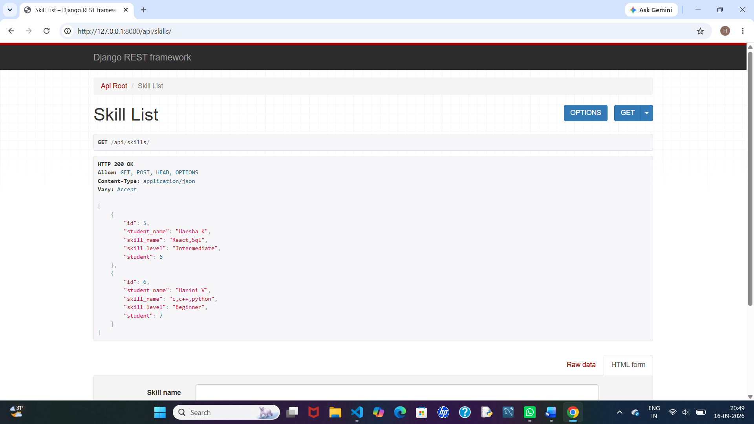
11. Installation and Execution Steps
Prerequisites:
- Python 3.10+ installed
- Node.js and npm installed
- Google Chrome or Microsoft Edge browser
Execution Steps:
- Open the backend directory in the terminal: cd backend
- Install Python dependencies: pip install django djangorestframework django-cors-headers
- Run database migrations: python manage.py migrate
- Start the Django development server: python manage.py runserver
- Open a new terminal and navigate to the frontend folder: cd frontend
- Install frontend packages: npm install
- Start Vite: npm run dev
12. Challenges and Solutions
CORS Blockage:
- Problem: The browser blocked JavaScript fetch() requests because the frontend and backend were running on different origins.
- Solution: Integrated django-cors-headers middleware and configured CORS settings in settings.py.
Real-Time UI Synchronization:
- Problem: Changes made through Create, Update, or Delete were not immediately visible without refreshing the browser.
- Solution: Used async/await fetch handlers and re-fetched the latest data after successful mutation requests.
13. Future Enhancements
- Machine Learning Integration: Implement TF-IDF or Cosine Similarity to calculate more precise job-description matches.
- Automated Resume Parsing: Allow students to upload PDF or Word resumes and automatically extract skills.
- Advanced Authentication and Roles: Integrate JWT-based secure login for students, recruiters, and administrators.
14. Git Repository and Reference Details
- Project Repository: https://github.com/harshakolandasamy/Smart-Internship-Skill-Intelligence
- Version Control Tool: Git and GitHub Web
- Primary Branch: main
- Commit History: Working source code committed and pushed to the remote repository.
- Compliance: Standard Operating Procedure (SOP) – Complete CRUD-Based Web Application Development Guidelines.

