**Document Status: Approved**

**List of Abbreviations**

DFD **D**ata **F**low **D**iagram

E-R **E**ntity **R**elationship

RS **R**equirement **S**pecification

**Table of Contents**

1. Introduction 3

1.1 Purpose 3

1.2 Scope 3

1.3 Definitions, Acronyms and Abbreviations 3

1.4 References 3

1.5 Coordinators 3

2. Software Requirements 3

2.1 Operational Requirements 3

2.2 Functional Requirements 4

2.3 User Interface Requirements 7

2.4 External Interface Requirements 18

3. Project Execution Related Requirements 18

3.1 Development Environment 18

Technologies to be used for development of the Application: 18

3.2 Design requirements 18

3.3 Coding requirements 18

3.4 Error handling requirements 18

3.5 Resource Requirements 18

Technologies to be used for development of the Application: 18

3.6 Risk management 18

3.7 Training Requirements 18

4. Testing Requirements 18

5. Quality Assurance Activities 19

6. Software Acceptance Criteria 19

7. Deliverables 19

7.1 List of Deliverables 19

7.2 Delivery 19

8. Requirements Acceptance Statement 19

# Introduction

## Purpose

This Project Aims at developing a Pharmacy Management System, which needs to manage transactions based on the requirements, which includes managing the inventory in the warehouse and keeping a check on the medicines sold and medicines in the stock. This Project also includes raising Invoices to the Retailers and billing to the patients who purchase the Medicines.

This automated system should support them in properly delivering the medicines on time for the patients without making them to wait for longer period

## Scope

The Scope of the project is limited to Admin operations, Admin InCharge operations and Patient Operations.

**Admin:**- Admin handles the medicines in inventory and manages the stock up to date.

**InCharge:**- Accept the Orders from patients and Delivers the Medicines on Time, Updates the Stock data

**Patient:**- Can Register themselves and order the Medicines, keep track of ordered Items and access the Bills related to Medicines

## Definitions, Acronyms and Abbreviations

Admin: - Owner the Pharmacy, Manage the Business operations related to stocks

InCharge :- Responsible for accepting the orders and Delivering Medicines on time.

Patient:- User of this application, can order Medicines and track the Status of order.

## References

## Coordinators

# Software Requirements

## Operational Requirements

Registration UI:

* Requirement 1: The Registration UI Should Provide secure signup functionality to register patients
* Requirement 2: The Registration UI should also provide a Login Page to securely authenticate users/patients and redirect them to Patient UI pages.

Patient/User UI:

* Requirement 1: The Patient Homepage UI should Provide a List of All medicines Available on Inventory.
* Requirement 2: It Should provide an Option to add the Medicines to the cart and place the Order.
* Requirement 3: The Patient UI should provide an option to track the Status of Ordered Items
* Requirement 4: the Patient UI also provides an Option to access Bills according to the Orders.

InCharge UI:

* Requirement 1: The InCharge UI also provides Option to View the List of Medicines available in the Stock
* Requirement2: The InCharge UI also provides Option to view and accept the Orders from the patient
* Requirement 3: The InCharge UI also provides Option to Generate Bill to various Options based on Medicines availability in the Stock
* Requirement 4: The InCharge UI also Supports Updating of Medicines according to the Orders received.

Admin UI:

* Requirement 1: The Admin UI provides List of Medicines available in the Stock
* Requirement 2: It provides an Option to Place a order for New Medicines from Retailers
* Requirement 3: The Admin UI also provides an Option to generate Bills based on Items Ordered.
* Requirement 4: It also provides an option to add a new scheme for medicines.

## Functional Requirements

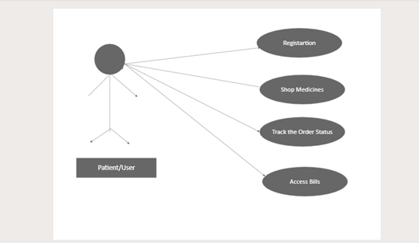

*FIGURE 2.2.1 PATIENT USE CASE DIAGRAM FOR PHARMACY MANAGEMENT SYSTEM*

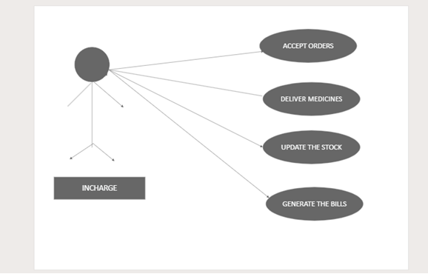

*FIGURE 2.2.2 INCHARGE USE CASE DIAGRAM FOR PHARMACY MANAGEMENT SYSTEM*

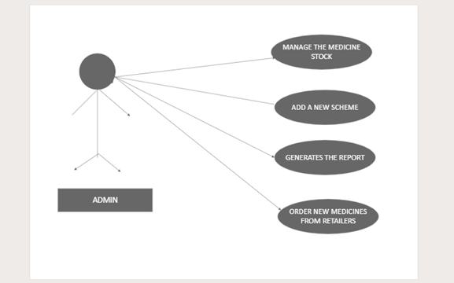

*FIGURE 2.2.3 ADMIN USE CASE DIAGRAM FOR PHARMACY MANAGEMENT SYSTEM*

***New Vehicle Registration***

|  |  |  |
| --- | --- | --- |
| Requirement Tag ID | *RS-1-1* | |
| *Source/Trigger* | *Registarton UI* | |
| *Description* | *Input* | *Email and Password* |
| *Process* | *The system verifies the entered credentials against stored User credentials and grants access if valid* |
| *Output* | *On Successful authentication and access to the Patient Home Page UI.* |
| *Validation Method* | *Verify the correctness of patient credentials, authenticate against stored data, and handle incorrect login attempts.* | |

|  |  |  |
| --- | --- | --- |
| Requirement Tag ID | *RS-1-2* | |
| *Source/Trigger* | *Patient UI - Add Medicines to cart and place order* | |
| *Description* | *Input* | *List of Medicines available in inventory Stock* |
| *Process* | *Patient/user can choose wide range of medicines available in the stock and add them into cart. To proceed to place and order* |
| *output* | *Indication of successfully addition of Order into the order Details* |
| *Validation Method* | *Ensures that the required quantity of medicines entered and placed the order successfully.* | |

|  |  |  |
| --- | --- | --- |
| Requirement Tag ID | *RS-1-3* | |
| *Source/Trigger* | *Patient UI - View the Order Details and access the Bills* | |
| *Description* | *Input* | *Patient Login credentials are enough* |
| *Process* | *Upon successful placement of order, patient can access the list of orders and delivery status and also expected date of delivery along with total bill* |
| *output* | *Display the List of orders placed by a particular user and provide essential information about the orders.* |
| *Validation Method* | *InCharge Ensures that all ordered medicines are available in stock and generates a bill and starts the delivery process.* | |

|  |  |  |
| --- | --- | --- |
| Requirement Tag ID | *RS-1-4* | |
| *Source/Trigger* | *InCharge UI - Home Page* | |
| *Description* | *input* | *InCharge Login credentials [Email and Password]* |
| *Process* | *Upon successful login the system shows the list of medicines available in the stock and an option to update the Stock. Along with Orders received from patients* |
| *output* | *can accept the orders and update the stock details.* |
| *Validation Method* | *based on order details InCharge can generate bills and update the stock by validating against the orders* | |

|  |  |  |
| --- | --- | --- |
| Requirement Tag ID | *RS-1-5* | |
| *Source/Trigger* | *InCharge UI - Accept the Orders* | |
| *Description* | *input* | *Orders received from the patients* |
| *process* | *InCharge should cross check with available medicines and ordered medicines, then generate bill accordingly* |
| *output* | *Confirmation of delivery and change in the status of orders in patient UI.* |
| *Validation Method* | *validate the stocks and also orders from the patients and accept the orders accordingly.* | |

|  |  |  |
| --- | --- | --- |
| Requirement Tag ID | *RS-1-6* | |
| *Source/Trigger* | *InCharge UI - Update the Stock Details* | |
| *Description* | *Input* | *completed orders from orders page* |
| *Process* | *InCharge should update the stock details upon successful delivery of Order* |
| *Output* | *Change the amount of stock available in stocks* |
| *Validation Method* |  | |

|  |  |  |
| --- | --- | --- |
| Requirement Tag ID | *RS-1-7* | |
| *Source/Trigger* | *Admin UI - Home page UI* | |
| *Description* | *Input* | *Admin Credentials in Enough to Login* |
| *Process* | *Upon successful login Admin can see a set of details like available stock, yet to completed stock, completed stock.* |
| *Output* | *Provides option to order new medicines from retailers and an option to generate bills, adding a new scheme* |
| *Validation Method* | *Validate the credentials and provide all stock inventory data.* | |

|  |  |  |
| --- | --- | --- |
| Requirement Tag ID | *RS-1-8* | |
| *Source/Trigger* | *Admin UI - Order Medicines Page UI* | |
| *Description* | *Input* | *Admin Credentials are enough* |
| *Process* | *Admin can order new medicines from retailers which are required, based on the stock existing.* |
| *Output* | *Confirmation of order, admin can be able to generate an invoice related to a particular order.* |
| *Validation Method* | *Validate all required fields and generate the invoice upon successful placement of order.* | |

|  |  |  |
| --- | --- | --- |
| Requirement Tag ID | *RS-1-9* | |
| *Source/Trigger* | *Admin UI - Add a New Scheme Page UI* | |
| *Description* | *Input* | *Admin credentials is Enough* |
| *Process* | *Admin can add a new scheme and choose the medicines this scheme should apply for and submit the details* |
| *Output* | *Upon successful submission of Scheme medicines data will be changed.* |
| *Validation Method* | *validates all required fields and verify the Details.* | |

## User Interface Requirements

Login UI :

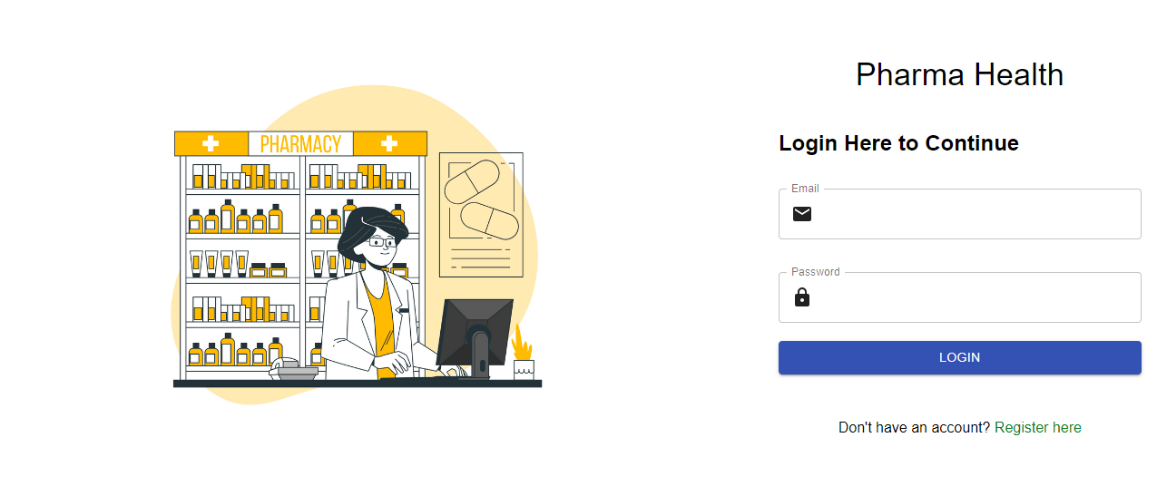

Registration UI:

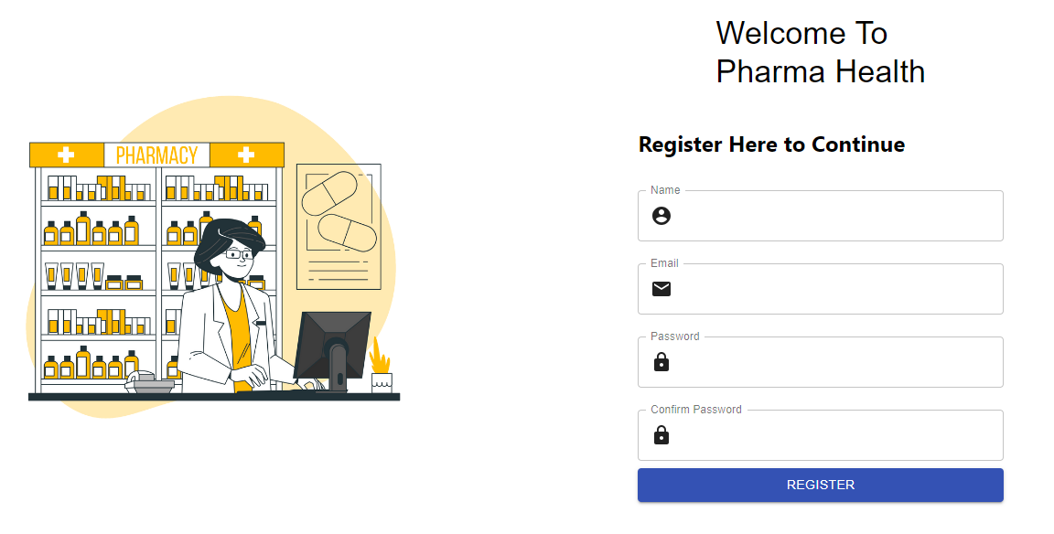

Admin Home UI:

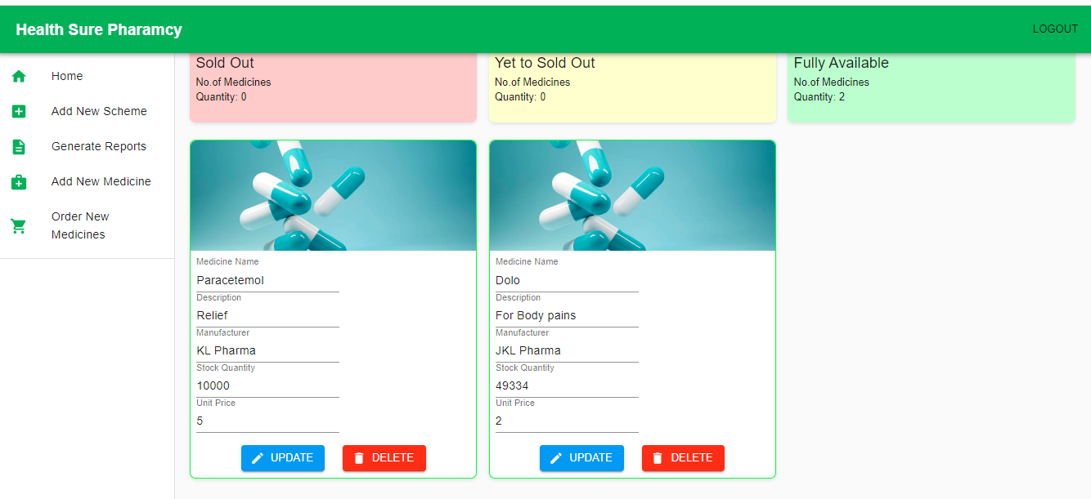

Admin Add New Scheme UI:

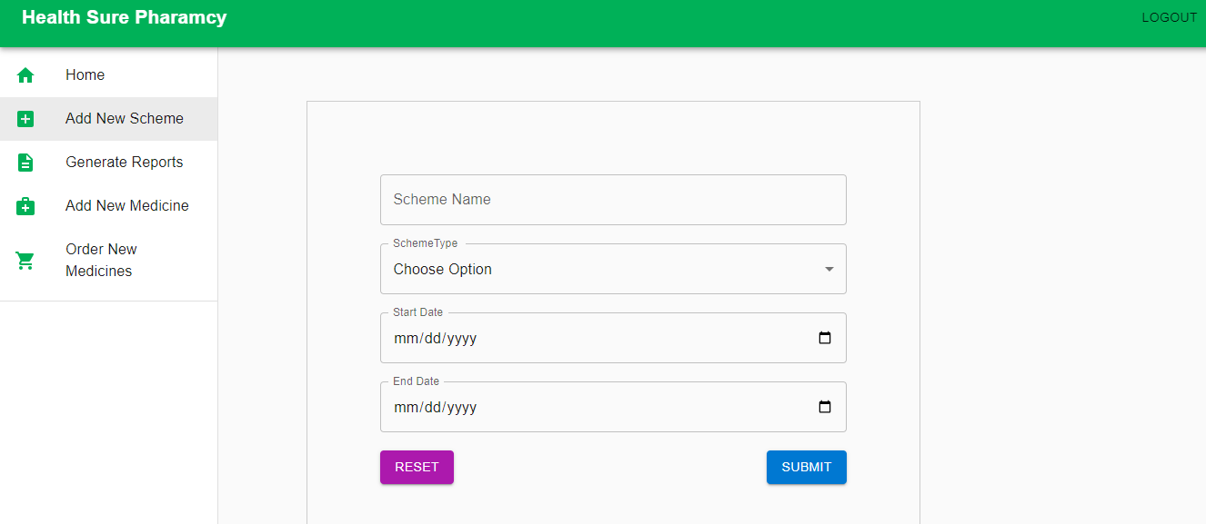

Admin Generate Reports UI:

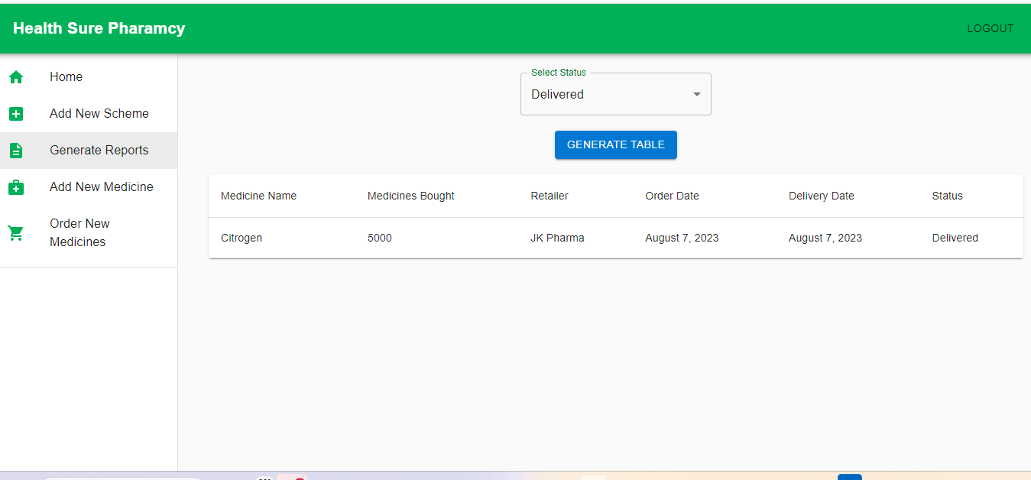

Admin Add New Medicine UI

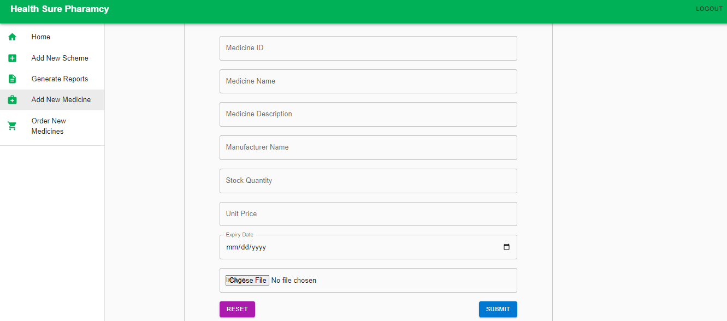

Admin Order New Medicines UI

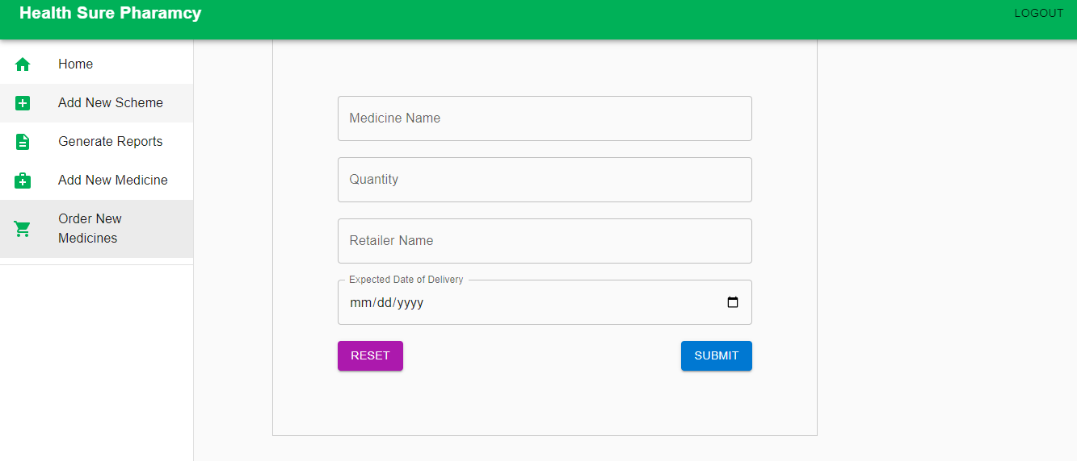

InCharge Home Page UI

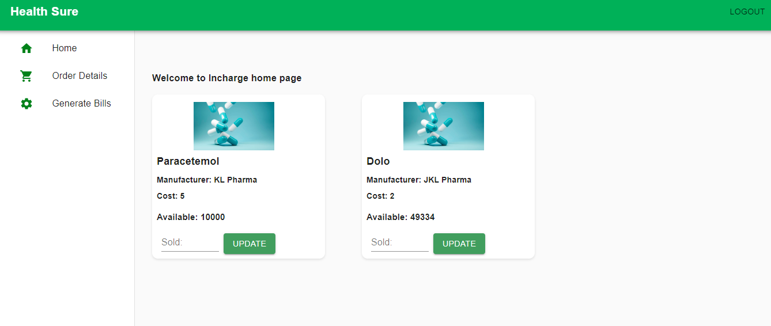

InCharge Order Details Page UI

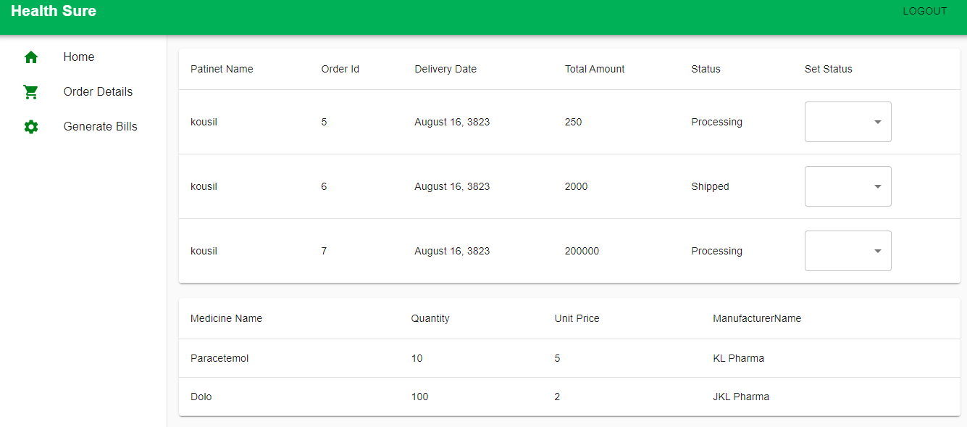

InCharge Generate Bills Page UI:

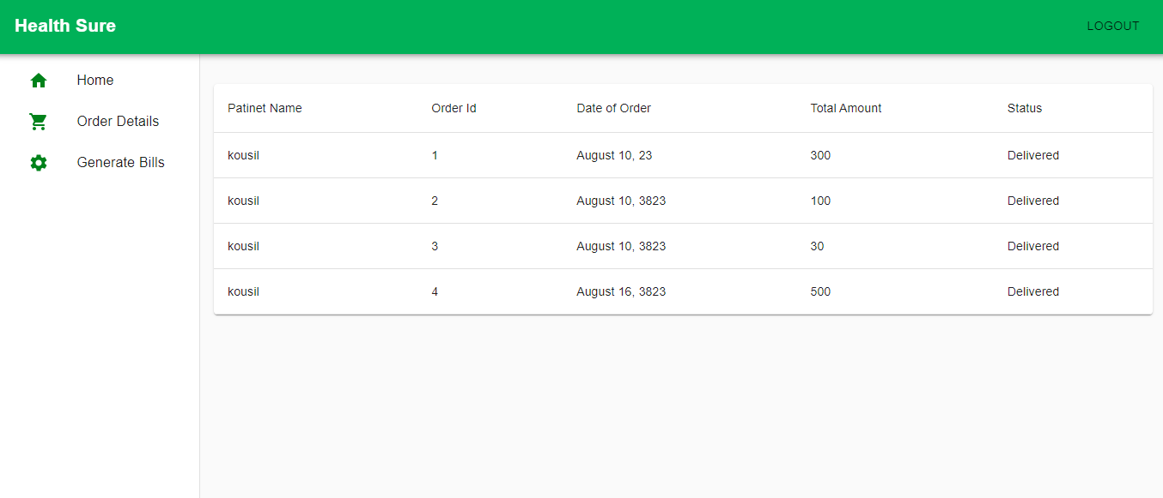

Patient Home Page UI:

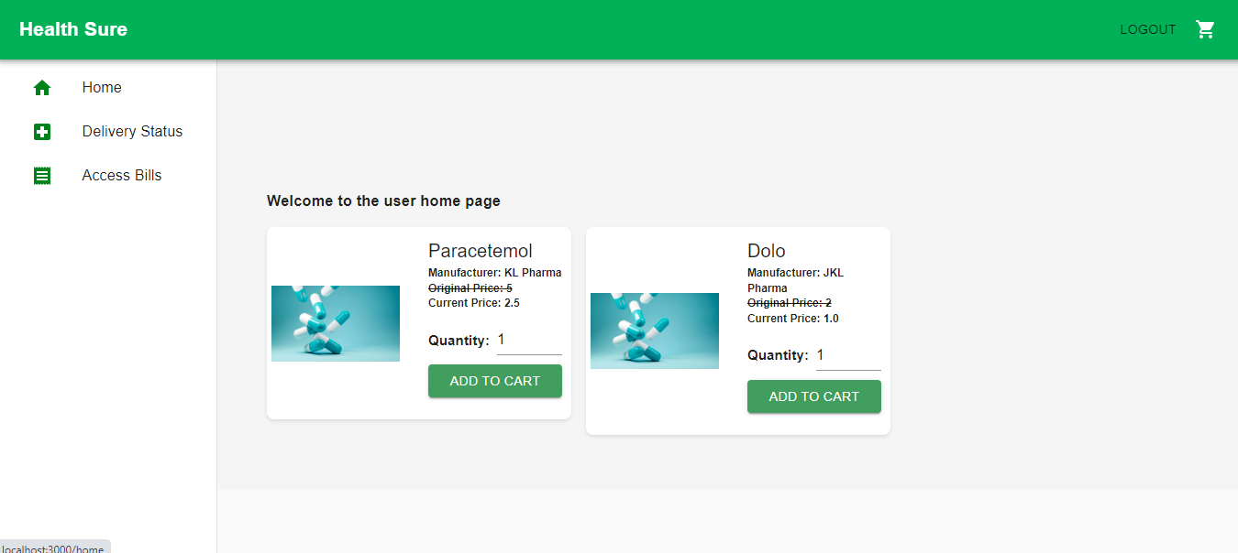

Patient Delivery Status Page UI:

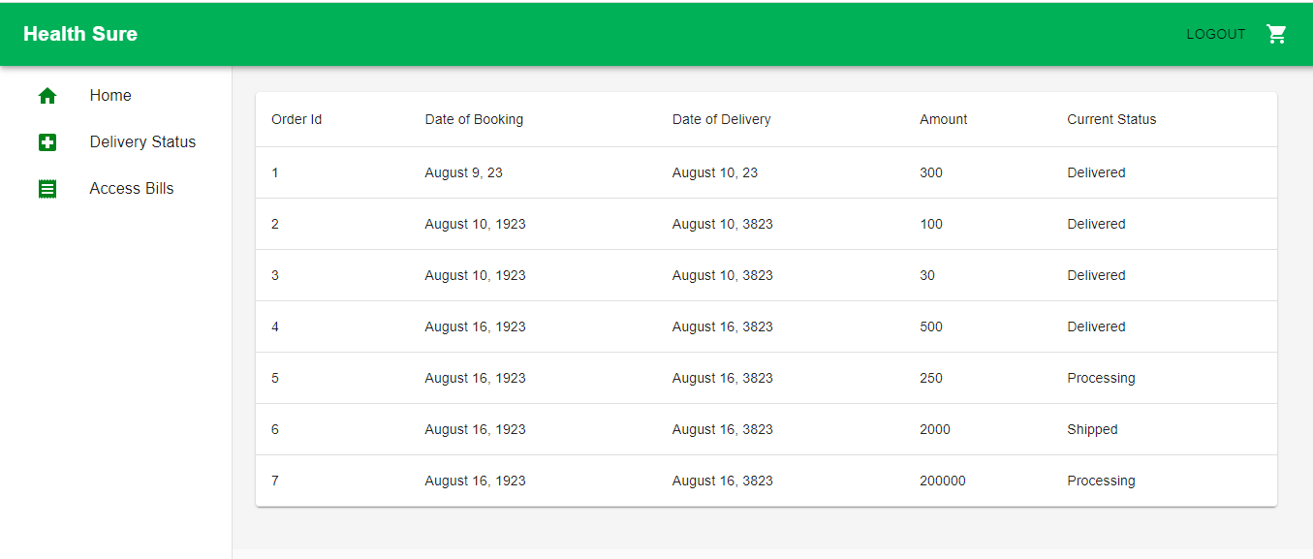

Patient Access Bills Page UI:

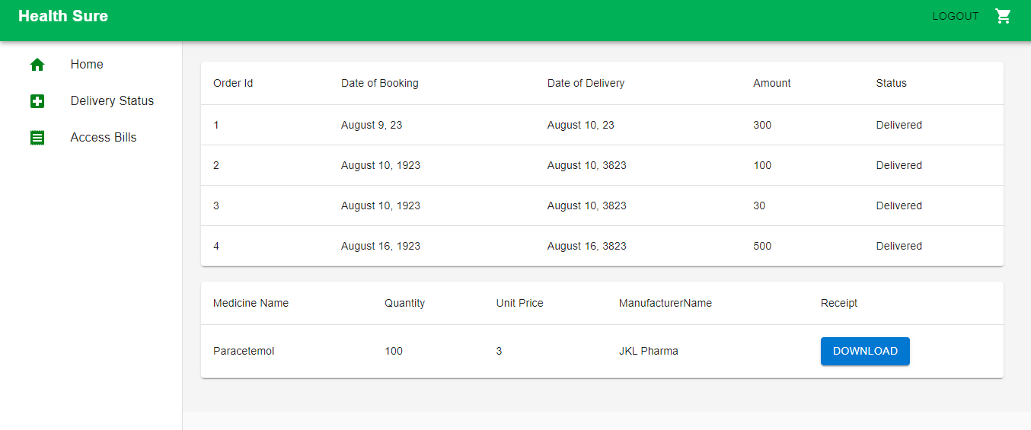

Patient Cart Page UI

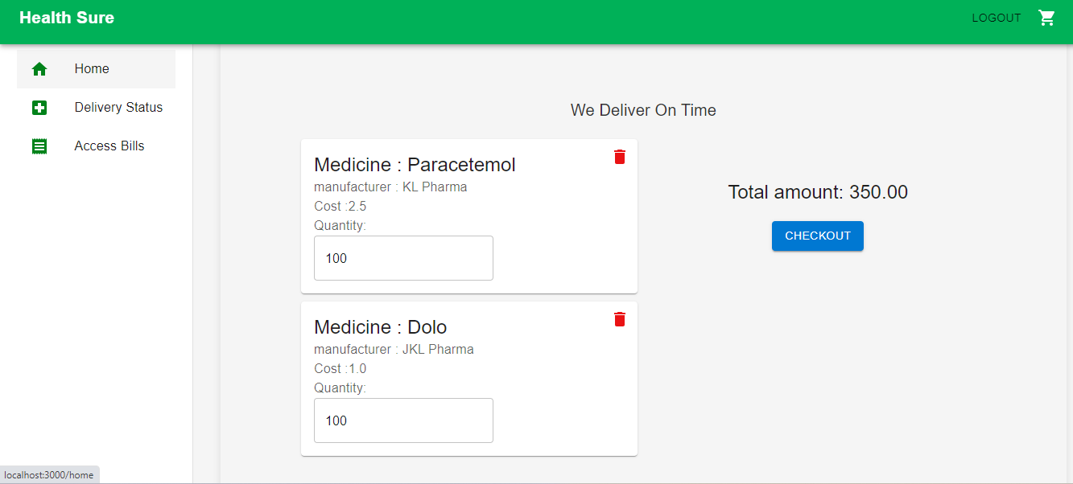

## External Interface Requirements

NA

# Project Execution Related Requirements

## Development Environment

## Technologies to be used for development of the Application:

* React JS
* Material UI
* Axios
* Java Script, HTML, CSS

Software tools that can be used for development:

* VS Code
* STS (Spring tool Suite).

## Design requirements

## Coding requirements

Since, entire application is being coded in React Js, Material Ui, Axios, JavaScript, Java, Spring and Microservice are certainly applicable here.

## Error handling requirements

## Resource Requirements

## Technologies to be used for development of the Application:

* React JS
* Material UI
* Axios
* Java Script, HTML, CSS

## Training Requirements

* Since the application being developed is greatly dependent on user interaction, the end user should be comfortable with GUI.
* End user should be given a walkthrough of the working of the entire application alone. Training should be provided with respect to efficient GUI usage.

# Testing Requirements

# Quality Assurance Activities

# Software Acceptance Criteria

# Deliverables

## List of Deliverables

UI Screen for: -

* Admin Module
* Add Medicine Module
* Order New Medicine Module
* Generate Reports Module.
* Add A scheme Module.
* List of Orders Module
* Order Bill generation module.
* Order new Medicines Module
* Track the Order Module
* Access Bills Module.

## Delivery

Delivered Front end design UI screens of Whole Pharmacy management application.

# **Requirements Acceptance Statement**

Requirements Acceptance statement consists of agreement to the above-mentioned requirement by the customer & supplier