**Measuring the Pulse of Prosperity:  
An Index of Economic Freedom Analysis**

### ****Abstract****

Economic freedom is a key indicator of a country's prosperity, reflecting the openness of its markets, regulatory efficiency, and individual liberty in economic activities. This project, titled **"Measuring the Pulse of Prosperity: An Index of Economic Freedom Analysis"**, aims to visualize and analyze economic freedom data across various countries using **Tableau Public**. The project presents an interactive dashboard that includes factors such as business freedom, trade openness, government integrity, and regulatory efficiency. The insights obtained from the visualizations help understand the relationship between economic freedom and national prosperity. This project serves as a useful tool for policymakers, economists, students, and analysts to compare, explore, and interpret how different economies perform and what influences their ranking on the economic freedom index.

### ****Keywords****

Economic Freedom, Tableau, Prosperity Index, Business Freedom, Trade Openness, Government Spending, Economic Growth, Data Visualization, Country Comparison, Policy Analysis.

### ****Introduction****

In today’s globalized economy, the concept of **economic freedom** plays a vital role in shaping national development and individual opportunities. Economic freedom is defined by the ability of individuals and businesses to operate and compete in an open market with minimal government intervention. Various global organizations, such as the Heritage Foundation and Fraser Institute, publish annual indexes that rank countries based on how free their economies are.

This project focuses on analyzing and visualizing the **Index of Economic Freedom** using **Tableau**, a powerful data visualization tool. The dataset includes metrics like property rights, judicial effectiveness, government size, fiscal health, monetary freedom, and labor freedom. By using visual storytelling, the project brings life to raw data and makes it easier to understand global economic patterns and policy impacts.

Through this project, users can interact with dashboards to explore trends, draw comparisons between countries, and evaluate how specific indicators affect the overall economic freedom score. The visual analysis also offers a deep understanding of which regions excel in economic liberty and where improvements are needed.

**Problem Statement**

While many organizations publish detailed reports on economic freedom, these are often lengthy and difficult for students, policymakers, and the general public to interpret quickly. Raw datasets and tabular formats do not provide the intuitive understanding necessary to grasp complex relationships between multiple economic indicators.

The key challenges are:

**Data Complexity**: Multiple indicators across numerous countries with varying data formats.

**Lack of Interactive Tools**: Static reports fail to allow real-time exploration or filtering.

**Understanding Cause-Effect**: It is difficult to visually correlate how certain freedoms influence economic performance or prosperity.

Hence, the problem is to create a **simple, interactive, and visual platform** using Tableau that:

1.Visualizes economic freedom across countries and regions.

2.Identifies key indicators that contribute most to economic prosperity.

3.Enables users to easily compare, analyze, and interpret data through interactive dashboards.

# Pre-requisites

• Basic understanding of data analytics and visualization concepts.  
• Familiarity with spreadsheet tools (e.g., Excel or Google Sheets).  
• Internet connection and access to Tableau Public account.  
• Tableau Desktop Public Edition installed on the system.

# Prior Knowledge

• Explore economic freedom indices across countries or regions.  
• Visualize the patterns of economic development using Tableau.  
• Gain hands-on experience with Tableau dashboards.  
• Draw meaningful insights using data storytelling techniques.

# Project Flow

1. Data Collection: Gather or download datasets containing economic indicators.  
2. Data Preparation: Understand and clean the dataset.  
3. Importing: Load the dataset into Tableau Public.  
4. Visualization: Create different visual charts using dimensions and measures.  
5. Dashboard & Storyboard: Combine charts into dashboards and build a story.  
6. Publishing: Save and publish the dashboard to Tableau Public.

# Insights & Observations

• Countries with higher economic freedom show better GDP and development.  
• Trade openness and low regulation positively influence growth.  
• Government spending and policy restrictions impact economic ranking.  
• Storytelling through dashboards enhances interpretability of data.

Result

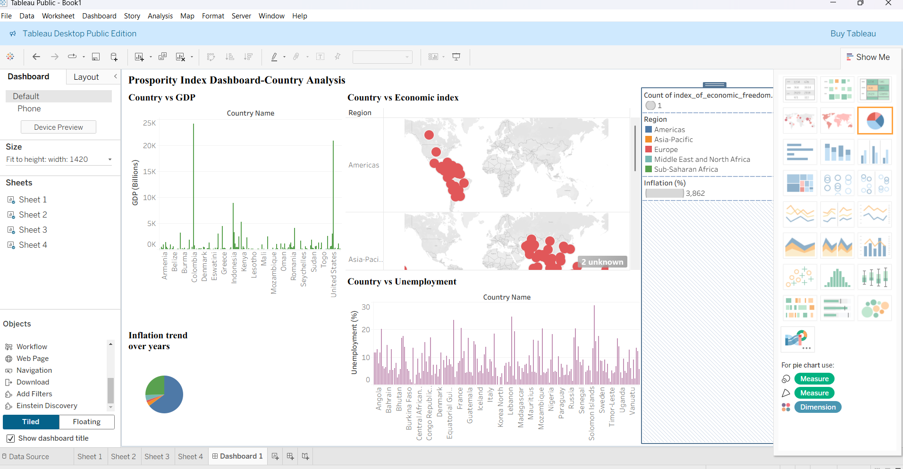

# Screenshot 2025-07-06 231030

# Screenshot 2025-07-06 231116

# Conclusion

This project gave a comprehensive understanding of economic freedom across various regions. By utilizing Tableau, we learned how to extract, visualize, and present data in an engaging and informative way. It has improved our analytical and visualization skills.

# Scope for Future Work

• Year-wise comparison of freedom index.  
• Integration with human development and employment indices.  
• Cluster-based region analysis.  
• Predictive modeling using economic indicators.

**Tableau Link**

[Prospority Index Dashboard-Country Analysis | Tableau Public](https://public.tableau.com/app/profile/kodela.sri.harsha/viz/ProsporityIndexDashboard-CountryAnalysis/Sheet1?publish=yes)