


Jagan Institute of Management Studies
(Affiliated to Guru Gobind Singh Indraprastha University)

PROJECT REPORT

ON

Society Subscription Management

Submitted in partial fulfillment of the requirement for the award of the degree of

Master of Computer Application
(Batch: 2024-2026)

Submitted By:

Name : Tanay Singh Parihar

Enrollment No : 00614004424

CERTIFICATE

This is to certify that the project report entitled “Society Subscription Management” submitted to Jagan Institute of Management Studies in partial fulfilment of the requirement for the award of the degree of MASTER OF COMPUTER APPLICATIONS (MCA) is an original work carried out by Mr. Tanay Singh Parihar, enrolment number 00614004424 under my guidance. The matter embodied in this project is authentic and is genuine work done by the student and has not been submitted whether to this University or to any other University / Institute for the fulfilment of the requirement of any course of study.

Signature of the Student:
Date: ...........................

Tanay Singh Parihar
00614004424

Signature of the Project Coordinator Date: ...........................

Prof. Manjot Kaur Bhatia
Department of IT
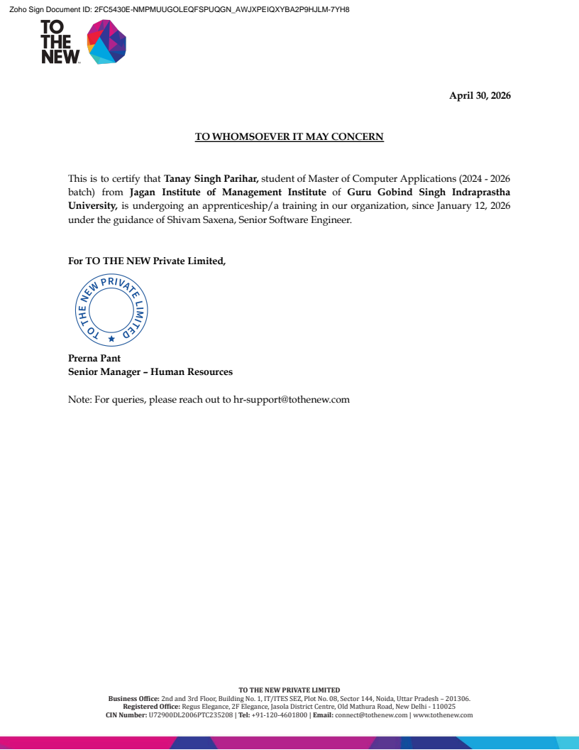

ACKNOWLEDGEMENT

I take this opportunity to present my votes of thanks to all the people who have guided and supported me throughout the execution of this project, which has led to the successful and satisfactory completion of the Society Subscription Management System.
I feel a great sense of gratitude towards my project guide, whose constant guidance, motivation, and encouragement made this work possible. Their valuable insights and constructive feedback at every stage of development were instrumental in shaping this project.
I would also like to express my sincere thanks to the Head of Department and all the faculty members of the Department of Information Technology for their time-to-time guidance and for providing the necessary resources and infrastructure to carry out this project.
I am thankful to the lab personnel for providing technical assistance and fulfilling the requirements for the completion of this project. This project would not have been completed without their support.
Finally, I express my heartfelt gratitude to my family and friends for their unwavering support and encouragement throughout this journey.

Student Name : Tanay Singh Parihar
Enrolment No.: 00614004424

ABSTRACT

The Society Subscription Management System is a comprehensive, full-stack web application designed to digitize and streamline the management of residential housing societies. The system provides a centralized platform for two key stakeholders — Administrators (Society Management) and Residents (Flat Owners/Tenants) — to interact with society operations through role-specific dashboards and workflows.

Administrators can manage flats and resident assignments, create and version subscription plans, generate automated monthly billing cycles, record payments through multiple modes (cash/UPI/online), view comprehensive financial reports with data visualization, and send targeted notifications to residents via Firebase Cloud Messaging. Residents can register securely, view current and historical dues, make online payments through a simulated gateway, download payment receipts, receive real-time notifications, and manage their profile information.

On the technical side, the system follows a three-tier architecture with clear separation of concerns. The frontend is built with Next.js 14+ using React 18, TypeScript for type safety, and Tailwind CSS for responsive styling with dedicated Admin and Resident portals. The backend uses Node.js with Express.js, implementing RESTful API design with JWT and Google OAuth 2.0 authentication. The data layer employs PostgreSQL with ACID-compliant transactions, automated migrations, and comprehensive constraints including UNIQUE, CHECK, and FOREIGN KEY validations.

Built with a user-centric design and robust backend, the Society Subscription Management System modernizes traditional society management methods and reduces manual coordination workload. It offers a scalable, secure, and reliable solution for residential communities seeking to automate billing, enhance transparency, and improve resident experience through digital transformation.

