NoSQL

**KUNCHALA HARSHA VARDHAN**

1. **Import `travel-sample` bucket:**

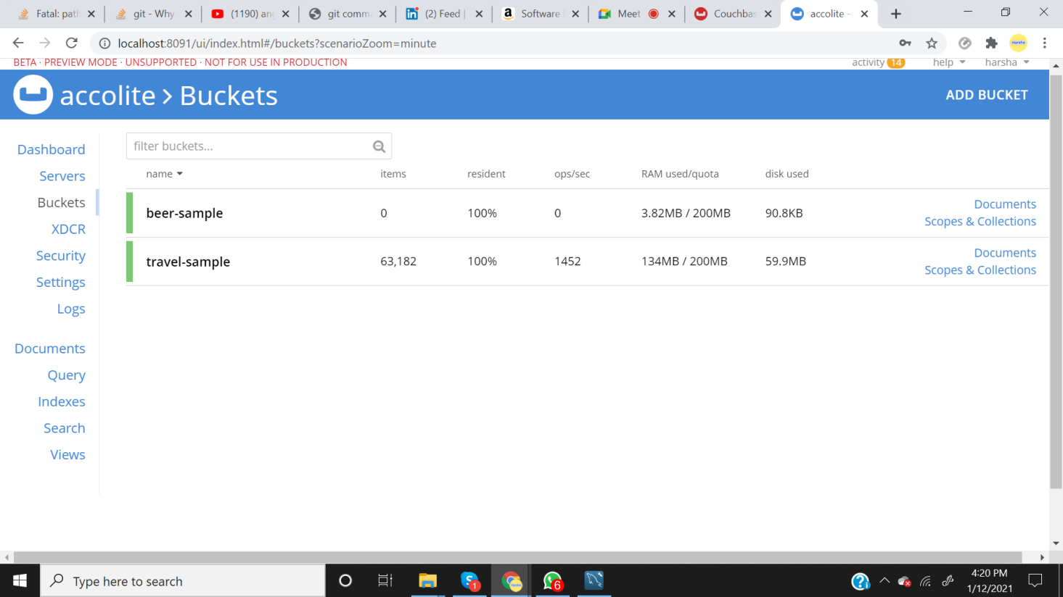

1. **Write a query to get the sum of all distances where type=”route” for each airline id:**

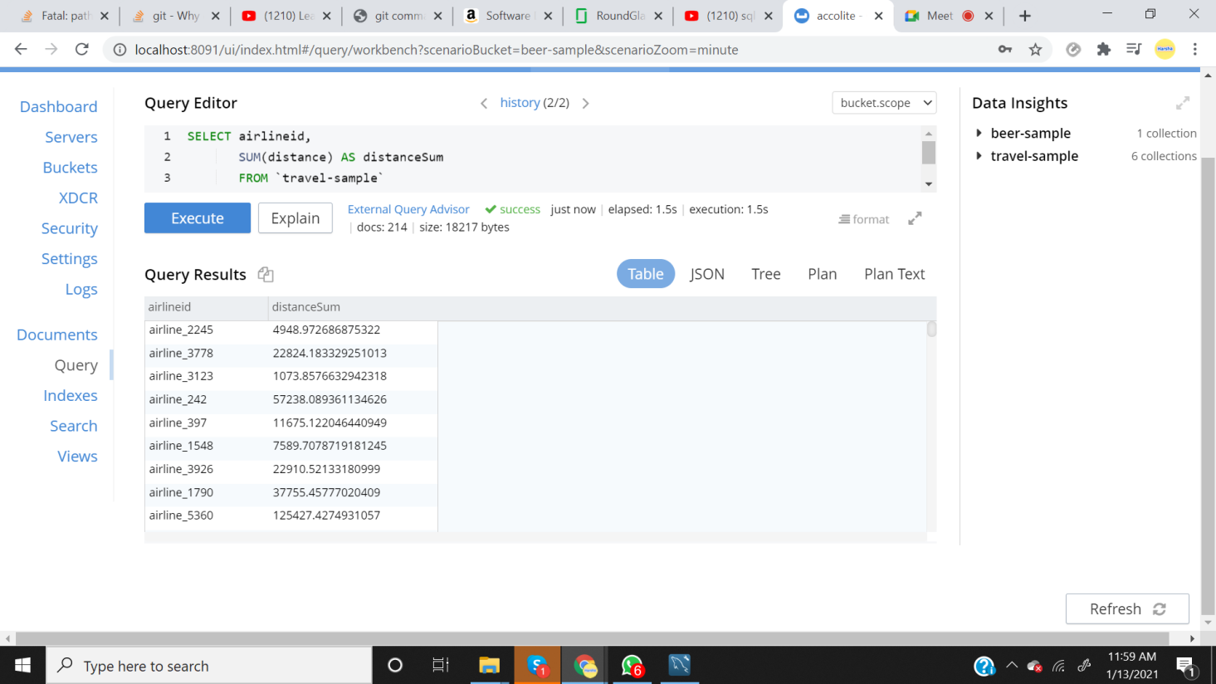

1. **Write queries to join(LEFT,RIGHT,INNER) type=”route”&amp;“airline” and fetch the data whose sourceairport=”SFO”:**

INNER JOIN:

"

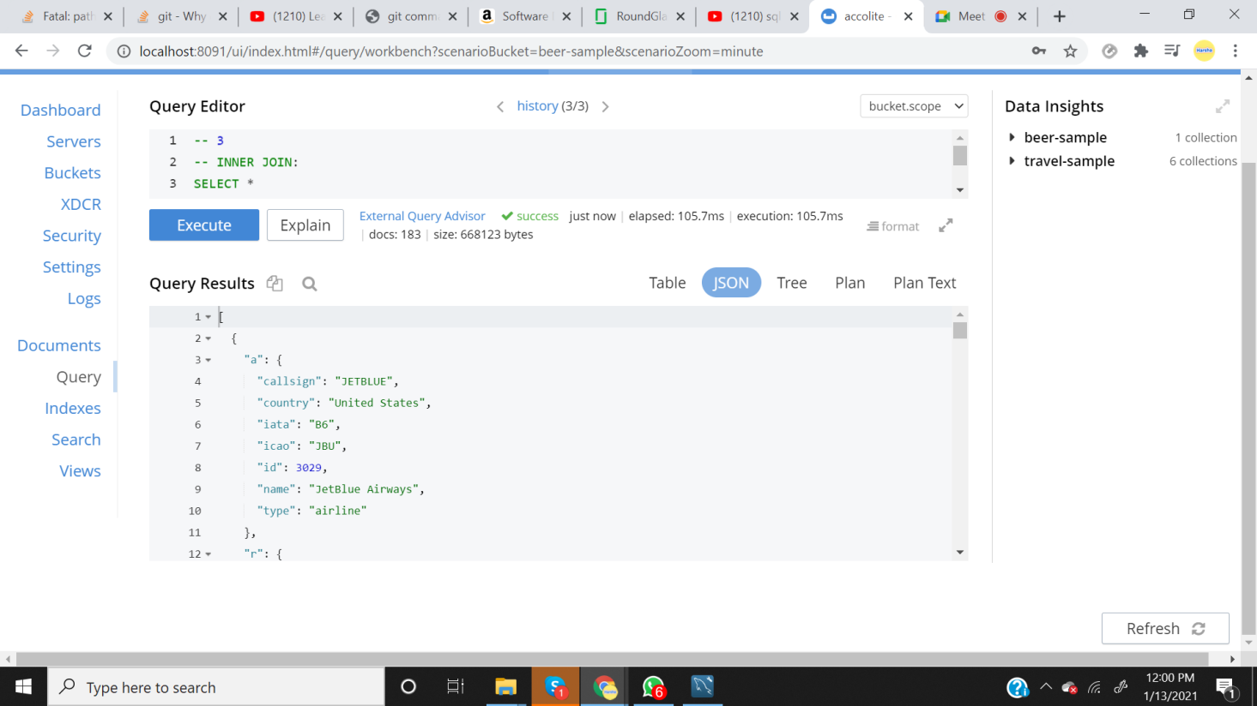

LEFT JOIN:

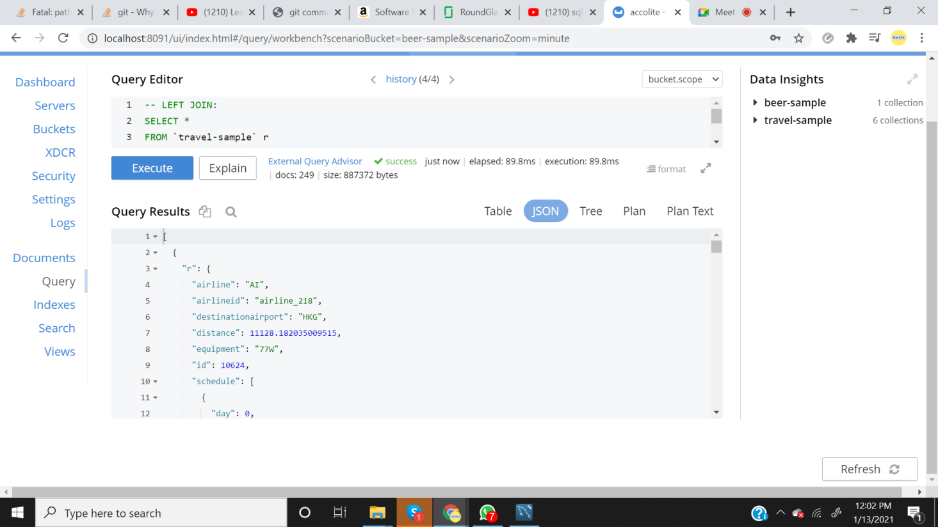

RIGHT JOIN:

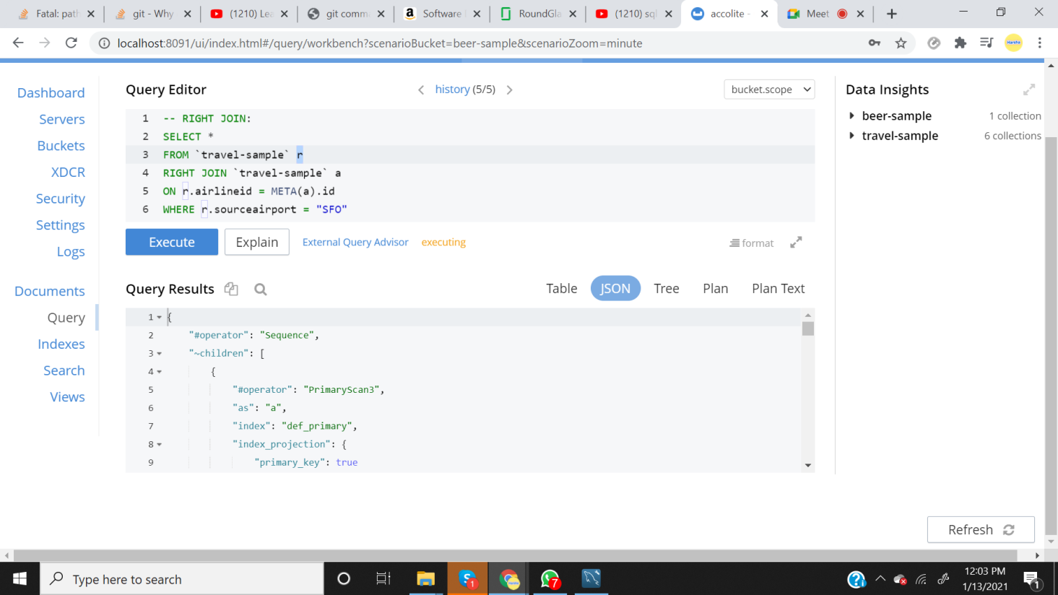

1. **Write a mapreduce to get the number of all documents based on entities(type):**

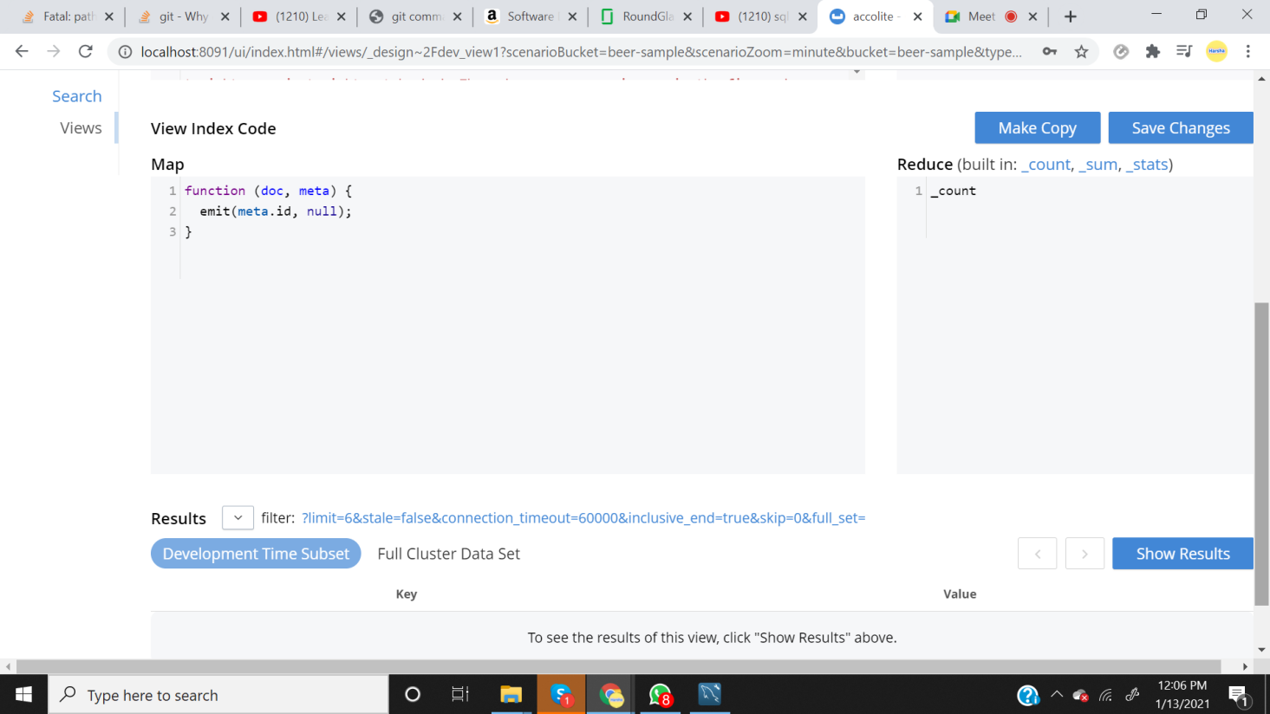

1. **Refer CLI interface &amp; try to export the travel sample data.**

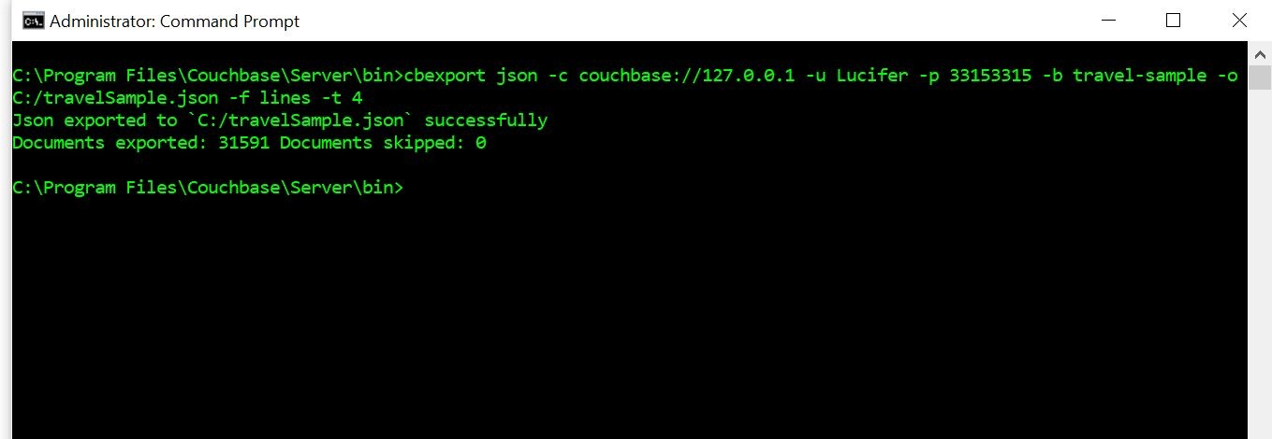

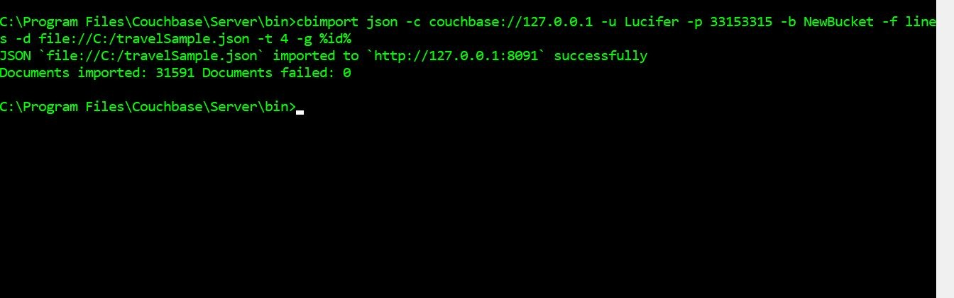

Imported Bucket:

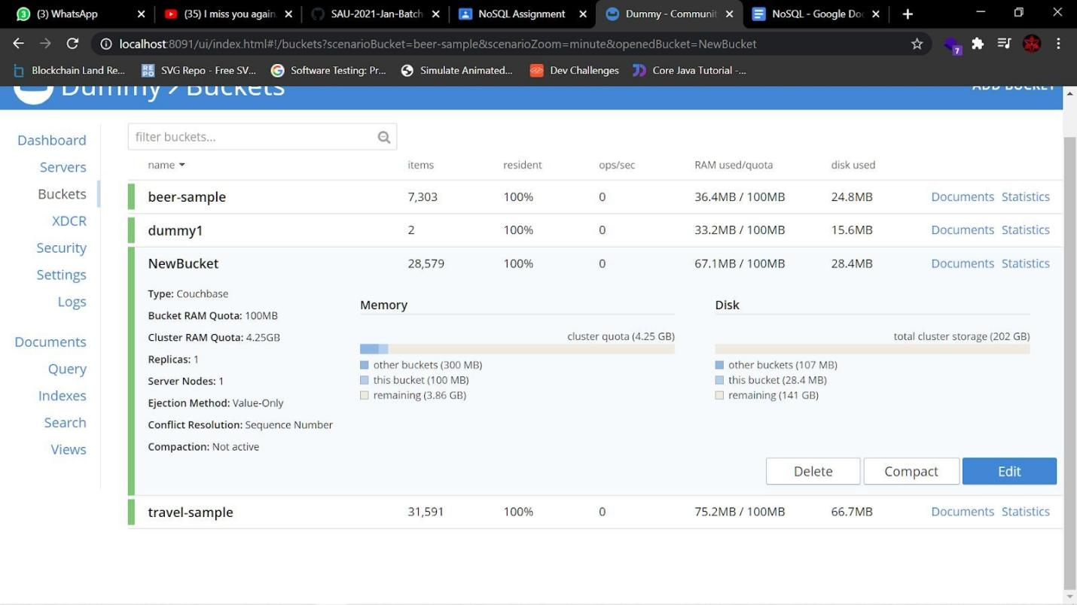

Imported data:

