Technical Evaluation — Web-based System Benchmark
DATEX II Road-Weather Adapter · Apache jMeter 5.6.3 · Design Science, Input Session 4
Research question: how do the adapter's response time, throughput and reliability scale as concurrent consumers increase? (Technical validation addresses system quality — DeLone & McLean.)

1. Experimental setup
Item | Value
Python | 3.12
Web framework | FastAPI + uvicorn (1 worker, --reload off)
Benchmark tool | Apache jMeter 5.6.3 (Java 21)
Network | localhost loopback
System under test | DATEX II adapter, 1 021 segments, 908 MB demo store

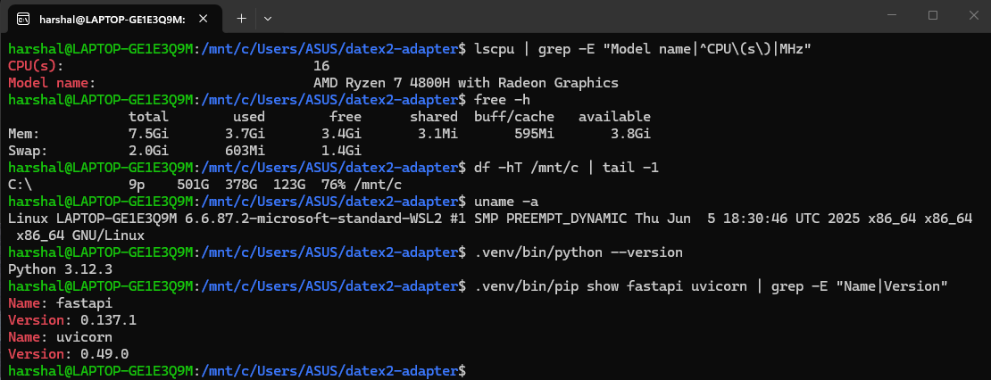

2. Methodology
- Three consumer profiles, mixed 60/30/10 % (Normal / Light / Heavy).
- Endpoints: GET /coverage · GET /datex · GET /fused · POST /transform · GET /geojson.
- 1-user warm-up, then 4 load levels: 10 / 50 / 100 / 200 concurrent users.
- Same uvicorn config throughout (fair comparison); no response timeout (error = hard failure).

3. Results
Summary (overall, per load level):
Users | Samples | Avg (ms) | Throughput | Error %
10 | 430 | 1,484 | 5.5/s | 0.00%
50 | 2150 | 10,777 | 4.0/s | 0.00%
100 | 4300 | 13,783 | 5.2/s | 0.00%
200 | 8600 | 31,104 | 4.5/s | 0.12%
Full per-endpoint detail:
Users | Endpoint | Samples | Avg (ms) | Throughput | Error %
10 | GET /coverage | 60 | 1,916 | 1.5/s | 0.0%
10 | GET /datex | 120 | 1,624 | 1.6/s | 0.0%
10 | GET /fused | 120 | 1,582 | 1.6/s | 0.0%
10 | POST /transform | 120 | 503 | 1.6/s | 0.0%
10 | GET /geojson | 10 | 7,815 | 0.13/s | 0.0%
50 | GET /coverage | 300 | 25,562 | 0.56/s | 0.0%
50 | GET /datex | 600 | 11,489 | 1.2/s | 0.0%
50 | GET /fused | 600 | 6,343 | 1.3/s | 0.0%
50 | POST /transform | 600 | 5,993 | 1.3/s | 0.0%
50 | GET /geojson | 50 | 23,939 | 0.18/s | 0.0%
100 | GET /coverage | 600 | 16,358 | 1.4/s | 0.0%
100 | GET /datex | 1,200 | 13,812 | 1.5/s | 0.0%
100 | GET /fused | 1,200 | 12,091 | 1.5/s | 0.0%
100 | POST /transform | 1,200 | 12,208 | 1.5/s | 0.0%
100 | GET /geojson | 100 | 37,181 | 0.24/s | 0.0%
200 | GET /coverage | 1,200 | 42,707 | 1.0/s | 0.08%
200 | GET /datex | 2,400 | 27,541 | 1.3/s | 0.25%
200 | GET /fused | 2,400 | 29,639 | 1.3/s | 0.12%
200 | POST /transform | 2,400 | 27,581 | 1.3/s | 0.00%
200 | GET /geojson | 200 | 64,119 | 0.29/s | 0.00%

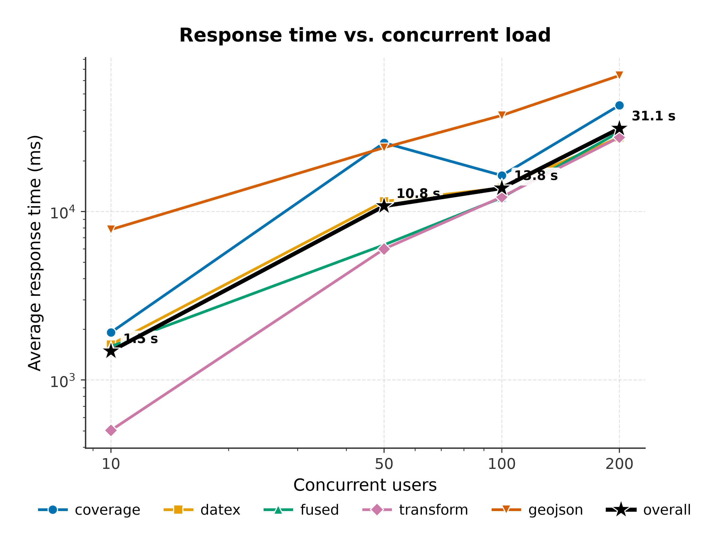
Figure 1. Average response time vs. concurrent users (log-log). Overall: 1.5 s → 31.1 s.
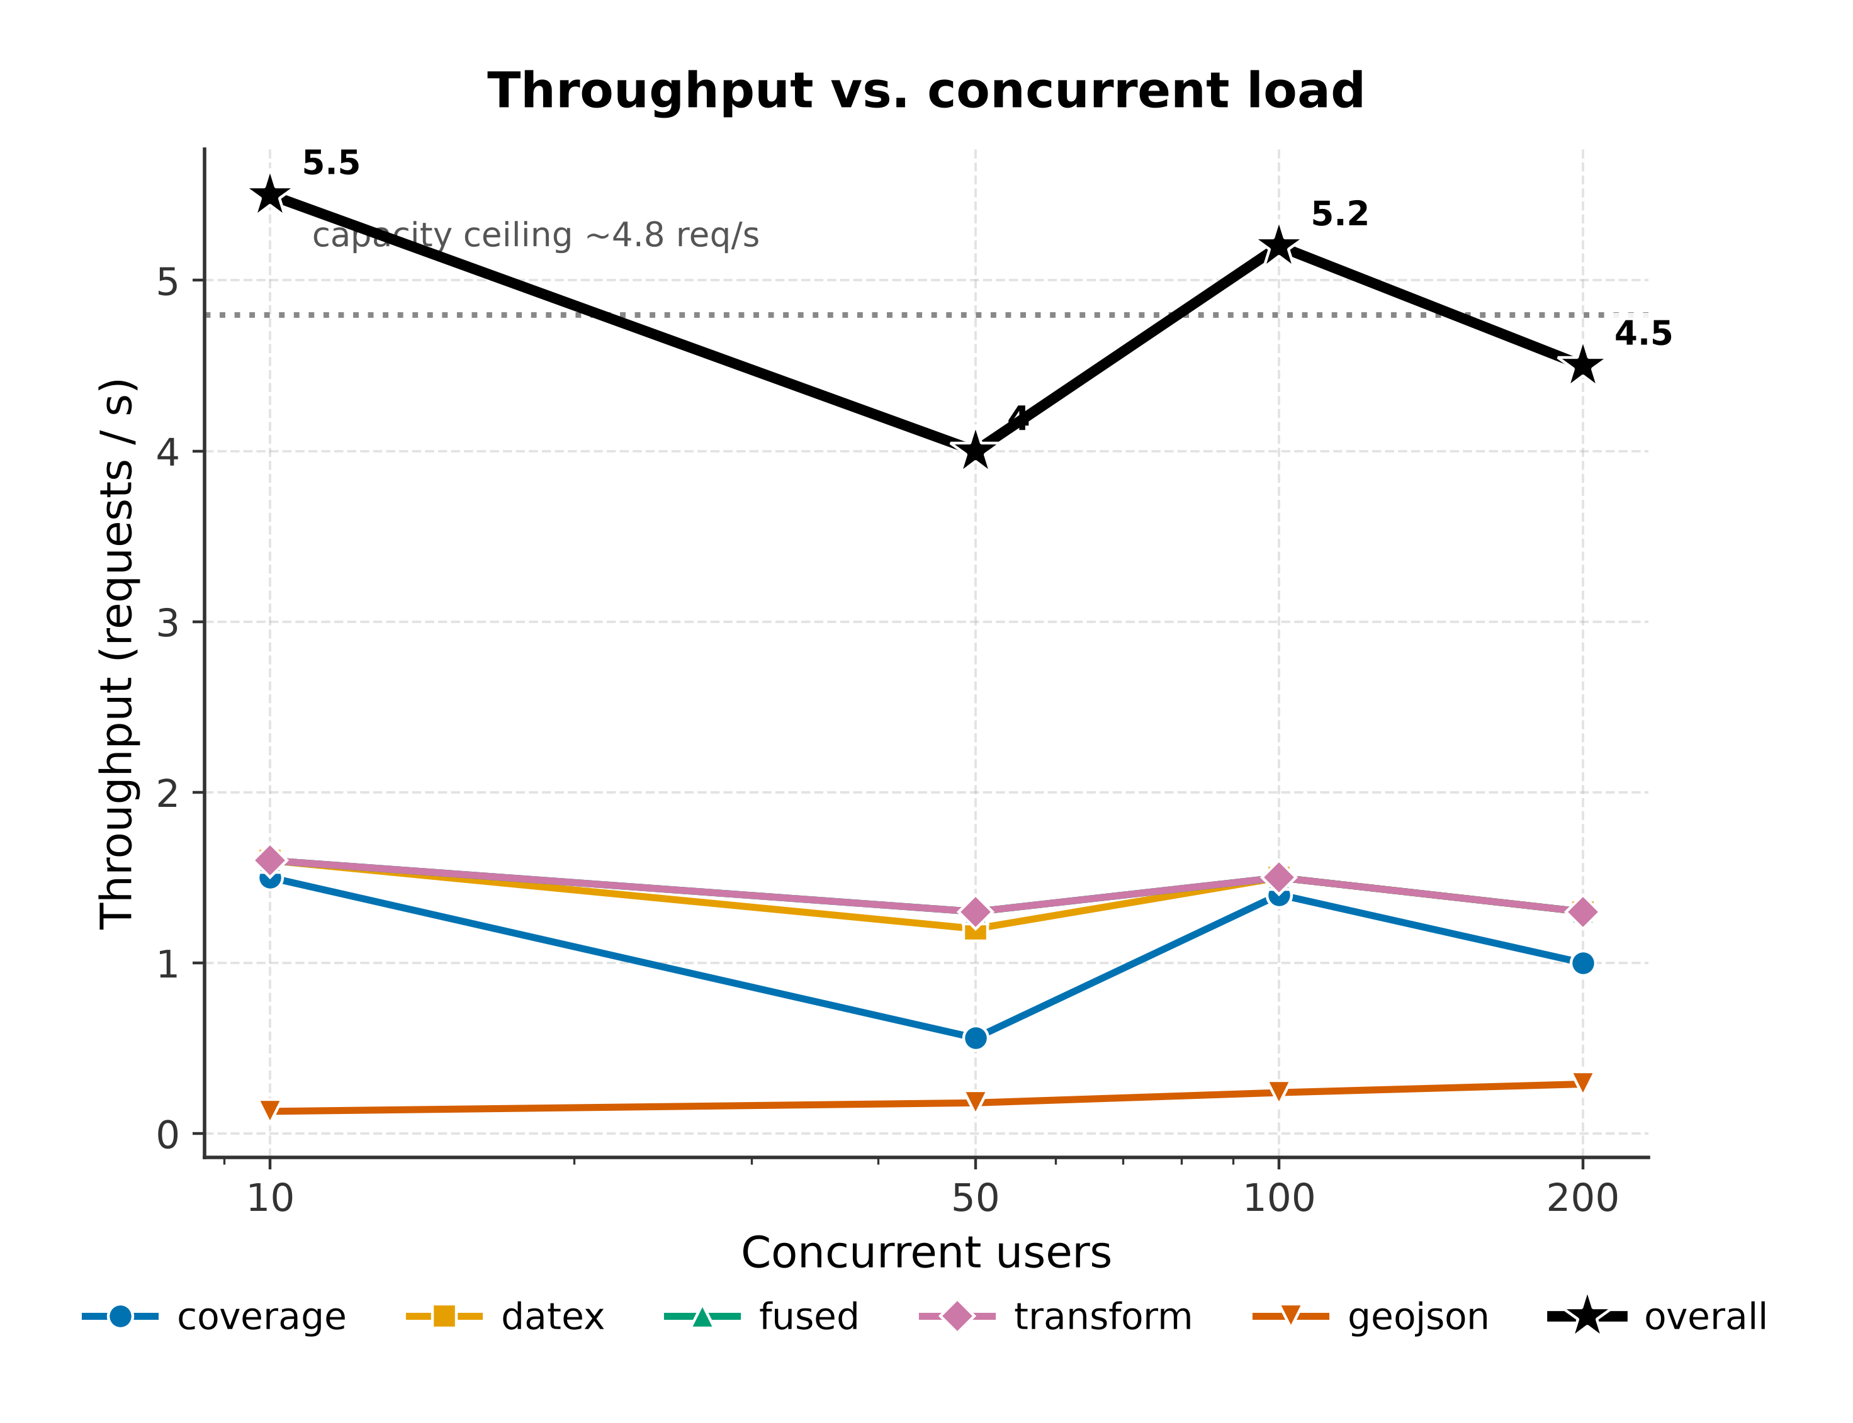
Figure 2. Throughput vs. concurrent users — flat ceiling ~4.8 req/s.
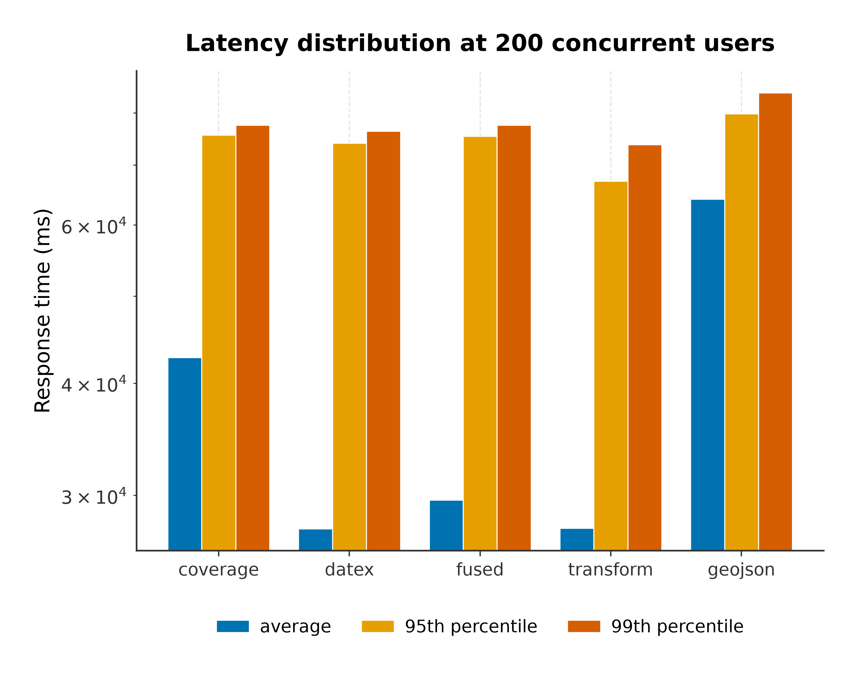
Figure 3. Average / 95th / 99th-percentile latency per endpoint at 200 users.
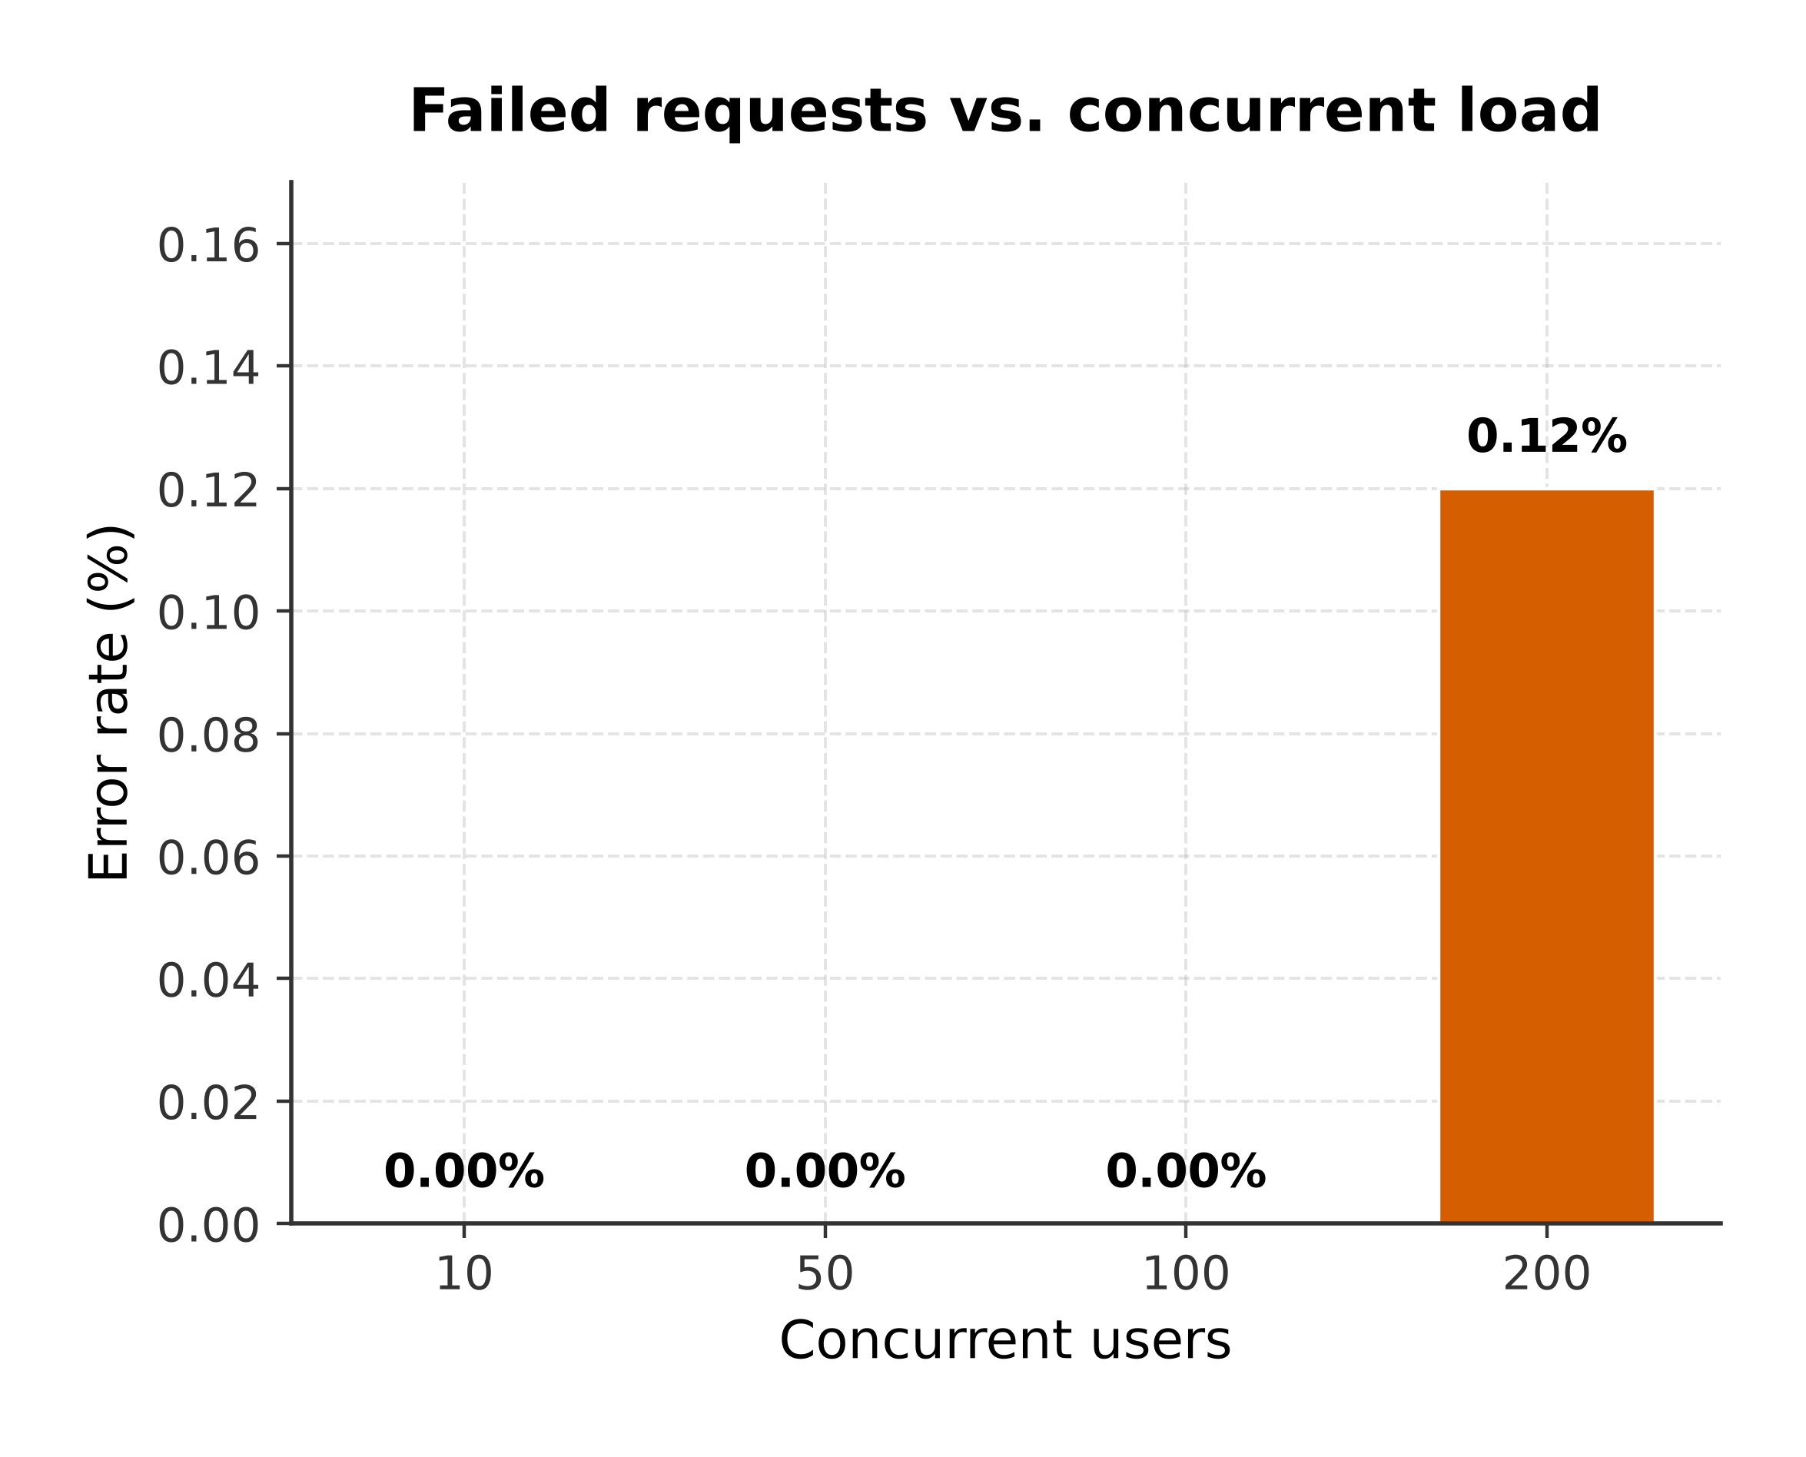
Figure 4. Error rate vs. load — 0% to 100 users, 0.12% at 200.

4. Key findings
- Throughput ceiling ≈ 4.8 req/s — flat from 10 to 200 users (20× load, same throughput).
- Latency scales with load beyond the ceiling (overall avg 1.5 s → 31.1 s).
- Graceful degradation: 0% errors to 100 users; first failures (0.12%) at 200 users.
- POST /transform most resilient; GET /geojson (full-network fuse, 4 MB) is the bottleneck.

5. Relation to previously published results
The README / evaluate.py report an isolated transform latency of ~5.7 ms (p95 ~6.9 ms). Under concurrent load the same operation's end-to-end latency is 0.5 s (10 users) → 27.6 s (200 users): the intrinsic compute is fast; the ceiling is a deployment trait (single Python worker, GIL), not the standardization logic. In the DATEX II / National-Access-Point setting the per-segment DATEX endpoint stays within second-scale availability at moderate load; the full-network GeoJSON feed is the operation to manage as consumers grow.

6. Performance bug found & fixed via benchmarking
GET /health averaged ~15 s — it re-scanned ~4.3 M rows (908 MB) on every call. Caching the invariant counts cut steady-state /health from ~13 s to ~0.2 s (~65×).
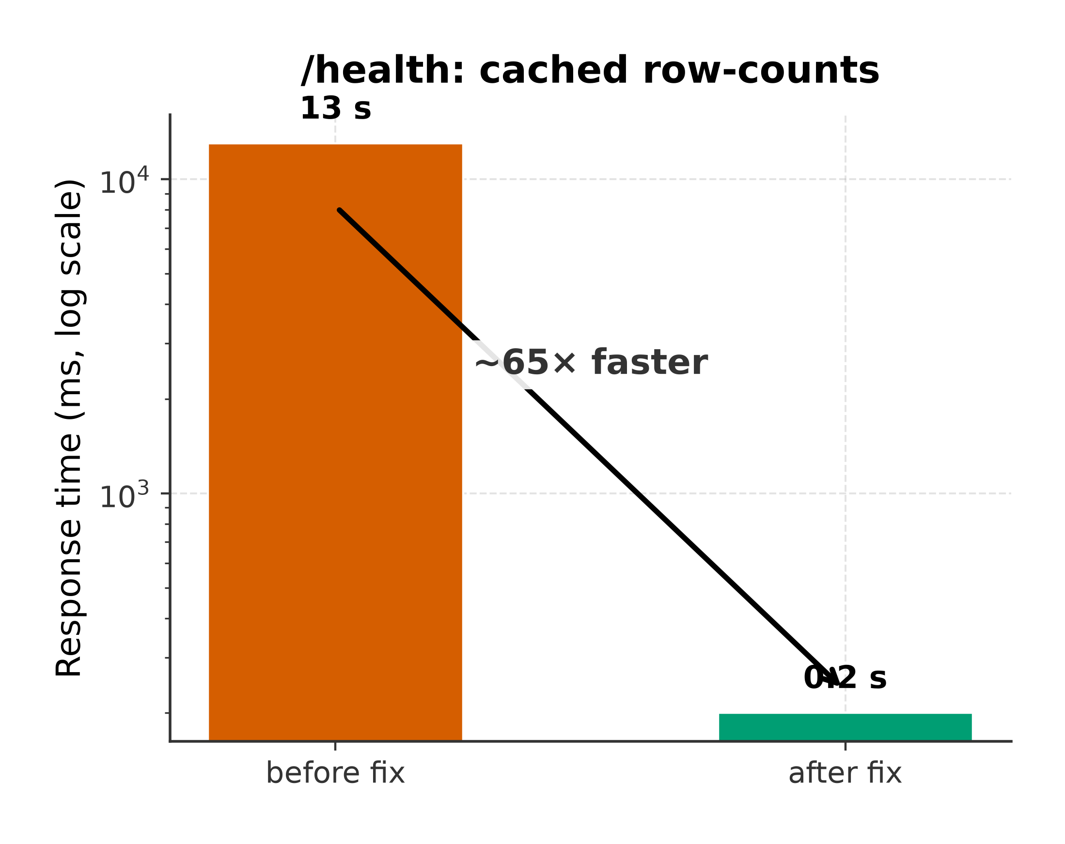
Figure 5. /health response time before vs. after caching (log scale).

7. Threats to validity
- Single-worker deployment (more workers is an untested lever).
- Loopback network — no real latency (upper bound for a co-located consumer).
- Shared host — jMeter competes with the server for CPU.
- Demo store on WSL2 drvfs is slower than native Linux I/O.

8. Conclusion
Benchmarking the DATEX II adapter as a web service located its operational ceiling at ~4.8 req/s under a single uvicorn worker, with response time scaling from 1.5 s (10 users) to 31 s (200 users) and zero failed requests up to 100 concurrent consumers — the system degrades in latency, not in correctness. The exercise also surfaced and fixed a genuine defect: the /health endpoint re-scanning 4.3 M rows on every call, cut from ~13 s to ~0.2 s (~65×) by caching. The key takeaway is that the standardization logic itself is fast; further capacity headroom comes from deployment choices (more uvicorn workers / processes), not from the adapter code.

