create a database called CARSHOWROOM

having the schema as mentioned below It has the

following four relations:

(\*) create a database called CARSHOWROOM



1. INVENTORY:

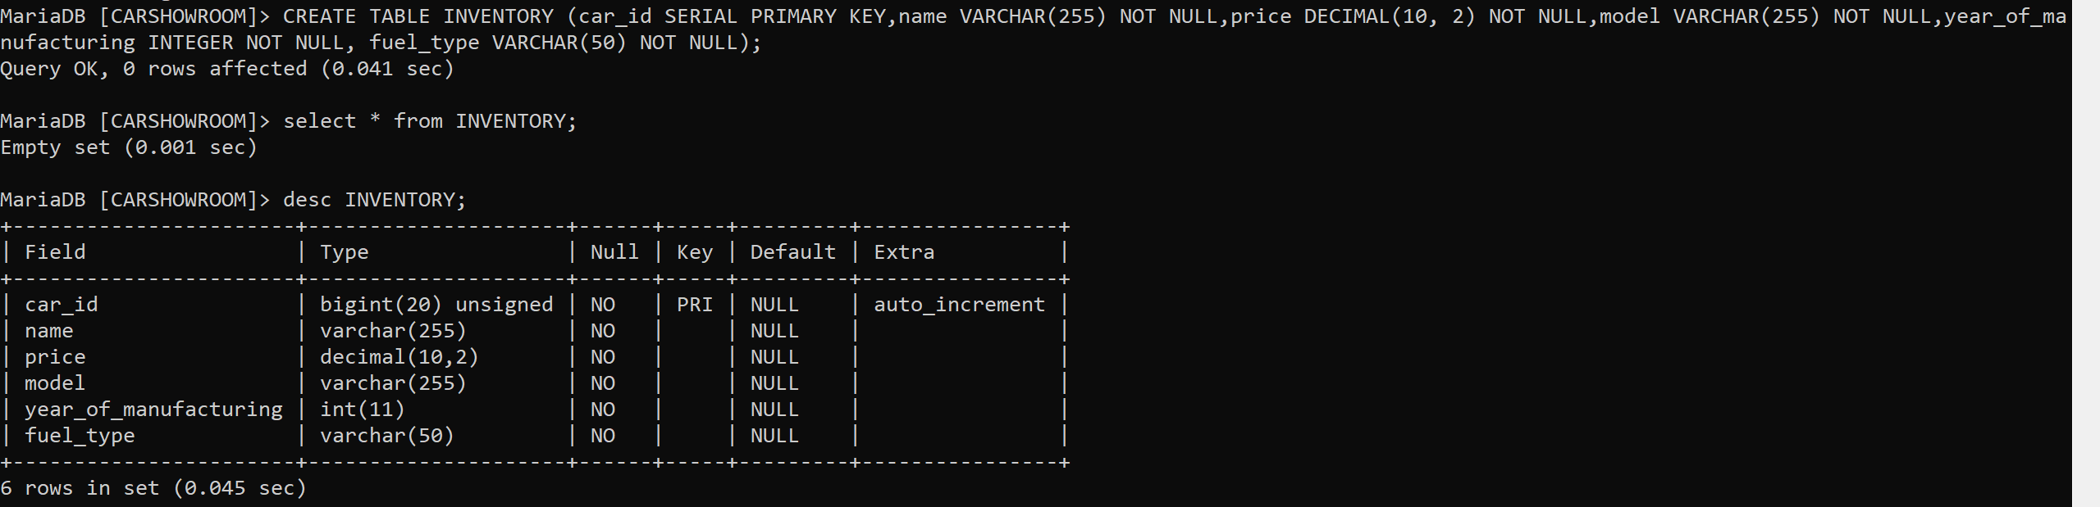

1. CUSTOMER

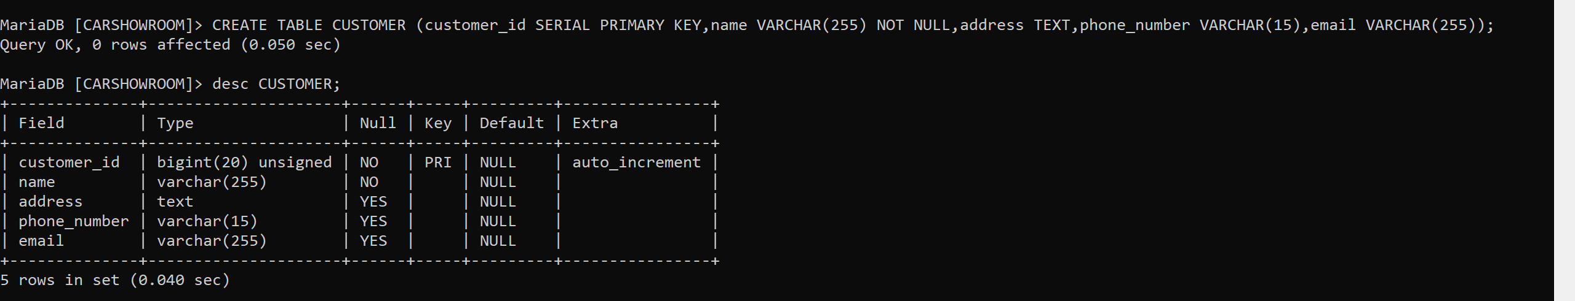

1. SALE:

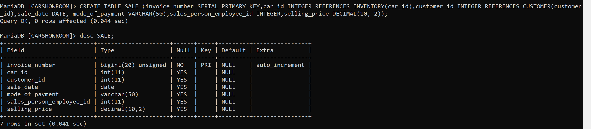

1. EMPLOYEE:

