Topic of Presentation
DELIVERY OF FETAL GROWTH RESTRICTION/IUGR

PRESENTED BY
Dr. Nidhi Patel
MS Final year,
Dept of Prasuti tantra and Stree roga.

GUIDED BY
Dr. Kola Vijaya Kumari
M.D (Ayu)
Professor and HOD,
Dept of Prasuti tantra and Stree roga

DEFINITION: -
- Fetal Growth Restriction (FGR) is said to be present in those babies whose birth weight is below the 10th percentile of the average for the gestational age. Growth restriction can occur in preterm, term or post-term babies.

TYPES:
Based on the clinical evaluation and ultrasound examination the small fetuses are divided into:
1. Fetuses those are small and healthy. The birth weight is less than 10th percentile for their gestational age. Tey have normal ponderal index, normal subcutaneous fat and usually have uneventful neonatal course.
2. Fetuses where growth is restricted by pathological process (true IUGR). Depending upon the relative size of their head, abdomen and femur, the fetuses are subdivided into:
(a) Symmetrical or Type I
(b) Asymmetrical or Type II.

MANAGEMENT
- Fetuses that are constitutionally small (70%) require no intervention.
- The fetuses that are symmetrically growth restricted (15%), should be investigated to exclude fetal anomalies, infections and genetic syndromes. Unfortunately, there is no effective therapy for this group.
- Finally, the growth restricted fetus owing to placental disease or reduced placental blood flow (chronic placental insufficiency), may be given some treatment.
- However, assessment of fetal well-being is more critical in the management as in majority there is no definitive therapy.
- Perinatal outcome is poor for women with early onset of IUGR (Less than 34 weeks) compared to late onset of FGR (>34 weeks).
- Decision for early delivery has to balance the risk of neonatal deaths due to complications, on the other hand delay in delivery that may increase the risk of IUFD.
- Majority of fetal deaths occur after the 36th week of gestation. So, correct diagnosis and timed intervention are essential.

General:
At present, there is no proven therapy for reversing growth restriction once it is established.
- However, the following may be tried with some success:
(1) Adequate bedrest, especially in left lateral position
(2) To correct malnutrition by balanced diet: 300 extra calories per day are to be taken
(3) To institute appropriate therapy for the associated complicating factors likely to produce growth restriction
(4) Avoidance of smoking, tobacco and alcohol
(5) Maternal hyperoxygenation at the rate of 2.5 L/ min by nasal prong, for short-term prolongation of pregnancy
(6) Antiplatelet agents during pregnancy are associated with moderate but consistent reductions in the relative risk for pre-eclampsia, birth before 34 weeks' gestation, SGA and other serious adverse outcomes.
A recent systematic review and meta-analysis of nine trials involving 1317 women with abnormal UtA Doppler at 20 weeks' gestation concluded that aspirin started before 16 weeks of pregnancy reduced the incidence of both pre-eclampsia and SGA. On the other hand, when aspirin was started after 20 weeks' gestation, no reduction was observed.
Low dose aspirin (50 mg daily) may be helpful in very selected cases with history of thrombotic disease, hypertension, preeclampsia, or recurrent IUGR.
(7) Maternal hyperalimentation by amino acids can improve fetal growth if it was due to maternal malnutrition. It is not helpful when placental function is deficient
(8) Maternal volume expansion may be helpful in improving placental perfusion.

Antepartum evaluation:
Serial evaluations of fetal growth and assessment of well-being should be done once the diagnosis is made.
- Ultrasound examination should be done at an interval of 3–4 weeks for the assessment of BPD, HC/AC, fetal weight and AFI.
- Fetal well-being is assessed by Kick count, NST, biophysical profile, amniotic fluid volume and cordocentesis for blood gases.
- Doppler ultrasound parameters are to be studied.

TIMING OF DELIVERY:
The factors to be considered are:
(1) Presence of fetal abnormality
(2) Duration of pregnancy
(3) Degree of FGR
(4) Associated complicating factor
(5) Underlying pathology (if known)
(6) Results of antenatal fetal surveillance
(7) Availability of neonatal intensive care unit (NICU).

- Optimum time of delivery for a growth restricted fetus may be between 34 weeks and 37 weeks depending upon the presence of any additional risk factors (e.g. Oligohydramnios, preeclampsia, abnormal Doppler study).
- Pregnancy ≥ 37 weeks: Delivery should be done.

- Pregnancy < 37 weeks: Uncomplicated mild IUGR: Fortunately, the majority falls in this group. Usual treatment as outlined above to improve the placental function may be employed. Pregnancy is continued at least 37 weeks. Thereafter delivery is done.

- Severe degree of IUGR:
- Delivery should be planned on the basis of fetal surveillance report.
- If the lung maturation is achieved as evidenced by presence of phosphatidylglycerol and L : S ratio of ≥ 2 from the amniotic fluid study (amniocentesis), delivery is done.
- If the lung maturation has not yet been achieved, intrauterine transport to an equipped center is ideal in such a case.
- Betamethasone therapy is given to accelerate pulmonary maturation when gestational age is less than 34 weeks. Corticosteroids reduce the risk of neonatal HMD and intraventricular hemorrhage (IVH).

Glucocorticoid therapy:
Maternal administration of glucocorticoids is advocated where the pregnancy is less than 34 weeks. This is beneficial when the delivery is delayed beyond 48 hours of the first dose. Benefit persists as long as 18 days.
Either betamethasone (Betnesol) 12 mg IM 24 hours apart for two doses or dexamethasone 6 mg IM every 12 hours for 4 doses is given.
Betamethasone is the steroid of choice (RCOG – 2004).

- Delivery to be done at 34 0/7 weeks of gestation in cases of FGR with additional risk factors for adverse perinatal outcome (Preeclampsia, oligohydramnios, AREDV).
- When delivery is to be done preterm, antenatal corticosteroids should be given.
- When delivery is to be done before 32 weeks, magnesium sulfate should be given to the mother for fetal and neonatal neuroprotection.
- Maternally administration of magnesium sulphate has been shown to have a neuroprotective effect and to reduce the incidence of cerebral palsy among pre-term infants.
- Australian guide- lines recommend administration of magnesium sulphate when delivery is planned before 30 - 32 weeks gestation.

MAGNESIUM SULPHATE FOR NEUROPROTECTION
- The Cochrane systematic review of the role of antenatal magnesium sulphate therapy for neuroprotection in pre- term infants found a significant reduction in the risk of cerebral palsy and a significant reduction in gross motor dysfunction.
- MgSO4 should be given when early preterm birth (less than 30 weeks) is planned or definitely expected within 24 hours.
- In the planned birth, it is recommended MgSO₄ be commenced 4 hours prior to delivery.
- In the unplanned delivery, MgSO₄ should only be given when the woman is in active preterm labour.
- MgSO₄ for neuro protection should be given in pregnancies less than 30 to 32 weeks, regardless of whether pregnancy is single or multiple, regardless of parity, regardless of anticipated mode of delivery and whether or not corticosteroids have been given.

DOSE :-
- Administer intravenous loading bolus dose of 4g of MgSO₄ over 20 minutes via a controlled infusion device.
- The loading dose is followed by a maintenance infusion of 1g of MgSO₄ per hour. When the rate is changed to the maintenance rate, the rate shall be checked and confirmed by 2 registered midwives.
- Continue at 1g/hour for 4 hours then cease MgSO₄ infusion.
- If the birth occurs before the 4 hour mark, discontinue the infusion at the time of birth.
- Prior to the commencement of MgSO4 infusion ensure:
- patella reflexes are present
- respirations are more than 12 per minute
- The correct order, medication, dose, and infusion rate is checked by 2 registered midwives.
- Calcium Gluconate 1g in 10 mL (2.2mmol calcium in 10mL) must be available at all times for treatment of MgSO₄ toxicity.
- Dose – administer ONE ampoule of Calcium gluconate 1g in 10mL( 2.2mmol calcium in 10mL) intravenously (IV) slowly.
- Administration must be authorized by a medical officer.
- ECG monitoring is recommended if Calcium gluconate is given
- Apply continuous fetal monitoring.

Fetuses with aneuploidy or congenital infection have poor outcome irrespective of gestational age and timing of delivery.

METHODS OF DELIVERY:
Before knowing the methods of delivery, have to check whether cervix is favorable or not, and for that one has to check BISHOP’S score.

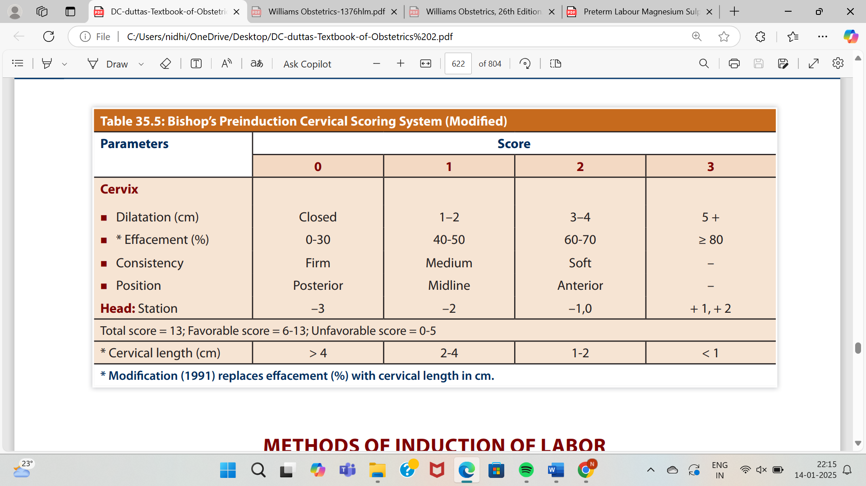
BISHOP’S SCORE

- If the cervix is unfavorable (SCORE < 6)
- Prostaglandin (PGE2) gel could be used when the cervix is unfavorable. The color of the liquor could be a guide for further management.

Prostaglandin E₂ (Dinoprostone)
- Dinoprostone gel: 0.5 mg (3 g gel) is commonly used for cervical ripening prior to induction.
- It is instilled into the endocervix and not beyond the internal cervical os. The dose can be repeated every 6 hours.
- If there is inadequate cervical change and minimal uterine activity, the dose can be repeated up to three times in 24 hours.
- The fetal heart should be monitored by continuous CTG for 15-30 minutes following each insertion and thereafter, periodically.
- The interval between the final dose and the initiation of oxytocin should be >6 hours to prevent uterine hyperstimulation.
- The side effects of prostaglandins include Gl upset such as diarrhea, vomiting, hyperpyrexia and hypertonus of the uterus.
- PGE₂ should be used cautiously in patients with glaucoma, severe hepatic or renal dysfunction or asthma. The gel should be stored in a refrigerator at 2-8°C.

Misoprostol (synthetic analogue of PGE₁)
- It is given in a dose of 25 µg vaginally or orally every 6 hours.
- The dosage should not exceed four doses in 24 hours. The major advantage of misoprostol is that it is stable at room temperature.
- It can be used for the induction of IUFD/ severe pre-eclampsia occurring in the second trimester. Though many organisations recommend the use of misoprostol for inducing labour in a term pregnancy with a viable fetus, caution should be exercised.
- Side effects include diarrhea, nausea, vomiting, febrile illness, tachysystole and meconium-stained liquor. Uterine rupture can occur if used for women who have a scarred uterus.

- If the cervix is favorable (SCORE > 6)
- Low rupture of the membranes followed by oxytocin is employed in cases such as pregnancy beyond 34 weeks with favorable cervix and the head is deep in the pelvis.

LOW RUPTURE OF THE MEMBRANES (LRM)

Procedures:
- Preliminaries:
- It is an indoor procedure. The patient is asked to empty her bladder.
- The procedure may be conducted in the labor ward or in the operation theater if the risk of cord prolapse is high.

- Actual steps:
- FHR status is monitored before and after the procedure.
- The patient is in lithotomy position.
- Full surgical asepsis is to be taken.
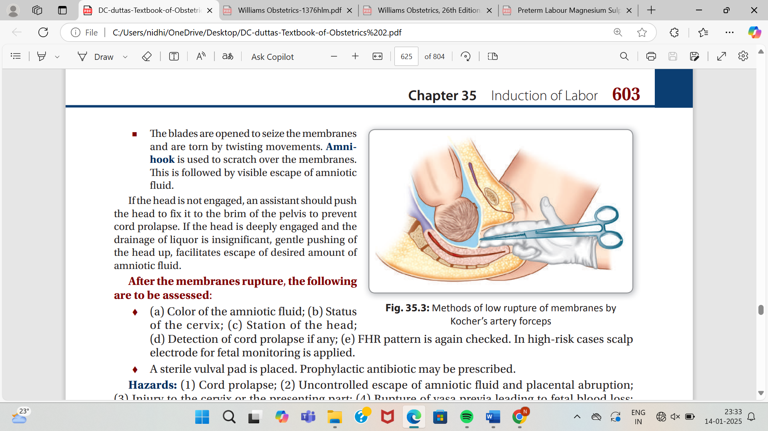
- Two fingers are introduced into the vagina smeared with antiseptic ointment.
- The index finger is passed through the cervical canal beyond the internal os.
- The membranes are swept free from the lower segment as far as reached by the finger.
- With one or two fingers still in the cervical canal with the palmar surface upwards, a long Kocher’s forceps with the blades closed or an amnion hook is introduced along the palmar aspect of the fingers up to the membranes.
- The blades are opened to seize the membranes and are torn by twisting movements. Amnion hook is used to scratch over the membranes. This is followed by visible escape of amniotic fluid.
- If the head is not engaged, an assistant should push the head to fix it to the brim of the pelvis to prevent cord prolapse.
- If the head is deeply engaged and the drainage of liquor is insignificant, gentle pushing of the head up, facilitates escape of desired amount of amniotic fluid.

- After the membranes rupture, the following are to be assessed:
(a) Color of the amniotic fluid;
(b) Status of the cervix;
(c) Station of the head;
(d) Detection of cord prolapse if any;
(e) FHR pattern is again checked.
- In high-risk cases scalp electrode for fetal monitoring is applied.
- A sterile vulval pad is placed. Prophylactic antibiotic may be prescribed.

OXYTOCIN INFUSION

- It is a synthetic analogue of endogenous oxytocin and is very potent. Oxytocin stimulates receptors in the uterus directly, thus, stimulating uterine contractions.
- The response to oxytocin increases after 20 weeks of gestation until the middle of the third trimester and then remains stable until term, after which it increases dramatically.
- The goal of oxytocin infusion is to induce uterine activity that can produce cervical dilatation and fetal descent without causing uterine hyperstimulation or fetal distress.
- Oxytocin infusion is not started within six hours of using prostaglandins. In order to avoid the risk of amniotic fluid embolism, oxytocin infusion should be avoided before rupturing the membranes.

Procedure

- Each ampoule contains 5 units (1 mL) of oxytocin.
- Oxytocin infusion should ideally be given via an infusion pump to avoid fluid overload.
- 6 units of oxytocin are mixed with 60 mL of normal saline, which gives a concentration of 100 miu/ml.
- This fluid is infused at 1.2 mL/hour (2 miu/minute) initially.
- Subsequently, the rate of infusion is increased every 15 minutes to 4 miu, 8 miu, 16 miu and 32 miu/ minute; the infusion is maintained at 32 miu/minute to achieve a good contraction pattern with contractions lasting more than 40 seconds, occurring three times in 10 minutes and relaxing between contractions.
- When oxytocin infusion results in a good labour pattern, the same rate is maintained until delivery.

In the absence of an infusion pump,
- 2.5 units of oxytocin are infused in 500 mL of Ringer's lactate or normal saline. The infusion rate is increased by 10 drops per minute every 30 minutes until a good contraction pattern is established.
- If there aren't three contractions in 10 minutes, each lasting more than 40 seconds with the infusion rate at 60 drops per minute, oxytocin concentration may be increased to 5 units in 500 mL of fluid in a primi.
- Alternatively, delivery by cesarean section should be undertaken. (The total dose of oxytocin should not exceed 5 units.)

Oxytocin infusion rates for the induction of labour
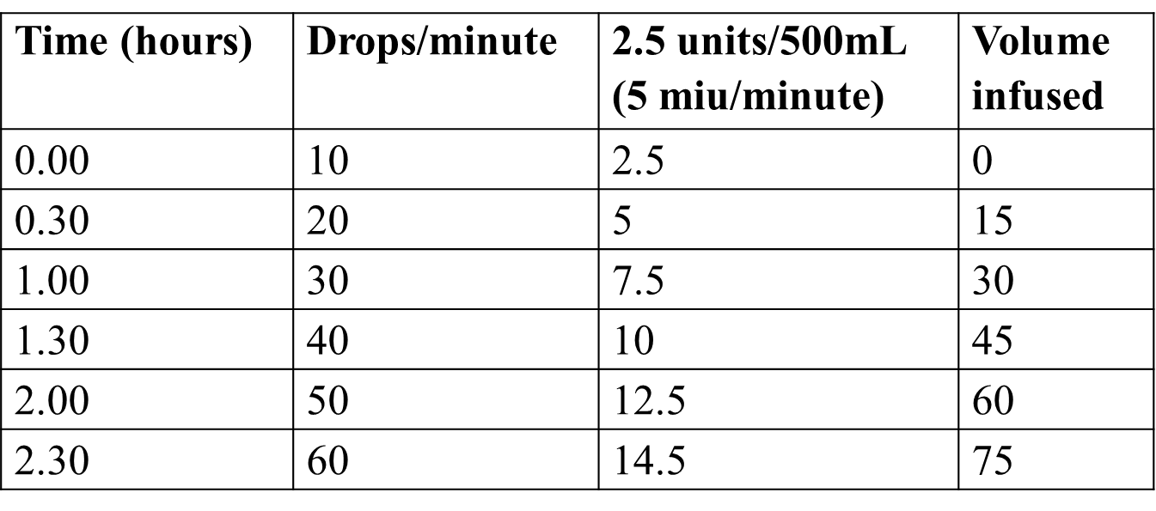
Monitoring a woman on oxytocin infusion
- Women receiving oxytocin should never be left alone.
- The woman is nursed on her left side.
- Her pulse, blood pressure and uterine contractions and the fetal heart rate are carefully monitored.
- A medical officer stays with the woman, watching the contractions, adjusting the rate of the drip and recording the fetal heart rate every half hour; preferably, continuous electronic monitoring is used.
- The oxytocin drip is discontinued if there are more than 5 uterine contractions in 10 minutes or when there are fetal heart irregularities. Uterine hypersensitivity usually gets corrected once the infusion is stopped.

- Intrapartum Management
- When lagging fetal growth is the result of placental insufficiency due to poor maternal perfusion or reduction of funcntional placenta, the fetal condition may be aggravated by labor.
- Equally important, oligohydramnios raises the likelihood of cord compression during labor.
- For these and other reasons, the frequency of cesarean delivery is increased.
- Intrapartum monitoring by clinical, continuous electronic and scalp blood sampling is needed as the risk of intrapartum asphyxia is high.
- The risk of neonatal hypoxia or meconium aspiration is also greater. Thus, care for the newborn should be provided immediately by an attendant who can skillfully clear the airway and ventilate a neonate as needed.
- The severely growth-restricted newborn is particularly susceptible to hypothermia and may also develop other metabolic derangements such as hypoglycemia, polycythemia, and hyperviscosity.
- Risk is greatest at the lowest extremes of birthweight.

- Cesarean delivery without a trial of labor is done when the risks of vaginal delivery are more (presence of fetal acidemia, absent or reversed diastolic flow in umbilical artery or unfavorable cervix).

- CARE DURING VAGINAL DELIVERY

- The delivery should be in an equipped institution where intensive intranatal monitoring (clinical and electronic) is possible and having facilities for neonatal intensive care unit.
- The precautions during labor are those required for preterm delivery.

The principles in management of preterm labor are:
(1) To prevent birth asphyxia and development of RDS;
(2) To prevent birth trauma. Duration of labor is usually short.

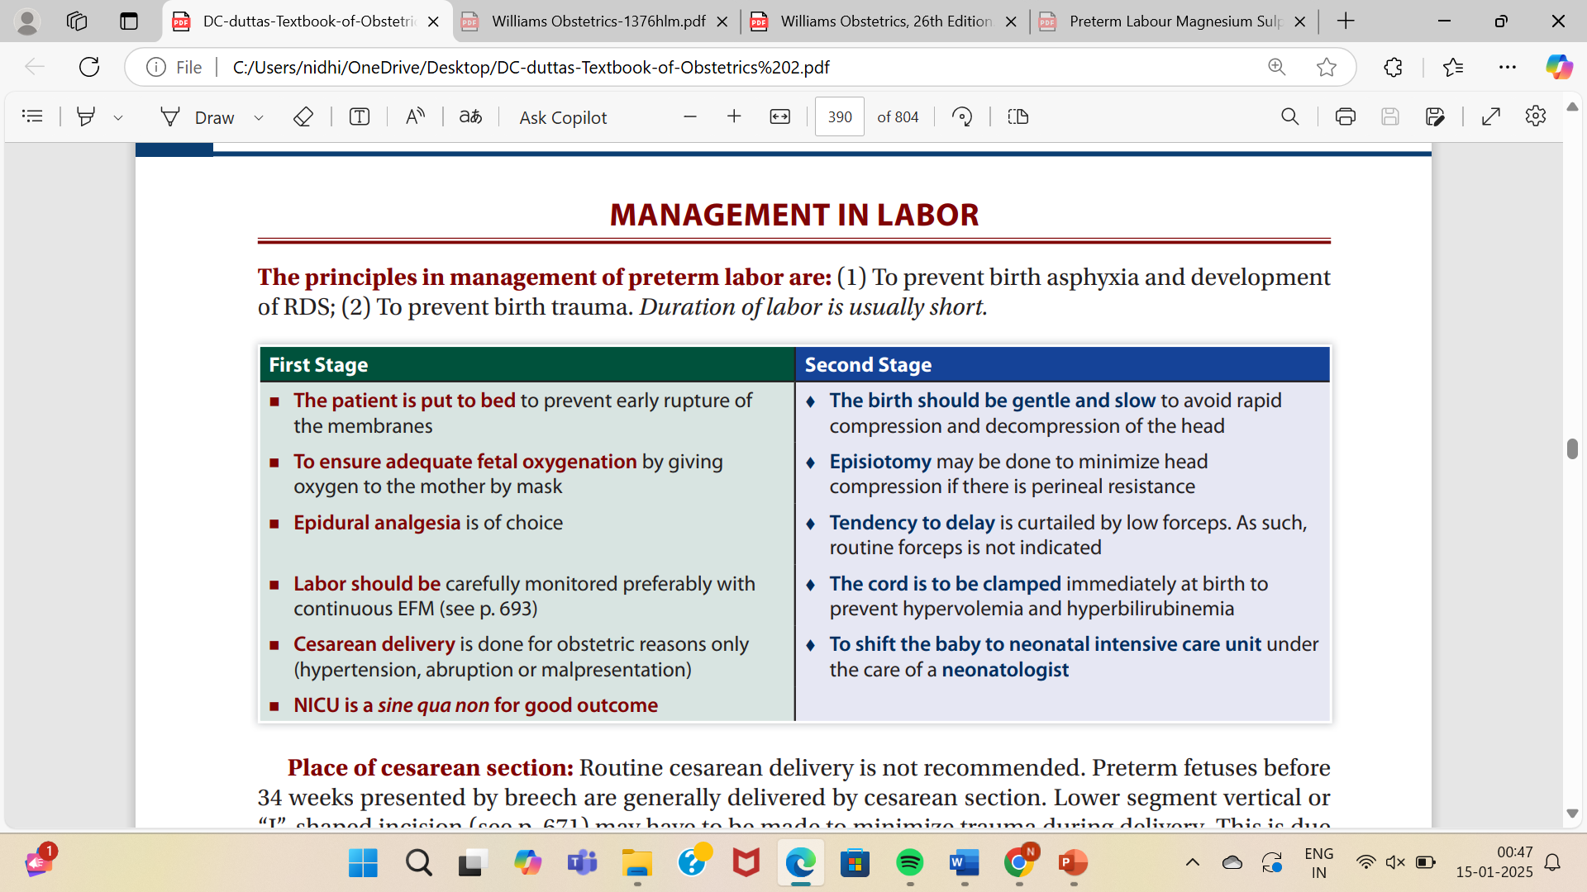
IMMEDIATE CARE OF THE BABY AFTER BIRTH
- A pediatrician should be available at the time of delivery.
- The same precautions as outlined in the preterm delivery are to be taken.
- The baby should be placed preferably in the neonatal intensive care unit.

CARE OF A PRETERM NEONATE

- IMMEDIATE MANAGEMENT FOLLOWING BIRTH
- The cord is to be clamped quickly to prevent hypervolemia and development of hyperbilirubinemia.
- The cord length is kept long (about 10–12 cm) in case exchange transfusion is required.
- The air passage should be cleared of mucus promptly and gently using a mucus sucker.
- Adequate oxygenation through mask or nasal catheter in concentration not exceeding 35%.
- The baby should be wrapped including head in a sterile warm towel (normal temperature 36.5–37.5°C). Hypothermia and its sequelae: Hypoxia → Hypoglycemia → Anaerobic metabolism → Metabolic acidosis.
- Aqueous solution of vitamin K 1 mg is to be injected intramuscularly to prevent hemorrhagic manifestations.

Intensive care protocols:
The same protocols as conducted in the management of preterm babies are to be followed. Special precaution is to be taken to prevent and treat complications.

- Preterm babies are functionally immature and “special care” is needed for their survival.
- Those requiring “special care” are judged by:
- Inability to suckle the breast and to swallow.
- Incapacity to regulate the temperature within limited range from 96°–99°F (35.6°–37.2°C).
- Inability to control the cardiorespiratory function without cyanotic attacks.

- The principles that are to be taken for the babies requiring special care are:
- To maintain a relatively stable thermoneutral condition
- keep delivery room warm, dry and then wrap the baby with a warm towel, keep the baby with mother—skin-to-skin contact.
- Adequate humidification to counter balance increased insensible water loss.
- Oxygen therapy and adequate ventilation.
- To prevent infection.
- To maintain nutrition and adequate nursing care.

ACCORDING TO AYURVEDA,
वाताभिपन्नगर्भ/गर्भशोष (IUGR)
आहारमाप्नोति यदा न गर्भः, शोषं समाप्नोति परिस्रुतिं वा।
तं स्त्री प्रसूते सुचिरेण गर्भं, पुष्टो यदा वर्षगणैरपि स्यात् ।। (च.सं.शा. 2/15)
- Acharya Charaka mentions that due to improper nourishment of foetus or vaginal discharges leading to shosha, the garbha achieves maturity after years together; likewise delivery of the foetus is also after years or prolong delay (Garbha shosha).

वाताभिपन्न एव शुष्यति गर्भः। स मातुः कुक्षि न पूरयति मन्दं स्पन्दते च ।। (सु.सं.शा. 10/57)
- Acharya Sushruta mentions that when the foetus is afflicted by vayu, it dries up and does not attain proper growth in the abdomen i.e. the abdominal height is less than the corresponding gestational age (Vatabhipanna garbha).

- Dalhaņa explains that due to affliction of vayu, absence of ojas and as said by Vṛddha Kashyapa that either rasa does not flow or flows slowly in garbha nadi, hence it does not get nourishment in time, develops very slowly and as a consequence quivering is feeble.

उपविष्टक (Upaviștaka)

यस्याः पुनरुष्णतीक्ष्णोपयोगाद्गभिण्या महति संजातसारे गर्भे पुष्पदर्शनं स्यादन्यो वा योनिस्स्रावस्तया गर्भो वृद्धि न प्राप्नोति निःस्स्रुतत्वात्, स कालमवतिष्ठतेऽतिमात्रं, तमुपविष्टकमित्याचक्षते केचित्।
(च.सं.शा. 8/26)

- Acharya Charaka mentions that after development and stability of foetus (i.e. 4th month onwards) when the mother indulges in hot, pungent, tikshna drugs, it causes bleeding per vaginum or discharge per vaginum leading to improper growth of foetus which results in prolonged intra-uterine stay of foetus.

उपशुष्कउपविष्टकयोः गर्भयोः प्रसवकालः (Time of delivery of upashushka and upavishtaka garbha)

वाग्भट-

तौ तु मातुराहारतेजसाऽल्पेनाप्यायमानौ यदा पुष्टो स्यातां केशदशनादियुक्तौ तदा वर्षगणैरपि प्रमदा प्रसूयत एव।। (अ.सं.शा. 4/14)

इन्दु-

तौ चोपविष्टकोपशुष्ककौ.....तदाकेशदशनादियुक्तौ बहुभिरपि वर्षेः प्रमदा प्रसूयेत।

(अ.सं.शा. 4/14, इन्दु टी.)

- Both upavishtaka and upashushka develop slowly under the influence of teja of mother's diet (mother's ahara agni) and maturity achieved after years, it consist of hair, nails etc. when the foetus is delivered.

- Acharya Charaka does not specify the time period and says 'कालमवतिष्ठतेऽतिमात्र' i.e. prolonged intra-uterine stay (कालातीति स्थायिनि) beyond the normal gestational period.

भेल-

सम्पूर्णगात्रो भवति यदा स रसभावतिः। तदा प्रसौत्यथाकाशं गर्भः स्त्रीकुक्षिविच्युतिः।।
(भे.सं.सा. 3/13)

- Maharshi Bhela says that only when the foetus attains maturity after being nourished by mother's ahara rasa, it is delivered.

उपशुष्कउपविष्टकयोः गर्भयोः सामान्य चिकित्सा (General treatment of upashushka and upavishtaka garbha)

तत्रापि लीनवत् प्रतीकारः। (सु.सं.शा. 10/59)

- Acharya Sushruta says that the treatment prescribed for lina garbha should be used.

- According to Sushruta Lina Garbha

......तां मृदुनं स्नेहादिक्रमेणोपचरेत्, उत्क्रोशरससंसिद्धामनल्पस्नेहां यवागूं पाययेत्, माषतिल- विल्वशलाटुसिद्धान् वा कुल्माषान् भक्षयेन्मधुमाध्वीकं चानुपिबेत् सप्तरात्रम्। कालातीतस्थायिनी गर्भे विशेषतः सधान्यमुदूखलं मुसलेनाभिहन्याद् विषमे वा यानासने सेवेत । (सु.सं.शा. 10/57)
- Patient is given sneha etc. (mrudu karmas). Yavagu prepared with utkrosha mamsa rasa (sea hawk) along with lot of sneha is given.

- Boiled gram (kulmasa) cooked with masha, tila, unripe bilwa is given followed by wine made of madhwika for 7 days. Inspite of the above management if the foetus continues to stay intrauterine, the woman should pestle grains/musali kanda in mortar, use vehicles, travel on uneven path etc.

भावमिश्र-

धान्यकुट्टनमुख्या स्याच्चिकित्सा तूभयोरपि । (भा.प्र.चि. 70/101, यो.र. स्त्रीरोग.)

- Acharya Bhavamishra and Yogaratnakara have said that pestling of paddy is the main line of treatment.
- It is believed to increase intra-abdominal pressure facilitating expulsion of foetus.

- Conclusion: -

When delivering a baby with Intrauterine Growth Restriction (IUGR), the primary focus should be on close monitoring using ultrasound and Doppler studies to assess fetal well-being, with delivery often considered when signs of fetal distress or placental insufficiency are present, and the decision should be based on gestational age, severity of IUGR, and the baby's condition.

- References: -

- DC Dutta’s textbook of Obstetrics
- Mudaliar and Menon’s Clinical Obstetrics
- Williams Obstetrics
- Textbook of Obstetrics by Dr. J B sharma
- Prasuti Tantra obstetrics by Dr. Hemalatha Kapoorchand
- Aria’s Practical Guide to High-Risk Pregnancy by Amarnath Bhide

