Topic of Presentation
प्रसव विज्ञानीयम्

PRESENTED BY:
Dr. NIDHI PATEL
MS Final year PG Scholar,
dept. of PSR

Guided by
DR. KOLA VIJAYA KUMARI
Professor & HOD
MD(AYU)

प्रसव (Labor)
निरुक्ति (Nirukti)
गर्भ विमोचनस्य इति। (अमरकोष)
प्रसवः गर्भ मोचनम्। (शब्दकल्पद्रुम)

- 'Prasava' literally means 'to get rid of/release of/free of garbha'.
- The process when the woman expels a foetus is called prasava.

पर्याय (Synonyms)
प्रसूतिः, प्रसव इति अमर। (अमरकोष)
- Prasūti, prasava are synonyms.

DEFINITION OF LABOR
- Series of events that take place in the genital organs in an effort to expel the viable products of conception (fetus, placenta and the membranes) out of the womb through the vagina into the outer world is called Labor.
- Labor is characterized by the presence of regular uterine contractions with effacement and dilatation of the cervix and fetal descent.
- A parturient is a patient in labor and parturition is the process of giving birth.
- Delivery is the expulsion or extraction of a viable fetus out of the womb.
- It is not synonymous with labor; delivery can take place without labor as in elective cesarean section.
- Delivery may be vaginal, either spontaneous or aided, or it may be abdominal.

- NORMAL LABOR (EUTOCIA):
- Labor is called normal if it fulfills the following criteria.
- Spontaneous in onset and at term.
- With vertex presentation.
- Without undue prolongation.
- Natural termination with minimal aids.
- Without having any complications affecting the health of the mother and/or the baby.

- ABNORMAL LABOR (DYSTOCIA):
- Any deviation from the definition of normal labor is called Abnormal labor.
- Thus, labor in a case with presentation other than vertex or having some complications even with vertex presentation affecting the course of labor or modifying the nature of termination or adversely affecting the maternal and/or fetal prognosis is called abnormal labor.
सामान्य प्रसव काल (Period for normal onset of labor)

तस्मिन्नेकदिवसातिक्रान्तेऽपि नवमं मासमुपादाय प्रसवकालमित्याहुरादशमान्मासात्। एतवान् प्रसवकालः वैकारिकमतः परं कुक्षाववस्थानं गर्भस्य। (च.सं.शा. 4/25)
- After completion of 8 months, from the first day of 9th month till 10th month is normal prasava kāla. Intrauterine stay after this is abnormal.

According to चक्रपाणि,

...... आदशमादिति वचनं प्रशस्ततरप्रसवकालाभिप्रायेण। सुश्रुते द्वादशमासपर्यन्तं सम्यक्प्रसवकालाभिधानं स्तोकदोष योरेकादश-द्वादशमासयोरल्यदोषत्वेनादोषपक्ष एव निक्षेपाद् बोद्धव्यम्। (च.सं.शा. 4/25, चक्र.टी.)
- Cakrapani clarifies that 9th and 10th month is the best period for normal labour, since 11th and 12th month onwards the abnormalities are less they can also be considered within normal limits (for normal labour).

According to सुश्रुत,

नवमदशमेकादशद्वादशानामन्यतमस्मिन् जायते। अतोऽन्यथा विकारी भवति ।।
(सु.सं.शा. 3/30)
- Acharya Sushruta explains between 9-12 month (i.e. 9th, 10th, 11th and 12th month) as gestational period for normal labour; beyond 12th month is abnormal.

According to वाग्भट – I

तस्मिन्नेकदिवसातिक्रान्तेऽपि प्रसवकालमाहुरासंवत्सरात्। अतः परं विकारी भवति।
(अ.सं.शा. 2/30)
- Acharya Vagbhatta-I accepts that from the 1st day of 9th month till 12th month of gestation is the period of normal labour, other than this is abnormal.

According to वाग्भट – II
तस्मिंस्त्वेकाहयातेऽपि कालः सूतेरतः परम्। वर्षाद्विकारकारी स्यात कुक्षौ वातेन धारितः।।
(अ.ह.शा. 1/66)
- Acharya Vagbhatta-II agrees with others that after completion of 8 months and from 1st day of 9th month to 12th month is normal prasava kala and beyond that the intrauterine stay is prolonged by abnormally vitiated vayu, hence it is pathological.

According to काश्यप,
दशमासं गर्भवासः। (का.सं.शा. 1/2)
नवमादिषु मासेषु जन्म। (का.सं.शा. 2/11)
- Acharya Kashyapa expresses two opinion, in one context he says 10th month and 9th month in another as normal.

According to भावमिश्र,
नवमे दशमे मासि नारी बालं प्रसूयते।
एकादशे द्वादशे वा ततोऽन्यत्र विकारतः ।। .......नारी गर्भ प्रसूयते......|
(भा.प्र.पू. 3/308, यो.र.स्त्रीरोग.)
- Acharya Bhavamishra and Yogaratnakara have same opinion as other acharyas, i.e. 9th. 12th gestational period is normal and beyond that is abnormal.

According to हारीत,
दशमे च प्रसूयेत तथैकादशमेऽपिवा। (हा.सं. षष्ठ. 1/23)
- Acharya Harita considers 10th and 11th month as normal period for the onset of labour.

Opinions of Various Acharyas Regarding Month of Labor

Achaarya Charaka | 9 and 10 month
Achaarya Sushruta | 9 10,11 and 12 month
Ashtanga Sangrahakaara | 9-12 month
Ashtanga Hridayakaara | 9-12 month
Achaarya Kashyapa | 9 month onwards
Achaarya Harita | 10 and 11 month
Achaarya Chakrapani | 9 and 10 month
Achaarya Bhavamishra | 9-12 month
Achaarya Yogaratnakara | 9-12 month
Western medicine:  From the date of LMP  From the date of conception | 280 Days  267 Days

Time of Onset of Labor
- Labor usually starts between weeks 37 and 42 of pregnancy.
- It may occur prior to 37 completed weeks, when it is called the preterm labor.
- It is very much unpredictable to foretell precisely the exact date of onset of labor.
- It not only varies from case to case but even in different pregnancies of the same individual.
- Calculation based on Naegele’s formula can only give a rough guide.
- Based on the formula, labor starts approximately on the expected date in 4%, 1 week on either side in 50%, 2 weeks earlier and 1 week later in 80%, at 42 weeks in 10%, and at 43 weeks plus in 4%.

प्रसव प्रारम्भ कारणानि (Causes for the onset of labor)
According to सुश्रुत,
कालस्य परिणामेन मुक्तं वृन्ताद्यथा फलम्। प्रपद्यते स्वभावेन नान्यथा पतितुं ध्रुवम् ।।
एवं कालप्रकर्षेण मुक्तो नाड़ीनिबन्धनात्। गर्भाशयस्थो यो गर्भो जननाय प्रपद्यते।।
(सु.स.नि. 8/7-8)
- Acharya Sushruta mentions that due to time factor just as the fruit detached from its stalk descends naturally, similarly garbha detaches from nadi bandha and takes part in labour.

According to हारीत,
जायते तस्य वैराग्यं गर्भवासास्य कारणात्। (हा.सं. षष्ठ. 1/230)
- Harita says it is due to the indifference or absence of desire or detachment of garbha to continue intrauterine life as the cause for labour onset.

According to भेल,
सम्पूर्ण गात्रो भवति यदा स रसभावितः।
तदा प्रसौत्यथाकाशं गर्भः स्त्रीकुक्षिविच्युतिः।। (भे.सं.शा. 3/13)
- Bhela is of opinion that attainment of full maturity of different body parts by foetus is the cause for labour onset.

According to चरक,
शुक्रासृगात्माशयकालसंपद्यस्योपचाराश्च हितैस्तथाऽर्थैः।
गर्भश्च काले च सुखी सुखं च सञ्जायते संपरिपूर्णदेहः।। (च.सं.शा. 2/6)
- Acharya Charaka's reference may be considered as an indirect reference for the cause of labour onset.
- He mentions, when shukra, artava, atma, garbhashaya, kala (time factor) all the factors are favourable or are at their best, then the fully grown mature foetus is born at apt time (i.e. normal gestation period) without any difficulty.

- These are some of the following factors that are explained as a Prasava karana.

- Kala Prakarsha
- After a specific period of gestation changes necessary for the process of Prasava occurs in body, such as estrogen inactivated due to conjugation becomes free and sensitizes myometrium for the action of pitocin, thus helps in myometrial stimulation.

- Mukta Naadi Nibhandha
- The word Mukta means “to get free”. Nadi means tubular organ or stalk and it can be said as detachment of Naadi from the Nibhandha, is the one of the cause for initiation for labor.

- Swabhava
- Where, Swa means self, Bhava means nature. It means nature (innate character).

- Garbha Vaasa Vairaagya
- Vairaagya means dislike or aversion.
- The fetus attaining complete maturity and there is aversion for its intra uterine stay.
- When the fetus is adequately mature it activates endocrine cascade that involves hypothalamus pituitary adrenals.
- Fetal pituitary is stimulated.
- Prior to onset of labor due to this there is increased release of ACTH which in turn stimulates fetal adrenals increased cortisol secretion accelerated production of oestrogen and prostaglandin from the placenta.

- Gatra Sampurnata (Stretching of Uterus)
- Stretching of the uterus by the mature fetus plays a role in the feto-maternal endocrine cascades.
- Uterine distension due to the stretching effect on the myometrium by the growing size of the fetus can help for the onset of labour.
- Mechanical stretching of myometrium due to Gatra Sampurnata (mature fetus) can promote the prostaglandin synthesis there by initiate’s labor (myometrium site rich in prostaglandin) this is called the optimal distension theory.

CAUSES OF ONSET OF LABOR

Uterine distension:
- Stretching efect on the myometrium by the growing fetus and liquor amnii can explain the onset of labor at least in twins or polyhydramnios. Uterine stretch increases gap junction proteins, receptors for oxytocin and specifc contraction associated proteins (CAPs).

Fetoplacental contribution:
- Cascade of events activate fetal hypothalamic-pituitary-adrenal axis prior to onset of labor → increased CRH → increased release of ACTH → fetal adrenals → increased cortisol secretion → accelerated production of estrogen and prostaglandins from the placenta

Estrogen:
The probable mechanisms are:
- Increases the release of oxytocin from maternal pituitary.
- Promotes the synthesis of myometrial receptors for oxytocin (by 100–200 folds), prostaglandins and increase in gap junctions in myometrial cells.
- Accelerates lysosomal disintegration in the decidual and amnion cells resulting in increased prostaglandin (PGF2α) synthesis.
- Stimulates the synthesis of myometrial contractile protein actomyosin through cAMP.
- Increases the excitability of the myometrial cell membranes.

Progesterone:
- Increased fetal production of dehydroepiandrosterone sulfate (DHEA-S) and cortisol inhibits the conversion of fetal pregnenolone to progesterone.
- Progesterone levels therefore fall before labor.
- It is the alteration in the estrogen : progesterone ratio rather than the fall in the absolute concentration of progesterone, which is linked with prostaglandin synthesis.

Prostaglandins:
- Prostaglandins are the important factors, which initiate and maintain labor.
- The major sites of synthesis of prostaglandins are—amnion, chorion, decidual cells and myometrium.
- Synthesis is triggered by—rise in estrogen level, glucocorticoids, mechanical stretching in late pregnancy, increase in cytokines (IL–1, 6, TNF), infection, vaginal examination, and separation or rupture of the membranes.
- Prostaglandins enhance gap junction (intermembranous gap between two cells through which stimulus fows) formation.

Oxytocin and myometrial oxytocin receptors:
- Large number of oxytocin receptors are present in the fundus compared to the lower segment and the cervix.
- Receptor number increases during pregnancy reaching maximum during labor.
- Receptor sensitivity increases during labor.
- Oxytocin stimulate synthesis and release of PGs (E2 and F2α) from amnion and decidua.
- Vaginal examination and amniotomy cause rise in maternal plasma oxytocin level (Ferguson reflex).
- Fetal plasma oxytocin level is found increased during spontaneous labor compared to that of mother. Its role in human labor is not yet established.

Neurological factor:
- Although labor may start in denervated uterus, labor may be also initiated through nerve pathways.
- Both α and β adrenergic receptors are present in the myometrium; estrogen causing the α receptors and progesterone the β receptors to function predominantly.
- The contractile response is initiated through the α receptors of the postganglionic nerve fibers in and around the cervix, and the lower part of the uterus.
- This is based on observation that onset of labor occurs following stripping or low rupture of the membranes.

प्रसव समये गर्भाशयन्तर गर्भ स्थिति (Intra-uterine situation of foetus during labor)
According to चरक,
स चपोस्थितकाले जन्मनि प्रसूतिमारूतयोगात्।
परिवृत्त्यावाशिरा निष्क्रामत्यपत्यपथेन, एषा, प्रकृतिः, विकृतिः पुनरतोऽन्यथा।
परं त्वतः स्वतन्त्रवृत्तिर्भवति। (च.सं.शा. 6/24)

- During the onset of normal labour due to prasava maruta the foetal head turns and comes forward (परिवृत्यार्वाक् शिरा) before being expelled through vaginal passage. This is normal and other presentation, lie, position etc. are abnormal.
- After delivery the foetus is independent for its nourishment.

According to सुश्रुत,
स योनिं शिरसा याति स्वभावात् प्रसवं प्रति। (सु.सं.शा. 5/45)
.......स्वभावात् पूर्वकर्मापेक्षात्..... (सु.सं.शा. 5/45, डल्हण)

- Acharya Sushruta says during labour the foetal head by its own nature or default goes towards the birth canal first.
- Dalhaņa says that it is a natural phenomenon influenced by deeds of previous life.

According to वाग्भट,
एवं जठरस्थो गर्भो जन्मकाले तु प्रसूतिमारूतयोगात्परिवृत्त्याऽवाशिरा निष्क्रामत्यनुचापराच्युता मातृहृदयात्।
एषा प्रकृतिः। विकृतिरतोऽन्यथा। (अ.स.शा. 2/35)

इन्दु-
जठरस्थो गर्भः प्रसूतिवशात् पृष्ठाभिमुखत्वात् परिवृत्त्य नाभ्याभिमुखो भूत्वाऽवाक् शिरा निष्क्रामति, अवाक् शिरा अधोमुखः। (अ.सं.शा. 2/35, इन्दु टी.)
- Acharya Vagbhatta says that foetal head during labour turns and comes forward due to prasuta maruta, then the placenta is detached from mothers heart and delivered.
- Indu says the foetus faces the back of the mother turns towards the umbilicus and delivered with head downward.

According to भेल,
तस्य तदुत्तरं तत् प्रथमं प्रतिपद्यते। तस्मात्तस्य शिरः प्रथमं, पुनर्वसुरात्रेयः प्रतिपद्यते, तदस्य गुरूतरं भवतीति।
(भे.सं.शा. 4/35)

- Bhela says the foetal part which presents first is delivered first. Punarvasu atreya says foetal head being the heaviest gravitates and comes first.
- Prasava maruta is apana vayu, it is called so because during labour apana vayu is actively involved in delivering the foetus, hence termed as prasava maruta owing to its function during labour.
- Our acharyas have already mentioned that apana vayu is responsible for expulsion of foetus.

अपानो.....। शुक्रार्तव शकृन्मूत्र गर्भनिष्क्रमण क्रियः। (अ.हृ.सू. 12/9)

- परिवृत्यावाकशिरा can be considered as internal rotation, as Charaka clearly mentions 'परिवृत्यावाक् शिरा निष्क्रामत्यपत्यपथेन' means to be expelled through birth canal the foetal head has to undergo rotation i.e. exactly what happens during mechanism of labour.

The Fetus-in-Utero
- LIE:
- The lie refers to the relationship of the long axis of the fetus to the long axis of the centralized uterus or maternal spine, the most common lie being longitudinal (99.5%).
- The lie may be -Longitudinal
-Transverse
-Oblique

- PRESENTATION:
- The part of the fetus which occupies the lower pole of the uterus (pelvic brim) is called the presentation of the fetus.
- Presentation may be -Cephalic (96.5%)
-Podalic (3%)
-Shoulder and other (0.5%)
-Compound presentation.

- PRESENTING PART:
- The presenting part is defined as the part of the presentation which overlies the internal os and is felt by the examining finger through the cervical opening.
- In cephalic presentation, the presenting part may be
-Vertex (most common)
-Brow
-Face, depending upon the degree of flexion of the head

- Similarly, the fetal legs in a breech presentation may be
-Flexed (complete breech)
-extended (frank breech)
-Foot may be present (footling).
- However, the term presentation and presenting part are often used synonymously and expressed more commonly in clinical practice according to the latter definition.

- ATTITUDE:
- The relation of the different parts of the fetus to one another is called attitude of the fetus.
- The universal attitude is that of flexion.

- DENOMINATOR:
- It is an arbitrary bony fixed point on the presenting part which comes in relation with the various quadrants of the maternal pelvis.
- The following are the denominators of the different presentations,
- Occiput in vertex
- Mentum (chin) in face
- Frontal eminence in brow
- Sacrum in breech
- Acromion in shoulder

- POSITION:
- It is the relation of the denominator to the different quadrants of the pelvis.
- For descriptive purpose, the pelvis is divided into equal segments of 45° to place the denominator in each segment.
- Thus, theoretically, there are 8 positions with each presenting part.
- Anterior, posterior, right or left position is referred in relation to the maternal pelvis, with the mother in erect position.

CAUSES OF PREPONDERANCE OF LONGITUDINAL LIE AND CEPHALIC PRESENTATION

- The fetus accommodates comfortably along the long axis of the ovoid shape of the uterine cavity at term.
- Hence, there is preponderance of longitudinal lie.
- The cephalic presentation, being the absolute majority amongst the longitudinal lie, can be explained by:
(1) Gravitation—the head being heavier comes down to the bottom.
(2) Adaptation — the smallest circumference of the flexed head is about 27.5 cm (11") and the circumference of the breech with both thighs flexed is about 32.5 cm (13”).
- Thus the cephalic and the podalic poles can be comfortably accommodated in the narrow lower pole and the wider fundal area of the uterus respectively.

Preponderance of Lie, presentation and presenting part
Lie | Presentation | Presenting Part of Cephalic
Longitudinal (99.5%) Transverse  Oblique (0.5%)  Unstable | Cephalic (96.5%)  Breech (3%)  Shoulder (0.5%) | Vertex – (96%)  Brow  Face (0.5%)

MECHANISM OF NORMAL LABOR

DEFINITION:

- The series of movements that occur on the head in the process of adaptation during its journey through the pelvis is called mechanism of labor.
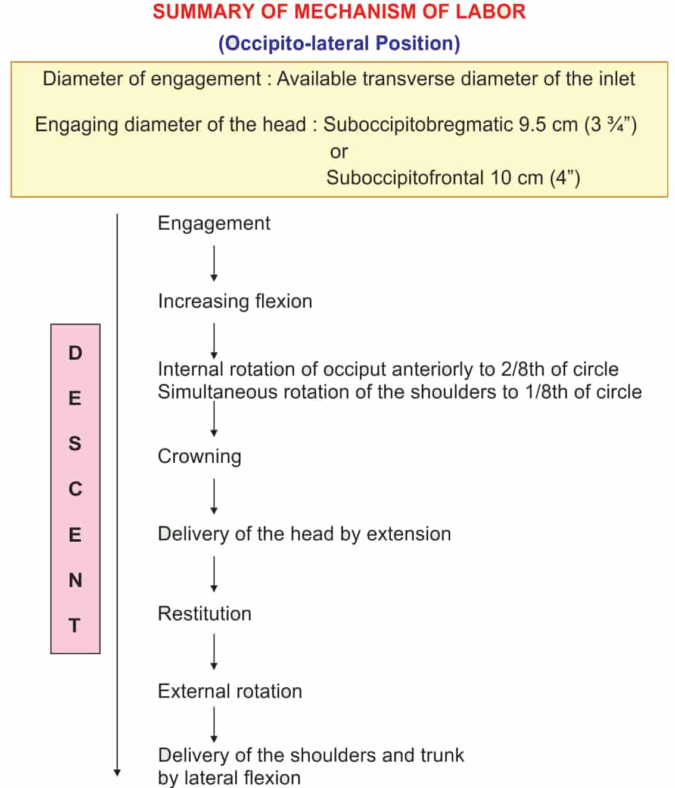

गर्भस्य लिङ्ग सूचक प्रसव पूर्वक स्राव (Characteristics of 'show' corresponding to the sex of the foetus)

तन्त्रीवर्णोऽल्पशः स्त्रावः पिच्छिलः पुत्रजन्मनि। किंशुकोदकसंकाशः पुत्रिकाजन्म शंसति।।
(का.सं.शा. 5/28)
- Acharya Kashyapa mentions that the colour and nature of the 'show' reveals the sex of the foetus.
Male child: Scanty, unctuous, yellowish pink (guduci)
Female child: Dark red like the wash of palasha flowers.

प्रसव समय आवेः प्रभाव तस्य महत्वं (Effect and significance of āvī during labor)

आव्यावृते स्त्रिया गर्भे विवृते चापरामुखे। ग्राहीषु वर्तमानासु सा विविवर्तेत गर्भिणी।।
न तीक्ष्णं ग्राहिशूलेषु क्षिप्रं नारी प्रजायते। विलम्बिताभिरावीभिर्गर्भः क्लेशयते स्त्रियम् ।।
(का.सं.शा. 5/30-31)

- Normally, during onset of labour there is presence of avi, dilatation of aparamukha along with grahishula.

[Avi is considered as normal uterine contractions and grahi is considered as abdominal muscle contractions.]
- Kashyapa further explains the significance of avi saying that inspite of strong abdominal contractions the female will not deliver spontaneously or quickly, as for an effective normal labour strong avis are a must.
- Ineffective, delayed avis cause distress to both mother and foetus.

Labor pain:
- Throughout pregnancy, painless Braxton Hicks contractions with simultaneous hardening of the uterus occur.
- These contractions change their character, become more powerful, intermittent and are associated with pain.
- Pain more often felt in front of the abdomen or radiating toward the thighs.

- FALSE PAIN:
(Synonym: false labor, spurious labor):

- It is found more in primigravidae than in parous women.
- It usually appears prior to the onset of true labor pain by 1 or 2 weeks in primigravidae and by a few days in multiparae.
- Such pains are probably due to stretching of the cervix and lower uterine segment with consequent irritation of the neighboring ganglia.
- False labor pain is:
- Dull in nature
- Confined to lower abdomen and groin,
- Not associated with hardening of the uterus,
- They have no other features of true labor pain
- Usually relieved by enema or sedative.

- True labor pain is characterized by:

- Painful uterine contractions at regular intervals
- Frequency of contractions increase gradually
- Intensity and duration of contractions increase progressively
- Associated with “show”
- Progressive effacement and dilatation of the cervix,
- Descent of the presenting part
- Formation of the “bag of forewaters”
- Not relieved by enema or sedatives.

Show

- With the onset of labor, there is profuse cervical secretion.
- Simultaneously, there is slight oozing of blood from rupture of capillary vessels of the cervix and from the raw decidual surface caused by separation of the membranes due to stretching of the lower uterine segment.
- Expulsion of cervical mucus plug mixed with blood is called “show”.

प्रसवकाले अपथ्यानि (Apathya during labor)

श्रमं नस्यं रक्तमुक्ति मैथूनं विषमाशनम्। विरुद्धान्नं वेगरोधमसात्म्यमतिभोजनम् ।। दिवानिद्रामभिष्यन्दि विष्टम्भिगुरु भोजनम्। योषितां प्रसवे प्राहुरपथ्यानि महर्षयः ।।
(भै.र. 68/115-6)

- These are considered uncongenial during labour-
- Exertion, nasya, blood letting, visama ahara, viruddha ahara, suppression of urges, asatmya diet and over eating, day sleep, abhishyandi, guru and vishtambhi diet.

CONCLUSION

- Pregnancy, parturition and puerperium are the three main stages occurring during active reproductive period of a woman’s life. Among them parturition is the stage that needs highest attention. Labour is a natures process. It concludes that the concept of Ayurveda can be proved in modern aspects as a very scientific description provided by the Acharya. As per evolution it got advanced but the roots are the same, change is natural and progressive, it should be adaptable.

REFRENCES
- Prasuti Tantra obstetrics by Dr. Hemalatha Kapoorchand
- Textbook of Prasuti tantra by Premavati Tiwari
- DC Dutta’s textbook of Obstetrics
- Mudaliar and Menon’s Clinical Obstetrics
- Williams Obstetrics
- Kashyap Samhita by P.V Tewari
- Harita Samhita by Gyanendra Pandey
- Pubmed

