Topic of Presentation
Abnormal development of Fallopian tube & Ovary

PRESENTED BY:
Dr. NIDHI PATEL
MS 2nd year dept. of PSR

Guided by
DR. KOLA VIJAYA KUMARI DR.R.VIJAYASANTHA KUMARI
Professor & HOD Associate Professor
MD(AYU) MD(AYU)

ABNORMAL DEVELOPMENT OF FALLOPIAN TUBE AND OVARY

INTRODUCTION: -
- DEVELOPMENT OF FALLOPIAN TUBE:-

- Between the fifth and sixth week after oocyte fertilization, a longitudinal groove called Müller's groove arises from the coelomic epithelium on each side lateral to the mesonephric duct.
- Embryos develop a genital ridge that forms at their tail end and eventually forms the basis for the urinary system and reproductive tracts.
- Either side and to the front of this tract, around the sixth week develops a duct called the paramesonephric duct, also called the Müllerian duct.
- A second duct, the mesonephric duct, develops adjacent to this.
- Both ducts become longer over the next two weeks, and the paramesonephric ducts around the eighth week cross to meet in the midline and fuse.
- One duct then regresses, with this depending on whether the embryo is genetically female or male.
- In females, the paramesonephric duct remains, and eventually forms the female reproductive tract.
- The portions of the paramesonephric duct which are more cranial—that is, further from the tail-end, end up forming the fallopian tubes.
- In males, because of the presence of the Y sex chromosome, anti-Müllerian hormone is produced. This leads to the degeneration of the paramesonephric duct.
- As the uterus develops, the part of the fallopian tubes closer to the uterus, the ampulla, becomes larger.
- Extensions from the fallopian tubes, the fimbriae, develop over time.

- ANATOMY AND FUNCTION OF FALLOPIAN TUBE: -
- The fallopian tubes are bilateral conduits between the ovaries and the uterus in the female pelvis. They function as channels for oocyte transport and fertilization.
- Uterine tubes/ Tortuous tubes
- Hallow muscular tube (10 cm in length and 1cm breadth)
- Situated in the medial 3/4th of upper free margin of the broad ligaments.
- 2 openings:-uterine opening
pelvic opening/Abdominal ostium
- The fallopian tube comprises four anatomical regions: uterine, isthmus, ampulla, and infundibulum.

ABNORMAL DEVELOPMENT OF FALLOPIAN TUBE: -
- TUBAL AGENESIS: -
- Tubal agenesis may contribute to infertility.
- The true etiology of ipsilateral ovarian and/or tubal absence has yet to be elucidated. The two most likely causes of ipsilateral ovarian and/or tubal absence may include an asymptomatic torsion of the adnexa with consequent organ ischemia and reabsorption, or a defect in the development of the Mullerian and gonadal structures underlying vascular anomalies.
- In the sixth week of gestation, the bilateral Mullerian ducts migrate towards the midline, meet, form luminal structures, fuse and finally form the uterus and upper one-fifth of the vagina. Rostrally, the Mullerian ducts form fallopian tubes.
- Any disturbance in the migration, fusion or resorption of these ducts may result in a Mullerian anomaly.
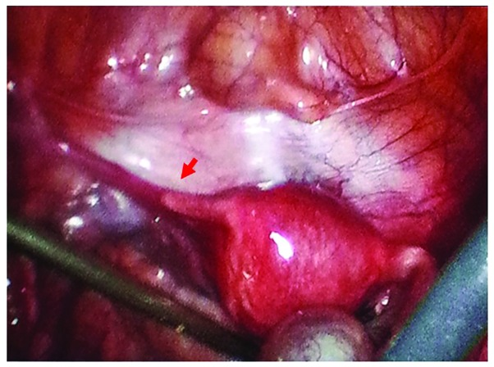
- Laparoscopic view reveals a round ligament on the left side and a normal uterus, with no visible left tube or ovary, only a 2-cm tubal remnant. The right fallopian tube and right ovary (with a corpus luteum) were considered to be normal (arrow indicates tubal remnant).

- DUPLICATION OR ACCESORY FALLOPIAN TUBE : -
- The accessory fallopian tubes are congenital and developmental Mullerian duct abnormality of the fallopian tube.
- These are non-patent cylindrical structured attached to the ampullary part of a normal-sized tube.
- The accessory fallopian tubes are one of the main contributory factors of infertility as their fimbria pick the ovum instead of fimbria ovarica of normal tube.
- Ectopic pregnancy, cystic swelling and pyosalpinx are other complications related to accessory fallopian tubes.
- Accessory fallopian tubes are rare developmental anomalies resulting from bifurcation of cranial ends of Mullerian ducts, which normally develops into fallopian tube.
- A 25-year-old woman with history of infertility whose hysterosalpingogram showed partial duplication of left fallopian tube.
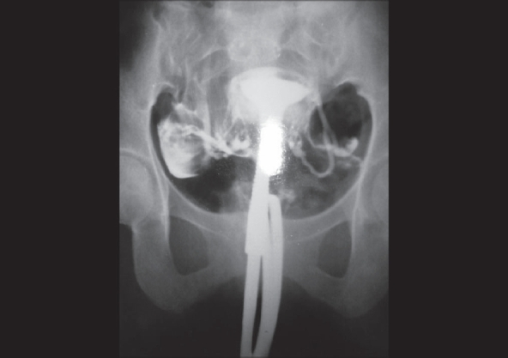

- DIVERTICULOSIS OF THE FALLOPIAN TUBES :-
- Tubal diverticula are small, thin-walled, outpouches present in the isthmus or ampullary portion of the fallopian tube.
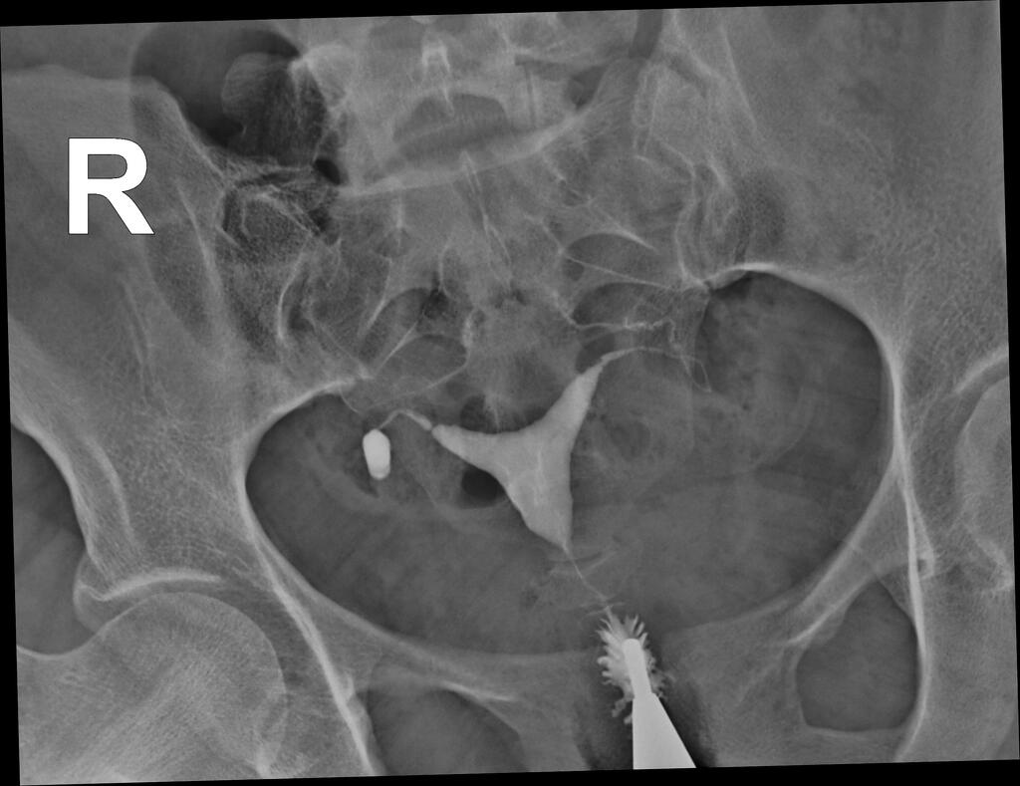
- Infertility was the commonest clinical association of diverticulosis. Among infertile patients, hydrosalpinx and tubal obstruction were slightly commoner in the presence of diverticulosis.

- Normal uterine shape
- The injected contrast spills freely out from the ends of the fallopian tube
- Diverticular outpouching at the isthmus portion of the right fallopian tube
- No filling defects

- DEVELOPMENT OF THE OVARY: -
SITE: -
- The ovary is developed on either side from the genital or gonadal ridge.
- This ridge is formed in a four week embryo between the dorsal mesentery (medially) and the mesonephric ridge (laterally) by the multiplication of the coelomic epithelium along with condensation of the underlying mesenchyme.

SOURCES:-
- The cortex and the covering epithelium are developed from the coelomic epithelium and the medulla from the mesenchyme.
- The germ cells are of endodermal origin. They migrate from the yolk sac to the genital ridge along the dorsal mesentery by ameboid movement between 20 and 30 days.
- The germ cells undergo a number of rapid mitotic divisions and differentiate into oogonia.
- The number of oogonia reaches its maximum at 20th week numbering about 7 million.
- The mitotic division gradually ceases and the majority enter into the prophase of the first meiotic division and are called primary oocytes.
- These are surrounded by flat cells (granulosa cells) and are called primordial follicles. At birth, there is no more mitotic division and all the oogonia are replaced by primary oocytes. The estimated number at birth is about 2 million.

INDIFFERENT OR PRIMITIVE GONAD
- Initially, the gonads do not acquire male or female morphological characteristics until the seventh week of development.
- Around the time of arrival of germ cells, the coelomic epithelium of the genital ridge proliferates.
- The irregular cords of cells (primitive sex cords) invaginate the underlying mesenchyme.
- These cords of cells surround the primordial germ cells and still have connection with the surface epithelium.
- It is difficult at this stage to differentiate between an ovary and testis.

DEFINITIVE GONAD
- In a XX individual, without the active influence of Y chromosome, the bipotential gonad develops into an ovary about two weeks later than testicular development.
- SRY gene located on the short arm of Y chromosome directly controls the differentiation of testis from the bipotential gonad.
- Apart from SRY, autosomal genes are also essential for differentiation of the gonads. Absence of SRY gene leads to female sex differentiation.
- Genetic control is of prime importance for differentiation of bipotential gonad. Genes that regulate the process are: Wilms’ tumor gene (WTI), FTZI and SRY. Second gene involved in development of testis is SOX9 and anti-Müllerian hormone (produced by Sertoli cells).
- DAXI gene expression is involved in ovarian differentiation. DAXI antagonizes the action of SRY gene.
- The surface becomes thicker and continues to proliferate extensively. It sends down secondary cords of cells into the mesenchyme (cortical cords), but unlike testis, maintains connection with the surface epithelium.
- In the fourth month, these cords split into clusters of cells, which surround the germ cells.
- The germ cells will be the future oogonia and the epithelial cells will be the future granulosa cells.
- From 20th week, the oocytes that are not surrounded by the granulosa cell envelope, are destroyed.
- The stromal mesenchymal cells also surround the follicular structure to form the future theca cells.
- Thus, a basic unit of a follicle is completed.
- By 28th week, number of these follicles are exposed to maternal gonadotropin and undergo various degrees of maturation (little short of antrum formation) and atresia.

DESCENT OF THE OVARY
- The cranial part of the genital ridge becomes the infundibulopelvic ligament.
- From the lower pole of the ovary, genital ligament (gubernaculum) is formed, which is attached to the genital swelling (labial).
- Gubernaculum is a fibromuscular band.
- The genital ligament gets an intermediate attachment as it comes close to Müllerian ducts (angle of the developing uterus).
- The part between the ovary and the Müllerian attachment is the ovarian ligament and the part between the cornu of the uterus to the end is the round ligament.
- The ovaries descend during the seventh to ninth months, and at birth, they are situated at the pelvic brim.

ANATOMY: -

- Female gonads and Lying in the ovarian fossa on the lateral pelvic wall.
- Concerned with germ cell maturation storage and its release.
- Intraperitoneal structures
- Almond in shape
- Measuring 3 x 2 x 1 cm.
- Nullipara- vertical, smooth and greyish pink
multipara- horizontal and uneven and grey in colour.
- 2 poles-upper and lower
- 2 borders-anterior and posterior
- 2 surfaces- lateral and medial

- ABNORMAL DEVELOPMENT OF OVARY: -
- STREAK GONAD or GONADAL DYSGENESIS: -
- It is the atypical development of the gonads in an embryo, with reproductive tissue replaced with functionless, fibrous tissue, termed streak gonads.
- Streak gonads are a form of aplasia, resulting in hormonal failure that manifests as sexual infantism and infertility, with no initiation of puberty and secondary sex characteristics.
- Gonadal development is a genetically controlled process by the chromosomal sex (XX or XY) which directs the formation of the gonad (ovary or testis).
- Gonadal dysgenesis arises from the failure of signalling in this tightly regulated process during early foetal development.
- Manifestations of gonadal dysgenesis are dependent on the aetiology and severity of the underlying defect.

CAUSES: -
- Pure gonadal dysgenesis 46, XX also known as XX gonadal dysgenesis
- Pure gonadal dysgenesis 46, XY also known as XY gonadal dysgenesis
- Mixed gonadal dysgenesis also known as partial gonadal dysgenesis, and 45,X/46,XY mosaicism
- Turner syndrome also known as 45, X or 45,X0
- Endocrine disruptions
46,XX gonadal dysgenesis
- 46, XX gonadal dysgenesis is characteristic of female hypogonadism with a karyotype of 46, XX.
- Streak ovaries are present with non-functional tissues unable to produce the required sex steroid oestrogen.
- Low levels of oestrogen effect the HPG axis with no feedback to the anterior pituitary to inhibit the secretion of FSH and LH.
- FSH and LH are secreted at abnormal elevated levels.
- Improper levels of these hormones will cause a failure to initiate puberty, undergo menarche, and develop secondary sex characteristics.
- If sufficient functional ovarian tissue is present, limited menstrual cycles can occur.
- The pathogenesis of 46,XX gonadal dysgenesis is unclear, as it can manifest from a variety of dysregulations.
- Interruption during ovarian development in embryogenesis can cause 46,XX gonadal dysgenesis with cases of abnormalities in the FSH receptor and mutations in steroidogenic acute regulatory protein (StAR protein) which regulates steroid hormone production.

Mixed gonadal dysgenesis
45,X/46,XY mosaicism
- Mixed gonadal dysgenesis, also known as X0/XY mosaicism or partial gonadal dysgenesis, is a sex development disorder associated with sex chromosome aneuploidy and mosaicism of the Y chromosome.
- Mixed gonadal dysgenesis is the presence of two or more germ line cells.
- The degree of development of the male reproductive tract is determined by the ratio of germ line cells expressing the XY genotype.
- Manifestations of mixed gonadal dysgenesis are highly variable with asymmetry in gonadal development of testis and streak gonad, accounted for by the percentage of cells expressing XY genotype.
- The dysgenic testis can have adequate functional tissue to produce satisfactory levels of testosterone to cause masculinisation.
- Mixed gonadal dysgenesis is poorly understood at the molecular level.
- The loss of the Y chromosome can occur from deletions, translocations, or migration failure of paired chromosomes during cell division.
- The chromosomal loss results in partial expression of the SRY gene, giving rise to abnormal development of the reproductive tract and altered hormone levels.

TURNER’S SYNDROME
- Turner syndrome, also known as 45,X or 45,X0, is a chromosomal abnormality characterised by a partial or completely missing second X chromosome, giving a chromosomal count of 45, instead of the typical count of 46 chromosomes.
- The cases usually present as primary amenorrhea with delayed secondary sex characters. The syndrome is characterized by short stature (height < 150 cm), webbing of the neck, cubitus valgus, broad shield chest, low hair line on the neck, lymphedema, short fourth metatarsals and poor development of secondary sex characters.
- They are mentally retarded and often associated with coarctation of aorta.
- Cardiac (coarctation of aorta), Renal anomalies (horseshoe kidneys) and multiglandular autoimmune disorders are common.
- 45X is the commonest chromosomal abnormality and 99% of fetuses are aborted.
- Vagina, uterus and fallopian tubes are present.
- The uterus is small but is responsive to exogenous estrogen.
- Gonads are ‘streaks’ (fibrous tissue) without any follicle nor any potentiality to produce hormone (chromosomally incompetent ovarian failure).
- Associated autoimmune disorders like Hashimoto’s thyroiditis, Addison’s disease, hypothyroidism are common.

Investigations:-
Confirmation of the clinical diagnosis is by the following.
- Sex chromatin study is negative.
- Karyotype is 45, XO.
- Serum E2 is very low.
- Serum FSH and LH are elevated.
- Autoantibodies may be present
- Thus, there is hypergonadotrophic hypogonadism state.

Mosaic variety:
- In mosaic variety, the classic features of Turner are absent.
- The individual is of normal height.
- Ovaries are ‘streaks’ with few follicles.
- Occasionally, menstruation can occur for few cycles until the follicles are exhausted. Pregnancy has also been recorded.
- Sex chromatin is doubtful.
- Karyotype is 46, XX/45, XO.

Structural abnormality of X chromosome
- Deletion of genetic material from short arm of ‘X’ chromosome leads to somatic features of Turner’s syndrome (short stature). Loss of the long arm near the centromere leads to primary amenorrhea.

- DIAGNOSIS:-
- At birth:
Most cases of ambiguous genitalia detected at birth are due to either congenital adrenal hyperplasia (21-hydroxylase deficiency) or to androgenic drugs administered to the mother in early pregnancy.

- At puberty:
Most cases presented at puberty are late manifestations of congenital adrenal hyperplasia, those of gonadal dysgenesis and rarely male intersex (testicular feminization).
In these conditions, the child is reared up as girl and she is brought to the clinician either for poor development of secondary sex characters or for primary amenorrhea with or without hirsutism.

- MANAGEMENT :-
- karyotyping should be done.
- The presence of ‘Y’ chromatin necessitates removal of the gonads as there is chance of dysgerminoma, seminoma or gonadoblastoma in such gonads, Substitution therapy using cyclic estrogen and progestogen will help to develop secondary sex characters.

Turner’s syndrome
- Exogenous growth hormone (GH) can increase the height.
- Low dose estrogen (conjugated estrogen 0.625 mg) orally daily for 25 days with progestin (medroxyprogesterone acetate 5 mg daily) for last 10 days is started after 13 years of age.

- ACCESSORY OVARY:-
- Ectopic ovaries including accessory ovaries and supernumerary ovaries are very rare gynecological conditions.
- Accessory ovary can be distinguished from supernumerary ovary by its relationship with normal ovary, as it is situated near or connected to normal ovary.
- It can also be found attached to the fallopian tube or one of the various ligamentous structures of the utero-ovarian complex.
- There are two theories which explain the formation of accessory ovaries.
- According to the embryological theory, they are formed as a result of the abnormal separation of a small part of the developing and migrating ovarian primordium.
- The second theory by Lachman and Berman explains the formation of accessory ovaries in cases of acquired conditions such as inflammation and surgery. According to this theory, part of the ovarian tissue which is detached from the ovary could implant anywhere in the pelvic cavity and continue to function in vivo.
- As accessory ovaries develop from abnormal embryogenesis, congenital anomalies, or genetic defects are often associated with them. These malformations include accessory fallopian tube, bicornuate uterus, and renal agenesis.

- UNDESCENDED OVARIES: -
- At birth, the ovaries are located at the pelvic brim. They gradually descend to the pelvis by puberty.
- Undescended ovaries (rare) are associated with absent Müllerian system or unicornuate uterus and can confuse the ultrasound scanning.
- The undescended ovaries are at risk of malignancy as with undescended testes.
- The undescended ovaries are seen in the absence of bilateral Müllerian duct in as much as 40% cases and unicornuate uterus in 20% cases.
- The ovaries can be located by ultrasound scanning, computed tomography (CT) and magnetic resonance imaging (MRI).
- The significance of undescended ovaries is as follows:
- They are associated with Müllerian duct anomalies and may adversely influence the menstrual and reproductive functions.
- Ovulation monitoring may be difficult.
- Ovarian pain may be misinterpreted as appendicitis or intestinal pain.
- Ovarian tumour may be misinterpreted as other abdominal tumour.
- Risk of malignancy

- Since these abnormally located ovaries may develop malignancy, it may be advisable to remove them and put the woman on hormonal replacement therapy. In vitro fertilization with donor egg may be possible if the uterus is present.

REFRENCES: -
- Shaw’s Textbook of Gynecology
- D C Dutta textbook of Gynecology
- Pubmed

