Topic of Presentation
COMPLICATIONS OF DIFFERENT STAGES OF LABOR

PRESENTED BY:
Dr. NIDHI PATEL
MS Final year PG Scholar,
dept. of PSR

Guided by
DR. KOLA VIJAYA KUMARI
Professor & HOD
MD(AYU)

DEFINITION OF LABOR
- Series of events that take place in the genital organs in an effort to expel the viable products of conception (fetus, placenta and the membranes) out of the womb through the vagina into the outer world is called Labor.

- NORMAL LABOR (EUTOCIA):
- Labor is called normal if it fulfills the following criteria.
- Spontaneous in onset and at term.
- With vertex presentation.
- Without undue prolongation.
- Natural termination with minimal aids.
- Without having any complications affecting the health of the mother and/or the baby.

- ABNORMAL LABOR (DYSTOCIA):
- Any deviation from the definition of normal labor is called Abnormal labor.
- Thus, labor in a case with presentation other than vertex or having some complications even with vertex presentation affecting the course of labor or modifying the nature of termination or adversely affecting the maternal and/or fetal prognosis is called abnormal labor.

STAGES OF LABOR
- FIRST STAGE
- It starts from the onset of true labor pain and ends with full dilatation of the cervix.
- It is, in other words, the “cervical stage” of labor.
- Its average duration is 12 hours in primigravidae and 6 hours in multiparae.

- SECOND STAGE
- It starts from the full dilatation of the cervix (not from the rupture of the membranes) and ends with expulsion of the fetus from the birth canal. It has got two phases—
(1) The propulsive phase—starts from full dilatation up to the descent of the presenting part to the pelvic foor.
(2) The expulsive phase is distinguished by maternal bearing down eforts and ends with delivery of the baby.
- Its average duration is 2 hours in primigravidae and 30 minutes in multiparae

- THIRD STAGE
- It begins after expulsion of the fetus and ends with expulsion of the placenta and membranes (afterbirths).
- Its average duration is about 15 minutes in both primigravidae and multiparae. The duration is, however, reduced to 5 minutes in active management.

- FOURTH STAGE
- It is the stage of observation for at least 1 hour after expulsion of the afterbirths.
- During this period maternal vitals, uterine retraction and any vaginal bleeding are monitored.
- Baby is examined.
- These are done to ensure that both the mother and baby are well

COMPLICATIONS OF FIRST & SECOND STAGE OF LABOR
- Cephalopelvic disproportion(CPD)
- The disparity in the relation between the head and the pelvis is called cephalopelvic disproportion.
- Disproportion may be either due to an average size baby with a small pelvis or due to a big baby (hydrocephalus) with normal size pelvis or due to a combination of both the factors.
- The course of events in labor is greatly modified depending upon the degree of pelvic contraction and presentation of the fetus:
(1) There is increased incidence of early rupture of the membranes;
(2) Incidence of cord prolapse is increased;
(3) Cervical dilatation is slowed;
(4) There is increased tendency of prolonged labor and in neglected cases, obstructed labor with features of exhaustion, dehydration, ketoacidosis and sepsis
(5) There is increased incidence of operative interference, shock, postpartum; and hemorrhage and sepsis

MANAGEMENT
- The moderate and the severe degrees are to be dealt by any one of the following:
 Induction of labor
 Elective cesarean section at term
 Trial labor

- Premature Rupture of Membranes(PROM)
- Spontaneous rupture of the membranes any time beyond 28th week of pregnancy but before the onset of labor is called prelabor rupture of the membranes (PROM).
- When rupture of membranes occur beyond 37th week but before the onset of labor, it is called term PROM and when it occurs before 37 completed weeks, it is called preterm PROM.

CAUSES:
- In majority, the causes are not known. The possible causes are:
(1) Increased friability of the membranes;
(2) Decreased tensile strength of the membranes;
(3) Polyhydramnios;
(4) Cervical incompetence;
(5) Multiple pregnancy;
(6) Infection—Chorioamnionitis, urinary tract infection and lower genital tract infection;
(7) Cervical length < 2.5 cm;
(8) Prior preterm labor and
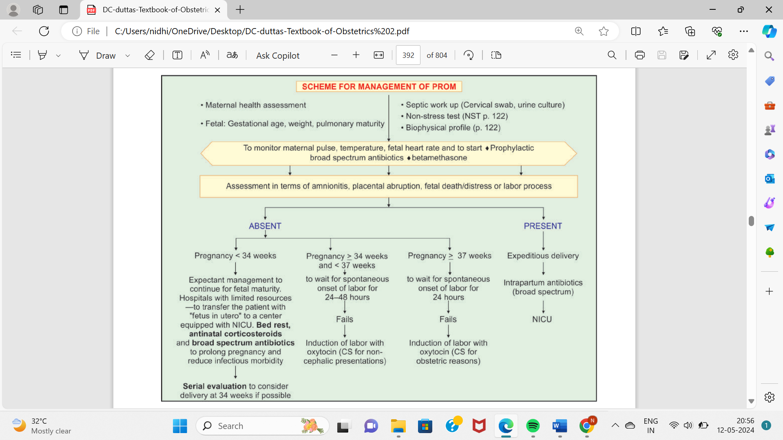
(9) Low BMI

- MALPOSITION & MALPRESENTATION:-
- Occiput-posterior position
- Arrested Occiput-posterior position
- DEEP TRANSVERSE ARREST (DTA)
- BREECH PRESENTATION
- Breech with extended legs (Frank breech)
- Footling presentation (25%)
- Knee presentation
- FACE PRESENTATION
- BROW PRESENTATION
- TRANSVERSE LIE
- SHOULDER PRESENTATION
- UNSTABLE LIE
- COMPOUND PRESENTATION

- CORD PROLAPSE:-
- There are three clinical types of abnormal descent of the umbilical cord by the side of the presenting part.
- All these are placed under the heading cord prolapse.

- Occult prolapse
- The cord is placed by the side of the presenting part and is not felt by the fingers on internal examination. It could be seen on ultrasonography or during cesarean section.

- Cord presentation
- The cord is slipped down below the presenting part and is felt lying in the intact bag of membranes.

- Cord prolapse
- The cord is lying inside the vagina or outside the vulva following rupture of the membranes.

Causes:-
- The following are the associated factors:
(1) Malpresentations—the most common being transverse (5–10%) and breech (3%) especially with flexed legs or footling and compound (10%) presentation,
(2) Contracted pelvis,
(3) Prematurity,
(4) Twins,
(5) Hydramnios,
(6) Placental factor— minor degree placenta previa with marginal insertion of the cord or long cord,
(7) Iatrogenic—low rupture of the membranes, manual rotation of the head
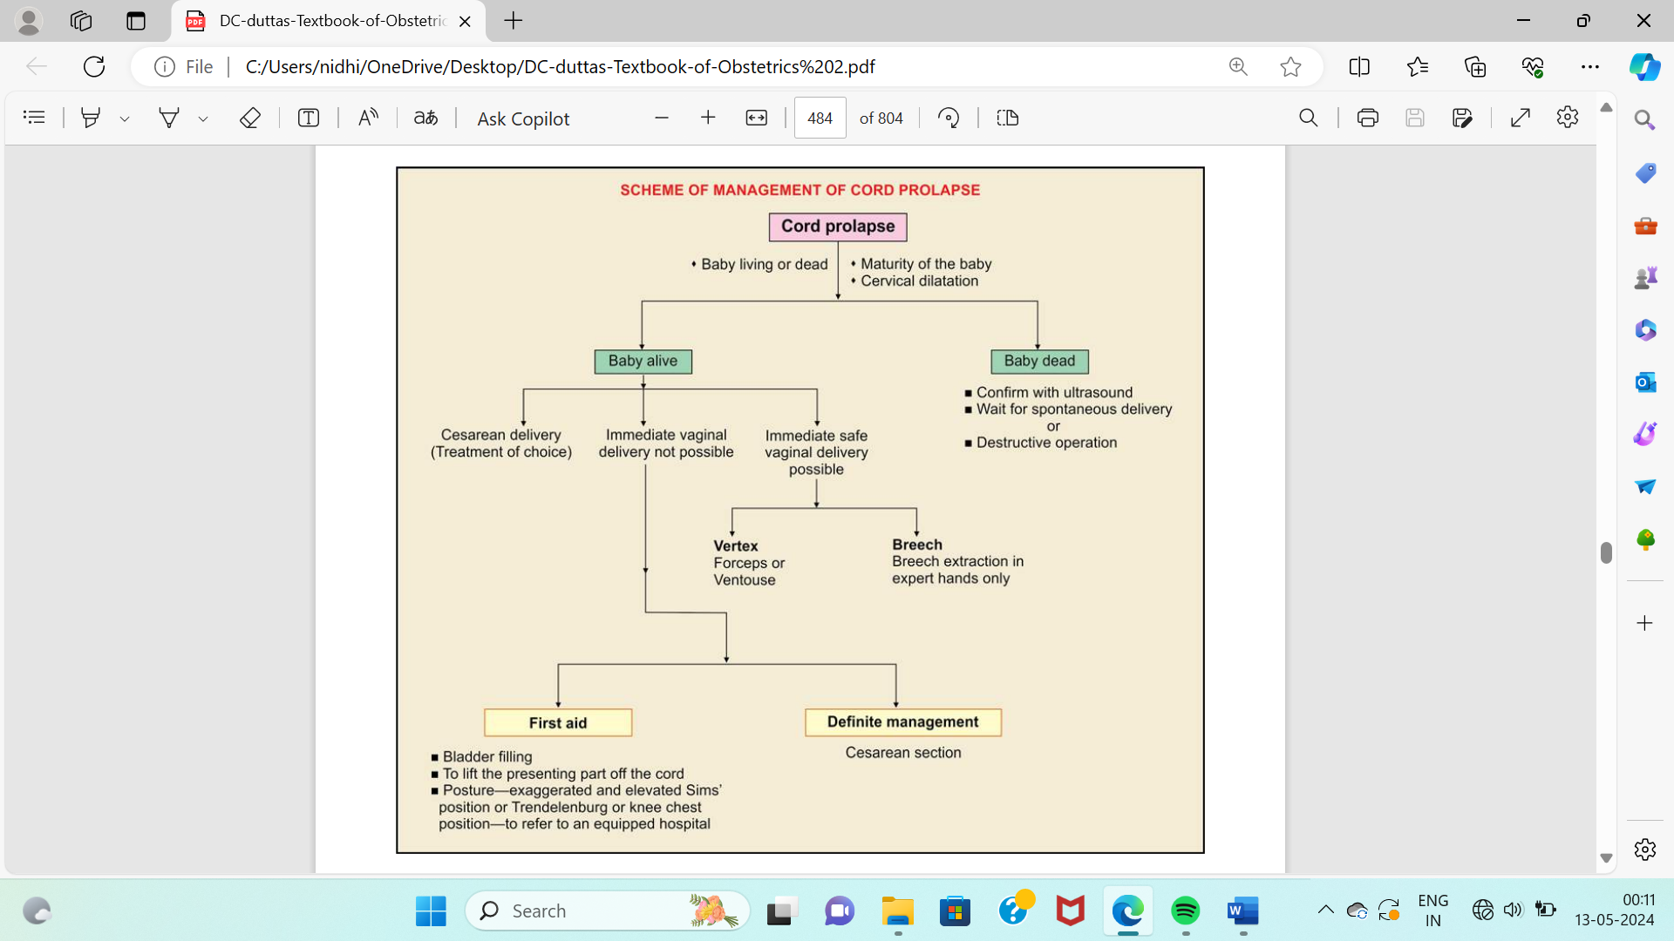
(8) Stabilizing induction
- PROLONGED LABOR:-
- The labor is said to be prolonged when the combined duration of the first and second stage is more than the arbitrary time limit of 18 hours.
- The prolongation may be due to protracted cervical dilatation in the first stage and/or inadequate descent of the presenting part during the first or second stage of labor.
- Labor is considered prolonged when the cervical dilatation rate is less than 1 cm/h and descent of the presenting part is less than 1 cm/h for a period of minimum 4 hours observation (WHO-1994).
- Prolonged labor is not synonymous with inefficient uterine contraction.
- Inefficient uterine contraction can be a cause of prolonged labor, but labor may also be prolonged due to pelvic or fetal factor.

- OBSTRUCTED LABOR:-
- Obstructed labor is one where in spite of good uterine contractions, the progressive descent of the presenting part is arrested due to mechanical obstruction.
- This may result either due to factors in the fetus or in the birth canal or both, so that further progress is almost impossible without assistance.

- SHOULDER DYSTOCIA
- The term shoulder dystocia is defined to describe a wide range of additional obstetric maneuvers to deliver the fetus after the head has been born and gentle traction has failed to deliver the shoulder.
- Shoulder dystocia occurs when either the anterior or the posterior (rare) fetal shoulder impacts on the maternal symphysis or on the sacral promontory respectively.
- Overall incidence varies between 0.2% and 1%.

Risk factors:
(1) Previous shoulder dystocia,
(2) Macrosomia (>4.5 kg),
(3) Diabetes,
(4) Obesity (BMI > 30 kg/m2 ),
(5) Induced labor,
(6) Prolonged first stage or second stage of labor,
(7) Secondary arrest of labor,
(8) Postmaturity,
(9) Multiparity,
(10) Anencephaly,
(11) Mid-pelvic instrumental delivery (more following ventouse than forceps),
(12) Fetal ascites

Management principles:
- Extra help is to be called
(a) To clear infant’s mouth and nose
(b) Not to give traction over baby’s head
(c) Never to apply fundal pressure as it causes further impaction of the shoulder
(d) To perform wide mediolateral episiotomy as it provides space posteriorly
(e) To involve the anesthetist (as analgesia is ideal) and the pediatrician (for infant’s resuscitation).

- PRECIPITATE LABOR:-
- A labor is called precipitate when the combined duration of the first and second stage is less than 3 hours.
- Prevalence is about 2%.
- Short labors may be associated with: placental abruption and uterine tachysystole.
- It is common in multiparae and may be repetitive.
- Rapid expulsion is due to the combined effect of hyperactive uterine contractions associated with diminished soft tissue resistance.
- Labor is short as the rate of cervical dilatation is 5 cm/hr or more for the nulliparous women.

Treatment:
- The patient having previous history of precipitate labor should be hospitalized prior to labor.
- During labor, the uterine contraction may be suppressed by administering ether or magnesium sulfate during contractions.
- Delivery of the head should be controlled.
- Episiotomy should be done liberally.
- Elective induction of labor by low rupture of membranes and conduction of controlled delivery is helpful.
- Oxytocin augmentation should be avoided.

- ABNORMAL UTERINE ACTION:-
- UTERINE INERTIA (HYPOTONIC UTERINE DYSFUNCTION)
- INCOORDINATE UTERINE ACTION
- TONIC UTERINE CONTRACTION AND RETRACTION

- UTERINE RUPTURE:-
- Disruption in the continuity of the all uterine layers (endometrium, myometrium and serosa) any time beyond 28 weeks of pregnancy is called rupture of the uterus.
- If someone has previously had a caesarian delivery, there is a small chance that the scar could open during future labor.
- Apart from a previous cesarean delivery, other possible risk factors include:
- the induction of labor
- the size of the baby
- maternal age of 35 years or more
- the use of instruments in vaginal delivery
- If this happens, the baby may be at risk of oxygen deprivation and a caesarian delivery may be necessary. The mother may be at risk of excessive bleeding.

COMPLICATIONS OF THIRD STAGE OF LABOR
- Of all the stages of labor, third stage is the most crucial one for the mother.
- The following are the important complications:
(1) Postpartum hemorrhage,
(2) Retention of placenta,
(3) Shock—hemorrhagic or non-hemorrhagic,
(4) Pulmonary embolism either by amniotic fluid or by air,
(5) Uterine inversion (rare)

- POSTPARTUM HEMORRHAGE (PPH)

- Quantitative definition
It is arbitrary and is related to the amount of blood loss in excess of 500 mL following birth of the baby (WHO).

- Clinical definition, which is more practical states,
“any amount of bleeding from or into the genital tract following birth of the baby up to the end of the puerperium, which adversely affects the general condition of the patient evidenced by rise in pulse rate and falling blood pressure is called postpartum hemorrhage”.

- The average blood loss following vaginal delivery, cesarean delivery and cesarean hysterectomy is 500 mL, 1000 mL and 1500 mL respectively.
- Depending upon the amount of blood loss, PPH can be
♦ Minor (< 1L),
♦ Major (> 1L) or
♦ Severe (> 2L)

- TYPES

Primary: Hemorrhage occurs within 24 hours following the birth of the baby. In the majority, hemorrhage occurs within two hours following delivery.
- These are of two types:
 Third stage hemorrhage—Bleeding occurs before expulsion of placenta.
 True postpartum hemorrhage—Bleeding occurs subsequent to expulsion of placenta (majority).
Secondary: Hemorrhage occurs beyond 24 hours and within puerperium, also called delayed or late puerperal hemorrhage.

- PRIMARY PPH
- CAUSES

- Atonic uterus (80%)
- Atonicity of the uterus is the commonest cause of postpartum hemorrhage.
- With the separation of the placenta, the uterine sinuses, which are torn, cannot be compressed effectively due to imperfect contraction and retraction of the uterine musculature and bleeding continues.
- The following are the conditions, which often interfere with the retraction of the uterus as a whole and of the placental site in particular.
- Grand multipara
- Overdistension of the uterus
- Malnutrition and anemia (Less than 9.0 g/dl)
- Antepartum hemorrhage (Both placenta previa and abruption)
- Prolonged labor (>12 hours)
- Anesthesia
- Initiation or augmentation of delivery by oxytocin
- Malformation of the uterus
- Uterine fbroid
- Mismanaged third stage of labor
- Placenta
- Precipitate labor
- Other causes of atonic hemorrhage are: Obesity (BMI > 35), Previous PPH, Age (>40 yrs), Drugs: Use of tocolytic drugs (ritodrine), MgSO4 , Nifedipine.

- Traumatic (20%)
- Trauma to the genital tract usually occurs following operative delivery; even after spontaneous delivery.
- Blood loss from the episiotomy wound is often underestimated.
- Trauma involves usually the cervix, vagina, perineum (episiotomy wound and lacerations), paraurethral region and rarely, rupture of the uterus occurs.
- The bleeding is usually revealed but can rarely be concealed (vulvovaginal or broad ligament hematoma).

- Retained tissues
- Bits of placenta, blood clots cause PPH due to imperfect uterine retraction.

- Thrombin
- Blood coagulation disorders, acquired or congenital, are less common causes of postpartum hemorrhage.
- The blood coagulopathy may be due to diminished procoagulants (washout phenomenon) or increased fibrinolytic activity.
- The firmly retracted uterus can usually prevent bleeding.
- The conditions where such disorders may occur are abruptio placentae, jaundice in pregnancy, thrombocytopenic purpura, severe preeclampsia, HELLP syndrome or in IUD.
- Specific therapy following coagulation screen including recombinant activated factor VII (rF VIIa) may be given.

- MANAGEMENT OF THIRD STAGE BLEEDING
- The principles in the management are:
 To empty the uterus of its contents and to make it contract.
 To replace the blood. On occasion, patient may be in shock. In that case patient is managed for shock first.
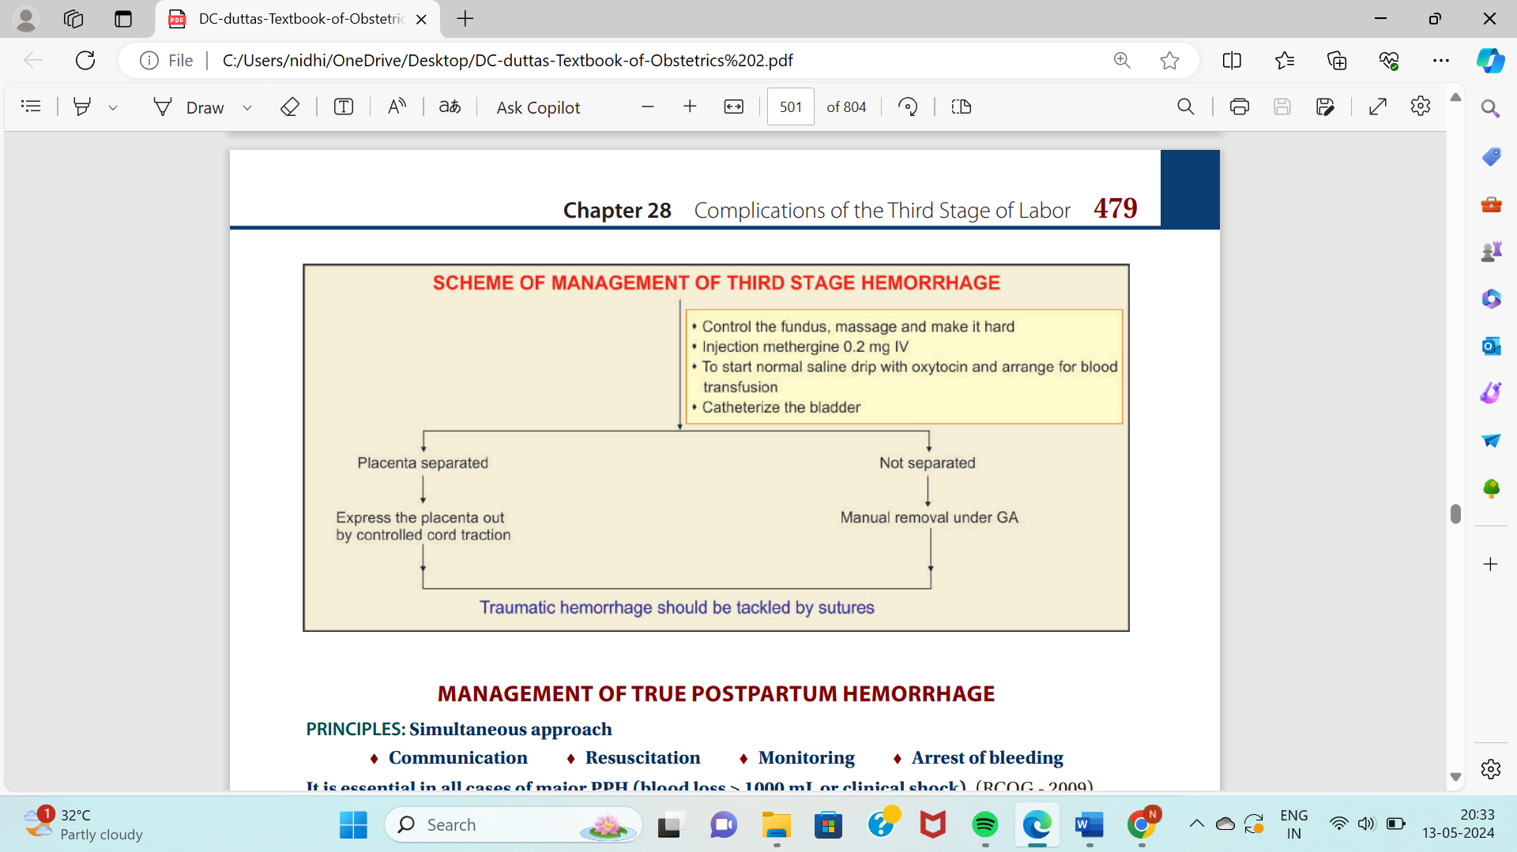
 To ensure effective hemostasis in traumatic bleeding.
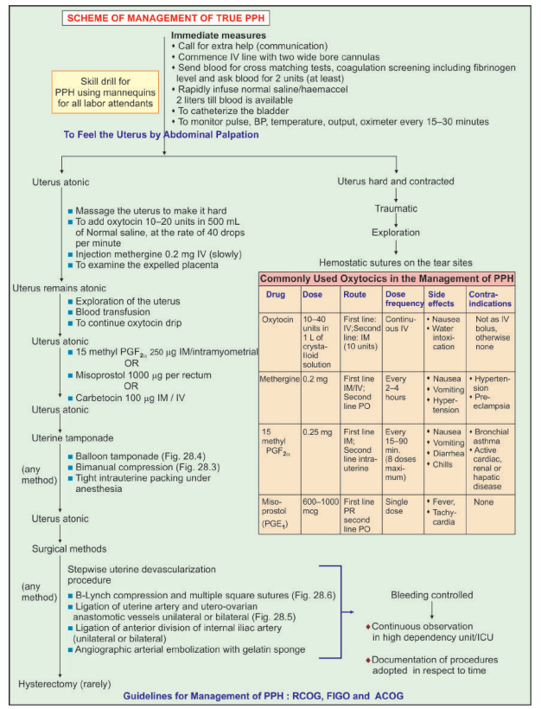
- MANAGEMENT OF TRUE POSTPARTUM HEMORRHAGE

- SECONDARY PPH:-

- CAUSES:-
- The bleeding usually occurs between 8th and 14th day of delivery.
- The causes of late postpartum hemorrhage are:
(1) Retained bits of cotyledon or membranes (most common),
(2) Infection and separation of slough over a deep cervicovaginal laceration,
(3) Endometritis and subinvolution of the placental site—due to delayed healing process,
(4) Secondary hemorrhage from cesarean section wound usually occur between 10–14 days. It is probably due to—(a) separation of slough exposing a bleeding vessel or (b) from granulation tissue,
(5) Withdrawal bleeding following estrogen therapy for suppression of lactation,
(6) Other rare causes are: chorionepithelioma—occurs usually beyond 4 weeks of delivery; carcinoma cervix; placental polyp; infected fibroid or fibroid polyp and puerperal inversion of uterus.

- DIAGNOSIS:-
- The bleeding is bright red and of varying amount. Rarely it may be brisk.
- Varying degree of anemia and evidences of sepsis are present.
- Internal examination reveals evidences of sepsis, subinvolution of the uterus and often a patulous cervical os.
- Ultrasonography is useful in detecting the bits of placenta inside the uterine cavity.

- MANAGEMENT:-
Principles:
- To assess the amount of blood loss and to replace it (blood transfusion).
- To find out the cause and to take appropriate steps to rectify it.
Supportive therapy:
(1) Blood transfusion, if necessary,
(2) To administer methergine 0.2 mg intramuscularly, if the bleeding is uterine in origin,
(3) To administer antibiotics (clindamycin and metronidazole) as a routine.
Conservative:
- If the bleeding is slight and no apparent cause is detected, a careful watch for a period of 24 hours or so is done in the hospital.
Active treatment:
- As the most common cause is due to retained bits of cotyledon or membranes, it is preferable to explore the uterus urgently under general anesthesia.
- One should not ignore the small amount of bleeding; as unexpected alarming hemorrhage may follow sooner or later.
- The products are removed by ovum forceps. Gentle curettage is done by using flushing curette.
- Methergine 0.2 mg is given intramuscularly. The materials removed are to be sent for histological examination.

- RETAINED PLACENTA:-
DEFINITION:
- The placenta is said to be retained when it is not expelled out even 30 minutes after the birth of the baby (WHO 15 minutes).
CAUSES:
- There are three phases involved in the normal expulsion of placenta:
- Separation through the spongy layer of the decidua, (2) Descent into the lower segment and vagina, (3) Finally its expulsion to outside.
- Interference in any of these physiological processes, results in its retention.

MANAGEMENT:
- Placenta is separated and retained—To express the placenta out by controlled cord traction.
- Unseparated retained placenta (apparently uncomplicated): Manual removal of placenta is to be done under general anesthesia.

- PLACENTA ACCRETA:-
- Placenta accreta is an extremely rare form in which the placenta is directly anchored to the myometrium partially or completely without any intervening decidua.
- The probable cause is due to absence of decidua basalis and poor development of fibrinoid layer. Overall incidence of placenta accreta or its variations is 1 in 550 deliveries.

Risk factors for placenta accreta: Most important are the placenta previa and prior cesarean delivery. Other risk factors include prior uterine surgery (dilatation and curettage, manual removal of placenta, synaecolysis or myomectomy) increasing maternal age and parity.

MANAGEMENT:
- In partial placenta accreta (focal) → Remove the placental tissue as much as possible. Effective uterine contraction and hemostasis are achieved by oxytocic and if necessary, by intrauterine plugging.
- In total placenta accreta → hysterectomy is indicated in parous women, while in patients desiring to have a child, conservative attitude may be taken. This consists of incising the uterus above the placental attachment and clamping and cutting the umbilical cord as close to its base as possible and leaving behind the placenta, which is expected to be autolyzed in due course of time. Appropriate antibiotics should be given.

- INVERSION OF THE UTERUS:-
- It is an extremely rare but a life-threatening complication in third stage in which the uterus is turned inside out partially or completely.
- The obstetric inversion is almost always an acute one and usually complete.

VARIETIES

 First degree—There is dimpling of the fundus, which still remains above the level of internal os.
 Second degree—The fundus passes through the cervix but lies inside the vagina.
 Third degree (complete)—The endometrium with or without the attached placenta is visible outside the vulva. The cervix and part of the vagina may also be involved in the process.
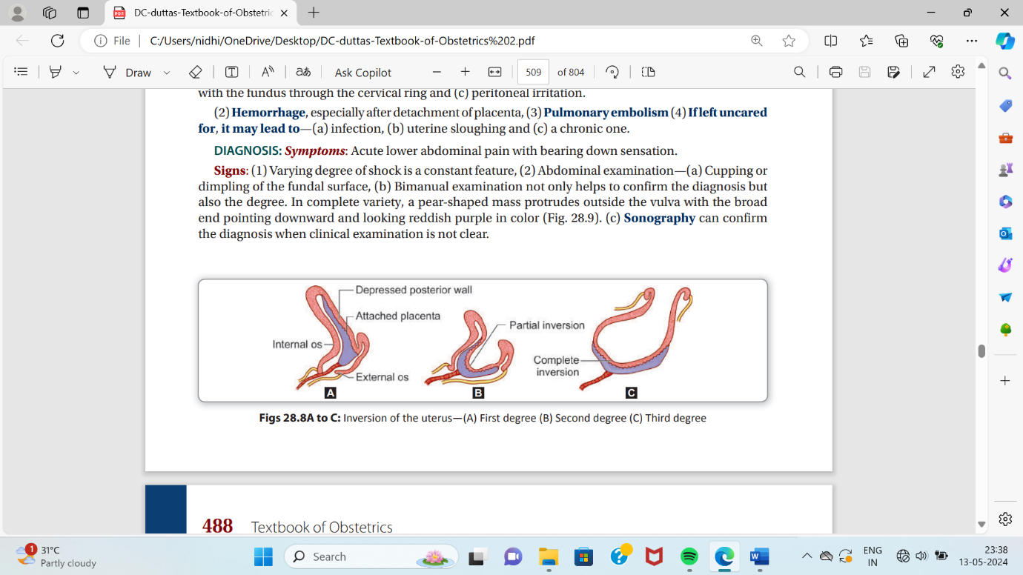

ETIOLOGY: The inversion may be spontaneous or more commonly induced.
- Spontaneous (40%): This is brought about by localized atony on the placental site over the fundus associated with sharp rise of intraabdominal pressure as in coughing, sneezing or bearing down effort. Fundal attachment of the placenta (75%), short cord and placenta accreta weakness of uterine wall at the placental site are often associated.

- Iatrogenic: This is due to the mismanagement of third stage of labor.
— Pulling the cord when the uterus is atonic especially when combined with fundal pressure
— Fundal pressure while the uterus is relaxed
—Faulty technique in manual removal.

Symptoms: Acute lower abdominal pain with bearing down sensation.

Signs:
(1) Varying degree of shock is a constant feature,
(2) Abdominal examination—(a) Cupping or dimpling of the fundal surface, (b) Bimanual examination not only helps to confirm the diagnosis but also the degree.
In complete variety, a pear-shaped mass protrudes outside the vulva with the broad end pointing downward and looking reddish purple in color
(c) Sonography can confirm the diagnosis when clinical examination is not clear.

MANAGEMENT:
- Call for extra help
- Before the shock develops, urgent manual replacement even without anesthesia, if it is not readily available, is the essence of treatment for a skilled accoucheur.

- Principal steps:
The patient is under general anesthesia.
(1) To replace that part first, which is inverted last with the placenta attached to the uterus by steady firm pressure exerted by the fingers.
(2) To apply counter support by the other hand placed on the abdomen.
(3) After replacement, the hand should remain inside the uterus until the uterus becomes contracted by parenteral oxytocin or PGF2α.
(4) The placenta is to be removed manually only after the uterus becomes contracted. The placenta may however be removed prior to replacement—(a) to reduce the bulk which facilitates replacement or (b) if partially separated to minimize the blood loss,
(5) Usual treatment of shock including blood transfusion should be arranged simultaneously.

Subacute stage:
(1) To improve the general condition by blood transfusion,
(2) Antibiotics are given to control sepsis,
(3) Reposition of the uterus either manually or by hydrostatic method may be tried,
(4) If fails, reposition may be done by abdominal operation

CONCLUSION
Proper care during labor is crucial to ensure a safe delivery and reduce the risk of complications. Monitoring maternal and fetal health, providing skilled medical assistance, and maintaining a supportive environment can mitigate potential risks, ensuring a positive birthing experience for both mother and baby.

REFRENCES
- DC Dutta’s textbook of Obstetrics
- Mudaliar and Menon’s Clinical Obstetrics
- Williams Obstetrics
- Textbook of Obstetrics by Dr. J B Sharma

