Topic of Presentation
EPILEPSY IN PREGNANCY

PRESENTED BY
Dr. Nidhi Patel
MS Final year,
Dept of Prasuti tantra and Stree roga.

GUIDED BY
Dr. Kola Vijaya Kumari
M.D (Ayu)
Professor and HOD,
Dept of Prasuti tantra and Stree roga.

EPILEPSY: -

- Epilepsy is a neurological disorder in which a person has two or more unprovoked seizures that occur more than 24 hours apart.
- A seizure is defined as a paroxysmal disorder of the central nervous system characterized by an abnormal neuronal discharge with or without loss of consciousness.

- Focal Seizures

- These originate in one localized brain area and affect a correspondingly localized area of neurological function.
- They are believed to result from trauma, abscess, tumor, or perinatal factors, although a specific lesion is rarely demonstrated.
- Focal seizures without dyscognitive features start in one region of the body and progress toward other ipsilateral areas of the body, producing tonic and then clonic movements.
- Simple seizures can affect sensory function or produce autonomic dysfunction or psychological changes.
- Cognitive function is not impaired, and recovery is rapid.
- Focal seizures with dyscognitive features are often preceded by an aura and followed by impaired awareness manifested by sudden behavioral arrest or motionless stare.
- Involuntary movements such as picking motions or lip smacking are common.

- Generalized Seizures

- These involve both brain hemispheres and may be preceded by an aura before an abrupt loss of consciousness.
- There is a strong hereditary component.
- In generalized tonic-clonic seizures, loss of consciousness is followed by tonic contraction of the muscles and rigid posturing, and then by clonic contractions of all extremities while the muscles gradually relax.
- Return to consciousness is gradual, and the patient may remain confused and disoriented for several hours.
- Absence seizures—also called petit mal seizures—are a form of generalized epilepsy that involve a brief loss of consciousness without muscle activity and are characterized by immediate recovery of consciousness and orientation.

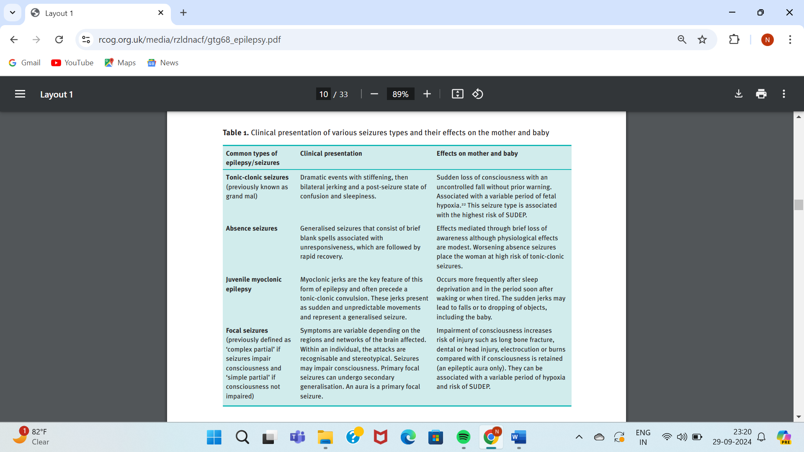
- Causes of Seizure

- Some identifiable causes of convulsive disorders in young adults include
- Head trauma
- Alcohol- and other drug-induced withdrawals,
- Cerebral infections,
- Brain tumors,
- Biochemical abnormalities,
- Arteriovenous malformations.
- A search for these is prudent with a new-onset seizure disorder in a pregnant woman. The diagnosis of idiopathic epilepsy is one of exclusion.

- Preconceptional Counseling

- Women with epilepsy should undergo education and counseling before pregnancy.
- Folic acid supplementation with 0.4 mg per day is begun at least 1 month before conception.
- The dose is increased to 4 mg when the woman taking antiepileptic medication becomes pregnant.
- These medications are assessed and adjusted with a goal of monotherapy using the least teratogenic medication.
- If this is not feasible, then attempts are made to reduce the number of medications used and to use them at the lowest effective dose.
- Medication withdrawal should be considered if a woman is seizure free for 2 years or more.
- Avoid valproate - Trimethadione is contraindicated.

- Epilepsy During Pregnancy

- The major pregnancy-related risks to women with epilepsy are increased seizure rates with attendant mortality risks and fetal malformations.
- Seizure control is the main priority.
- Earlier studies described worsening seizure activity during pregnancy, however, this is not as common nowadays because of more effective drugs.
- Contemporary studies cite increased seizure activity in only 20 to 30 percent of pregnant women.
- Women who are seizure free for at least 9 months before conception will likely remain so during pregnancy.
- Increased seizure frequency is often associated with decreased and thus subtherapeutic anticonvulsant serum levels, a lower seizure threshold, or both.
- An impressive number of pregnancy-associated alterations can result in subtherapeutic serum levels.
- These include nausea and vomiting, decreased gastrointestinal motility, antacid use that diminishes drug absorption, pregnancy hypervolemia offset by protein binding, induction of hepatic enzymes such as cytochrome oxidases, placental enzymes that metabolize drugs, and increased glomerular filtration that hastens drug clearance.
- Importantly, some women discontinue medication because of teratogenicity concerns.
- Finally, the seizure threshold can be affected by pregnancy-related sleep deprivation as well as hyperventilation and pain during labor.

- The effect of pregnancy on epilepsy

- It is uncertain.
- The frequency of convulsions is unchanged in majority (50%), increased in 45% and decreased in about 5% of women.
- Serum concentration of anticonvulsant falls in pregnancy.
- All anticonvulsants interfere with folic acid metabolism.
- Folic acid deficiency has been associated with neural tube defects and other congenital malformations.

- Effects of epilepsy on pregnancy

- Incidence of fetal malformations, IUGR, oligohydramnios, preeclampsia and stillbirths are increased.
- Birth defects are increased by twofold.
- This could be related to the severity of the disease with its genetic predilection and also due to the anticonvulsants used.
- Pattern of abnormalities is related to the type of anticonvulsant drugs (valproate 5.9%, Carbamazepine 2.3% and Lamotrigine 2.1%).
- Increased incidence of cesarean delivery, preeclampsia, and postpartum hemorrhage.
- Postpartum depression rates have also been reported to be increased in epileptic women.

- The malformations include

- Cleft lip and/or palate, mental retardation, cardiac abnormalities, limb defects and hypoplasia of the terminal phalanges.
- Sodium valproate is associated with neural tube defects.
- There is chance of neonatal hemorrhage and is related to anticonvulsant induced reduction of coagulation factors (vitamin K dependent).
- The risk of developing epilepsy to the offspring of an epileptic mother is 10%.
- It is now believed that, untreated epilepsy is not associated with an increased fetal malformation rate.
- The fetus of an epileptic mother who takes certain anticonvulsant medications has an indisputably increased risk for congenital malformations.
- Moreover, monotherapy is associated with a lower birth defect rate compared with multiagent therapy.
- Thus, if necessary, increasing monotherapy dosage is at least initially preferable to adding another agent.

FETAL ANTICONVULSANT SYNDROME
- Earlier fetal anticonvulsant syndrome was called fetal hydantoin syndrome. It is now known that most antiepileptic drugs can cause the abnormalities.
- The major abnormalities include: cleft lip and palate, microcephaly, neural tube defects, congenital defects, fetal growth restriction and developmental delay.
- The minor congenital abnormalities include: low set abnormal ears, flat nasal bridge, hypertelorism, nail and distal digital hypoplasia, epicanthic folds and long philtrum.

Dosage and Effects of Anti-epileptic Drugs
 | Usual dosage (per day) | Maternal effects | Fetal effects | Malformation rate (%)
Carbamazepine | 600-1200 mg per day in three divided doses | Drowsiness, leucopenia, slight hepatotoxicity, ataxia | Rarely craniofacial and neural defects | 1-2%
Phenytoin | 150-300 mg in two divided doses | Gingival hyperplasia, megaloblastic anemia, nystagmus, hirsutism | Fetal hydantoin  syndrome, Craniofacial anomalies, fetal growth restriction, cardiac defect, clefts, finger nail hypoplasia developmental delay | 5-11%
Phenobarbitone | 60-180 mg daily at night | Drowsiness | Clefts, cardiac anomalies, urinary tract anomalies | 10-20%
Valproic acid | 500-2000 mg in three divided doses | Drowsiness, ataxia, alopecia, thrombocytopenia | Neural tube defects, craniofacial and skeletal defects, low cognitive performance | 10% with mono therapy, higher with polytherapy
Lamotrigine | 300-500 mg in two divided doses |  | Increased rate of cleft lip and palate | 1%
Levetiracetam | 1000-3000 mg in two divided doses |  | Skeletal abnormalities, impaired growth | 1%
Topiramate | 100 mg per day |  | Cleft lip and palate | 2-3%

- Management

- The dose of the chosen drug should be kept as low as possible.
- Valproate and phenytoin are found to be most teratogenic.
- The commonly used drugs are: carbamazepine 0.8–1.2 mg daily in divided doses, phenytoin 150–300 mg daily in two divided doses.
- Lamotrigine 300–500 mg/day is given and it is not an enzyme inducer.
- Newer drugs used with safety are: topiramate (100–400 mg/day) and levetiracetam 1–3 gm/day (not enzyme inducer).
- Serum levels may be measured in patients with frequent seizures to assess therapeutic levels and compliance.
- Fits are controlled by IV phenytoin with a slow loading dose of 15–20 mg/kg.
- It is highly effective, has a long duration of action and side effects are less.
- Otherwise, benzodiazepine 10–20 mg slow IV may be given.
- Folic acid 4 mg daily is to be started before pregnancy and to be continued throughout.
- Prenatal diagnosis with serum αFP at 16 weeks and detailed fetal anatomy scan at 18 weeks with real time ultrasonography (Level II) including fetal echocardiography is done.
- There is decrease in free level of most of the anticonvulsants in pregnancy.
- The reasons are: delayed gastric emptying, reduced absorption, increased protein binding, nausea, vomiting, increase in plasma volume, increased hepatic metabolism and renal clearance.
- Vitamin K 10 mg a day orally is to be given to mother in the last two weeks.

Labor management

- Vaginal delivery is the aim with cesarean delivery being indicated for usual obstetric indications and for status epilepticus and recurrent seizures.
- As there is a higher risk of convulsions during labor due to disturbed sleep, hyperventilation, reduced intake and absorption of anticonvulsant medicines, the drugs must be given in regular dosage.
- Sometimes intravenous phenytoin is given.
- For seizures during labor, it is better to give intravenous diazepam in 10-20 mg dosage.

- Breast Feeding and Contraception

- There are limited available data regarding the safety of breast feeding with the various anticonvulsant medications.
- There is no contraindication for breastfeeding.
- Infant is given injection vitamin K 1 mg IM at birth to prevent neonatal hemorrhage due to decreased vit K dependent clotting factors.
- The infant may be drowsy.
- Readjustment of the anticonvulsant dosage is necessary and to bring down the dose to the prepregnant level by 4–6 weeks postpartum.
- Steroidal contraceptives are better to be avoided due to hepatic microsomal enzyme induction. Some of the anticonvulsant agents are associated with increased oral contraceptive failures.
- Combined pill containing 50 microgram of estrogen is recommended and depot provera should be given every 10 weeks instead of 12 weeks.
- Copper T and levonorgestrel intrauterine system (LNG IUS) is ideal as its efficacy is not affected by liver enzymes.
- The risk of having epilepsy of an infant born to a mother with a seizure disorder is four times higher compared to a normal one.

- Status epilepticus

- Uncontrolled repeated seizures are known as status epilepticus.
- Management is the same as in non-pregnant state.
- Intravenous 20 mg diazepam or phenytoin (50 mg per minute up to 180 mg) should be given.
- Suction of secretions and maintenance of airway should be done. Any precipitating factors like hypoglycemia, infection and non- compliance should be treated energetically.
- For respiratory depression, endotracheal intubation and positive pressure ventilation may be needed.
- Neuromuscular blockage or general anesthesia may be required for uncontrolled seizures.

ACCORDING TO AYURVEDA,

- APASMARA
अपस्मारं पुनः स्मृतिबुद्धिसत्त्वसम्प्लवाद्बीभत्सचेष्टमावस्थिकं तमः प्रवेशमाचक्षते || (Ch.Chi.10/3)
- The verse means- There are disturbances of the three aspects of the body- Smriti (memory), Budhi (intellect) and Sattva (psychic).
- Because of loss of these three, patient’s body starts behaving weirdly and he loses all his memory associated with the whole event.
- NIDANA

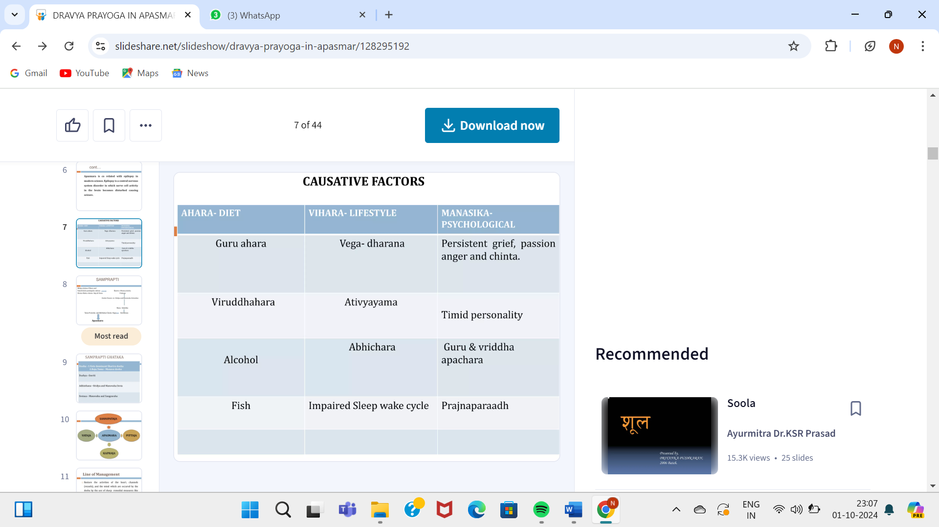

- SAMPRAPTI
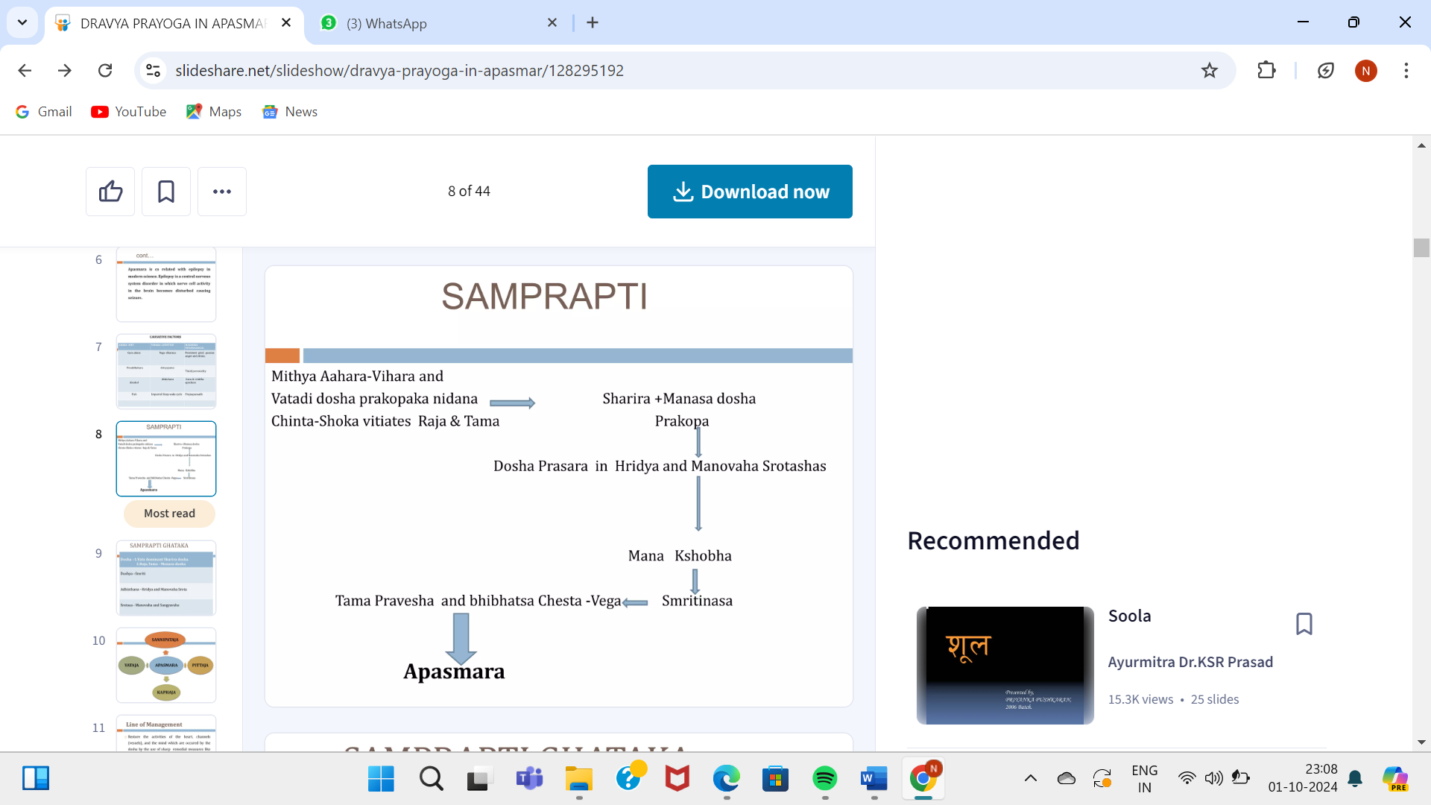

- Types and its lakshana:-

Vataja Apasmara

The symptoms of Vataja Apasmara are-
- अभीक्ष्णमपस्मरन्तं – Very frequent attacks and seizures of the epilepsy
- क्षणेन सञ्ज्ञां प्रतिलभमानम्– The short duration of the seizure, very small attacks.
- उत्पिण्डिताक्षम् – Eyeballs seems enlarged during the seizures.
- असाम्नाविलपन्तम्– Meaningless sounds/ uttering of the words.
- उद्वमन्तं फेनम्– Froth from mouth.
- अतीवाध्मातग्रीवम्– Stiffness of the neck.
- आविद्धशिरस्कं– Head rolls on a side.
- विषमविनताङ्गुलिम् – Stiffness and deformed shape of fingers.
- अनवस्थितपाणिपादम् – Instability in arms and legs.
- अरुणपरुषश्यावनखनयनवदनत्वचम् – Dryness increases in nails, eyes, skin.
- अनवस्थितचपलपरुषरूक्षरूपदर्शिनं – After the attack patient tells about hallucinations like looking some unstable, moving and blackish objects.
- वातलानुपशयं विपरीतोपशयं च वातेनापस्मरन्तं विद्यात् – Food and medicines which causes imbalance of the Vata increases the complexity of the disease.

Pittaja Apasmara

- अभीक्ष्णमपस्मरन्तं – Frequent seizures
- क्षणेन सञ्ज्ञां प्रतिलभमानम् – Quick recovery time
- अवकूजन्तम् – Problem in breathing when attack comes.
- आस्फालयन्तं भूमिं – Patient falls on the ground suddenly.
- हरितहारिद्रताम्रनखनयनवदनत्वचं – Yellow coloration of skin, eyes and nails.
- रुधिरोक्षितोग्रभैरवादीप्तरुषितरूपदर्शिनं – Hallucinations of red, bright and terrifying objects.
- पित्तलानुपशयं– Food and medicines which aggravates the pitta, complicates the condition of the patient.

Kaphaja Apasmara

- चिरादपस्मरन्तं – Seizures doesn’t appear very frequently.
- चिराच्च सञ्ज्ञां प्रतिलभमानं – Patient regains the normalcy after a long period.
- पतन्तम् – Patient falls on the ground.
- अनतिविकृतचेष्टं– While falling down, there are not severe movements or any problems.
- लालामुद्वमन्तं – Excessive saliva secretions.
- शुक्लनखनयनवदनत्वचं – Whiteness in the skin, nails and eyes is predominant.
- शुक्लगुरुस्निग्धरूपदर्शिनं– Patient has hallucinations of whitish, soft things.
- श्लेष्मलानुपशयं – foods and medicines which aggravates kapha increase the problem of the patient.

- CHIKITSA

- Kashyapa has mentioned specific treatment for akshepa i.e., seizures in pregnancy.
- Sushruta and Vagbhata include akshepa as asadhya mudhagarbha lakshana.

सुश्रुत-
....विपरीतेन्द्रियार्थाक्षेपक योनिभ्रंश.....कासभ्रमनिपीडितान् परिहरेत। (सु.सं.नि. 8/6)

वाग्भट-
...विपरीतेन्द्रियार्थमाक्षेपयोनि......श्वास भ्रमाभिपन्नां....वर्जयेत्। (अ.सं.शा. 4/31)

Akşepa, bhrama are among the bad prognostic signs of mudhagarbha where the case is rendered hopeless and should be rejected.

- केवल वातिक/असंसृष्ट दोष (Only vātika)
आक्षेपके समुत्पन्ने तथैवप्यपतानके। मातुलुङ्गरसः पेयो बिडसैन्धवसंयुतः ।
अग्निमन्थस्य निर्यूहः क्वथितो वरुणस्यवा। लावो वा तैत्तिरो वाऽपि रसः स्निग्धः प्रशस्यते।
पानार्थं वातशमनो वादूलो रस एव च। असंसृष्टे तु कर्तव्यो विधिरेष सुखावहः। (का.सं.खि. 10/111-114)
- Anyone of the following may be administered:
i) Matulunga swarasa + vida and saindhava lavaņa.
ii) Agnimantha or varuņa kwatha
iii) Sneha of lava/tittira with mamsa rasa.
iv) Vadula swarasa or Kwatha or Kwatha of vata shamana dravya.

- पित्तोपसृष्ट (Associated with pitta)
पित्तोपसृष्टे तु हितो जाङ्गलो मधुरो रसः। शृतो मधुरकैः सर्वैर्दाडिमाम्लसमायुतः । (का. खि. 10/114-115)
- Sweetened jangala mamsa rasa or Madhura varga dravya kashaya with dadima.

- वातश्लेष्म समुत्थ (Vata with shleshma)

वातश्लेष्मसमुत्थे तु व्यम्लस्तु कटुको रसः । यवक्षारेण संयुक्तो जाङ्गलः सततं हितः ।
मृदवः पाणितापश्च पित्तवर्ये हितास्तथा। घृतसेकोऽथवा कार्यो जीर्णे गर्भ विशेषतः ।
उष्णो वा यदि वा शीतो व्याधिमासाद्य तत्त्वतः । (का.सं.खि. 10/115-116)

- Amla and katu rasa prayoga.
- Yavakshara with jangala mamsa rasa.
- Swedana with warm palms.
- Swedana with ghruta especially in late pregnancy.
- Hot/cold fomentation is given with due consideration to the status of the disease.

- CONCLUSION

- Epilepsy brings special issues for women, particularly in pregnancy. In birth control, conception, pregnancy, and postpartum care, women with epilepsy face challenges to carefully balance maintaining seizure freedom with minimizing adverse effects from antiseizure medications and other nonpharmacologic treatments. Management of epilepsy in patients of childbearing age requires careful counseling and planning. Practitioners who care for women with epilepsy should keep up-to-date with the latest guidelines and recommendations to provide the best possible care.

- REFRENCES

- DC Dutta’s textbook of Obstetrics
- Mudaliar and Menon’s Clinical Obstetrics
- Williams Obstetrics
- Textbook of Obstetrics by Dr. J B sharma
- Prasuti Tantra obstetrics by Dr. Hemalatha Kapoorchand
- Kashyap Samhita by P.V Tewari
- Pubmed

​

