**Practical 1:**

**Implementation of Data partitioning through Range and List partitioning**

1. **Range Partitioning**

**1.1 Create table sales with the following columns:**

|  |  |
| --- | --- |
| prod_id | Number |
| cust_id | Number |
| time_id | Date |
| channel_id | Char |
| promo_id | Number |
| quantity_sold | Number |
| amount_sold | Number |

**Partition this table into 4 using range partition and time_id as partitioning key. Give partition names as:**

**sales_q1_2006, sales_q2_2006, sales_q3_2006, sales_q4_2006.**

**Query:**

CREATE TABLE sales (prod_id number,

cust_id number,

time_id date,

channel_id char,

promo_id number,

quantity_sold number,

amount_sold number)

PARTITION by range(time_id)(

PARTITION sales_q1_2006 VALUES less than (to_date('2006-mar-31','yyyy-MON-dd')),

PARTITION sales_q2_2006 VALUES less than (to_date('2006-jun-31','yyyy-MON-dd')),

PARTITION sales_q3_2006 VALUES less than (to_date('2006-sep-31','yyyy-MON-dd')),

PARTITION sales_q4_2006 VALUES less than (to_date('2006-dec-31','yyyy-MON-dd')));

**Output:**

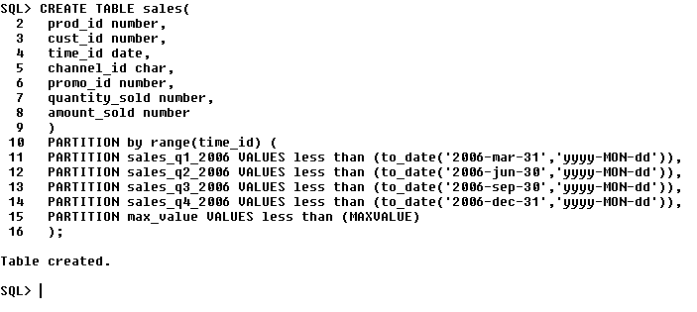

**Store quarterly data into each partition. For example, partition sales_q1_2006 will store records for first quarter 01-jan-2006 to 01-mar-2006**

**sales_q1_2006 will store records for second quarter 01-apr-2006 to 01-jun-2006. And so on.**

**Query**:

insert into sales values(46,1298, to_date('2006-jan-02','yyyy-MON-dd'),'A', 101, 23, 45032);

insert into sales values(5,1838, to_date('2006-feb-27','yyyy-MON-dd'),'X', 101, 7, 1432);

insert into sales values(1,1848, to_date('2006-mar-17','yyyy-MON-dd'),'Q', 101, 37, 35032);

insert into sales values(3,9566, to_date('2006-jun-11','yyyy-MON-dd'),'P', 101, 45, 65032);

insert into sales values(345,6355, to_date('2006-apr-21','yyyy-MON-dd'),'P', 101, 12, 5032);

insert into sales values(8,3365, to_date('2006-may-15','yyyy-MON-dd'),'O', 101, 19, 5932);

insert into sales values(180,0707, to_date('2006-jul-24','yyyy-MON-dd'),'O', 101, 82, 180000);

insert into sales values(6,1011, to_date('2006-aug-11','yyyy-MON-dd'),'B', 101, 29, 45132);

insert into sales values(44,9935, to_date('2006-oct-18','yyyy-MON-dd'),'M', 101, 34, 4232);

insert into sales values(12,5463, to_date('2006-oct-10','yyyy-MON-dd'),'M', 101, 3, 452);

insert into sales values(11,4378, to_date('2006-nov-02','yyyy-MON-dd'),'Y', 101, 8, 4526);

insert into sales values(14,5438, to_date('2006-dec-25','yyyy-MON-dd'),'Y', 101, 38, 11032);

**Output:**



**Write a command to view records in each partition.**

**Query**:

select * from sales PARTITION(sales_q1_2006);

select * from sales PARTITION(sales_q2_2006);

select * from sales PARTITION(sales_q3_2006);

select * from sales PARTITION(sales_q4_2006);

**Output:**

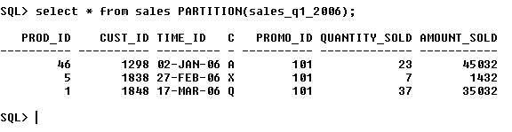

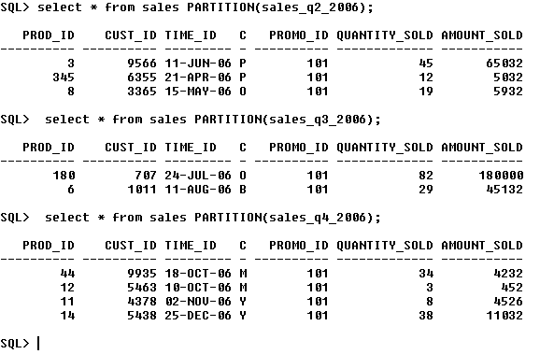

**Write a command to display the partition structure.**

**Query**:

select table_name,partition_name,partition_position,high_value,num_rows from ALL_TAB_PARTITIONS where table_name='SALES2';

**Output:**

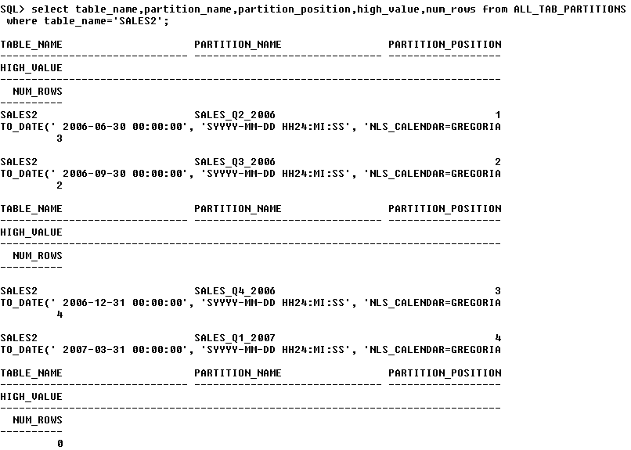

**Write a command to add a new partition called sales_q1_2007 for the next quarter value.**

**Query**:

alter table sales add PARTITION sales_q1_2007 VALUES less than (to_date('2007-mar-31','yyyy-MON-dd'));

**Output:**

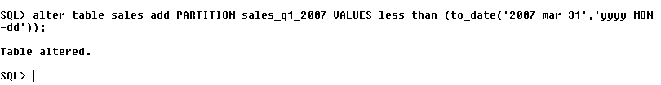

**Write a command to delete all records from partition sales_q1_2006.**

**Query**:

delete from sales partition(sales_q1_2006);

**Output:**

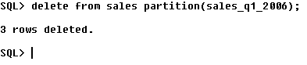

**Write a command to delete a partition.**

**Query**:

alter table sales drop PARTITION sales_q1_2006;

**Output:**

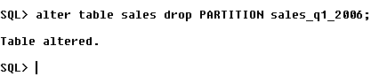

**List Partitioning**

**1.2 Create table Student with the following columns:**

|  |  |
| --- | --- |
| Student_id | Number |
| Student_name | Number |
| Student_dob | Date |

**Create list partition with student_name as partition key. Create following two partitions.**

**stu_divA with values 'a','b','c','d','e','f','g','h','i','j','k'**

**stu_divB with values 'n','o','p','q','r','s','t','u','v','w','x','y','z'**

**Query**:

create table STUDENT (

student_id number,

student_name char,

student_dob date

)

PARTITION by LIST(student_name) (

PARTITION stu_divA values('a','b','c','d','e','f','g','h','i','j','k'),

PARTITION stu_divB values('n','o','p','q','r','s','t','u','v','w','x','y','z')

);

**Output:**

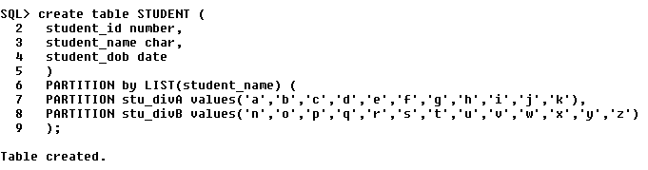

**Write a command to view records in each partition.**

**Query**:

select * from STUDENT partition(stu_divA);

select * from STUDENT partition(stu_divB);

**Output:**

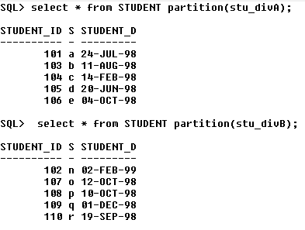

**Write a command to display the partition structure.**

**Query**:

select table_name, partition_name, partition_position, high_value, num_rows from ALL_TAB_PARTITIONS where table_name='STUDENT';

**Output:**

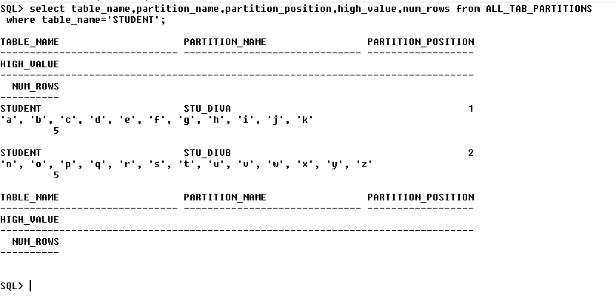

**Write a command to add a new partition called stu_null for the null values.**

**Query**:

alter table STUDENT add PARTITION stu_null VALUES (NULL);

**Output:**

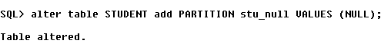

**Write a command to display records from stu_null partition.**

**Query**:

insert into STUDENT(student_id,student_dob) values(101,to_date('24-07-1998','dd-MM-yyyy')); //Inserting Values

select * from STUDENT partition(stu_null);

**Output:**

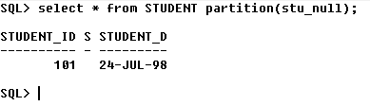

**Write a command to add a new partition called stu_default for the default values.**

**Query**:

alter table STUDENT add PARTITION stu_default VALUES (DEFAULT);

**Output:**



**Write a command to display records from stu_default partition.**

**Query**:

select * from STUDENT partition(stu_default);

**Output: Created a table with default value for student_name field as ‘N’**

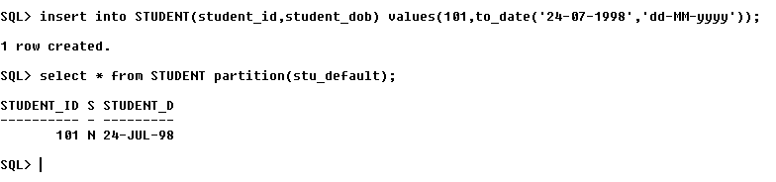

**Write a command to add values ‘l’ and ‘m’ in a partition stu_divA**

**Query**:

alter table STUDENT modify PARTITION stu_divA ADD VALUES ('I', 'm');

**Output:**

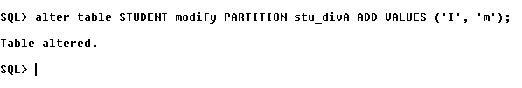

**Write a command to display records from stu_divA partition.**

**Query**:

select * from STUDENT partition(stu_divA);

**Output:**

