Software Engineering

The term **software engineering** is the product of two words, **software**, and **engineering**.

The **software** is a collection of integrated programs.

Software subsists of carefully-organized instructions and code written by developers on any of various particular computer languages.

Computer programs and related documentation such as requirements, design models and user manuals.

**Engineering** is the application of **scientific** and **practical** knowledge to **invent, design, build, maintain**, and **improve frameworks, processes, etc**.

Software engineering is defined as a process of analyzing user requirements and then designing, building, and testing software application which will satisfy those requirements.

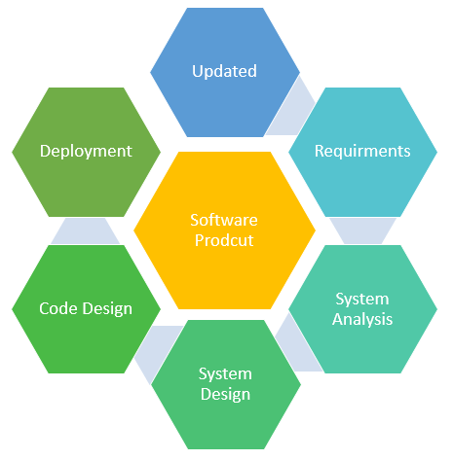

**Software Engineering** is an engineering branch related to the evolution of software product using well-defined scientific principles, techniques, and procedures. The result of software engineering is an effective and reliable software product.

Why is Software Engineering required?

* Software Engineering is required due to the following reasons:
* To manage Large software
* For more Scalability
* Cost Management
* To manage the dynamic nature of software
* For better quality Management

Here are important reasons behind the popularity of software engineering:

* **Large software** – In our real life, it is quite more comfortable to build a wall than a house or building. In the same manner, as the size of the software becomes large, software engineering helps you to build software.
* **Scalability-**If the software development processwere based on scientific and engineering concepts, it is easier to re-create new software to scale an existing one.
* **Adaptability**: Whenever the software process was based on scientific and engineering, it is easy to re-create new software with the help of software engineering.
* **Cost-** Hardware industry has shown its skills and huge manufacturing has lower the cost of the computer and electronic hardware.
* **Dynamic Nature**- Always growing and adapting nature of the software. It depends on the environment in which the user works.
* **Quality Management**: Offers better method of software development to provide quality software products.

**Software Project Management (SPM)** is a proper way of planning and leading software projects. It is a part of project management in which software projects are planned, implemented, monitored and controlled.

**Software Project Management consists of several different type of managements:**

1. **Conflict Management:**  
   Conflict management is the process to restrict the negative features of conflict while increasing the positive features of conflict. The goal of conflict management is to improve learning and group results including efficacy or performance in an organizational setting. Properly managed conflict can enhance group results.
2. **Risk Management:**  
   Risk management is the analysis and identification of risks that is followed by synchronized and economical implementation of resources to minimize, operate and control the possibility or effect of unfortunate events or to maximize the realization of opportunities.
3. **Requirement Management:**  
   It is the process of analyzing, prioritizing, tracing and documenting on requirements and then supervising change and communicating to pertinent stakeholders. It is a continuous process during a project.
4. **Change Management:**  
   Change management is a systematic approach for dealing with the transition or transformation of an organization’s goals, processes or technologies. The purpose of change management is to execute strategies for effecting change, controlling change and helping people to adapt to change.
5. **Software Configuration Management:**  
   Software configuration management is the process of controlling and tracing changes in the software, part of the larger cross-disciplinary field of configuration management. Software configuration management include revision control and the inauguration of baselines.
6. **Release Management:**  
   Release Management is the task of planning, controlling and scheduling the build in deploying releases. Release management ensures that organization delivers new and enhanced services required by the customer, while protecting the integrity of existing services.

**The Three Sphere model for Systems management:**

The three-sphere model of systems management deals with the business, organizational and technological aspects and/or issues related to the project that should be defined and considered in order to select and manage projects effectively and successfully. In terms of addressing its advantage on the business side, a project should supplement or serve as an answer to the business goals; whereas, the technological sphere should state the proper hardware and software issues to be resolved. As for the organizational aspect, matters involving the stakeholders should be taken into full consideration. If the project manager would be able to point out as early as possible the aforementioned issues and integrate it to the project it would definitely aid in determining if an organization should invest and produce the project.

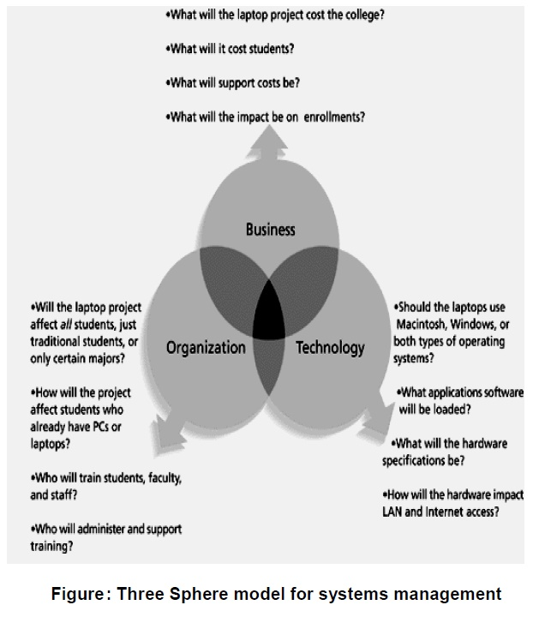

A Case:

A programmer was given a task to convert a static website of a magazine into a dynamic PHP website; what prompts the management to engage into this project is the fact that the web has become more sophisticated and that there has been a major shift of “print” audience to the internet. You’ll find below the business, organizational and technological issues of the said project.

Business issues:

1. Would the website be the medium in response to the impact of the internet in a publishing company?

2. Would the website supplement the magazine in terms of advertising?

3. What will the project cost the company?

4. What would be the impact of the website to the sales of the magazine?

5. What would be the cost of maintaining the whole system for the website?

Technological issues:

1. What operating system, server platform, scripting language and database should be used?

2. What will be the server and desktop specifications?

3. Does our current network setup allow employees to develop this project, or do we need an upgrade?

4. Do we have the right internet connection to support this project?

Organizational issues:

1. Do we have the existing manpower to develop the project?

2. What would be the impact of the website to the magazine’s print division?

3. How will the website affect our print audience?

The most important issues are from the business and organization spheres, since these two primarily follows the business philosophy – it would definitely be pointless if a project fails to meet the endeavors either on the business or organizational side – it’s doomed to fail if that is the case. Among the three, I guess the technological issues are the easiest to resolve.