**Practical 1**

**Aim**: Understanding REPL (Read, Eval, Print, Loop) / Node.js Console   
 **AKA NodeShell**

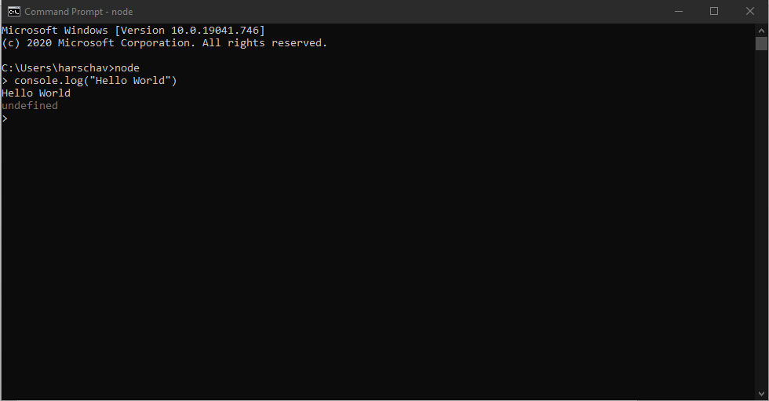

2nd Part: **Understanding node.js with simple function**

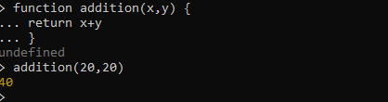

3rd Part: Variables

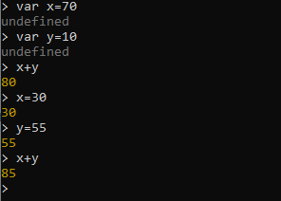

**4. Understanding JavaScript standard functions.**

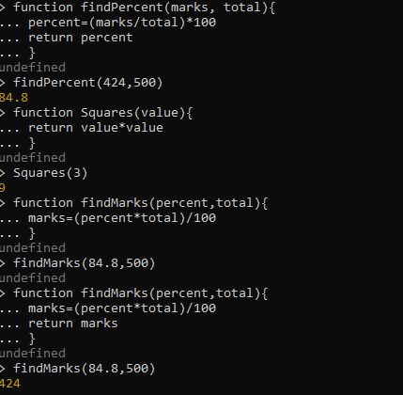

**Date: 08-02-2021**

**1. E) Reading data from file.**