**LATE BHAUSAHEB HIRAY S.S.**

**TRUST’S INSTITUTE OF COMPUTER APPLICATION**

**ISO 9001-2008**

**CERTIFIED**

**S.N. 341, Next to New English School, Govt. Colony, Bandra**

**(East), Mumbai – 400051,**

**Date:**

**CERTIFICATE**

**This is to certify that Mr./Ms. Harshal Jaywant Chavan Roll No. 202124 is a student of FYMCA Semester-II has completed successfully full-semester practical/assignments of subject User Interface Lab for the academic year 2021 – 22.**

**Subject In-Charge Director**

**External Examiner**

**INDEX**

|  |  |  |  |  |
| --- | --- | --- | --- | --- |
| **Sr. No** | **Contents** | **Page Number** | **Marks** | **Sign** |
| 1 | Introduction to UI life cycle and UI tools. |  |  |  |
| 2 | Project Proposal and Requirement Gathering |  |  |  |
| 3 | Analysis |  |  |  |
| 4 | Design |  |  |  |
| 5 | Prototype |  |  |  |
| 6 | Implementation |  |  |  |
| 7 | Usability Evaluation of the Design |  |  |  |

**PRACTICAL NO -1**

**Aim:** Introduction to UI Lifecycle and UI Tools.

**Description:**

1.UI Lifecycle:

“User Interface” or UI Development is not a new term in software development life cycle. Starting from a small web site development to application or software development, User Interface plays a very important role. Many people believe, UI development is just about coding HTML, CSS and Java-Script but UI is way beyond these technical terms.

UI Development is not limited to Website development but extended to any kind of application development including client server. Even in wireframes and Prototyping we make use of UI technologies.

A user is not going to experience a software or website based on the backend technology used, but based on the User Interface and its experience.

This topic is intended to understand

– **The role and importance of User Interface development in the SDLC**

– **How UI Development can be catered in each phase of SDLC starting from the Requirement gathering phase.**

**Introduction**

Product development is the process of designing, creating, and marketing an idea or product. The product can either be one that is new to the marketplace or one that is new to a particular company, or an existing product that has been improved. In many instances a product will be labelled new and improved when substantial changes have been made.

Today Product development is becoming a need for every business, from a simple website to ecommerce websites, banking domain to mobile technology every business needs software or a product to communicate with the users.

We can categorize the product into this broad bucket

● Consumer Products

○ Public Safety,

○ Rugged Handheld Computers Utilities,

○ Mobile & Fleet Management

○ Mapping & GIS,

● Embedded Systems

○ Portable Devices In-Vehicle Navigation & Telematics Tracking,

○ Instrumentation,

○ Security

● Engineering & Construction

○ Construction

○ Construction Asset Management

○ Marine Construction

○ Mining

○ Surveying

○ Infrastructure

● Agriculture Solutions

○ Precision Agriculture

○ Guidance

○ Flow and Application Control

○ Water Management

○ Information Management

● Advance devices

○ Defence

○ Precise Timing

Each of these products needs a User Interface through which a user can accomplish their tasks. Having the best user interface provides the best customer experience and today’s competitive market-place demands that companies maximize the ease of use for their customers.

All product development goes through a similar development lifecycle, starting from requirement gathering to testing phase. Unfortunately, in the development cycle of most of the applications, the user interface design does not begin until most of the development has been completed, and is usually starved for time and resource

The results are hardly positive. Either the UI design is severely affected by assumptions made during the application development or additional resources are added to rework or completely re-program all or part of the application to accommodate new design. This leads to problems like design compromises, delay, budget overruns etc.

Given this the most effective strategy is to integrate and design the UI parallel to each phase of development lifecycle

In short, integrating UI design in the development process have several businesses benefits as follows:

– Create a better product

– Increase customer satisfaction and retention

– Allow greater flexibility in responding to customer feedback

– Lower development costs

– Shorten the development lifecycle

Let's look at the UI design process and how we can integrate it in all the phases.

**User Interface design process**

User interface development process can be categorized into 4 phases as below:

– Research and Analysis

– Design and Branding

– Prototype Development

– Production

This structured process can maximize communication between the company and its clients, lower development costs, and most importantly deliver the best user interface design.

This process is flexible and modular, thus allowing client to determine which phases are appropriate for their needs, and can be applied to both the creation of user interface for new applications as well as enhancements of existing applications.

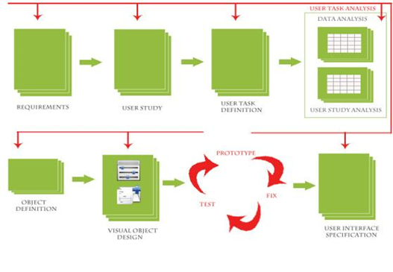

**2.1 Research and Analysis**

**Process:**

In the traditional Research & Analysis phase, two categories of information are gathered and analysed by the user experience team.

1) Information about the users of the application

2) Information about the application itself

This establishes the context for User Interface design and this context informs the entire design process. Additionally, during this phase as a part of UI development, UI developers can start researching current market trends, UI technologies, and competitive analysis. This research can help the UX team during the consecutive phase of SDLC and both UI and UX team will have clarity of things possible and impossible and LOE (level of effort) required during development.

For existing applications the Research & Analysis phase also determines the strengths and weaknesses of the current UI.

How:

The user data is gathered answering the following questions

– Who are the users?

– What are their skill levels?

– What are their qualitative expectations for the application?

– What task do they need to perform with this application?

– Under what environmental conditions will they use this application?

– Under what time conditions and constraints will they use this application?

The application information is gathered answering the following questions

– What problem is the application intended to solve?

– What are the functional purposes of the application?

– What are the operational purposes of the application?

– What are the marketing purposes of the application?

– What are the user interface specifications of the application?

– What are the software, hardware and graphical requirements to create and deliver the application?

The User Interface trends can be gathered answering the following questions

– What are the current UI trends?

– What are the current UI design patterns?

– Which are the latest tools and technologies being used?

– What tools and technologies are our competitors using?

– Pros and Cons of using any latest technology for the current product?

**Deliverables:**

– Personas

– Competitive landscape

– Usability goals

– Functional and non functional specifications

**2.2 Design and Branding**

**Process**:

During the design and branding phase, User Interface design is created that addresses the specific needs identified in the research & analysis phase and creates, revise or leverage the applications brand.

**Involving UI design into Design phase**

During the design phase UI developers can work closely with the UX team to define the User interface (Wireframes, Visual design). A User Experience team may think out of the box while creating wireframes and visual design, but may not be aware of challenges, possibilities and limitations. Involving UI developers in this phase may ease the process, as UI developers understand the technologies and possibilities. This will reduce the last minute efforts from the UI developer’s side and additionally both the UI and UX team, as well as client will have a clear expectations set.

**Deliverable:**

– A discussion of the design philosophy and strategy used to create the UI design, including an explanation of how research brief informed the UI design

– A comprehensive set of screen layouts illustrating every part of the UI design

– Key screen that presents the visual design and branding for the application.

**Wireframe:**

Wireframes are presented as a comprehensive set of screen layouts consisting of Black and white sketches of every screen in the application. At this point the visual and graphic design processes have not yet begun.

Wireframe is an important step; because it helps the clients focus on how they will interact with the application rather than become entrenched in relatively subjective issues such as color or visual style. It enables us to postpone those and other subjective issues

By necessity this is a cyclic process, and once the screen layouts have been approved, a visual design is created that is informed by the UI design.

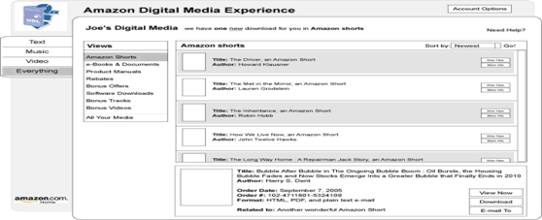

**Visual design**

Visual design process begins with the branding of the application.

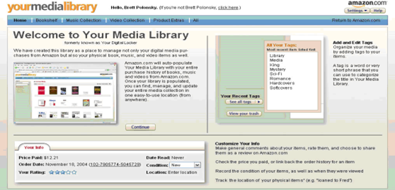

**2.3 Prototype development**

Process:

Using the approved design document as blueprint, prototypes of the User Interface designs are created. Based on clients needs the prototypes are created using HTML or flash. Prototypes can be low fidelity or high fidelity based on user needs.

The scope of the prototype created during this phase is tailored to the specific application and the user testing requirements. Some applications require a comprehensive click through or working model of the entire interface, while others only require a prototype of core functionality.

The prototype serves as

– A communication and review tool for the client

– An implementation guide for the software developer

– A user testing tool

– A working prototype enables clients to see how the user interface will perform without having a committed programming resource.

Another benefit to a working prototype is that it dramatically improves the communication among UI design, marketing and application development teams, as well as any other key stakeholders since marketers, designers and developers often think and use language differently, having a functional prototype leaves fewer issues open to interpretation or misunderstandings

Prototypes are in fact an opportunity to identify any remaining user interface issues. Should there be design documents and prototypes modified to incorporate changes prior to final approval.

Once the prototype is approved, the development team can work to implement new user interface design quickly and efficiently without interrupting the development process to correct design is-sues.

The utilization of prototypes also has significant marketing benefits. Since the prototype closely stimulates the actual application, extensive user testing can be one before the programming starts, which also produces significant cost savings. Additionally positive user feedback is a validation of design, confirming that the application delivers a user experience that meets or exceeds customer expectations. This positive feedback can be used for both internal and external marketing purposes, by building confidence in the rollout and promoting user adoption.

Deliverable: Interactive prototype of the new user interface

**2.4 Production**

A proper UI and UX team collaboration and Integration of UI design from the starting of SDLC can reduce a lot of efforts and confusion. Also it can help in successful and timely delivery of the products in any company without any slippages and can increase customer satisfaction. Additionally it can help build ongoing relations with our clients.

**2. Wireframing & Prototyping UX Design Tools:**

**1.Adobe XD:**

Adobe XD is a vector-based digital design tool for websites and apps. Use it to create and collaborate on everything from prototypes to mockups to full designs.

Here’s how Adobe describes it: “Adobe XD is the fastest and most reliable UX design solution on the market for companies of 10 or 10,000. Break through bottlenecks, iterate rapidly, and scale for the future. The security and control you need are built right in.”

Adobe XD is relatively new to the market – it was released in beta in 2016 – and was originally called Adobe Experience Design CC.

The tool works on Mac and Windows machines as well as iOS and Android for mobile functionality. You can use it as a direct download (the license pings your desktop every month) or in the cloud for mobile devices.

The tool is quickly becoming a solid competitor to more established wireframing and prototyping apps, such as Sketch or Figma, thanks to strong corporate backing from Adobe and user familiarity, plus cross-platform support).

XD filled a significant gap in the Adobe suite of tools. Before its release, many of the available features weren’t a part of Photoshop or Illustrator and designers had to piece together elements if they wanted to use Adobe software for creating user interfaces.

Who Should Use It?

Adobe XD works for individual designers and developers wanting to create in a vector format.

Adobe XD also works for teams that want to create user experiences and collaborate on the process. You can even build a design systemthat helps keep everyone on track with a single project.

XD works for all types of projects because it is scalable. It’s backed by the security and infrastructure that you expect from Adobe and allows for specific user controls with business plans.

**Key Features:**

Key features include:

● Ability to prototype using linked artboards that you can view on mobile devices as well.

● Repeat grid that lets you replicate elements such as lists or galleries (this is something that sets this tool apart from many others).

● Assets panel that allows you to manage colors, styles, and components within a project.

● Design using voice commands.

● Create and design symbols for logos and buttons; plus move them around using drag and drop on and between artboards.

● Keyboard shortcuts for faster workflows, including moving and resizing objects.

● CSS snippets in design specs are automatically generated, making it easy to copy and paste from XD to live projects.

● Automatic responsive resizing for objects on artboards.

● Compatibility with custom plugins for extra functionality.

● Mobile functionality for sharing and commenting so you can work on the go.

● Ability to share designs and prototypes with others, including clients, in a secure environment.

● Integrates with other tools such as Slack or Jira.

● Automatically animate changes between artboards to create cool interactive content or micro-interactions.

● Edit Photoshop images and files right in XD.

● Adobe is teasing a co-editing feature that will be released soon, giving you the ability to collaborate on projects with others in real-time.

● extensive documentation and tutorials to make learning easy.

**2. Figma:**

Figma is a web-based graphics editing and user interface design app. You can use it to do all kinds of graphic design work from wireframing websites, designing mobile app interfaces, prototyping designs, crafting social media posts, and everything in between.

Figma is different from other graphics editing tools. Mainly because it works directly on your browser. This means you get to access your projects and start designing from any computer or platform without having to buy multiple licenses or install software.

Another reason why designers love this app is that Figma offers a generous free plan where you can create and store 3 active projects at a time. It’s more than enough for you to learn, experiment, and work on small projects.

How to use Figma?

Figma is a web-based app. All you need to start using the app is a desktop computer or a laptop with a good browser and an internet connection. Then you can visit the Figma website to register a free account. And you can start working on your designs right away.

The PROs & CONs

It is more of two sides of the coin if we talk about this topic. They give you some handy features on one side but there’s a catch on the other. Vice versa. You can think in the opposite way.

1. Real-time Collaboration

● Pros

Think about this:

“You are a member of three-person designers in a company. You could edit one design file together at the same time. Transparently. You could watch your team-mates working on a screen while you are working on another one!”

Can you imagine how many hours can be saved? Yup, plenty!

● Cons

But there is a catch; you need to be always (almost) online to be working like this.

But in the end, even though this connectivity thing seems like an issue, it’s actually worth it. Think about another thing: When you are working, many companies demand you to turn on your messenger app (Slack, WhatsApp, Skype, you name it), which means, you need to be online as long as you are working. Especially when you are in a remote mode.

2. Quick and Easy File Sharing

● Pro:

I quickly press some keys and open the file he mentioned, I can see that he is wandering around some design screens (or Artboards, that is how Figma call it). He added, “Which one is actually the latest homepage design?” … Aaah, I said to myself. We actually left this one on our last conversation with their Design Lead and we thought the Design Lead would change something again. But he didn’t.

Then, just with some clicks, I remove the unnecessary screens and that’s it. Finished. It only takes 5 minutes. Imagine, if I first need to sync or download the latest file from the client, and then re-upload them again, it could take 30 to 60 minutes, depending on the internet connection.

● The Con:

you must be aware of who did the last edit. Even though there is a Version Control Function on Figma, it would change the entire version. While maybe, you just want to revert one or two small elements.

3. Cloud-based

● Pros: You can open the files on different computers without the need to download or copy the file manually.

● Cons: No Internet No Figma

4. Caches

● Cons: Since it’s browser-based, sometimes you can't see your partner’s design right away. Not because of the connection, but rather, browser caches.

● Pros: To fix this, just refresh your Figma files a few times.

**3.Sketch:**

Sketch is the ultimate tool for iOS, Android and Web design. It barely weighs 45MB in disk space, compared to Photoshop's 2.17GB. As soon as you open it, you are greeted with an infinite canvas. Just like native Mac apps, you have a familiar user interface with a Toolbar, Navigator and Inspector. As a result, new users will find Sketch far more approachable because it doesn’t get in the way of producing simple designs.

Features:

What sets Sketch apart from the rest is its well-rounded set of features that cater to my requirements as a UI designer. Sure, it does not have the gazillion functions and filters of Photoshop, the built-in prototyping capabilities of Adobe XD, the collaboration features and vector networks of Figma or the cross-platform capabilities of all of the above. Sketch simply does what I need for the most part, does it well, and has a thriving plugin ecosystem that more often than not makes up for what’s not already built in.

What follows is just a sample of Sketch’s features that make life easy for me and the team at my UX design studio day to day.

1.Artboards and Pages

For as long as I can remember, my biggest pet peeve with Photoshop was its single canvas. Creating a new file for every page on a website just didn’t make sense to me. Fireworks understood the problem, and its page feature was a godsend. Illustrator got around this with artboards. In today’s mobile and responsive era, though, neither of those concepts is enough.

2.Mirror and Sketch Cloud

There was a time when design was usually handled by an individual designer (or two) who worked on individual Photoshop files that didn’t really have much to do with each other. Today, it is not uncommon to see teams of tens or even hundreds(!) of designers working together on a single product. That makes the ability to collaborate on design files extremely critical. Sketch has enabled a designer to share a read-only view of the file open in the app for some time now. Simply share a URL, and anyone else on the same Wi-Fi network will be able to view the file you’re working on. This is very helpful when you want to share a work in progress with a fellow designer or developer sitting at the other end of the office or even in the same room, where everyone can see the files on their own screens.

3.Smarter dimensions

Smarter dimensions are another nice touch. Need to increase the width of an element by 23 pixels? Forget the mental math — append +23 to the width field, and let Sketch do the math for you. The same goes for subtraction, multiplication and division. You can even use percentage values to change dimensions proportionally to the element’s parent

4.The (Awesome) Plugin Ecosystem

One of the things that makes Sketch so powerful is the almost endless stream of plugins available for it. Bohemian Coding has made it easy for users to build on top of Sketch’s functionality and extend it in almost any way imaginable.

4.Pencil

Pencil controls shapes in its document by means of stencils. Each stencil (Rectangle, for example) is indeed a template to generate shapes. Each template defines:

● The look: how the generated shape looks by means of SVG elements.

For example: the Rectangle stencil defines a shape formed by a single SVG <rect> element.

● The properties: which properties the shape has plus optional extra constraints on them.

For example: the Rectangle stencil has a 'box' property of type Dimension, a 'strokeStyle' property of type StrokeStyle and a 'fillColor' property of type Color.

● The behaviours: how the shape's look is changed according to changes made to its properties.

For example: the Rectangle <rect> element has its fill and fill-opacity change to the 'fillColor' property of the shape.

● The actions: which actions that external objects and users can ask the shape to do.

For example: the Rectangle stencil defines a 'Remove border' action to allow users setting the 'strokeStyle' width property to 0px and hence makes the <rect> element's border disappear.

Stencils are organized in collections. Each collection contains a set of related stencils and can be installed into or uninstalled from Pencil using the collection manager.

The Process of Creating Shapes from Stencils

After being installed into Pencil, a stencil can be used to create shapes by dragging it into the drawing pane of a page. When a stencil is dropped into a page, the following actions will be taken by Pencil to create a shape for that stencil:

1. Creating a shape as an SVG element containing all SVG elements defined in the content section of the stencil definition.

2. Putting the newly-created shape into the page content.

3. Setting initial values for all properties in the shape to the default values as defined in the stencil.

4. Applying all behaviours defined in the stencil to make the shape looks changed according to these initial property values.

Features:

Easy GUI Prototyping

Pencil provides various built-in shapes collection for drawing different types of user interface ranging from desktop to mobile platforms. Starting from 2.0.2, Pencil is shipped with Android and iOS UI stencils pre-installed. This makes it even easier to start prototyping apps with a simple installation.

Popular drawing features are also implemented in Pencil to simplify the drawing operations.

Built-in Shape Collections

Starting from 2.0.2 Pencil has even more shape collections included by default. The list of built-in collections now includes general-purpose shapes, flowchart elements, desktop/web UI shapes, Android and iOS GUI shapes.

There are also many other collections created by the community and are distributed freely on the Internet. You can easily grab a collection and install it into Pencil with a simple drag-and-drop operation.

Diagram Drawing Support

Pencil now supports connectors which can be used to "wire" shapes together in a diagram. A collection of flowchart shapes are also available for drawing diagrams.

Exporting to Different Output Formats

Pencil supports outputting the drawing document into different types of formats. You can have your drawing exported as a set of rasterized PNG files or as a web page that can be delivered to the viewers.

Pencil also supports exporting documents into popular formats including OpenOffice/LibreOffice text documents, Inkscape SVG and Adobe PDF.

Easily Find Cliparts from the Internet

Pencil has a clipart browser tool that integrates with OpenClipart.org to let users easily find cliparts by keywords and add them into the drawing by a simple drag-and-drop operation.

Clipart listed by the tool are in vector format and hence good for users in scaling to appropriate sizes.

Inter-page linking

Elements in a drawing can be linked to a specific page in the same document. This helps users define the UI flow when creating application or website mock-ups.

Linking’s defined in a document are converted into HTML hyper-links when the document is exported into web format. This process creates an interactive version of the mock-up in which viewers can see a simulated flow when clicking on the UI elements.

5.MockFlow:

MockFlow is a powerful tool for drawing UI wireframes that also extends as a full planning suite for product design. MockStore provides a vast collection of UI component packs and templates to kickstart design for any interface

Features:

Visualize:

Rapidly sketch interface layouts in a short time without any complexity

Collaborative:

Draw UI collaboratively in MockFlow with its powerful cloud features such as role-based permissions, real time editing, annotated comments and design approvals to name a few.

HandOff:

Create beautiful StyleGuides in minutes to document your brand's UI guidelines. Also, auto-generate design specifications and documentation from wireframes.

Power-ups:

Extend your UI workflow with numerous addons called Power-ups. Over 30+ powerful add-ons are available to help on everything related to UI and this list is growing fast.

6.UXPin

UXPin is a code-based design tool that merges design and engineering into one unified process. Thanks to conditional interactions, variables, state-based animations, and powerful expressions, you can build prototypes that feel like the real thing. In other words, anything that's on the web can be accurately prototyped in UXPin.

UXPin has native desktop apps available for both macOS and Windows devices as well as its web-based version.

● Download it for Mac or Windows (recommended)

● Use it in the browser

Sign up for a 14-day free trial. Then, choose a plan that's right for you, or use the free plan.

Minimum Technical Requirements

To use the UXPin desktop app, you must be running:

● On macOS devices, macOS Sierra or later.

● On Windows devices, Windows 10 in a 64-bit environment.

● Browser: Mozilla Firefox, Apple Safari, Google Chrome

Optionally on Preview, you may use Apple Safari or Mozilla Firefox. Also, make sure that you have a stable internet connection. Different browser add-ons and plugins might affect UXPin performance. That's why it's best to disable them for UXPin.

Using UXPin on Mobile

You can view your prototypes on mobile devices (iOS and Android) in the UXPin Mirror app. As you make changes in the editor, the prototype on your mobile device will update on the fly.

Supported versions:

● Android 5.0 or later

● iOS 10 or later

Get the app from Google Play or App Store.

Working on Multiple Devices

When it comes to using UXPin on more than one computer, you can be logged in on two devices at a time; one on which you’re working in the browser and one with an open desktop app.

Working Offline

You can continue editing the currently open page in the UXPin desktop app even if you're offline. However, please note that some things might not work while you're offline. Keep the browser or desktop app open until the internet connection is back which is when your changes will be synced automatically.

SAML and SSO

If you need enhanced security requirements, we can configure SAML SSO for you.

(SAML) Security Assertion Markup Language is a security standard for logging into applications.

(SSO) Single Sign-On allows users to log into many apps or websites via a single set of login details.

At UXPin, we support the SAML 2.0 protocol. Thanks to that, you can use services, such as Okta and OneLogin to integrate with UXPin's SSO. As we handle the process individually with each customer, please contact your Account Manager for more details.

**Conclusion:** Understood the concept of UI Lifecycle and uses of UI Tools.

**Screenshots:**

**1.User Interface Design Process: -**



**2.Wireframing & Prototyping UX Design Tools:**

**1.Adobe XD :**

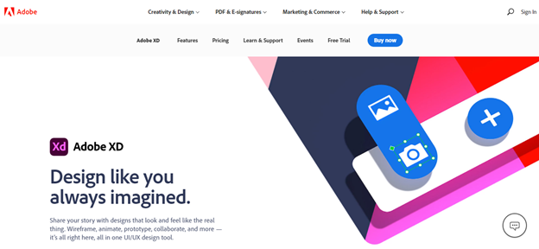

**2.Figma**

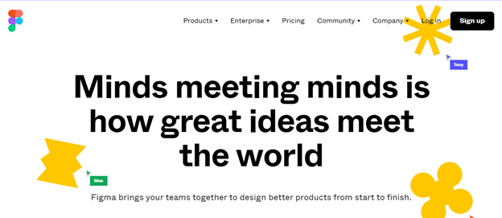

**3.Sketch**

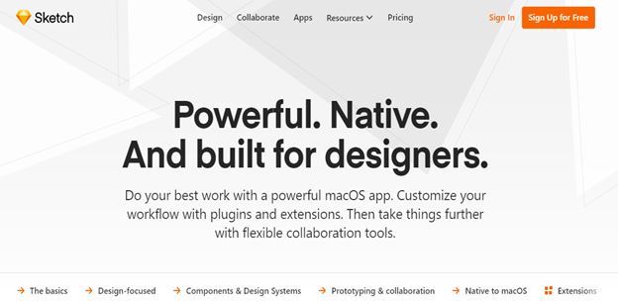

**4.Pencil**

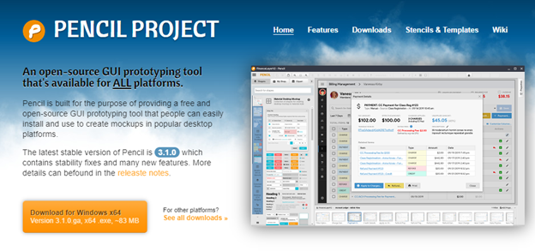

**5.MockFlow**

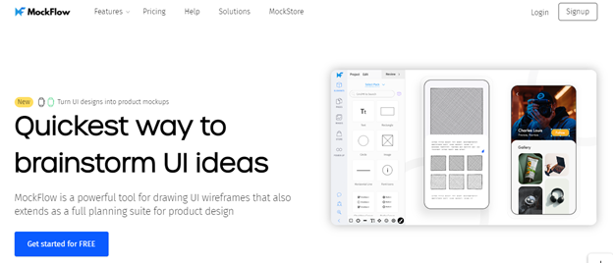

**6.UXPin**

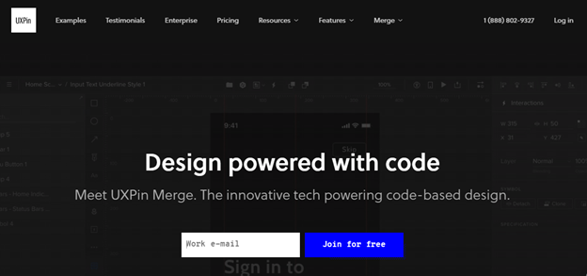

**PRACTICAL NO-2**

**Aim:** Project Proposal and Requirement Gathering (Choose the project).

Project Title – **Appointment Scheduler**

**Description:** The main objective of the project is to computerize the maintenance of the patient details in the hospital. The biggest benefit of an Appointment Scheduler is that the 'traditional' way of making appointments is excruciatingly slow. Normally, a customer or client has to call and discuss a slot for an appointment. This often means that companies have to hire extra staff, which increases costs. An appointment scheduler can give your clients 24/7 access to your appointments system at a much lower cost than hiring a few extra staff to reply to queries outside of office hours.

**Let sum up problem statement -**

The main objective of the project is to computerize the maintenance of the patient details in the hospital. The biggest benefit of an Appointment Scheduler is that the 'traditional' way of making appointments is excruciatingly slow. Normally, a customer or client has to call and discuss a slot for an appointment. This often means that companies have to hire extra staff, which increases costs. An appointment scheduler can give your clients 24/7 access to your appointments system at a much lower cost than hiring a few extra staff to reply to queries outside of office hours.

**main purpose of this project is:** In this project, the patient can register on the website and can login to check the availability of the Doctors with the required specialization. They can make any appointments and can cancel it at any time. After successfully booking/cancelling the appointment, patient will receive an email along with the details. The admin can login the website and can add the list of doctors with their specializations and will give login credentials to the doctor. The admin will have the rights to view all the appointments of the patients. The Doctor can login with the credentials provided by the admin and can change the password. They can view the appointments and can cancel them if needed. Based on availability of doctors, patients would be able to make appointments rather than visiting or calling which may lead to miscommunications and errors enter into the process.

The proposed system will be available for customers 24*7 which means your business is more available for clients without hiring extra staff

**Input -**

The raw facts and information that is required to achieve the desired output are implied as 'Input to the project'. Input to the system is the primary phase of software development. Without raw facts and information about the system, we can't determine the derivative of output.

Basically, inputs are based on the nature of the system’s various components or sub-systems. The inputs concerned to the proposed project are the type of information common to all the expenses such as amount, date, type, and notes associated with it.

**Output -**

Before the development of any project begins, its output is first decided and processed. The sheer reason is that the output of the project is the final result of the project. And all the requirements end there. In other words, the output fulfils the purpose of the development of the proposed system. The output concerned with the proposed system are of two types:

1. On-Screen display

The user can view, modify, and delete the desired expense. Here the user is provided with multiple filter options to preview and modify the desired record of the expense. All the required information associated with a particular case is displayed on the screen for the user.

2. Reports

The importable reports are a crucial aspect of this software. They provide the user with an option to back up their data as well as the output format which is in JSON format can be further used with other desired parsing mechanisms to perform desired operations.

REQUIREMENT SPECIFICATION

FOR DEVELOPMENT

Windows

● Operating Systems: Windows 7 SP1 or later (64-bit), x86-64 based

● Disk Space: 1.32 GB (does not include disk space for IDE/tools).

FOR PRODUCTION

● Android device running Android 4.1 (API level 16) or higher.

**Conclusion:**

1. Help users to manage the cost of their daily expenses.
2. Helpful for the people who are frustrated with the daily budget management.
3. Wish to manage money.
4. Preserve the record of their daily cost.
5. Overcome wastage of money.

**PRACTICAL NO-3**

**Aim:** Analysis

**Description:**1) User Analysis-

# 2) Domain Analysis-

**Conclusion:** User Analysis, Domain analysis, Persona and Er-diagram has been done and understood.

**Screen-Shots:**

**User Persona-**

**Entity Relationship Diagram-**

**PRACTICAL NO -4**

**Aim:** Design Creation of Scenario. Write a scenario that involves all three of the tasks identified for the chosen project.

a) Explain the Scenario

b) Sketch the scenario (use any tool or hand sketches)

c) Draw a mental model.

**Description:**

**Scenario in UI-**

### What is a user scenario?

User scenarios are stories which designers create to show how users might act to achieve a goal in a system or environment. Designers make scenarios to understand users’ motivations, needs, barriers and more in the context of how they would use a design, and to help ideate, iterate and usability-test optimal solutions.

### Why are user scenarios important?

User scenarios are important as these enable [usability](https://pidoco.com/en/help/ux/usability) experts and developers to get into the mindset of potential users. With user scenarios the focus is on users’ needs rather than the technological aspects of design. Another benefit of user scenarios is that they are written in a language that all team members should understand, regardless of specialism. There are many different user scenarios created for any one product or application design. Because the scenario should avoid technical processes, these should leave team members open-minded as to how these actions can be performed.

### How to create user scenarios?

User scenarios are created by writing clearly what interaction needs to take place in order for a task to be carried out. A scenario should be understood by those who do not have a technological background. The user scenario should not just be confined to the user’s interaction with technology, but also the other things that happen while this interaction takes place. User scenarios can therefore include cultural information and context and a description of the circumstances that lead the user to use the product or application. For example, a user scenario describing how someone uses a mobile phone app could include information that the device is used while the user is on the train, or that an action is interrupted by an incoming call. This information can help developers adapt their designs to improve the [usability](https://pidoco.com/en/help/ux/usability) and [user experience](https://pidoco.com/en/help/ux/user-experience) of an application.

**Sketch in UI-**

UI Sketching is, of course, a kind of drawing on a paper but it is not a usual drawing – its purpose is to reveal the result of problem-solving thinking. It communicates the idea to other people. It is also important to remember that sketches are not wireframes. Some designers mistake these two things.

The main purpose of sketches is to quickly visualize the core idea – how the user interface may look and how it could work. Sketches are raw, but they give you the ability to draw your concept faster.

## Advantages of Sketches-

* think more openly and creatively about your ideas.
* create abundant ideas without worrying about their quality.
* invent and explore concepts by being able to record ideas quickly.
* record ideas that you come across.
* discuss, critique, and share ideas with others.
* choose ideas worth pursuing.
* archive your ideas for later reflection.
* have fun creating while designing.

**Mental Model-**

Mental models are abstract, inner representations that people have regarding things from the external world. Mental models include your basic ideas of what something is or how it is supposed to work. Designers frequently research to identify users’ mental models and apply these findings into the design framework, in order to build on top of the users’ existing expectations and beliefs.

**Conclusion:** User-Scenario, Sketching the Scenario and Mental model has been done and understood.

**User Scenario-**

|  |
| --- |
| **User- Harshal Chavan**  **Age- 22**  **Profession- Software Engineer** |

Scenario 1:

|  |  |
| --- | --- |
| **Scenario** | **Goals and Expectations** |
| Patients/Users don’t want to go to hospital every time she wants to book an Appointment | User/Patients can register themselves in the application and directly book the appointment with any doctor assigned for each disease category. |

Scenario 2:

|  |  |
| --- | --- |
| **Scenario** | **Goals and Expectations** |
| Doctors not able to keep track of the Patient appointments. | Registered Doctors can view their patient appointments for the entire day and slot information. |

Scenario 3:

|  |  |
| --- | --- |
| **Scenario** | **Goals and Expectations** |
| Patients need to cancel appointment as he/she won’t be able to visit the hospital on selected time slot. | Patients can cancel Appointments according to their convenience. |

Scenario 4:

|  |  |
| --- | --- |
| **Scenario** | **Goals and Expectations** |
| Hospital Admin staff should be able to Add/Remove doctor appointments based on Hospital requirements. | Hospital Admin staff can Add/Remove doctor appointments based on Hospital requirements. |

**Sketch-**

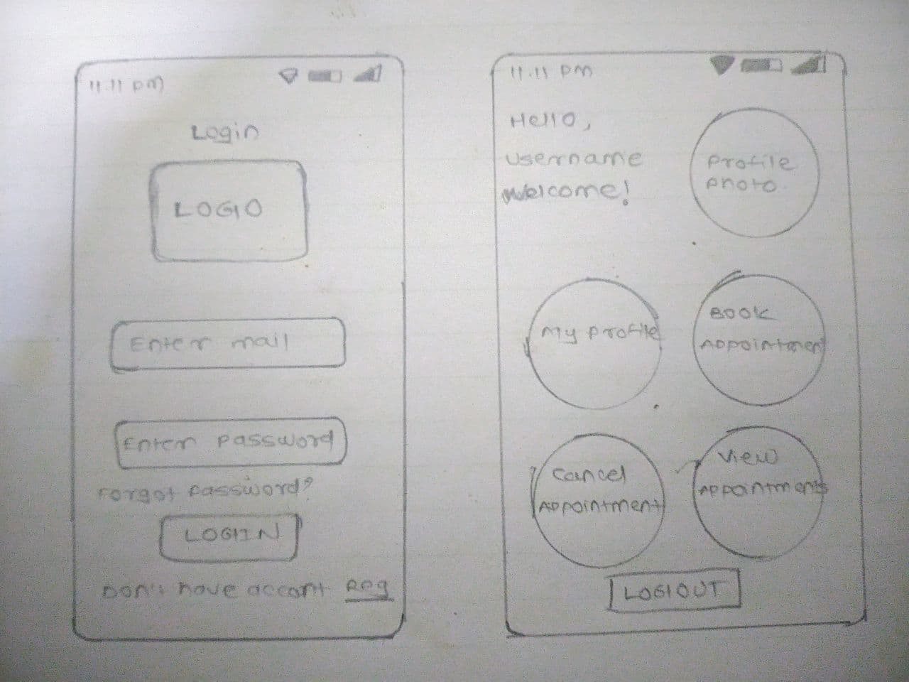

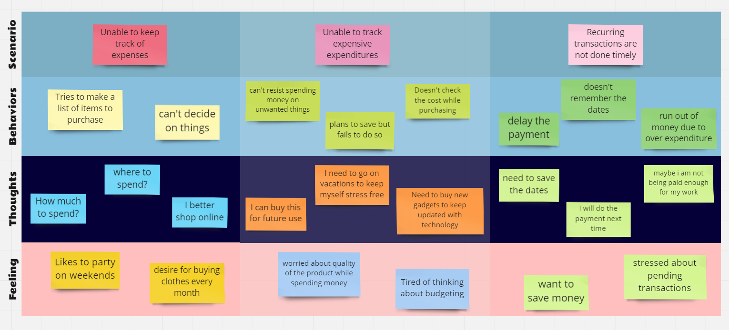

**PRACTICAL NO - 5**

**Aim:** Creating a Paper Prototype and High-Fidelity prototype (Wire Frame using Figma tool.

1) Paper prototype

2) Wireframe.

**Description:**

**Paper prototype-**

In [human–computer interaction](https://en.wikipedia.org/wiki/Human%E2%80%93computer_interaction), paper prototyping is a widely used method in the [user-centered design process](https://en.wikipedia.org/wiki/User-centered_design), a process that helps developers to create software that meets the user's expectations and needs—in this case, especially for [designing](https://en.wikipedia.org/wiki/User_interface_design) and [testing](https://en.wikipedia.org/wiki/Usability_testing) [user interfaces](https://en.wikipedia.org/wiki/User_interface). It is [throwaway prototyping](https://en.wikipedia.org/wiki/Software_prototyping#Throwaway_prototyping) and involves creating rough, even hand-sketched, drawings of an interface to use as prototypes, or models, of a design. While paper prototyping seems simple, this method of [usability testing](https://en.wikipedia.org/wiki/Usability_testing) can provide useful feedback to aid the design of easier to use products.

**Benefits of Paper prototyping-**

Paper prototyping saves time and money since it enables developers to test product interfaces (from software and websites to cell phones and microwave ovens) before they write code or begin development. This also allows for easy and inexpensive modification to existing designs which makes this method useful in the early phases of design. Using paper prototyping allows the entire creative team to be involved in the process, which eliminates the chance of someone with key information not being involved in the design process. Another benefit of paper prototyping is that users feel more comfortable being critical of the mock up because it doesn't have a polished look.

Paper prototyping is the quick way to generate digital ideas by sketching on the paper. In a tight VPC workshop, the quick ideas need to be explored and evaluated. Usually, paper prototyping is preferred as the tools to generate the ideas visually and evaluate in the team and with target customers.

**Wireframe-**

Wireframing is a way to design a website service at the structural level. A wireframe is commonly used to layout content and functionality on a page which takes into account user needs and user journeys. Wireframes are used early in the development process to establish the basic structure of a page before visual design and content is added.

The aim of a wireframe is to provide a visual understanding of a page early in a project to get stakeholder and project team approval before the creative phase gets under way. Wireframes can also be used to create the global and secondary navigation to ensure the terminology and structure used for the site meets user expectations.

#### Advantages of Wireframe-

One of the great advantages of wireframing is that it provides an early visual that can be used to review with the client. Users can also review it as an early feedback mechanism for prototype usability tests. Not only are wireframes easier to amend than concept designs, once approved by the client and the users they provide confidence to the designer.

From a practical perspective, the wireframes ensure the page content and functionality are positioned correctly based on user and business needs. And as the project moves forward they can be used as a good dialogue between members of the project team to agree on the project vision and scope.

**Conclusion:** Paper prototype and Wireframe has been done and understood.

**Screen-Shots:**

**Paper prototype-**



**High Fidelity Wireframe-**

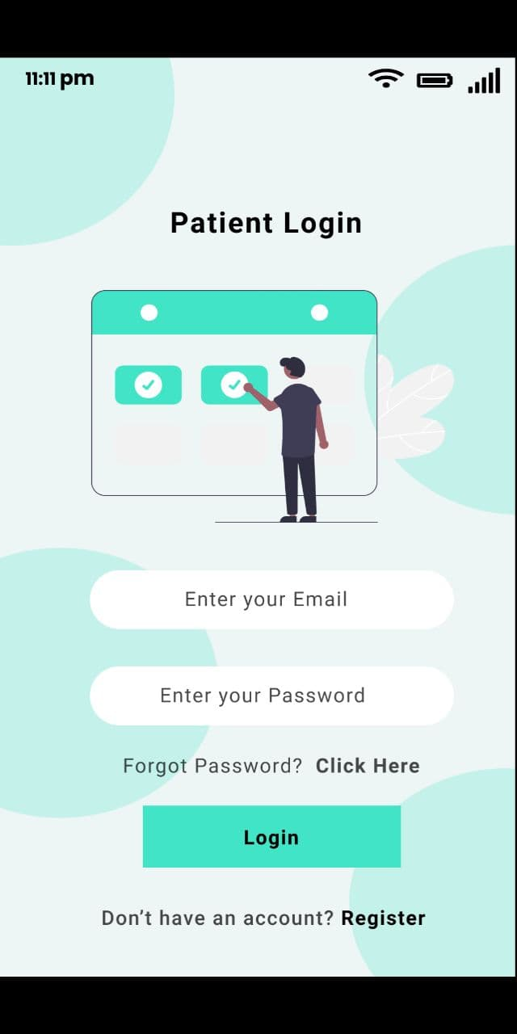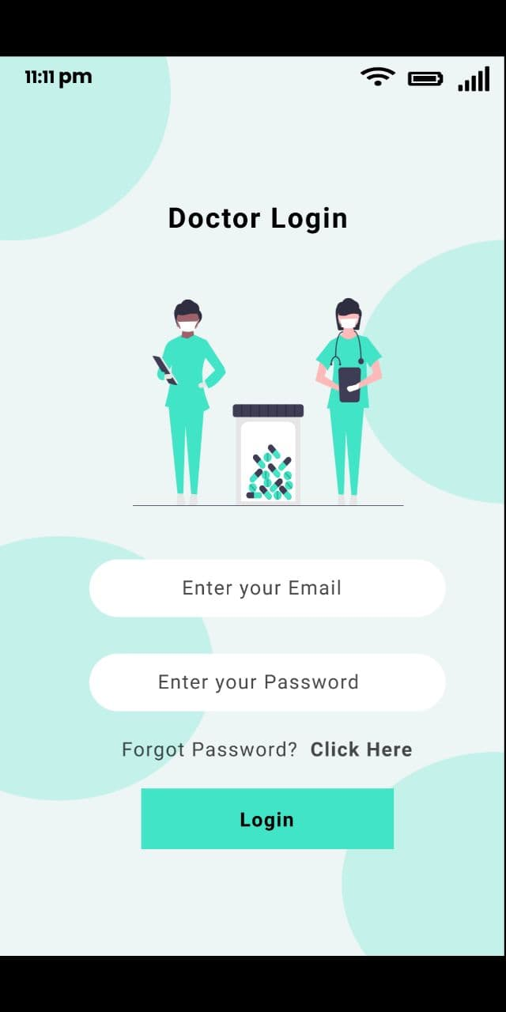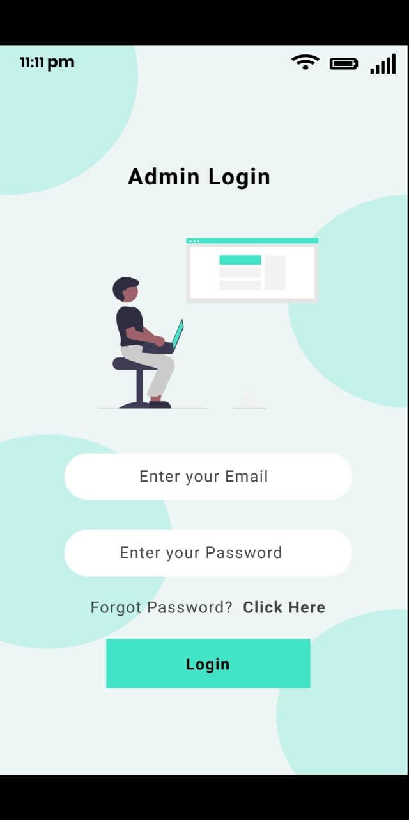

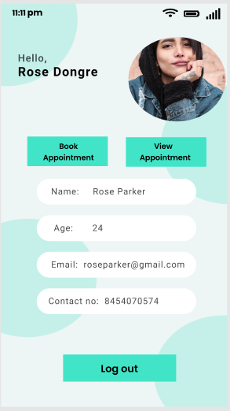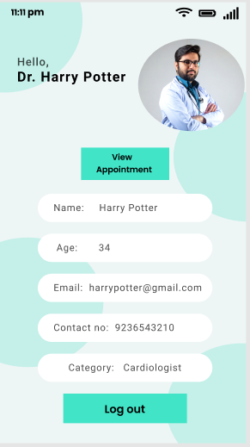

**PRACTICAL NO-6**

**Aim:** The Code should be Optimal and User Friendly

**Description:**

**Importance of user interface**

System users often judge a system by its interface rather than its functionality.

A poorly designed interface can cause a user to make catastrophic errors.

Poor user interface design is the reason why so many software systems are

never used.

**Graphical user interfaces**

Most users of business systems interact with these systems through graphical user

interfaces (GUIs) – although, in some cases, legacy text-based interfaces are still used.

**GUI characteristics**

Icons

Menus

Colourful UI

Animations

**GUI Advantages**

They are easy to learn and use – Users without experience can learn to use the

system quickly.

The user may switch quickly from one task to another and can interact with

several different applications – Information remains visible in its own window

when attention is switched.

Fast, full-screen interaction is possible with immediate access to anywhere on

the screen.

**User Centered Design**

User Centered design is approach to UI design where the needs of the use rare

paramount and where the user is involved in the design process.

UI design always involves the development of prototype interfaces.

**UI Design Principles**

UI design must take account of the needs, experience and capabilities of the

system users.

Designers should be aware of people’s physical and mental limitations (e.g.

limited short-term memory) and should recognize that people make mistakes.

UI design principles underlie interface designs although not all principles are

applicable to all designs.

**Project Details:**

We completely changed the user interface as the earlier interface was poorly designed and was not user friendly.

We’ve developed user interface based on different user type’s (Admin, Doctors, Patients) convenience.

**Screen1:** Splash Screen

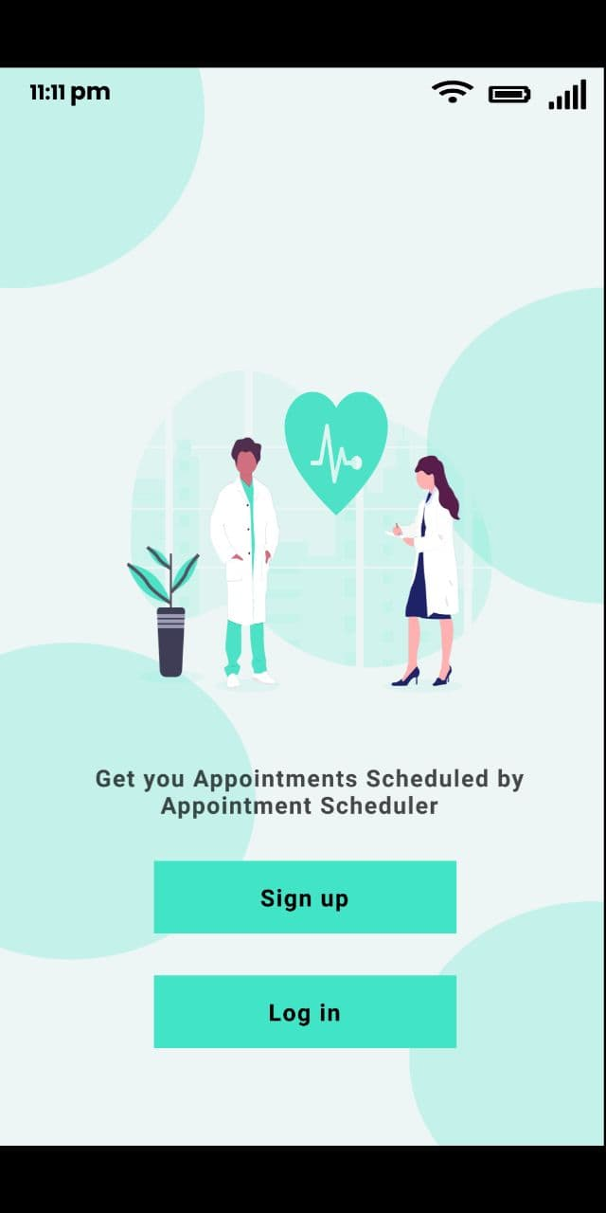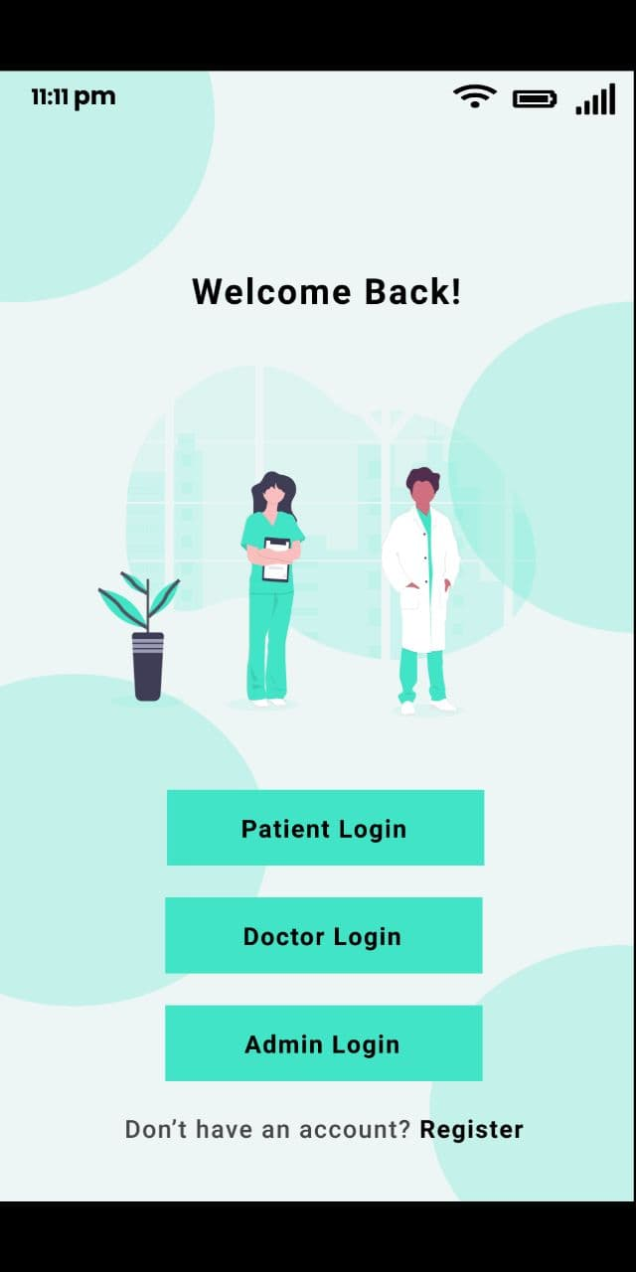

**Screen2: Log in for Doctor/Admin/Patient**



**Screen 3: Patient Registration**

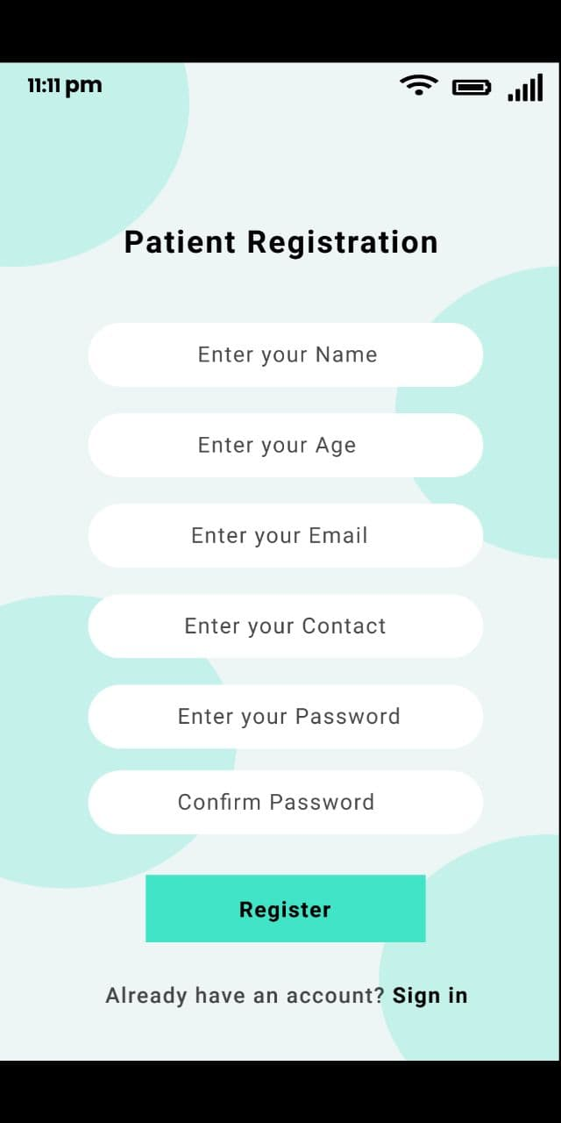

**Screen 4: Dashboard for Patients, Doctors and Admin**

We’ve designed 3 dashboards as there are 3 types of users mainly using this application.

**Patient Dashboard**

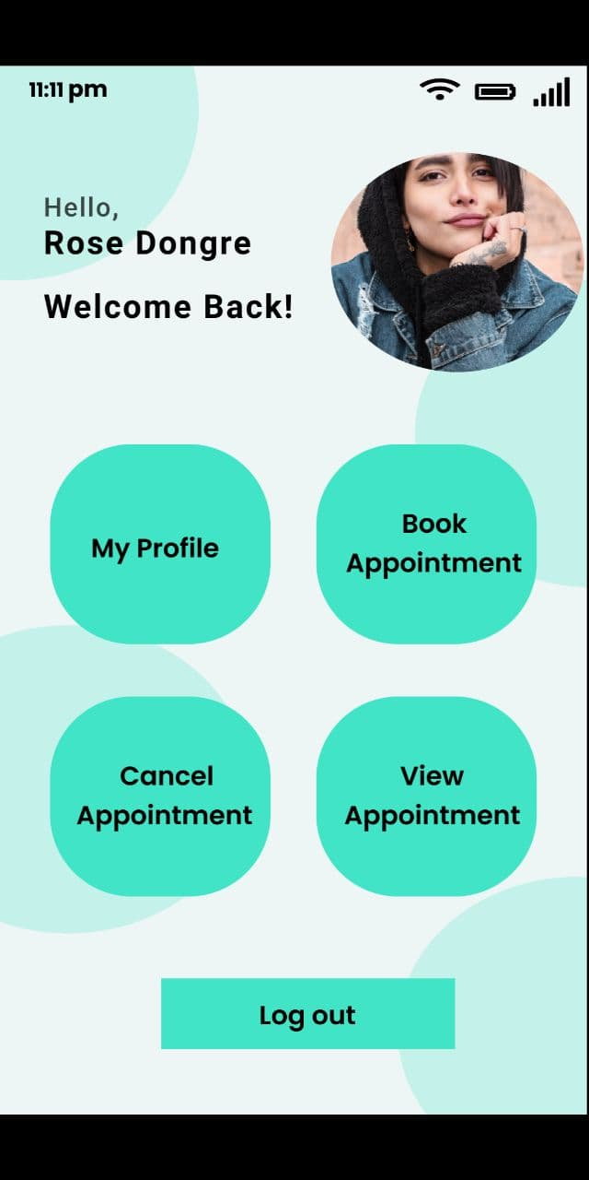

**Doctors Dashboard**

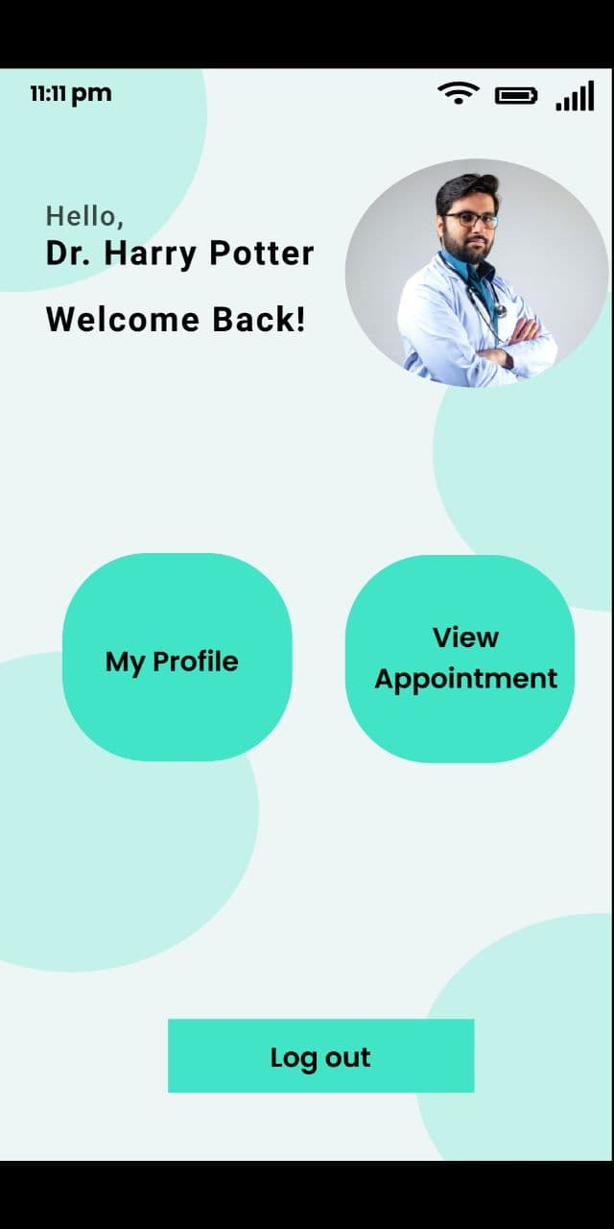

**Admin Dashboard**

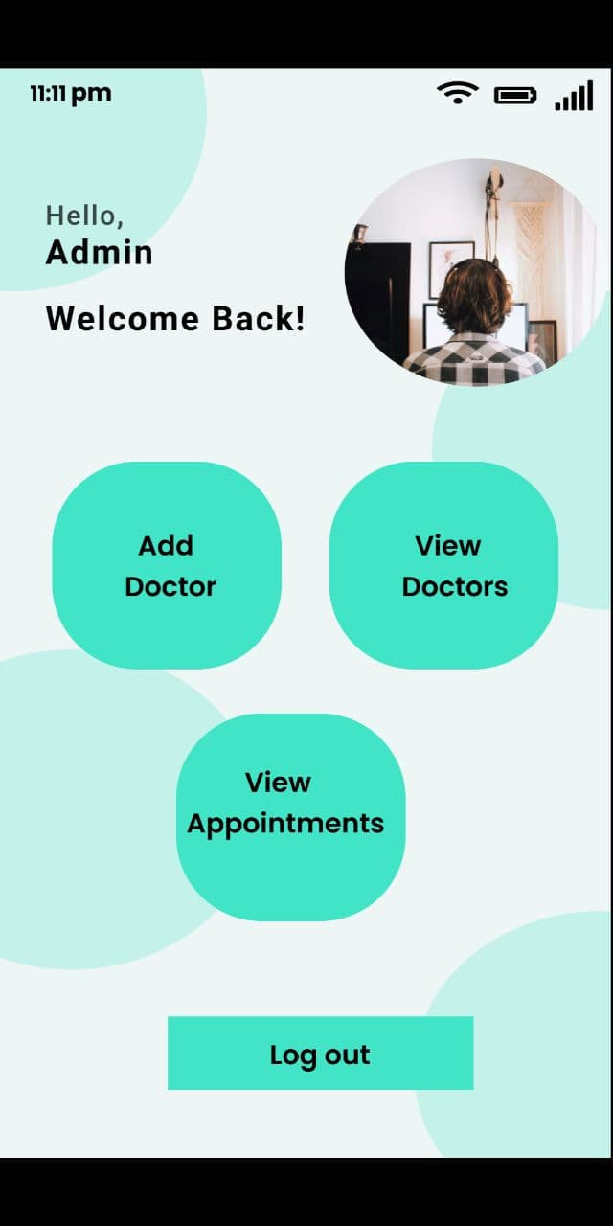

**Screen 5: Book Appointment for Patients**

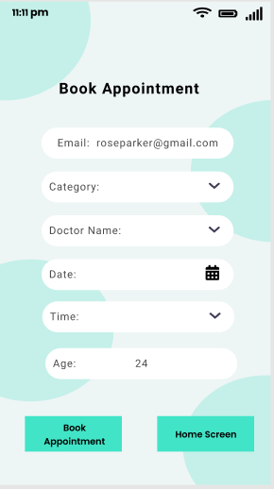

**Screen 6: Profile screen for Patients, Doctors.**



**Screen 6: View Appointment details (For patients and Doctors)**

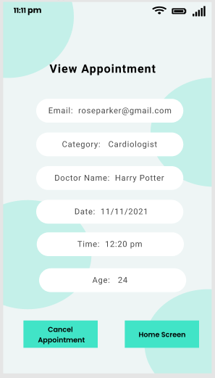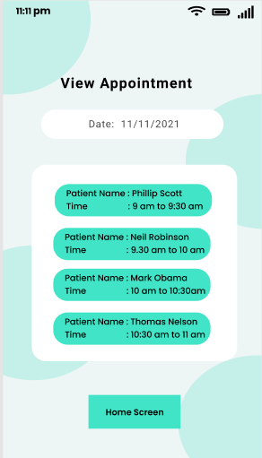

**Screen 7: Cancel Appointments (For Patients)**

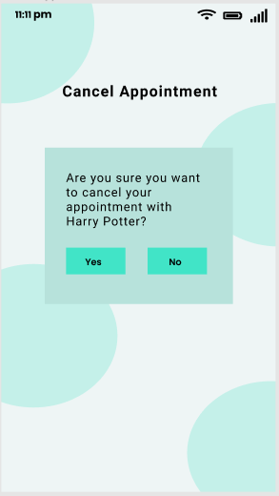

**Screen 8: Add Doctors (For Admins)**

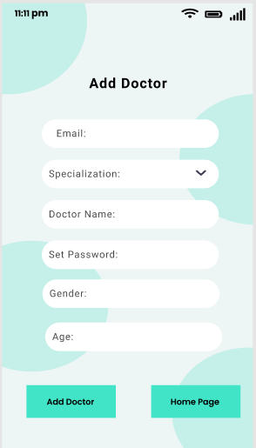

**Screen 9: View Doctors and Appointment Pages (For Admin)**

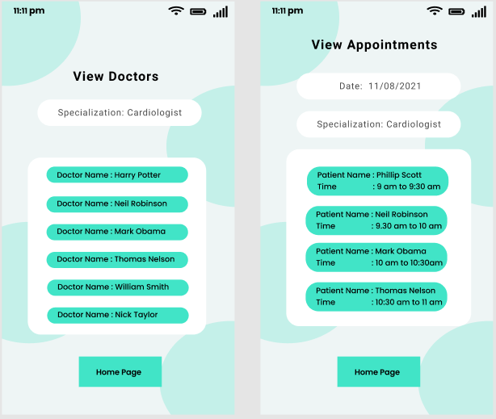

**Screen 11: Forgot Password? (For Doctors, Patients)**

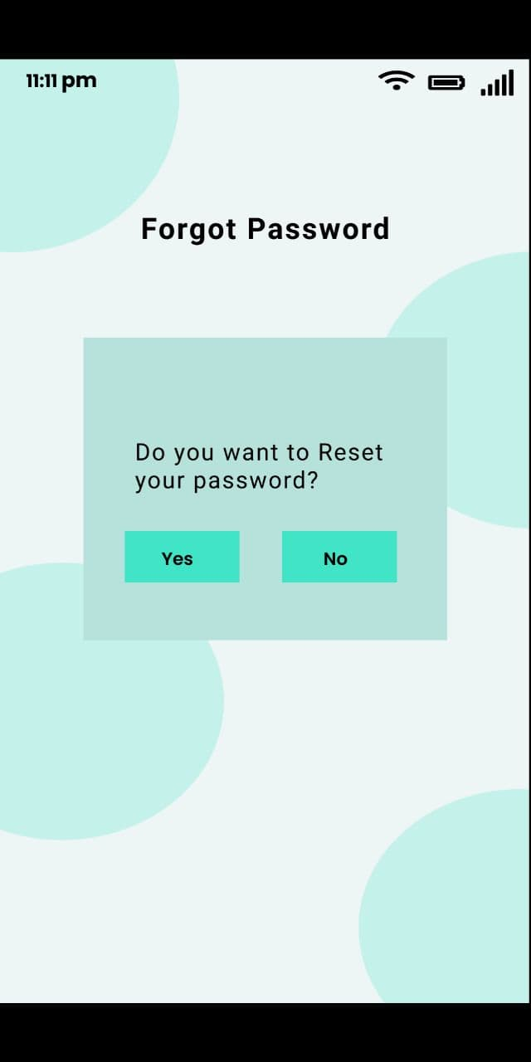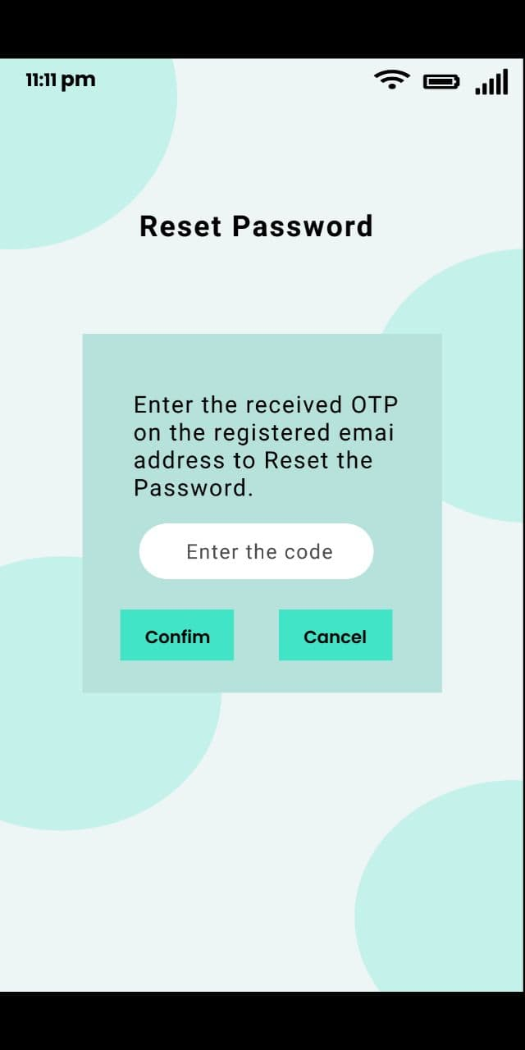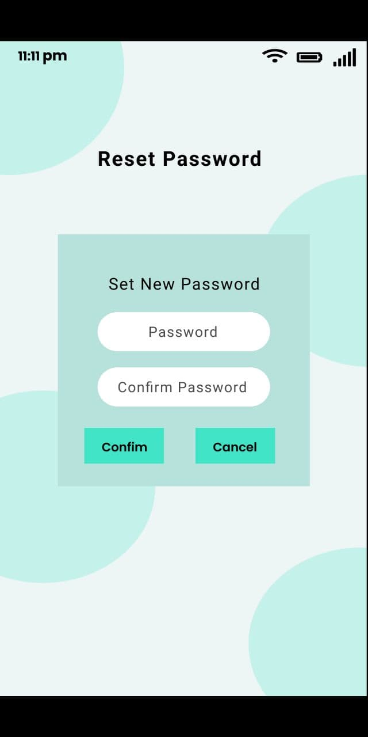

**Conclusion:**

System users often judge a system by its interface rather than its functionality.

Poor user interface design is the reason why so many software systems are

never used.

So, to overcome such a scenario we have implemented a modern UI where patients can book/cancel appointments with different specialist on time slot selected based on patients’ convenience. Patients can view appointments and plan their day accordingly and Hospital Admin staff who can add/remove doctors based on hospitals requirements.

**PRACTICAL NO-7**

**Aim:** Usability Evaluation of the Design

Testing of User Interface from Third Party (Test scripts)

**Description:**

User Interface Design refers to the design of the user interface

for software, websites or applications. It’s about programming the look of things, with a

view to facilitating usability and to improve the user experience.

In simple terms, a user interface is the features of a device or an application that allow a

user to interact with it. Let’s say you are filling a company’s contact form on a website,

your user interface, in this case, would consist of a text box, a drop-down list, a radio

button and any other component which would allow you to enter your data into the

company’s system.

User Interface is important in the sense that it makes it easier for your target audience to

clearly see what your products are. It is designed in a way to display the services that you

offer without ambiguity, in order to draw your visitors’ attention and keep them on your

site. Simply put, a good User Interface is important because it can turn potential visitors

to buyers as it facilitates interactions between the user and your website or web

application.

An interface is a point where users interact with the website they’re using. UI is a main

part of building an engaging website.

**A good User Interface Design presents** a seamless

blend of visual design, interaction design, and information architecture:

Visual Design

Visual design improves a site’s ornamental value by strategically implementing elements

such as fonts, colours, and images among other things. When professionally done, visual

design makes a page elegant without compromising on its function or content.

Interactive design

The interactive design looks at how users interact with technology. It then uses the

understanding of such interactions to create an interface with behaviours that are well

thought-out. Excellent interactive design not only anticipates how a person interacts with

a system but also antedates and fixes problems in good time. It may also invent new ways

through which a system interacts and responds to users.

**Information Architecture**

Information architecture is designed to help users find the info they need to complete

various tasks. It, therefore, involves labelling, structuring, and organizing the web content

in a manner that makes it easily accessible and sustainable.

**UI Design Best Practices**

Designing the perfect user interface comes from knowing the users as well as

understanding their tendencies, preferences, skills, and goals.

Remember the following practices of a good User Interface Design.

Simple Interfaces are best- use a clear language and avoid inessential elements.

Maintain Consistency by using common UI elements. Use elements that users are

familiar with. This ensures things get done fast. It also guarantees user comfort and

gratification.

Use smart, purposeful page layouts. Try to draw attention to the most important

aspects of the website.

Colours and textures should be appropriately used to draw the attention of the

user to a particular or given component. See F5 Studio’s post about web design

for ordinary business

Use the typeface to increase readability and legibility of the content

Use defaults to reduce the burden of the user where appropriate.

These best practice of UI design base on 10 rules to design User Interface

F5 Studio web designers use the best practices of UI design for our works

**5 MISTAKES TO AVOID IN UI DESIGN**

Not implementing a user-centred design: This part is easy to ignore whereas it is

one of the important aspects of UI Design. When designing, you should keep in

mind the needs, preferences,

Problems of the users. Avoiding to do so might have a negative impact on your

business and cause it to collapse.

Not learning more about the target audience: Again, this point illustrates more

what we just talk about. Instead of designing with your own preferences and tastes,

rather design as if you were the customer. Just think about what the customer

would love, and if possible, conduct a survey or interview some potential customers

to truly understand what they need.

Excessive use of dynamic effects: Using too much animations effect is not

synonymous with a great design. So avoiding excessive decorative animations can

help optimize the user experience.

Not exploring further: the pressure of meeting the deadlines, and the heavy

workload can make the designer avoid to explore other possibilities to get inspired

and more creative before they elaborate on their design plan.

Crafting too much beforehand. Especially in the early stage of design, we just want

to have the right picture of the design in mind and start work. However, this

conception is not always efficient. At times, exploring other sources can reveal some surprising things.

We hereby give a few tasks to the user to test our application.

Task given are as follows:

1. Splash Screen
2. Register
3. Login
4. In Dashboard for Patients, Doctors and Admins

**Conclusion:**

User Interface Design refers to the design of the user

interface for software, websites or applications. It’s about programming the look of things, with a view to facilitating usability and to improve the user experience.

**Output:**

|  |  |
| --- | --- |
| **Project Name: Appointment Scheduler** | |
| **Test Case Template** | |
| **Test Case ID: TL001** | **Test Designed by: - Harshal Chavan** |
| **Module Name: Login** | **Test Designed date: 13-AUG-2021** |
| **Test Title: Login Page Navigation** | **Test Executed by: Harshal Chavan** |
| **Description: Verify navigation of user after clicking on Login button** | **Test Execution date: 16-AUG-2021** |
| **Pre-conditions: App successfully installed on device** | |
| **Dependencies: User must have Android device with version higher than 4.2.2** | |

|  |  |  |  |  |  |  |
| --- | --- | --- | --- | --- | --- | --- |
| **Step** | **Test Steps** | **Test Data** | **Expected Result** | **Actual Result** | **Status (Pass/Fail)** | **Notes** |
|  |  |  |  |  |  |  |
| 1 | Validate Sign Up Page | Name, Age, Email, Contact, Password | User should be able to create an account | User is able to create an account | Pass | NA |
| 2 | Validate Login Page | UserId, password | User should be able to login | User is able to login | Pass | NA |
| 3 | Validate Patient able to Book for Appointment | Category, Doctor name, date, time | User should be able to book an appointment | User is able to book an appointment | Pass | NA |
| 4 | Validate Doctor able to View Appointment | NA | Doctor should be able to view the appointment | Doctor is able to view the appointment | Pass | NA |
| 5 | Validate Patient able to cancel Appointment | NA | Patient should be able to cancel the appointment | Patient is able to cancel the appointment | Pass | NA |

**Following are the Screenshots after test execution:**

**Screen1:** Splash Screen



**Screen2: Log in for Doctor/Admin/Patient**



**Screen 3: Patient Registration**



**Screen 3: Dashboard for Patients, Doctors and Admin**

We’ve designed 3 dashboards as there are 3 types of users mainly using this application.

**Patient Dashboard**



**Doctors Dashboard**



**Admin Dashboard**



**Screen 4: Book Appointment for Patients**



**Screen 5: Profile screen for Patients, Doctors.**



**Screen 6: View Appointment details (For patients and Doctors)**



**Screen 7: Cancel Appointments (For Patients)**



**Screen 8: Add Doctors (For Admins)**



**Screen 9: View Doctors and Appointment Pages (For Admin)**



**Screen 11: Forgot Password? (For Doctors, Patients)**

