**Assignment - 6**

Exercise 1 gives you all necessary API so that you start receiving all simulated sensor data on ST BLE Sensor App. Make change in the program so that it can send actual HTS221 temperature sensor data rather than simulated data.

Code:

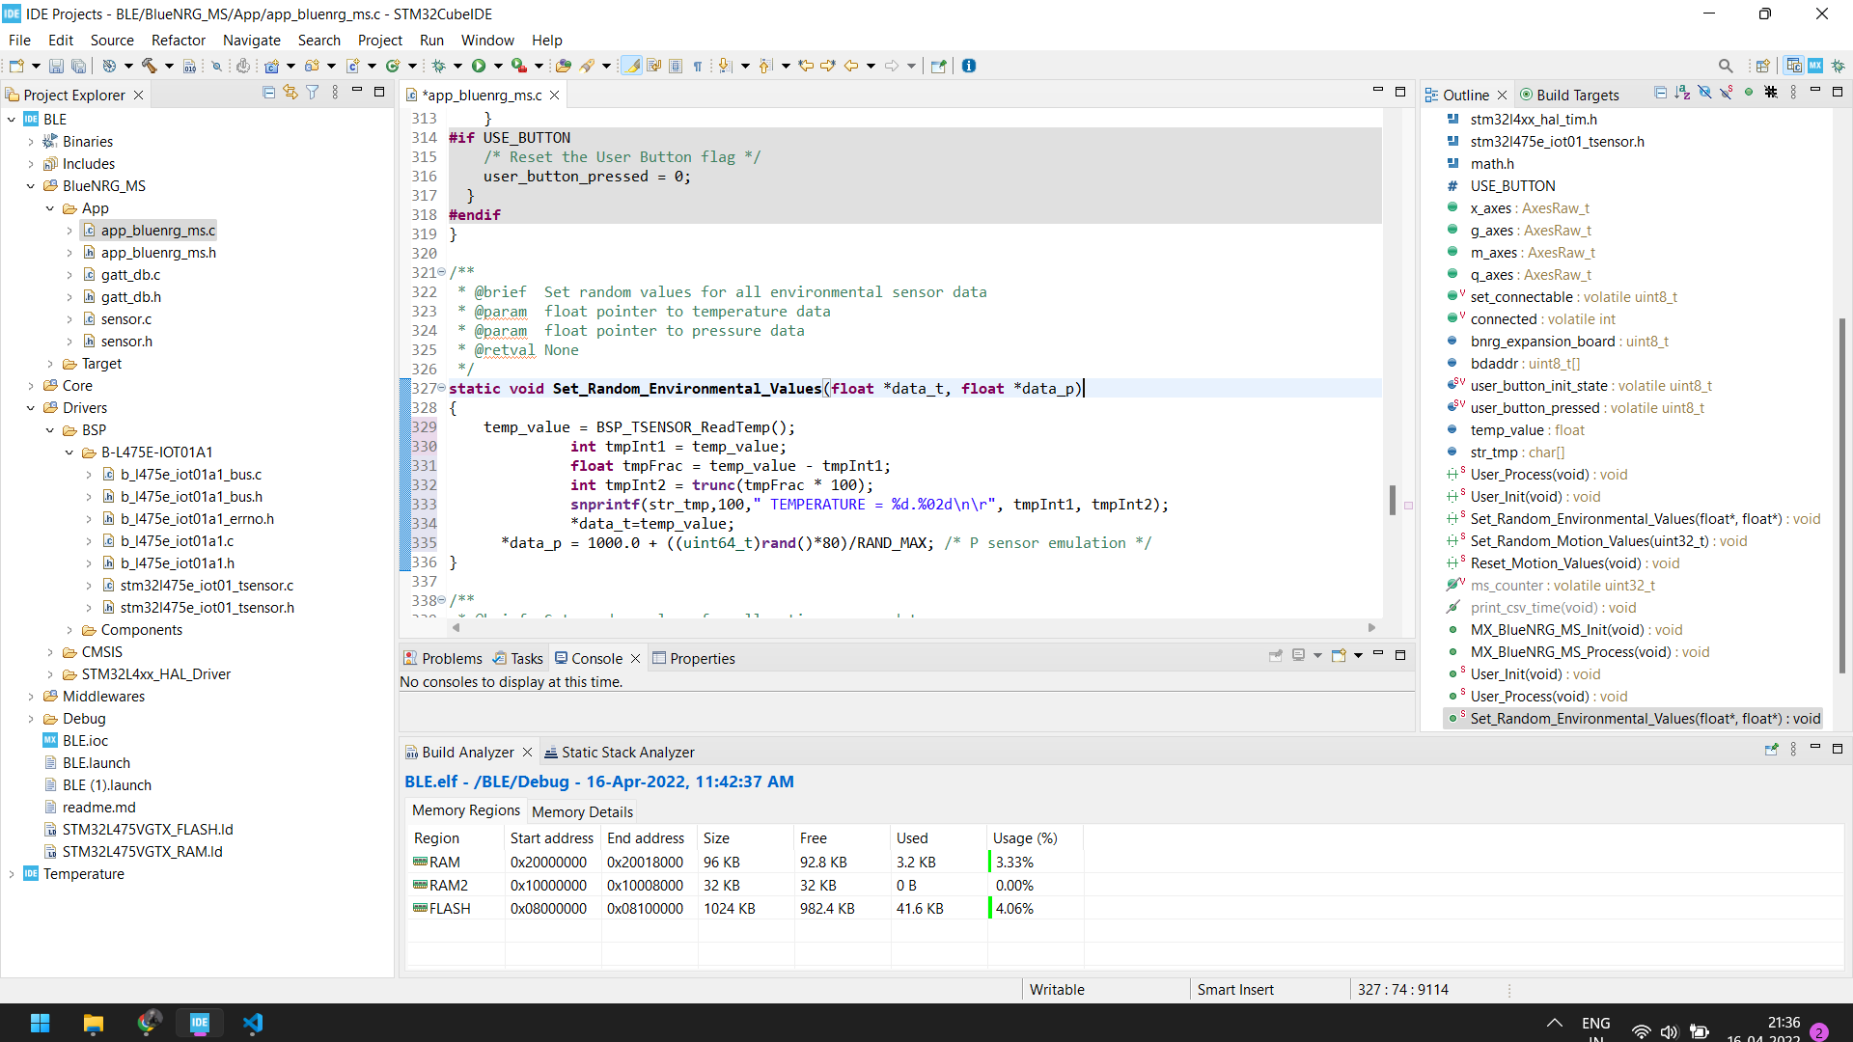

Output: 