Project – Established connection which can transfer data from different VPC of different availability zones

**Solution:**

**Source: Test EC2 from ap-south-1a (Test)**

**Receiver: Prod EC2 from ap-south-1b (Prod)**

* For Source Connection:

1. **Create with VPCs in the same account and Region**

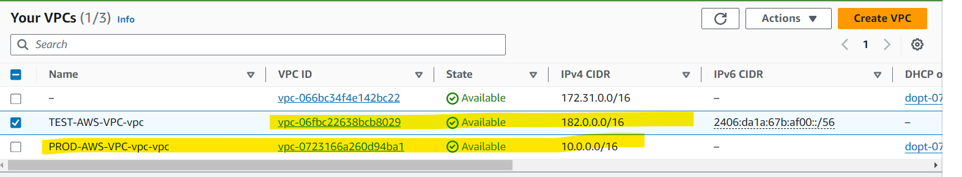

1. 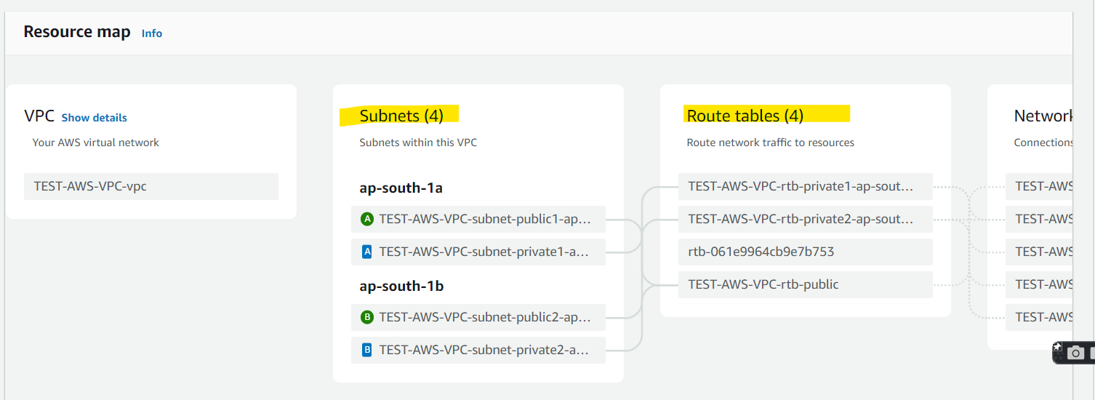**Configured Subnets & Route Tables**
2. **Now, for accessing internet we have to Configured Internet Gateway**
   1. 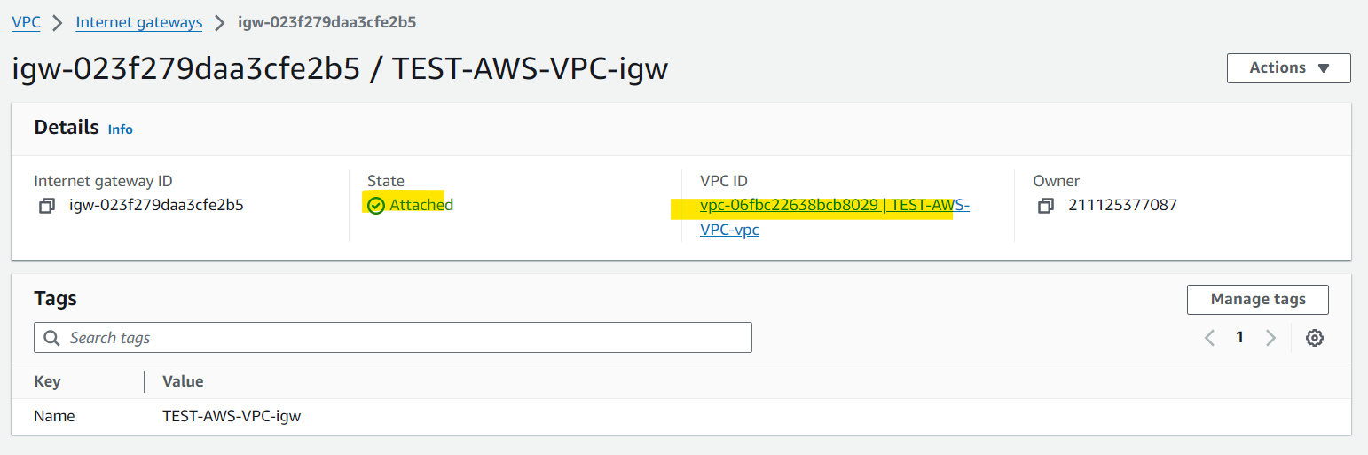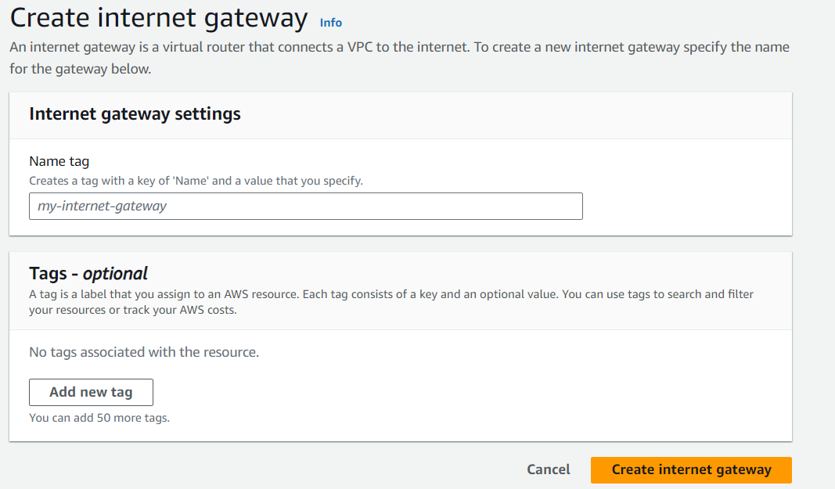
3. **Same configuration needed for PROD VPC of different AZ.**

Now, For Estb. Connection we have to create a **VPC peering connection**, first create a request to peer with another VPC. We can request a VPC peering connection with another VPC in your account, or with a VPC in a different AWS account.

For an inter-Region VPC peering connection where the VPCs are in different Regions, the request must be made from the Region of the requester VPC.

Steps:

1. Configure the following information, and choose **Create peering connection** when you are done:
   * **Name**: You can optionally name your VPC peering connection.
   * **VPC ID (Requester)**: Select the VPC in your account with which you want to create the VPC peering connection.
   * For **Select another VPC to peer with**, choose **My account** and select another of your VPCs.
2. Configure the following information, and choose **Create peering connection** when you are done:
   * **Name**: You can optionally name your VPC peering connection.
   * **VPC ID (Requester)**: Select the VPC in your account with which you want to create the VPC peering connection.
   * For **Select another VPC to peer with**, choose **My account** and select another of your VPCs.
   * (Optional) To add a tag, choose **Add new tag** and enter the tag key and value.
3. Choose **Actions**, **Accept request**.
4. When prompted for confirmation, choose **Accept request**.
5. Choose **Modify my route tables now** to add a route to the VPC route table so that you can send and receive traffic across the peering connection. For more information, see [Update your route tables for a VPC peering connection](https://docs.aws.amazon.com/vpc/latest/peering/vpc-peering-routing.html).

To activate the request, the owner of the accepter VPC must accept the request. For an inter-Region VPC peering connection, the request must be accepted in the Region of the accepter VPC.

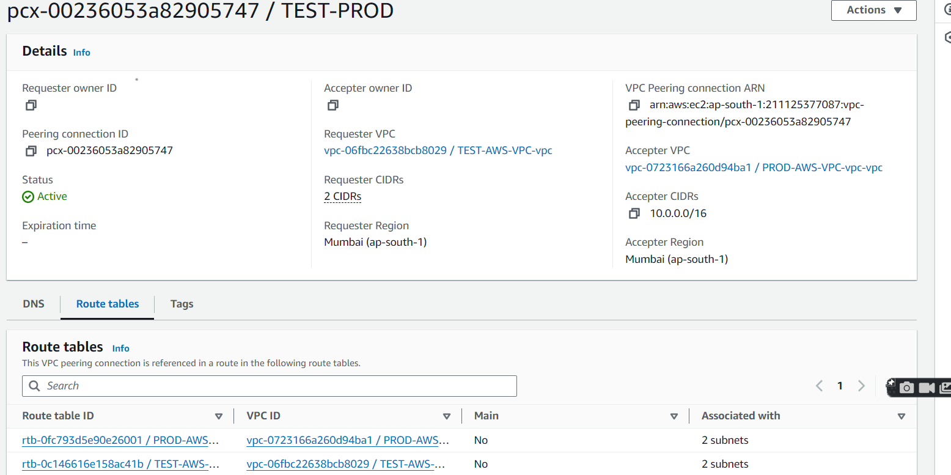

Also, we have to Configured Route Tables & route both Source & Destination CIDR

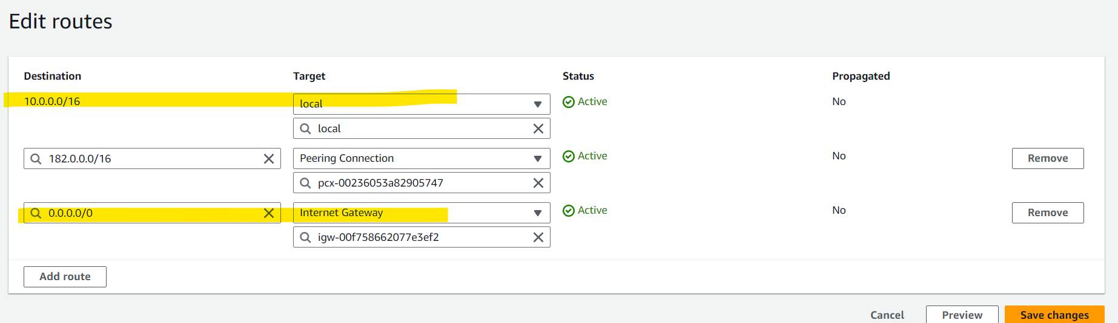

Also, we have to **e**nsure that your VPCs do not have overlapping IPv4 CIDR blocks. If they overlap, the status of the VPC peering connection immediately goes to failed. This limitation applies even if the VPCs have unique IPv6 CIDR blocks.

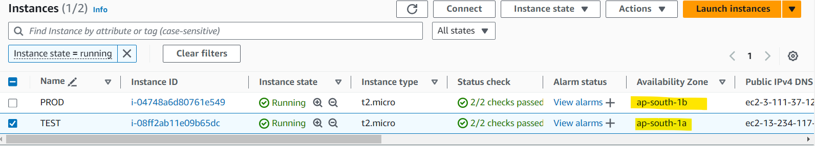

We have to make sure that, in Every EC2 machine Security Zone we have to allow ICMP Traffic of our associated CIDR.

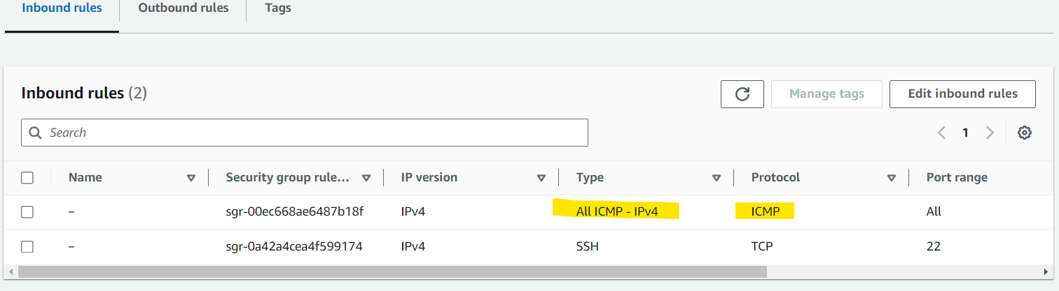

**Final Result of Successful Connections:**

