67th ANNUAL GENERAL BODY MEETING

NOVEMBER 12, 2016

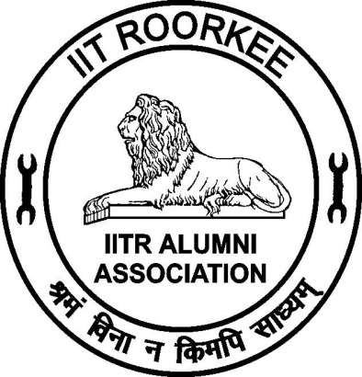

IITR ALUMNI ASSOCIATION
INDIAN INSTITUTE OF TECHNOLOGY ROORKEE
(Formerly University of Roorkee)
ROORKEE – 247 667

EXECUTIVE COMMITTEE 2016 – 2017
Prof. Prem Krishna
President
Prof. S. P. Gupta
Vice President
Dr. Achal Kumar Mittal
Honorary Secretary
Dr. R. D. Garg
Joint Secretary
Er. Dinesh Pawar
Treasurer
Prof. Sandeep Singh
Dean, Alumni Affairs & International Relations
Dr. Pradeep Kumar
Immediate Past Secretary
Elected Members

Er. Apoorva Agarwal | Er. Nand Kishore Shrama |  | Er. Sunil Kumar Pundir
Shri Salil Swaroop Arya | Er. Naresh Chandra Garg |  | Er. (Mrs.) Surjeet Sharma
Dr. Ashok Kumar Gupta | Dr. Bhawna Sindhu |  | Dr. Satyendra Mittal
Er. Harish Kumar Goyal | Er. Pradeep Kumar Bansal |  | Er.Virendra Kumar Mittal
Er. Manoj Goel | Er. Sharat Chandra Gupta |  | Er. Vishnu Kant
Co-opted Members

Prof. S.C. Handa |  | Prof. P.P. Agarwal

IIT ROORKEE ALUMNI ASSOCIATION

Proceedings and agenda for the 67th Annual General Body Meeting & Felicitation of Silver Jubilee Alumni

- Welcome address by Secretary
- Obituaries
- Kulgeet
- Welcome Speech - by Dr. S.P. Gupta, Vice President
- Presidential address - by Prof. Prem Krishna (Text of speech is at Appendix -1)
- Felicitation to Silver Jubilee Alumni
- Address by Director, IIT Roorkee
- Agenda for annual general body meeting

Item No. 67.1: Confirmation of minutes of the 66th AGBM held on November 07, 2015

Minutes of the AGBM held on 7th Nov. 2015 were circulated and no comments were received on the recording of the minutes. The minutes circulated to the members are given in the report (Appendix-2) and are put up for confirmation by the house.

Item No. 67.2: Consideration of the Annual Report for the period from November 01, 2015 to October 31, 2016 (Appendix-3)

Item No. 67.3: Consideration of the Audited Accounts for the period from April 1, 2015 to March 31, 2016. (Appendix-4)

Item No. 67.4: Appointment of auditors for audit of accounts of the Alumni Association for the financial year 2016 – 2017.

M/S Awasthi Prakash & Associates, Roorkee, have audited the accounts for the period from April 1, 2015 to March 31, 2016 and they eligible for re-appointment.

Item No. 67.5: Consideration of the budget for the year 2016– 2017. (Appendix-5)

Item No. 67.6: To consider abolition of the following clause of rules & regulations for participation in election to EC in view of online mode of elections with the participation of large number of alumni.

6.2(k) “Normally no elected/nominated office bearer shall hold office for more than three consecutive years except under exceptional circumstances approved by the Executive Committee”.

Item No. 67.7: To consider nomination of more than two member on the Executive Committee by the president representing special interests.

As per clause 6.2 (h) of rules & regulations of the association the President can nominate two members on the Executive Committee representing special interests.

The Executive in its meeting held on April 30, 2016 suggested that number of co-opted members should be more than two and this issue be discussed in the AGBM.

Item No.67.8:7 To report that the Executive Committee in its meeting held on May 20, 2015 considered and approved the following changes in the bye-laws relating to election of Executive Committee.

Existing | Revised
3.1 Vice President, Joint Secretary, Treasurer and members of the Executive Committee shall be elected in the Annual General Body Meeting through simple majority of votes | 3.1 Vice President, Joint Secretary, Treasurer and members of the Executive Committee shall be elected by the General Body Meeting through simple majority of votes, cast on line.
3.2 A notice of the General Body Meeting may be served on any member either personally or by sending it through ordinary post or through news paper advertisement of through e-mode | 3.2 A notice of the election may be served by e-mode and advertisement on the IITRAA website.

Elections to the Executive Committee for the year 2016-17 were conducted online on the basis of the above changes in the bye-laws approved by the Executive Committee. This could not be reported to the General Body at its last meeting through an oversight. The online elections gave opportunity to all IITRAA members to contest elections and take part in the voting as compared to the facility available to a limited number of members, present in the AGBM in the past. More than 950 members took part in casting their votes. The elections were held in the months of February-March 2016 and in future elections will be held during these months.

The names of the office bearers for the elected to the Executive committee for 2016-17 are given on back side of the coverpage of this book.

Item No. 67.9: To report the result of elections for the Executive Committee for the year 2016 -17.
The details of the executive committee constituted for the year 2016-17 appears at appendix-6.

Item No. 67.10: To report that the Executive Committee in its meeting held on September 10, 2016 has decided to institute a research award of Rs. One Lakh at IIT Roorkee to be given annually to a young IITR Alumnus.

The IIT Roorkee has been requested to accept the proposal and the rules for the award are being drafted.

Item No. 67.11: Declaration of Name of ROBA Quiz Winner

Any other item with the permission of the Chair
Vote of Thanks
National Anthem

Appendix -1

Address by Prof. Prem Krishna, President, IITR Alumni Association

Distinguished Guests; Dear Alumni, particularly the Silver Jubilee alumni, and, their families; Ladies and Gentleman:

I have great pleasure in welcoming you all to this, the 67th Annual General Meeting of the IIT Roorkee Alumni Association. I particularly wish to felicitate our Silver Jubilee Alumni of the 1991 batch, many of whom are returning to this campus after 25 years, happily for us, with their families in many cases. As we all know, this institution has the longest history in engineering education in the Country. The important thing of which the Roorkee alumni can be proud, is that a tradition of excellence has been maintained, in whatever may have been the name or system under which the institution functioned. There have been changes all along but the dynamics has been positive always.

Our alumni have served the cause of National development admirably, for almost a century plus serving in the public sector initially, but in the industry too in recent decades, as the opportunities have grown there. This Silver Jubilee batch, has grown with this change.

The IITR Alumni is a reservoir of highly competent technical hands with a great potential – one estimate put down our contribution as being a million man years.. The young alumni who inherit this wonderful band of Roorkee alumni year after year, have every reason to look up to it. However, in order that the alumni as individuals or groups can tap the potential better, it is imperative that there is good connectivity. As I had mentioned last year also, the IITRAA is committed to this objective. I had mentioned about the EC’s proposal to run ‘on–line’ elections for electing the Executive Council 2015-16, which has been successfully carried out, and, it enabled much wider participation compared to earlier years.

Furthermore the issue of a bi-monthly e-Newsletter since July 2014 has helped in bringing out news of our alumni. We have also brought out ‘memorabilia’ - volumes called ‘SMRITIKA’ for the degree recipients of 2017. In all these new initiatives the support and cooperation from the Director, and the Dean AAIR, Prof. Sandeep Singh. has been invaluable. Also the office bearers, and, the members of the EC, as well as our rather thin office staff, have played their part fully and I wish to thank them for this.

I wish to share a welcome development at the PANIIT India, where IITRAA is duly represented. The working of this organisation had been rather troubled in the last couple of years. Through concerted effort in the last few months the problems are in the past, and, the PAANIIT is looking forward to playing its due role.

Before I end, I wish to congratulate the Silver Jubilee alumni and earnestly hope that they will carry fond memories of this re-union, and, return to the campus for their, Golden and Diamond Jubilees besides re-unions before these. I thank all of you who have come to attend this Annual General Body Meeting, and have given me a patient hearing.

Prem Krishna
President,
IITR Alumni Association (2016 – 17)
Appendix -2
Minutes of the 66th Annual General Body Meeting (AGBM) of the IIT Roorkee Alumni Association held on November 07, 2015.
The 66th AGBM was held on November 07, 2015 at 4.30 PM in the O.P. Jain Auditorium of Civil Engineering Department. Over 250 Alumni were present. Among them were around 190 Silver Jubilee Alumni of 1990 batch & B. Arch 1991 batch.
At the outset, the House condoled the sad demise of the following alumni
R. K. Jain BE Civil 1951, Satish dhusia, BE Civil1986, Vijay Arora Mechanical 1990, Dev Verma, Civil 1961, Amrish Goel, Civil 1991, J. M. Mahajan, Mechanical 1961, Arun Katiyar Civil 1993, Rajeev Garg, Metallurgy 1979, Arun Mishra 1975, Atul Charan Architecture 1976, Ajay Garg Metallurgy 1976, Alok Kaul E&C 1975, Rajeev Trikha E&C 1985.
The members stood in silence for two minutes to pay their homage to the departed souls.
The meeting was adjourned for a while and reassembled to take up the agenda further as given below.
The meeting started with the recitation of Kulgeet.
Prof. V. K. Gupta, Vice President welcomed the members of the Alumni Association of Silver Jubilee (1990 batch and B. Arch 1991 batch) as well as Non-Jubilee Alumni.

  - The minutes of the 65th AGBM held on November 05, 2014 were confirmed. The minutes were considered and approved as such.

  - Prof. Prem Krishna, the President welcomed the Silver Jubilee Alumni and non-Jubilee Alumni and presented his address.

  - Felicitation of Silver Jubilee Alumni (1990 Batch and B. Arch 1991 Batch):
The alumni were felicitated by the President, IITRAA and Director, IIT Roorkee by presenting a memento to each of them.

At the end of this ceremony few of the alumni gave their responses, which included the old memories of their stay at the University of Roorkee as well as some feedback suggestions for furthering the interaction between IITR and the alumni.
  - As Prof. Pradipta Banerji, Director, IIT Roorkee presented the message to the Jubilee Alumni.

  - The Annual Report for the period from November 01, 2014 to October 31, 2015 was presented and considered. The report was adopted by the house.
  - The Audit report giving the Audited Account for the period from April 1, 2014 to March 31, 2015 was considered and adopted.

  - Appointment of the auditor for the financial year 2015-16 was considered. It was resolved that the same Chartered Accountant as in Financial Year 2014-15 i.e. M/s Awasthi Prakash & Associates, Roorkee be continued for Financial Year 2015-16 also.
  - Budget for the year 2016-17 was considered and was approved.

  - Under Any other item : No item was discussed

The secretary proposed vote of thanks. The meeting ended with the recitation of National Anthem.

Achal Kumar Mittal
Honorary Secretary
Appendix-3

Annual Report of the IITR Alumni Association for the period from November 1, 2015 to October 31, 2016

It is a great pleasure for me to present the Annual Report of the IITR Alumni Association for the period of November 01, 2015 to October 31, 2016. This report presents various activities undertaken by the Association during the period under report.

Membership

The membership of the Alumni Association is increasing steadily. At present, we have 32670 members as against 30351 members during the last year i.e. as on October 31, 2016. We have enrolled these members in the period since 1941.

Finance and Accounts

The audited accounts are printed on the following pages. As per the directions of the General Body of the Association, M/s Awasthi Prakash & Associates Chartered Accountant, Civil Lines, Roorkee have duly audited the accounts.

Jubilee Alumni Meet - 2015

The 2015 Jubilee Functions for the Alumni included customary Silver (25 years), Golden (50 Years) and Diamond (60 years) Jubilees, besides the two new additions, the Coral (35 years) and Ruby (40 years) were celebrated.

Jubilee Alumni Meets 2015 were celebrated with great enthusiasm. Silver Jubilee function for the 1990 pass out batch on November 07-08, 2015 and Golden (1965 batch) & Diamond (1955 batch) Jubilee functions were celebrated on 24-25 Nov. 2015 35 Diamond & Golden Alumni and 190 - Silver Jubilee Alumni participated in the meet along with their families. This year Ruby Jubilee (40 years) for 1975 batch and Coral Jubilee (35 years) for 1980 batch were celebrated on December 18-19, 2015 some of the alumni visited the campus for the first time after graduating from the erstwhile University of Roorkee. This year a new meet named - Pearl Jubilee (30 years) Reunion for 1986 batch was also celebrated on January 9-10, 2016.

All the Jubilee Alumni along with their families had separately met their respective batch mates with great zeal and nostalgia. They enjoyed games on Lal Bahadur Shastri Stadium with great gusto.

The Jubilee Alumni visited Anushruti (formerly Roorkee School for the Deaf) and many of them did noble thing of donations for the school. A large number of student volunteers participated in Jubilee function. Visiting alumni appreciated their enthusiasm and participation.

Annual General Body Meeting

The 66th Annual General Body Meeting of the Association was held in the evening of 07th November, 2015 in O.P. Jain Auditorium and was attended by over 200 members. The meeting started with welcome by Prof. V. K. Gupta, Vice President.

During the AGBM the Alumni of 1990 and 1991 (B. Arch) batches were felicitated for completing Silver Jubilee of their graduation.

Programme for Accompanying Spouses

An interesting session for all the accompanying spouses and children was organized in the Khosla International House (earlier known as Afro-Asian Hostel). In this session, an informal cultural function was arranged, where the spouses narrated interesting stories regarding their husbands and their emotional involvement with Roorkee. Accompanying children cherished this occasion with great enthusiasm.

Anushruti Programme

All the Jubilee Alumni visited Anushruti (formerly Roorkee School for the Deaf) and many of them did the noble thing of donations for the school.

Elections to EC
This time Elections for the Executive Committee for the year 2016-17 were held online.

Scholarship
Scholarship amounting to Rs. 65000/- were given to the students studying at IIT Roorkee.
Website

The Alumni Association has been able to establish its own independent website. The website is www.iitraa.in. This website is being maintained and updated from this year by a professional outfit called Alma Connect Solutions Pvt. Ltd.

E-newsletter

IITR Alumni Association has taken the initiative to bring out a bi-monthly e-newsletter. This e-newsletter is being sent to those members whose email addresses are available with us. It is also available on our website www.iitraa.in.

Yearbook

An yearbook containing details of students who were admitted to various programmes through JEE with views of their fellow classmates was published by the Alumni Association this year and distributed to all graduating students at the time of convocation 2016 of IIT Roorkee

Acknowledgements

I am extremely grateful to Prof. Prem Krishna, President, Prof. Pradipta Banerji Director IITR and the Working President, for their guidance, support and encouragement received by me during the period.

I am thankful from the bottom of my heart to all the members of the Executive Committee and fellow Alumni from the Institute and all the local chapters who have helped me in the activities of the Alumni Association.

(Achal Mittal)
Honorary Secretary
Appendix -4

Appendix-5

Budget Estimates for the year 2017 – 2018

Income |  | Expenditure
Membership fee | 25,00,000 | Printing & Stationery+ Year Book | 1,100,000
Interest | 14,00,000 | Postage | 30,000
Registration fee | 35,00,000 | Mementos & souvenir | 8,00,000
 |  | Transport/Travelling | 80,000
 |  | Salary of staff /Honorarium | 8,00,000
 |  | Hospitality | 9,50,000
 |  | Boarding & Lodging | 1,050,000
 |  | Audit & Contingencies | 35,000
 |  | Telephone & FAX | 15,000
 |  | AGM | 2,00,000
 |  | Activities with Local Chapters | 2,50,000
 |  | PAN IIT | 50,000
 |  | Photo identity cards for members | 40,000
 |  | Webpage including office Assistant wages | 2,50,000
 |  | Office & Computer & peripherals Maintenance | 1,50,000
 |  | Alumni Lecture series | 1,50,000
 |  | Charity/Contributions to National Activities/students | 2,50,000
 |  | Consumables / Contingencies Miscellaneous | 5,00,000
 |  | Savings | 7,00,000
Total | 74,00,000 |  | 74,00,000

Appendix-6

The results of the Elections to the executive Committee for the year 2016-17

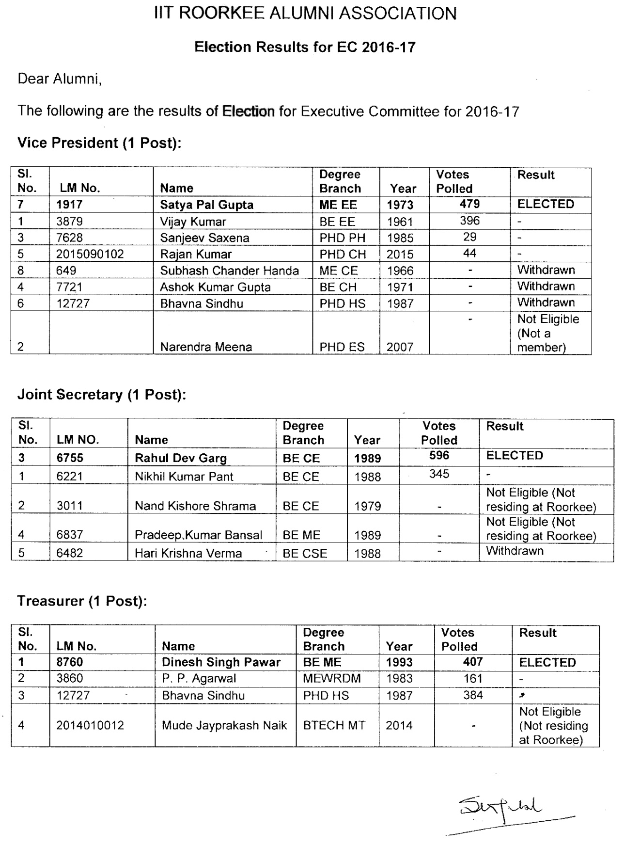

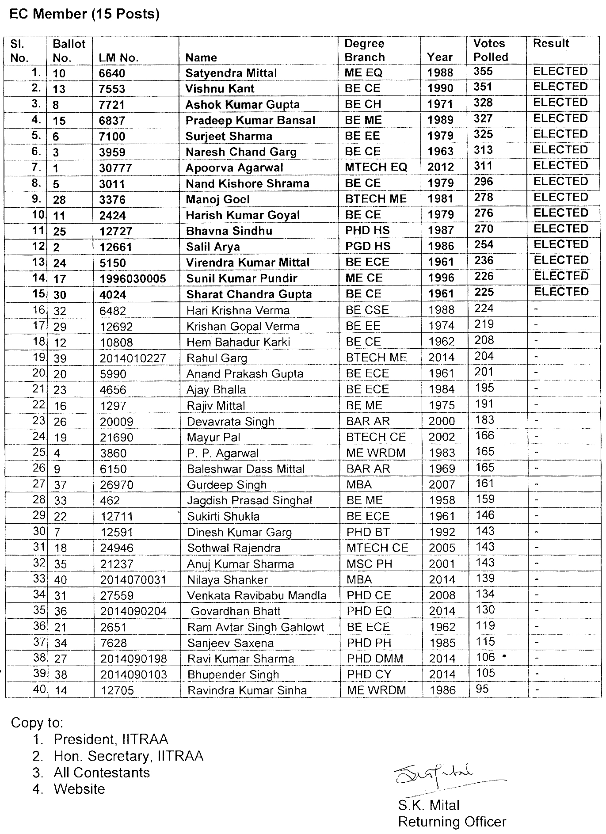

IITR ALUMNI ASSOCIATION

PRESIDENTS AND SECRETARIES
Year | President | Secretary
2015-16 | Prem Krishna | Achal Mittal
2014 | Prem Krishna | Pradeep Kumar
2013 | J. L. Gaindhar | Pradeep Kumar
2012 | J. L. Gaindhar | N. K. Samadhiya
2011 | P.K. Pande | N. K. Samadhiya
2009-10 | D. V. Singh | Ashok K. Ahuja
2007-08 | R. K. Singh | Manoj K. Arora
2004-06 | V. K. Agnihotri | R. P. Maheshwari
2002-03 | Pradip Baijal | S. K. Ghosh
1998-2001 | H.S. Agarwal | A. K. Mathur
1997 | D.V. Singh | V. K. Goel
1996 | D.V. Singh | Surendra Kumar
1995 | Ashok Bhatnagar | Surendra Kumar
1994 | S.K. Khanna | S. C. Handa
1993 | R.P. Singhal | S. C. Handa
1992 | Rajendra Prakash | S. C. Handa
1991 | Harish Chandra | V. P. Bansal
1990 | Raj Kumar Jain | Ashok K. Jain
1989 | Bhupal Singh | Ashok K. Jain
1988 | G.C. Agarwal | Ashok K. Jain
1987 | G.C. Agarwal | S. K. Mittal
1986 | R.C. Mangal | S. K. Mittal
1985 | Vijendra Singh | S. K. Mittal
1984 | K.M.Maheshwari | V. K. Tiwari
1983 | O.P. Jain | V. K. Tiwari
1982 | D.R. Singh | A. K. Gupta
1980-81 | Dinesh Mohan | A. K. Gupta
1979 | Hari Krishna | A. K. Agarwal
1978 | V.R. Vaish | A. K. Agarwal
1977 | K..C. Goyal | V. Charan
1976 | J.S. Dhillon | Satish Chandra
1975 | N.D. Gulhati | Shamsher Prakash
1974 | Jivan Datt | Shamsher Prakash
1973 | S.K. Jain | R. N. Agrawal
1972 | H.G. Verma | R. N. Agrawal
1971 | Jai Krishna | A. S. Arya
1970 | S. C. Katoch | A. S. Arya
1969 | J. P. Mital | M. K. Singhal
1968 | Baleshwar Nath | Satish Chandra
1967 | D. B. Anand | Satish Chandra
1966 | D. S. Nag | Satish Chandra
1965 | D. C. Baijal | Rajendra Prakash
1964 | H. P. Sinha | Rajendra Prakash
1963 | Yadav Mohan | Rajendra Prakash
1962 | G.K. Agarwal | K. V. Mital
1961 | Kanwar Sain | K. V. Mital
1960 | P.L. Verma | Dinesh Mohan
1959 | Karnail Singh | Dinesh Mohan
1958 | Ghananand Pandey | Dinesh Mohan
1957 | H.K.L. Sethi | S. N. Gupta
1956 | K.N. Kathpalia | S. N. Gupta
1955 | M.S. Bisht | S. N. Gupta
1954 | M.S. Mathur | S. N. Gupta
1953 | Balbir Singh | S. N. Gupta
1952 | A.N. Khosla | S. N. Gupta
1951 | L.P. Misra | S. N. Gupta
1950 | C.A. Hart | Jai Krishna
1949 | N.N. Chakravarti | Jai Krishna
1947-48 | B.D. Puri | Jai Krishna
1946 | G. Lacey | Jai Krishna
1940-45 | M.G. Sardana | Jai Krishna

