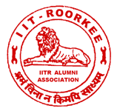
Dr. R.D.Garg
Honorary Secretary
Email: rdgarg@gmail.com
Phone: 01332 – 285630, 271541 (O)
Fax: 01332 – 285630
E-mail:iitraa@gmail.com
Website: www.iitraa.in
IITR ALUMNI ASSOCIATION
Indian Institute of Technology Roorkee
(FORMERLY UNIVERSITY OF ROORKEE)
ROORKEE – 247 667 (UTTARAKHAND), INDIA

VISION, INNOVATION,
TEAM WORK & EXCELLENCE

No. IITRAA/JUB/DJ/2017-18
Date: June 07, 2017
Dear Sir,

We have pleasure in informing you that Diamond Jubilee Meet is being organized by IIT Roorkee Alumni Association (IITRAA) from November 23-25, 2017. Since you are completing 60 years of your graduation from the erstwhile University of Roorkee (Now IIT Roorkee) we are happy to invite you to join the meet with your spouse. I am sure meeting old friends and classmates will be great fun. You will also be able to see how the campus has changed since your days.

All arrangements for your stay and meals during the meet shall be made by the IITRAA. If you are joining the programmes, you are requested to please send us the attached form duly filled. We will be holding felicitation function for the Jubilee Alumni on November 24, 2017 at Roorkee during the Meet and you are cordially invited to join the same.

If any alum wants to have exclusive personal car for his use, IITRAA office will arrange it with the request to settle the bill directly with the service provider with intimation to us.

Accommodation booking will be done on receipt of attached form duly filled by August 31, 2017 beyond which we will have to release the unallocated rooms.

I hope you will be joining this mega event with your spouse and intimate us your programme by August 31, 2017 positively.

It is also humbly requested to kindly share this information with your batchmates, as we may not be having their contact details.

With best wishes and regards

Yours sincerely

R.D. Garg
Honorary Secretary

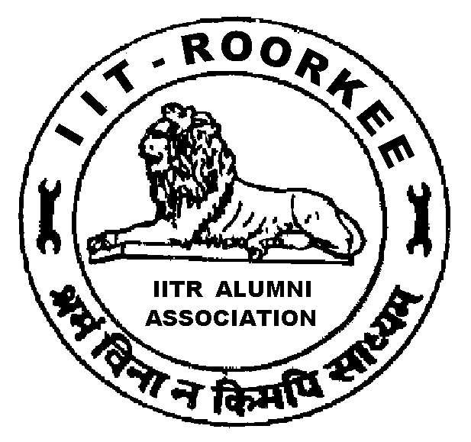
IITR ALUMNI ASSOCIATION
Indian Institute of Technology Roorkee
ROORKEE – 247 667 (UTTARAKHAND) INDIA

DIAMOND JUBILEE MEET 2017

TRAVEL PROGRAMME and PAYMENT DETAILS

1. Name:
2. Date and Time of Arrival:
3. Mode of Transport:
4. Accommodation Required_____ Not Required____
5. Whether Spouse is accompanying you? Yes_____ No_____
6. Whether driver is accompanying you? Yes_____ No_____
7. Date, Time & Mode of Departure:

Signature

IITR ALUMNI ASSOCIATION
Indian Institute of Technology Roorkee
ROORKEE – 247 667 (UTTARAKHAND) INDIA

Photograph(s)

DIAMOND JUBILEE -2017

BIO-DATA FOR INCLUSION IN SOUVENIR

1. Name (as entered in your degree) :________________________________________
2. Degree obtained from UOR: ______Branch :__________Year of passing:________
3. Date of Birth:__________________________________________________________
6. IITRAA Life Membership No. (if you know):_________________________________
7. Postal Address with PIN Code: ___________________________________________
___________________________________________
____________________________________________
8. Phone Nos.: Mobile:___________________ Landline:______________________
9. Email Id: __________________________________________________
10. Name of Spouse : ____________________11. Date of Marriage:_______________
(DD/MM/YYYY)
12. Children (Names, Age and Education): (i)_________________________________ (ii)_________________________________
(iii)_________________________________
13. Please attach a high contrast colour photograph of yourself and your spouse
14. Present Position and Organisation:________________________________________
______________________________________
15. Brief biodata giving your achievements / awards briefly (Maximum 10 lines):_________
________________________________________________________________________________________________________________________________________________________________________________________________________________________________________________________________________________________________________________________________________________________________________________________________________________________________________________________________________________________________________________________________________________________________________________________________________________________________________________________________________________________________________________________________________________

Signatures
* If you have not obtained Membership card so far, kindly send us your digital photo and signatures separately.

IITR ALUMNI ASSOCIATION
Indian Institute of Technology Roorkee
ROORKEE – 247 667 (UTTARAKHAND), INDIA

DIAMOND & GOLDEN JUBILEE ALUMNI MEET - 2017
TENTATIVE PROGRAMME
Time | Function | Venue
23rd November 2017 (Thursday)
1200 – 2200 | Registration | KIH*
24th November 2017 (Friday)
0800 – 1000 | Registration / Breakfast |  | LBS Stadium*
1000 – 1200 | Cricket Match/Games for Alumni & their Spouses |  | LBS Stadium
1200 – 1300 | Group Photograph of Jubilee Alumni & their Spouses |  | James Thomason Building*
1300 – 1430 | Alumni Lunch |  | LBS Stadium
1430-1630 | Free Time
1600 – 1630 | Alumni Tea |  | O.P.Jain Auditorium*
1630 – 1900 | Felicitation programme |  | O.P.Jain Auditorium
1630 - 1800 | Recreation Programme for Accompanying spouses (including Tea) |  | KIH
1930 – 2130 | Alumni Dinner |  | LBS Stadium
25th November 2017 (Saturday)
0800 – 1030 | Breakfast at Anushruti* & visit to its facilities
1100 – 1300 | Alumni Day celebrations at James Thomason Building lawns
1300 – 1400 | Lunch |  |  | KIH
*
KIH : Khosla International House (formerly AA Hostel)
LBS Stadium : Lal Bahadur Shastri Stadium
James Thomason Building : Main Building
O.P. Jain Auditorium : Auditorium in Civil Engg, Deptt.
Anushruti : Roorkee School For Deaf and Dumb, IIT Campus

