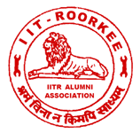
Dr. R.D.Garg
Honorary Secretary
Email: garg_fce@iitr.ac.in
Phone: 01332 – 285630, 271541 (O)
Fax: 01332 – 285630
E-mail: iitraa@gmail.com
Website: www.iitraa.in
IITR ALUMNI ASSOCIATION
Indian Institute of Technology Roorkee
(FORMERLY UNIVERSITY OF ROORKEE)
ROORKEE – 247 667 (UTTARAKHAND), INDIA

VISION, INNOVATION,
TEAM WORK & EXCELLENCE

No. IITRAA/GJ/2017-18
Date: June 7, 2017
Dear Sir,

We have pleasure in informing you that Golden Jubilee Meet is being organized by IIT Roorkee Alumni Association (IITRAA) from November 23-25, 2017. Since you are completing 50 years of your graduation from the erstwhile University of Roorkee (Now IIT Roorkee) we are happy to invite you to join the meet with your spouse. I am sure meeting old friends and classmates will be great fun. You will also be able to see how the campus has changed since your days.

Let me confess at the outset that accommodation arrangement has been a point of dissatisfaction among alumni in the past. We have been having a dialogue with the Institute on this point. The institute administration has been quite understanding and cooperative on the subject. It is likely that on the whole, we may get few more rooms this year than previous year though it may still fall short of expectations. There are likely to be four broad types of accommodations available, Khosla International House, other guest houses in the campus, some hostel in the campus and hotels outside. We request you to confirm by August 31, 2017 if you are planning to join the reunion.

All arrangements for your stay and meals during the meet shall be made by the IITRAA. You will be required to contribute a sum of Rs. 9000/- to meet the expenses on your boarding and lodging etc. If you are joining the programmes you are requested to please send us the attached form duly filled along with the contribution of Rs. 9000/- which can be remitted either by bank transfer to the IITRAA bank Account No. 10660278834 with the State Bank of India, IIT Roorkee Branch or Multicity Cheque payable on a bank at Roorkee by August 31, 2017. Confirmation of accommodation booking will be done on receipt of payment.

Each batch is requested to nominate a batch coordinator. We will give total rooms availability in various places to the batch coordinator. He will be requested to allot rooms and tell us. If any alumnus wants hotel accommodation outside the campus, IITRAA office will coordinate the booking.

We will be holding felicitation function for the Jubilee Alumni on November 24, 2017 at Roorkee during the Meet and you are cordially invited to join the same.

If any alum wants to have exclusive personal car for his use, IITRAA office will arrange it with the request to settle the bill directly with the service provider with intimation to us.

Accommodation booking will be done for all payments received by August 31, 2017 beyond which we will have to release the unallocated rooms, if any. Any alum who does not make payment by the specified date, is still most welcome to join the meet. However we will request him to arrange for accommodation at his own

I hope you will be joining this mega event with your spouse and intimate us your programme and pay the contribution of Rs. 9000/- by August 31, 2017 positively.

It is also humbly requested to kindly share this information with your batchmates, as we may not be having their contact details.

With best wishes and regards

Yours sincerely

R.D. Garg
Honorary Secretary

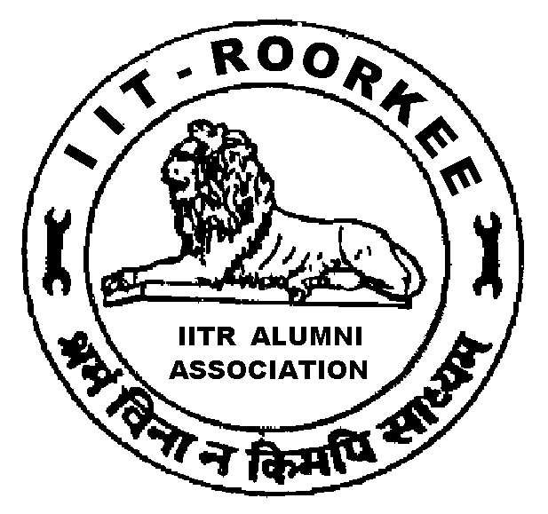
IITR ALUMNI ASSOCIATION
Indian Institute of Technology Roorkee
ROORKEE – 247 667 (UTTARAKHAND) INDIA

GOLDEN JUBILEE MEET 2017

TRAVEL PROGRAMME and PAYMENT DETAILS
1. Name:
2. Date and Time of Arrival:
3. Mode of Transport:
4. Accommodation Required_____ Not Required____
5. Whether Spouse is accompanying you? Yes_____ No_____
6. Whether driver is accompanying you? Yes_____ No_____
7. Date, Time & Mode of Departure:

8. For payment of Rs 9,000/-

Multicity Cheque No. ______________ dated_________________

Electronic Transfer Transaction No. & date___________________
Bank name____________________________________________

(You can remit the Contribution either by DD / Multicity Cheque or Internet Banking. To facilitate reconciliation of payment, please mention your name, year & branch at the back of DD/Cheque. Payment to be made in favour of Honorary Secretary, IITR Alumni Association and payable at Roorkee. For Electronic Transfer, you may use following details:
Name of Bank : State Bank of India, IIT Roorkee Branch (01069),
A/c No : 10660278834
IFSC : SBIN0001069
If you are making the payment through Electronic Transfer please inform us the details of transaction with bank name immediately after payment.

Signature

IITR ALUMNI ASSOCIATION
Indian Institute of Technology Roorkee
ROORKEE – 247 667 (UTTARAKHAND) INDIA

Photograph(s)

GOLDEN JUBILEE -2017

BIO-DATA FOR INCLUSION IN SOUVENIR

1. Name (as entered in your degree) :____________________________________________
2. Degree obtained from UOR: ______Branch :__________Year of passing:_____________
3. Date of Birth:_____________________________________________________________
6. IITRAA Life Membership No. (if you know):_____________________________________
7. Postal Address with PIN Code: ______________________________________________
_____________________________________________
_____________________________________________
8. Phone Nos.: Mobile:___________________ Landline:___________________________
9. Email Id: _________________________________________________
10. Name of Spouse : ____________________11. Date of Marriage:___________________
(DD/MM/YYYY)
12. Children (Names, Age and Education): (i)_____________________________________
(ii)___________________________________
(iii)___________________________________
13. Please attach a high contrast colour photograph of yourself and your spouse
14. Present Position and Organisation:__________________________________________
_________________________________________
15. Brief biodata giving your achievements / awards briefly (Maximum 10 lines):__________
___________________________________________________________________________________________________________________________________________________________________________________________________________________________________________________________________________________________________________________________________________________________________________________________________________________________________________________________________________________________________________________________________________________________________________________________________________________________________________________________________________________________________________________________________________________________________

Signatures
* If you have not obtained Membership card so far, kindly send us your digital photo and signatures separately.

IITR ALUMNI ASSOCIATION
Indian Institute of Technology Roorkee
ROORKEE – 247 667 (UTTARAKHAND), INDIA

DIAMOND & GOLDEN JUBILEE ALUMNI MEET - 2017
TENTATIVE PROGRAMME
Time | Function | Venue
23rd November 2017 (Thursday)
1200 – 2200 | Registration | KIH*
24th November 2017 (Friday)
0800 – 1000 | Registration / Breakfast |  | LBS Stadium*
1000 – 1200 | Cricket Match/Games for Alumni & their Spouses |  | LBS Stadium
1200 – 1300 | Group Photograph of Jubilee Alumni & their Spouses |  | James Thomason Building*
1300 – 1430 | Alumni Lunch |  | LBS Stadium
1430-1630 | Free Time
1600 – 1630 | Alumni Tea |  | O.P.Jain Auditorium*
1630 – 1900 | Felicitation programme |  | O.P.Jain Auditorium
1630 - 1800 | Recreation Programme for Accompanying spouses (including Tea) |  | KIH
1930 – 2130 | Alumni Dinner |  | LBS Stadium
25th November 2017 (Saturday)
0800 – 1030 | Breakfast at Anushruti* & visit to its facilities
1100 – 1300 | Alumni Day celebrations at James Thomason Building lawns
1300 – 1400 | Lunch |  |  | KIH
*
KIH : Khosla International House (formerly AA Hostel)
LBS Stadium : Lal Bahadur Shastri Stadium
James Thomason Building : Main Building
O.P. Jain Auditorium : Auditorium in Civil Engg, Deptt.
Anushruti : Roorkee School For Deaf and Dumb, IIT Campus

