**DAY-01**

**08/10/2021**

**Name**: Harshal Acharya

**Roll No**: 12

**Batch**: B11

**Topics:-**

1. Dimensions ,Measures
2. Exploring Menus
3. 3 ways to add data source
4. Exploring 24 Charts
5. Adding Colours
6. Adding labels and formatting

**Datasets:** Office Supplies

**Dimensions:-**

* Item
* Order Date
* Region
* Rep (Representative)
* Measure Names

**Measures:-**

* Unit Price
* Units
* Measure Values

**Exploring Menus:-**

* Worksheets
* Dashboard
* Story

**3 Ways To Add Data Source:-**

* Data Menu
* Data Source(Bottom Left)
* Home

**Exploring 24 Charts:-**

Pie Chart

Area Chart

Bar Graphs

.

.

.

**How many units sold in each region?**

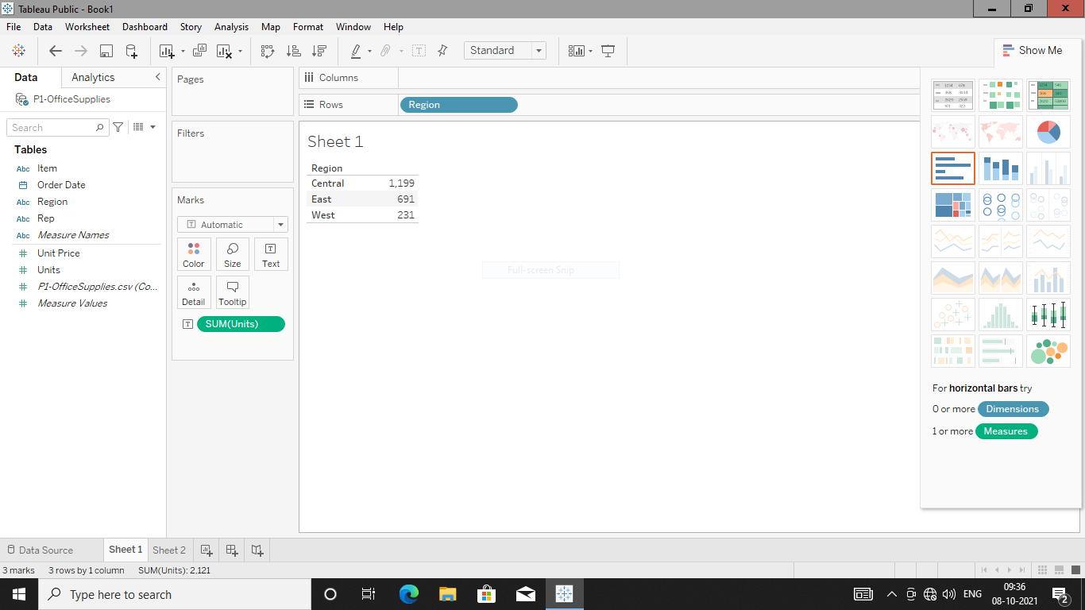

**Create Bar Chart (Sorted Region) for the same.**

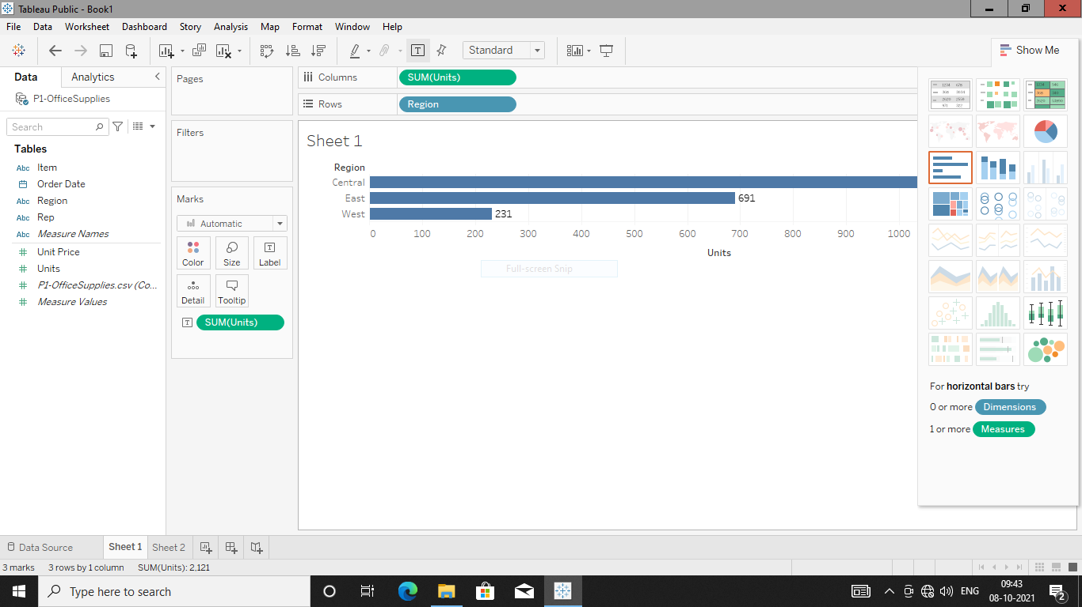

**Area Charts:**

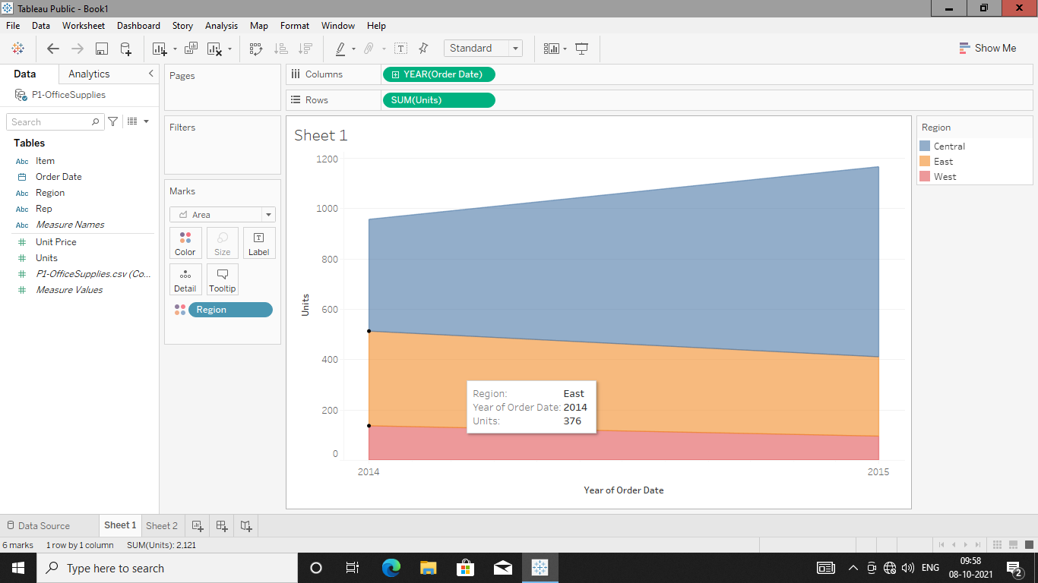

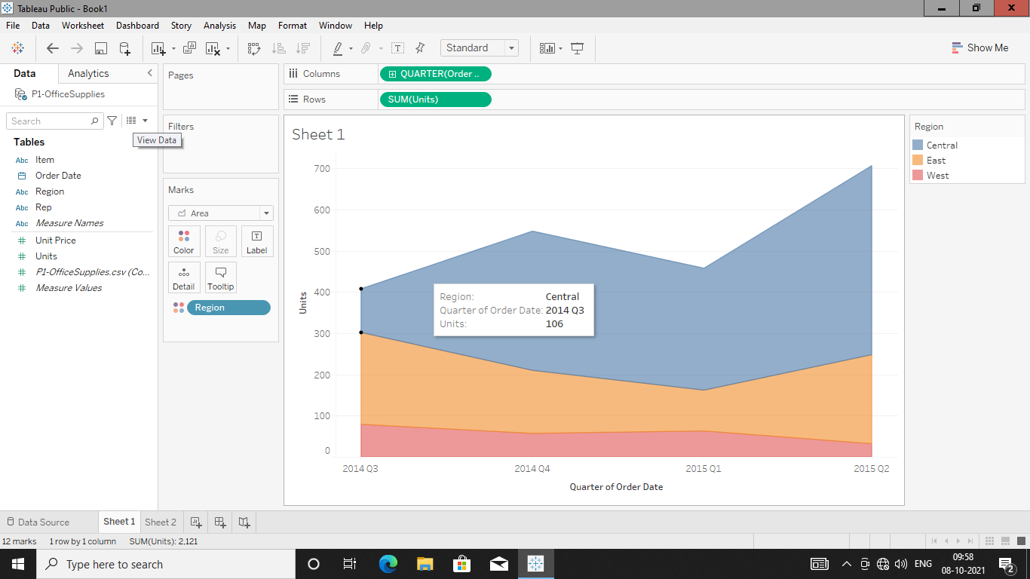

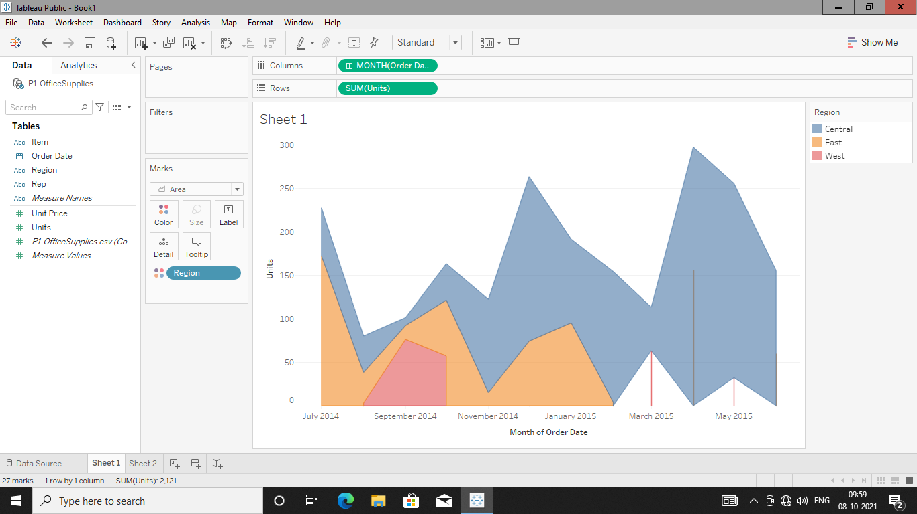

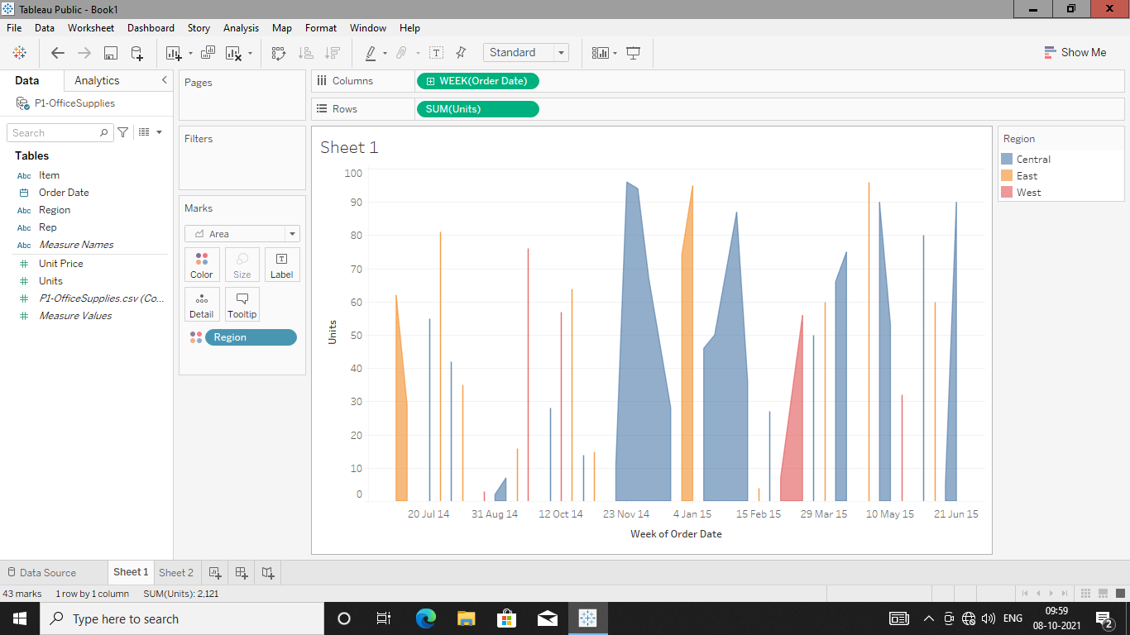

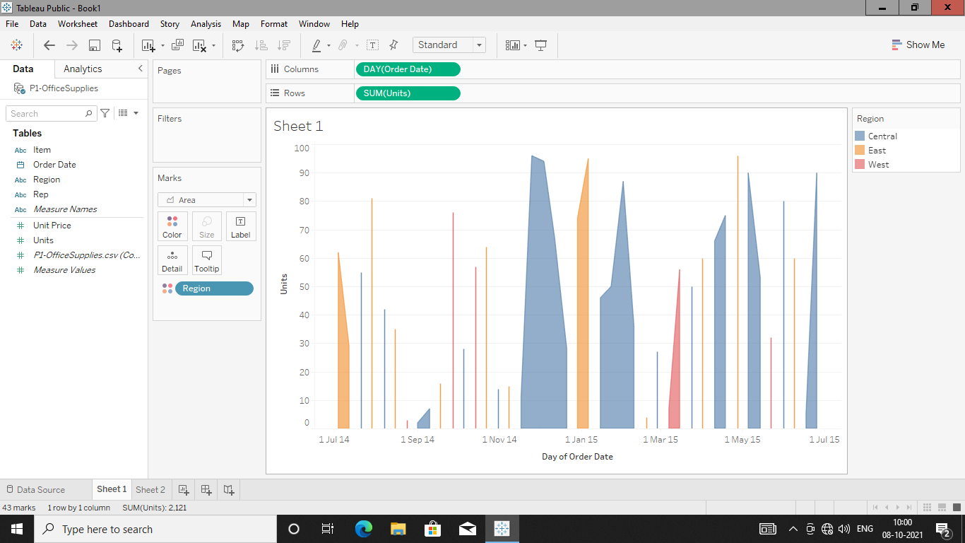

**Representative who have sold highest units:-**

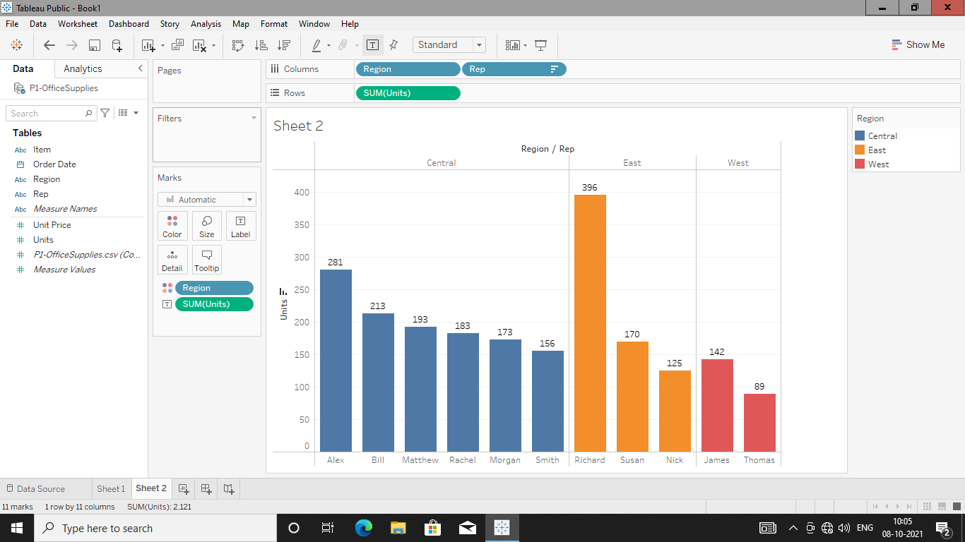

**Find Total Sales (Calculated fields) who got bonus?**

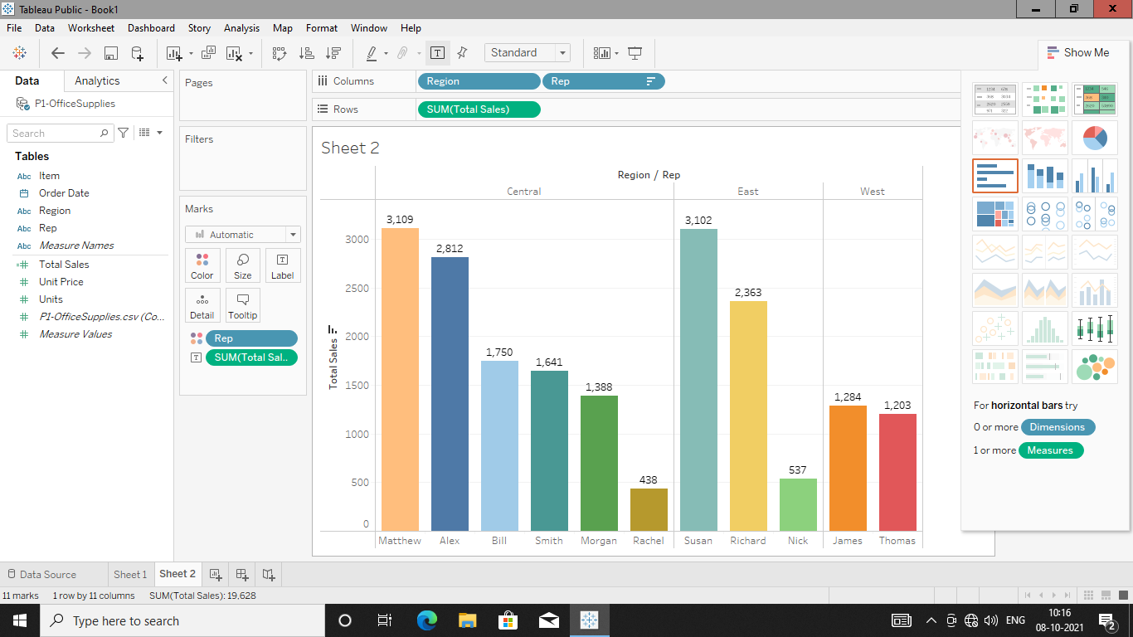

**Exploring Colour Pallete**

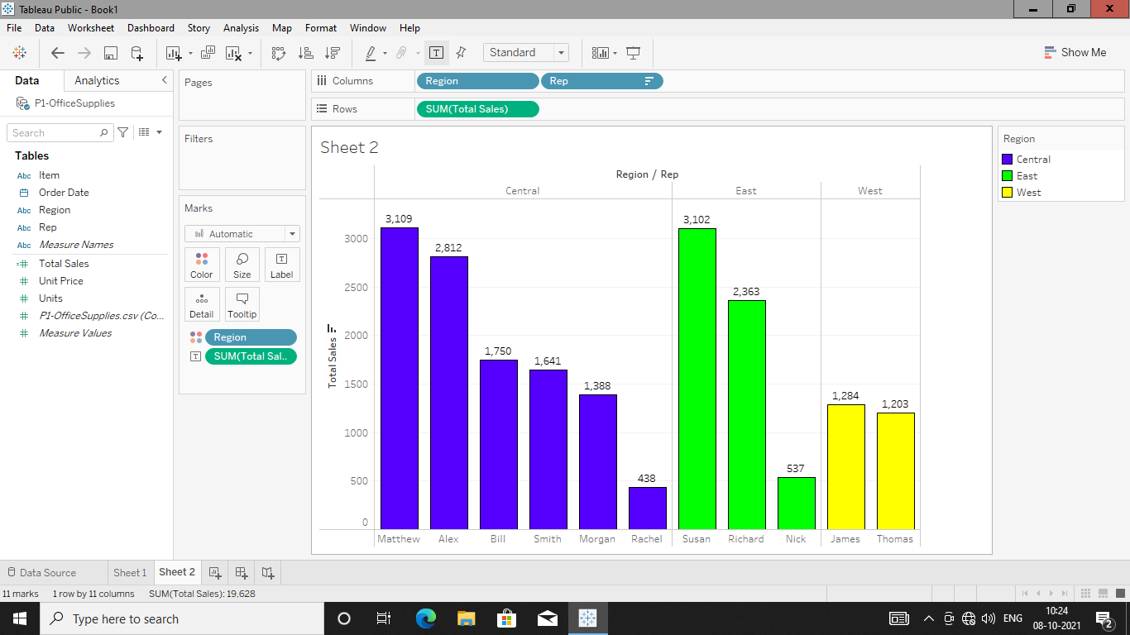

**Adding Labels 🡪 Edit Labels i.e. $301K and formatting Axis,Pane Labels.**

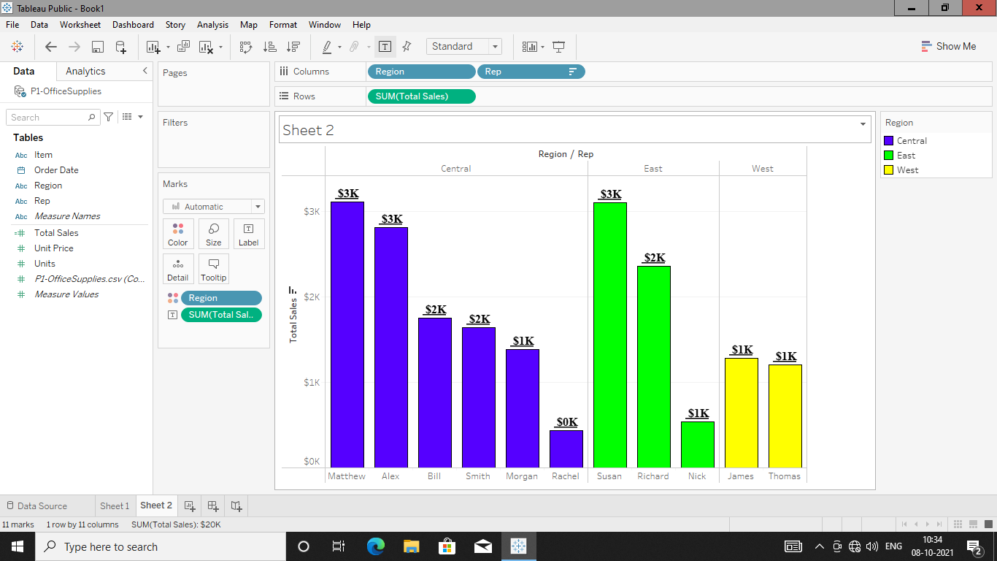

**24 Charts From “Show Me” Tab:**







