**DAY-04**

**12/10/2021**

**Name**: Harshal Acharya

**Roll No**: 12

**Batch**: B11

**Datasets:** covid_19_data

**Dimensions:**

* Country
* Last Update
* Observation Date

**Measures:**

* Confirmed
* Deaths
* Recovered
* S.No.

**Datasets:** Amazing Mart

**Topics:**

* Create Dashboards
* Add Interactive Action-Filters
* Add Interactive Action-Highlights

**Create Dashboards**

Amazing Mart:

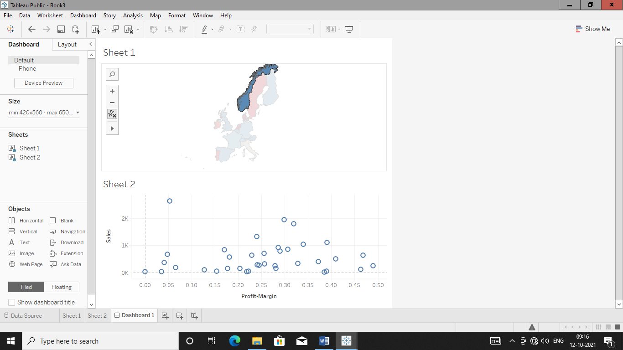

Covid-19:

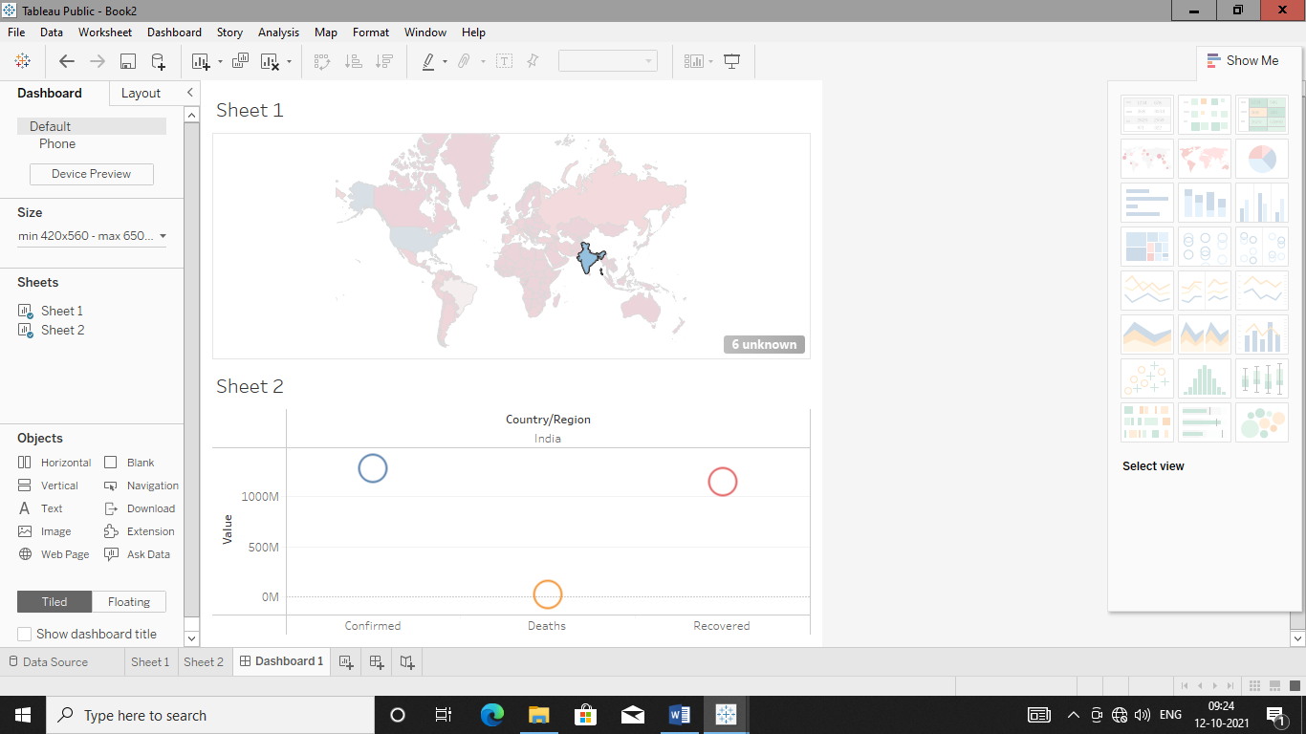

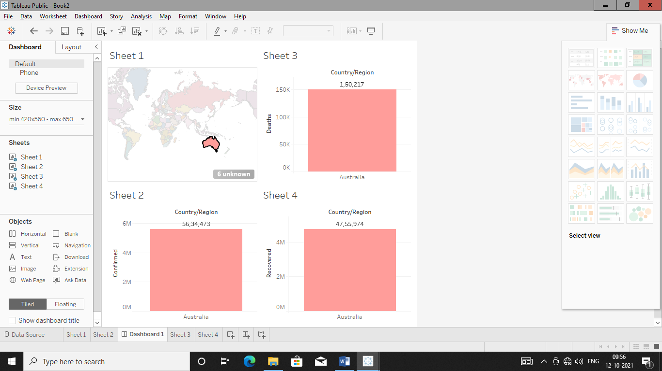

Office Supplies:

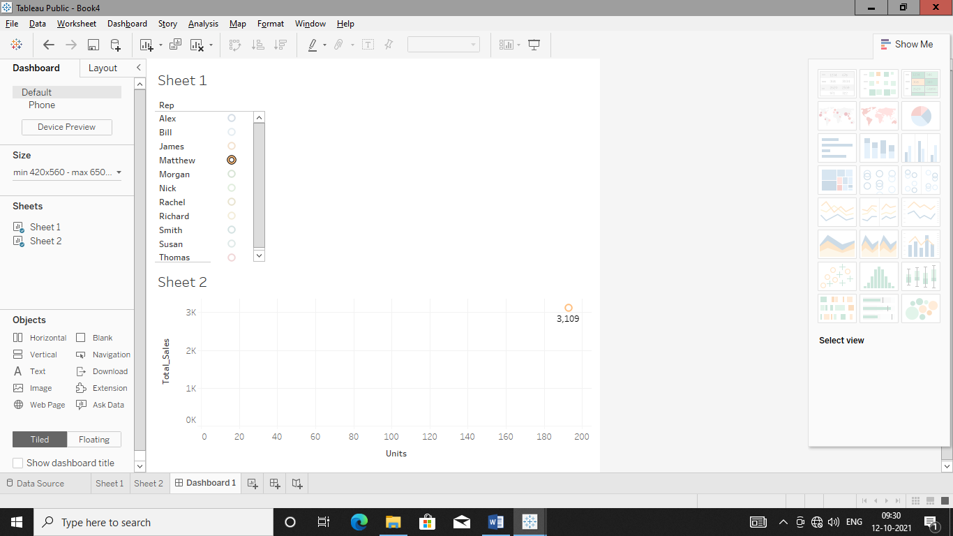

Add Action Filter

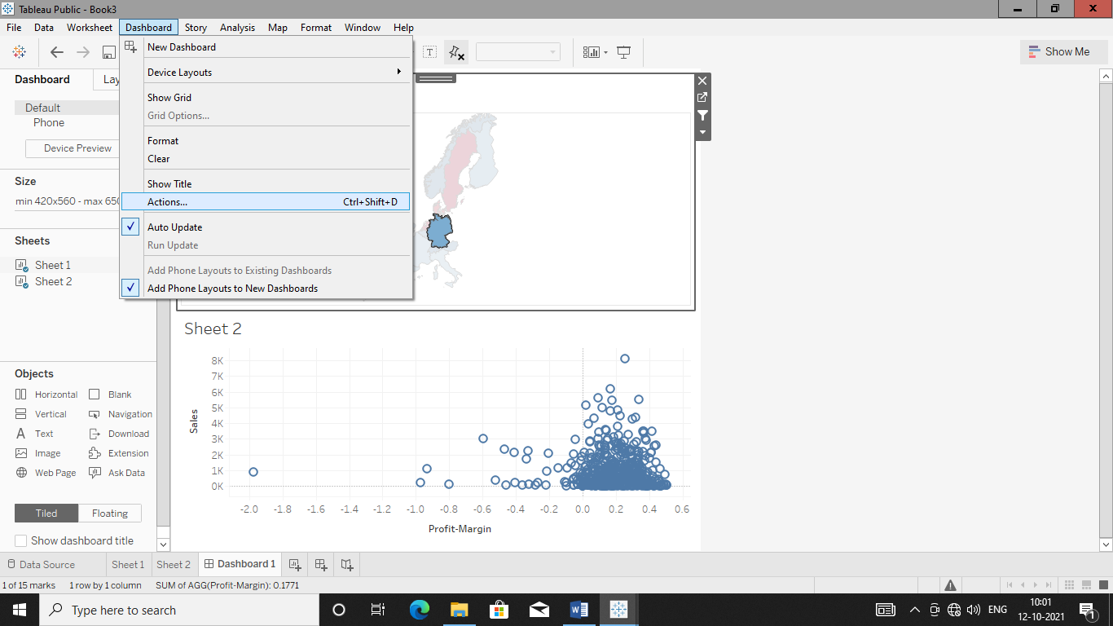

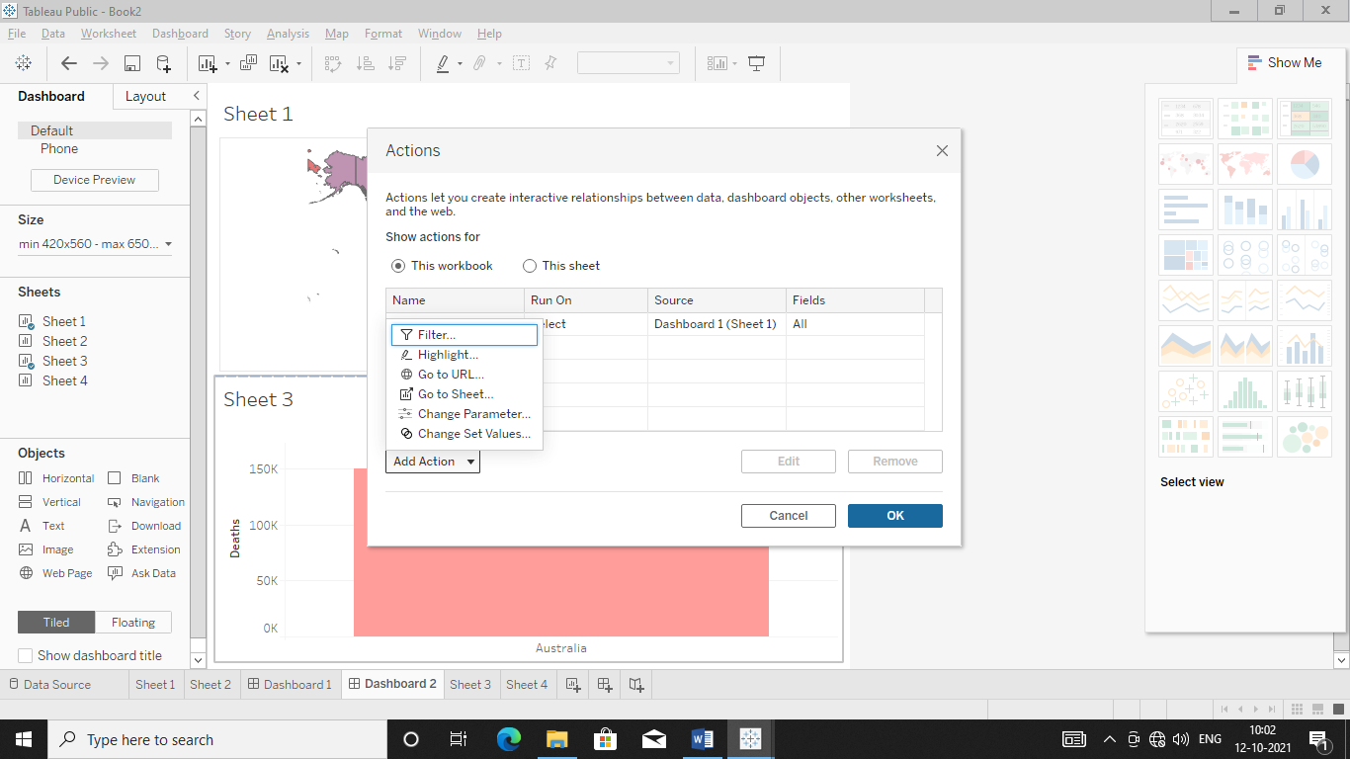

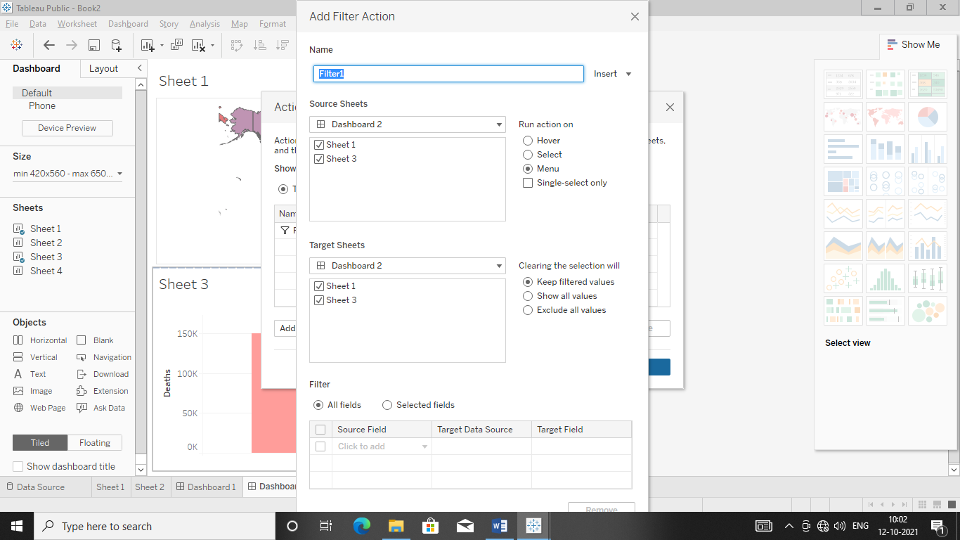

Add Action Highlighter

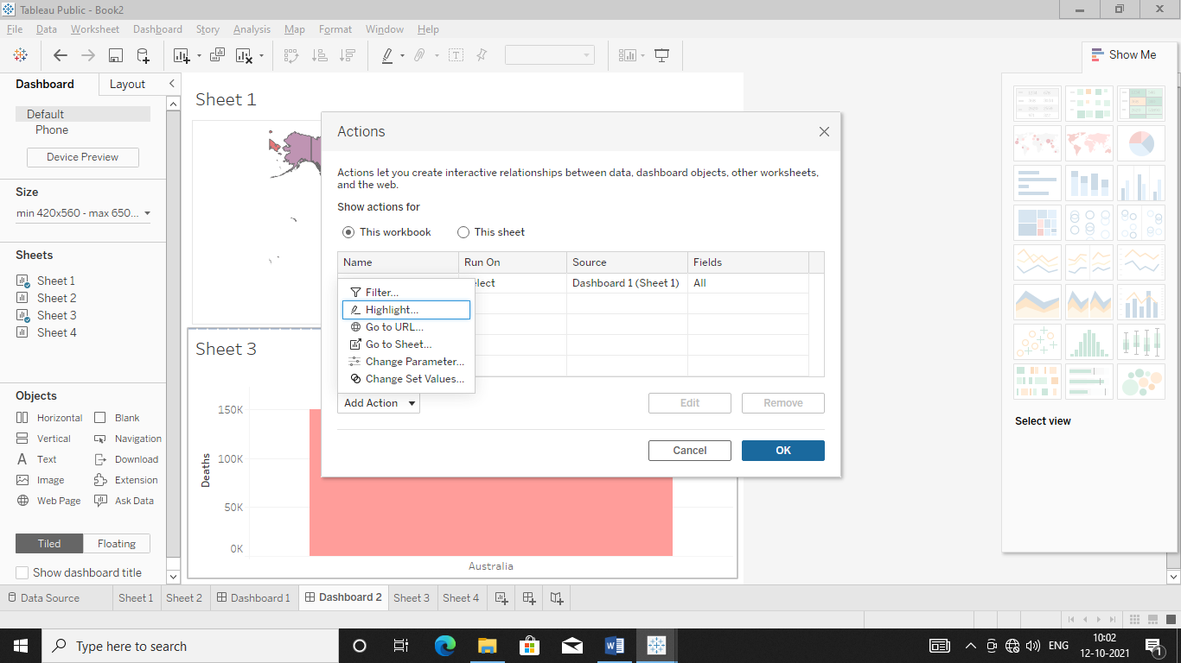

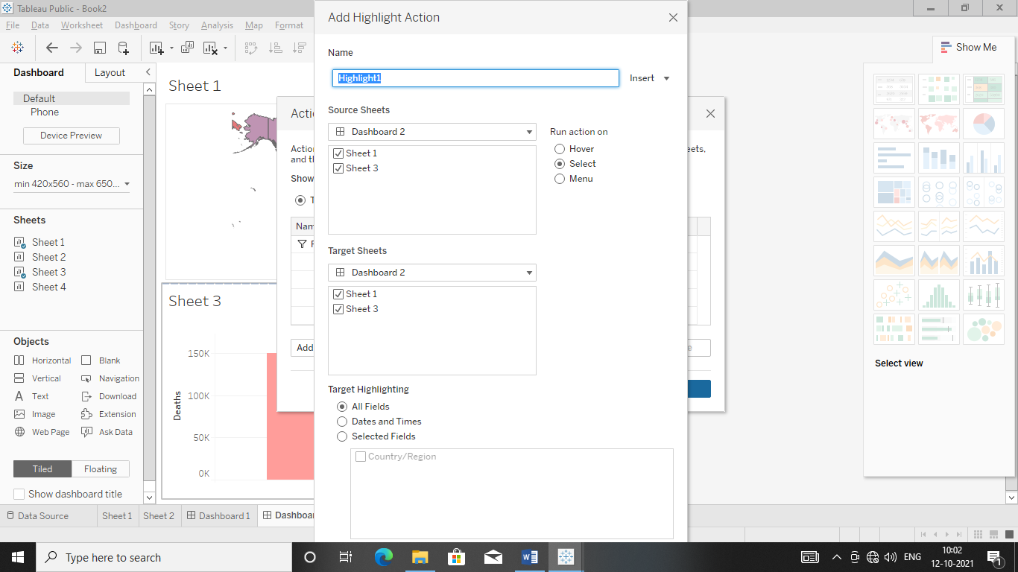

**Dataset:** Netflix

Make Dashboard With Five Questions

Sheet 1:

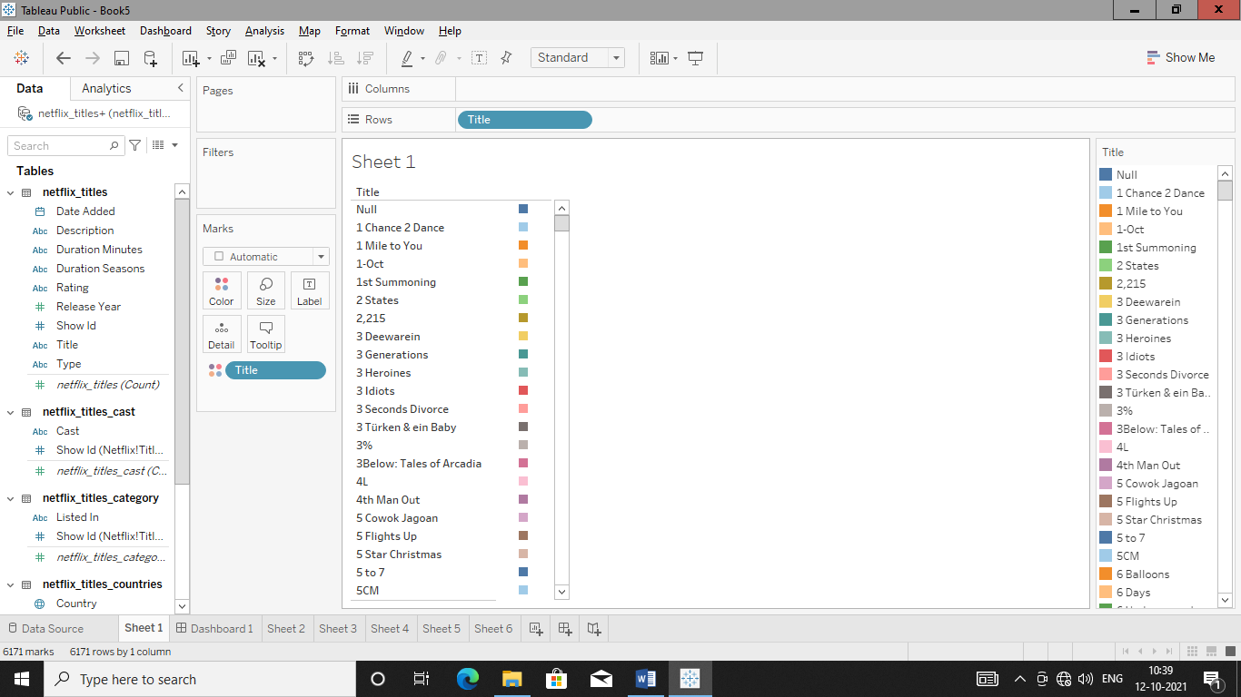

Sheet 2:

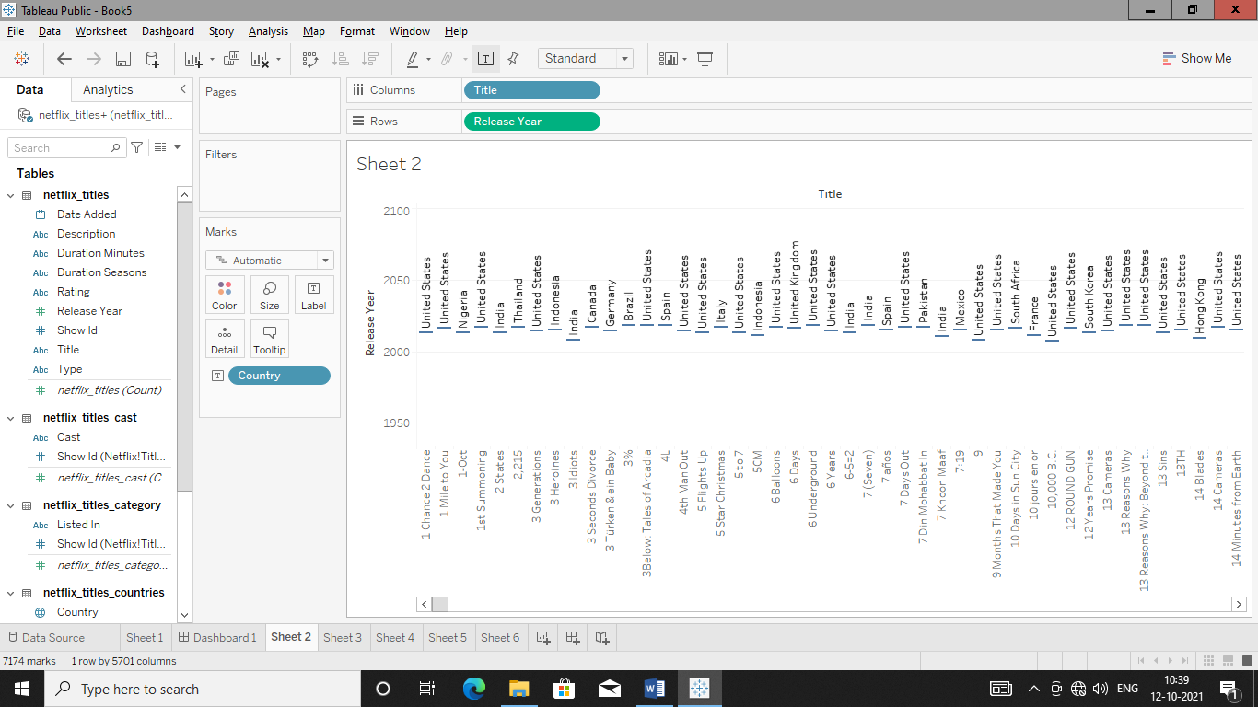

Sheet 3:

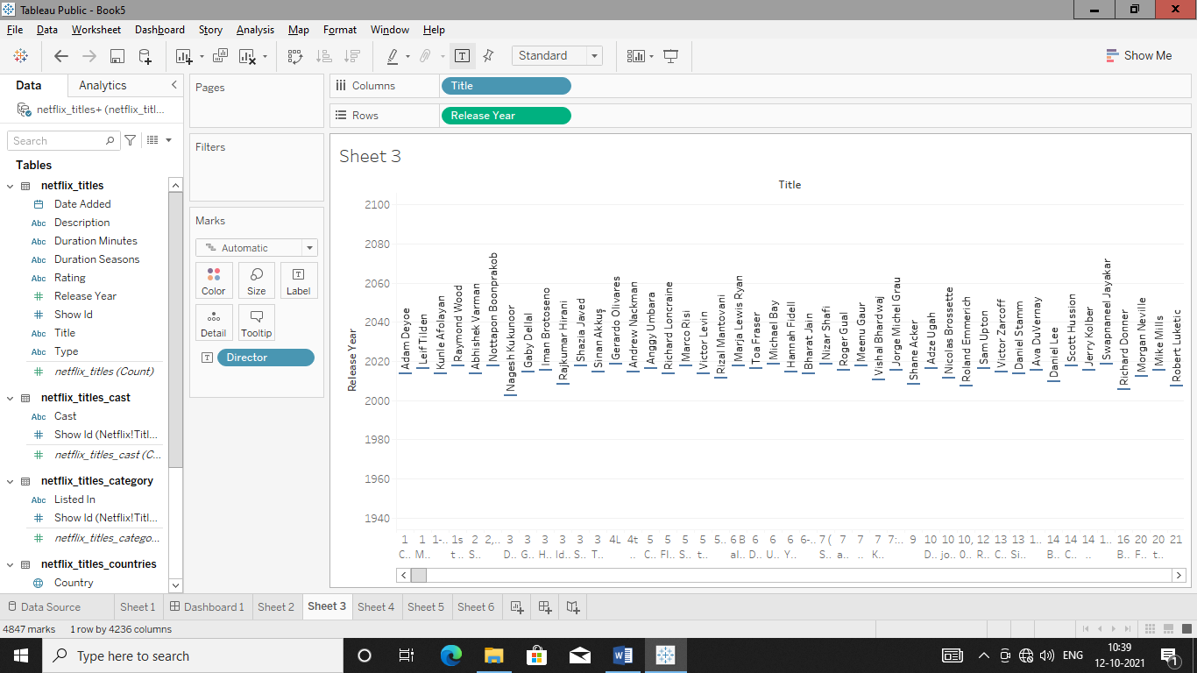

Sheet 4:

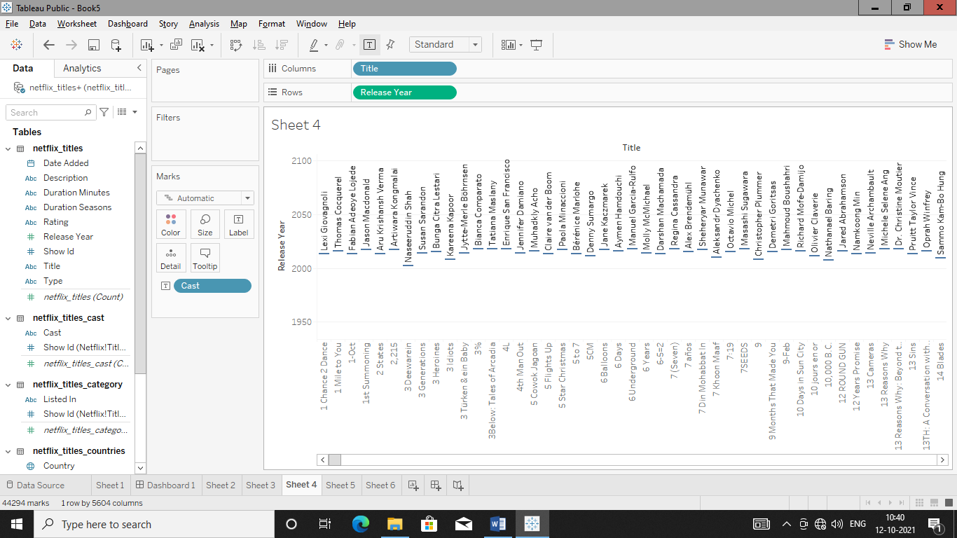

Sheet 5:

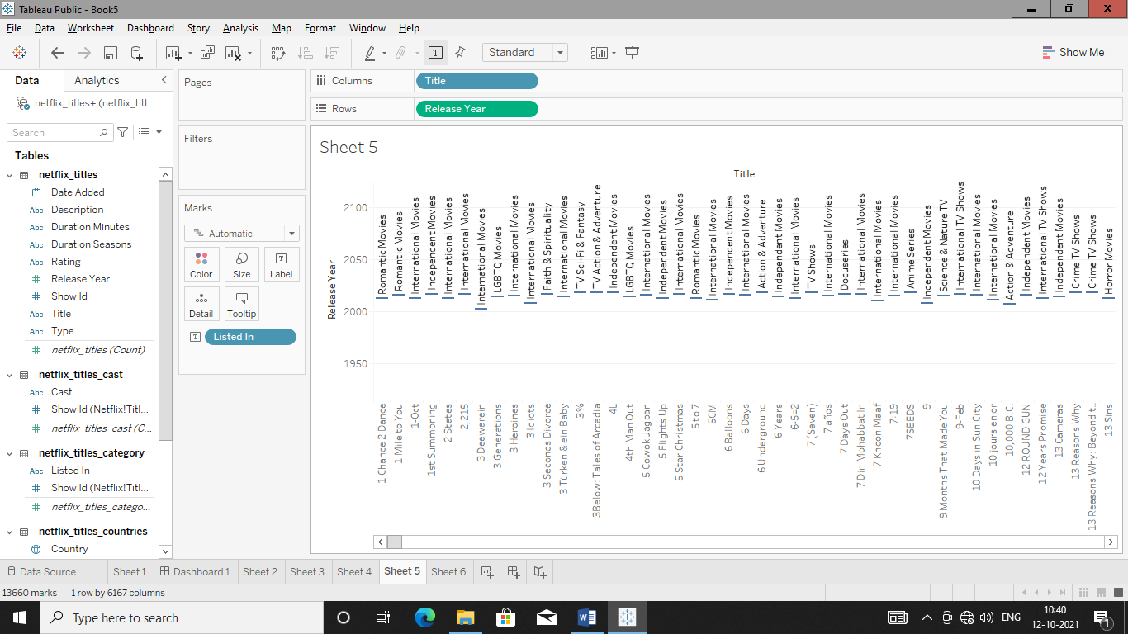

Sheet 6:

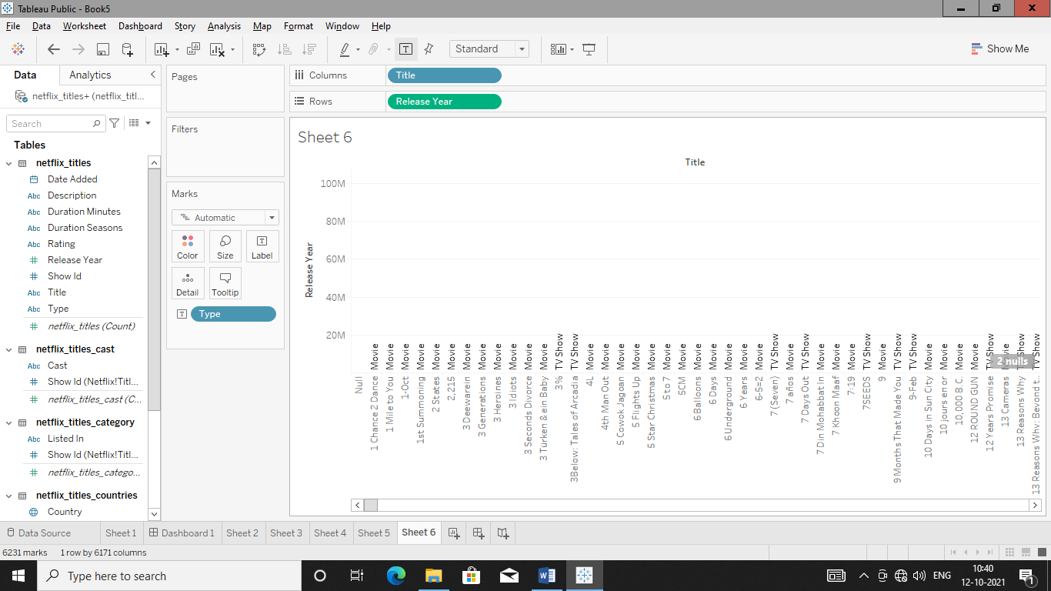

Dashboard:

