**DAY-05**

**13/10/2021**

**Name**: Harshal Acharya

**Roll No**: 12

**Batch**: B11

**Datasets:** Amazing Mart EU

**Topics:**

Data Joining & Data Blending

**Data Joining:**

**Joining Of Tables-**

Add Dataset and then drag and drop one table to that side.

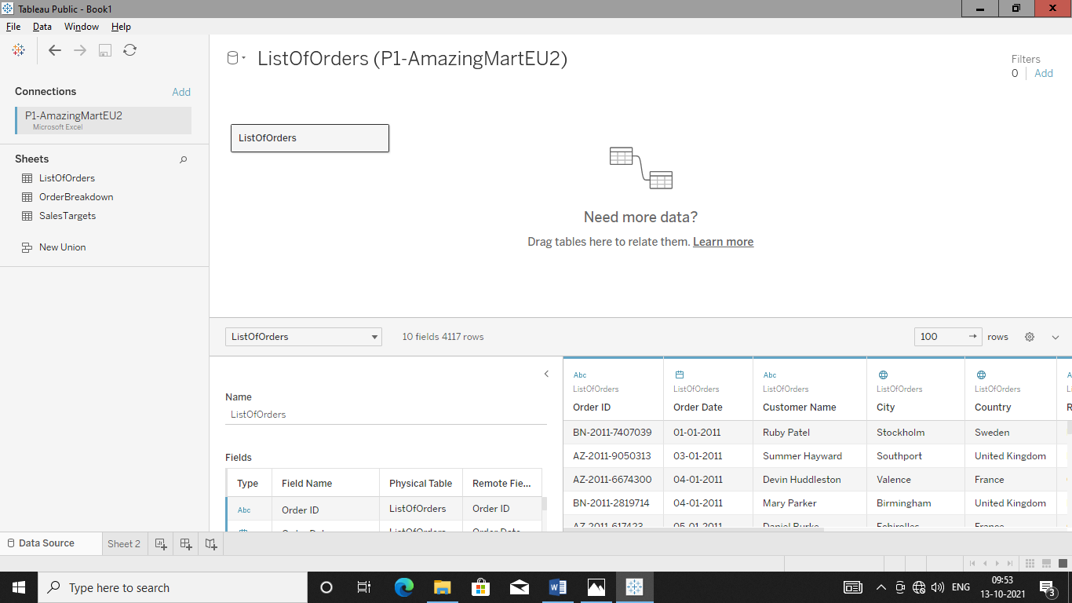

Double click on ListofOrders to go in physical level to make join.

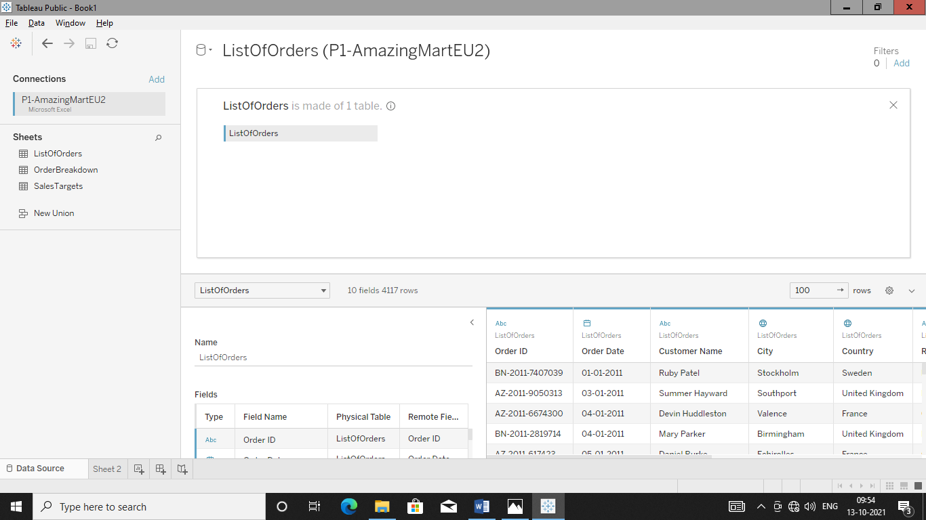

Drag & Drop another table to which join is to be formed.

Here tableau will automatically form join with respect to data source.

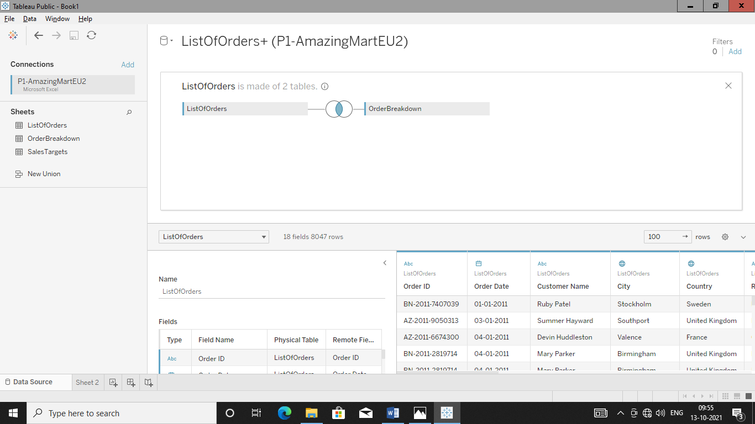

Now we want to work with all three table so now again connect to data source and drag and drop third table to use it which secondary table.

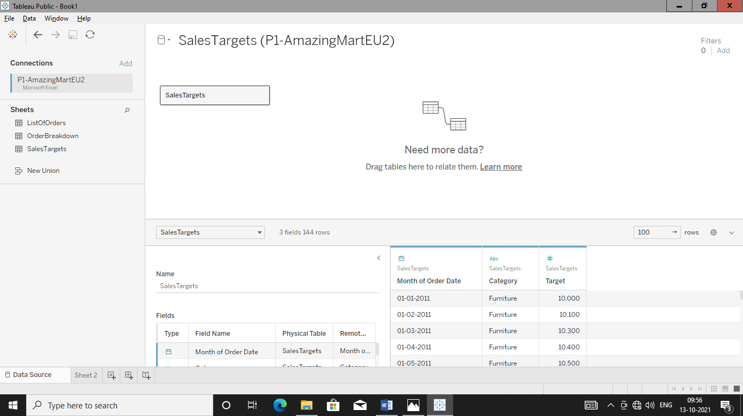

Go in sheet to see all data which came in two table form i.e. primary & secondary.

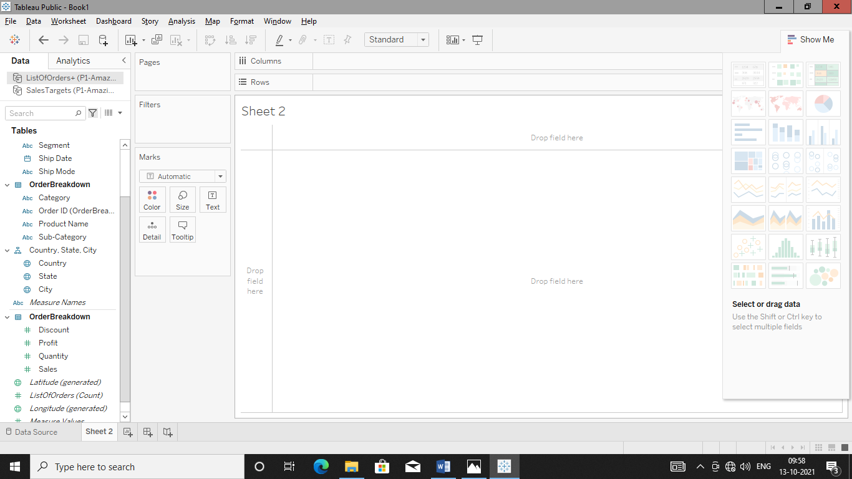

**Q.** Find total sales and Target for each ‘Category’ (for each month of a year).

For this make plot between month wise sales line chart in order to get information about sales category wise.

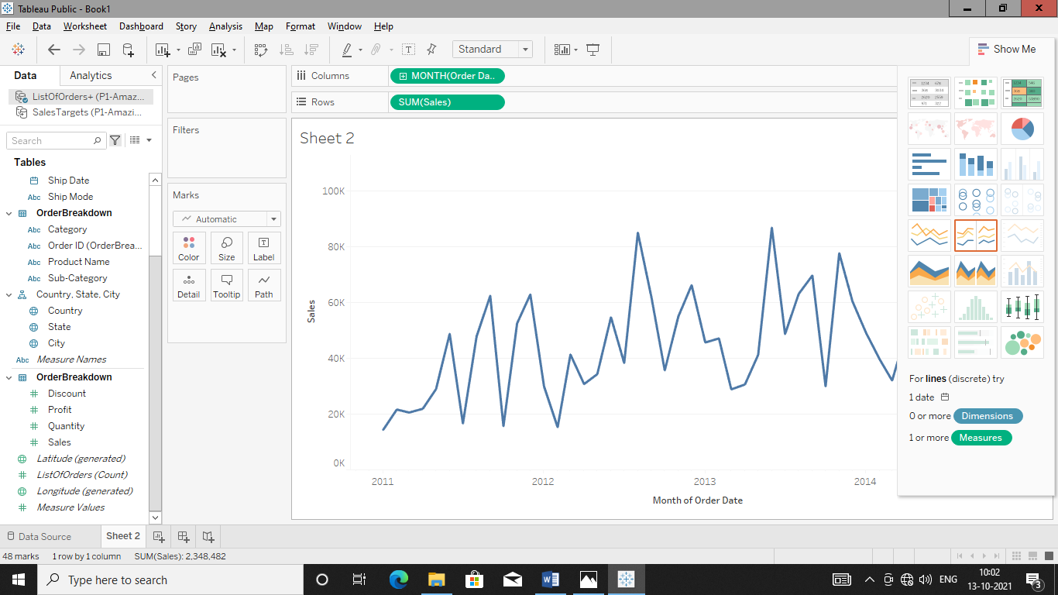

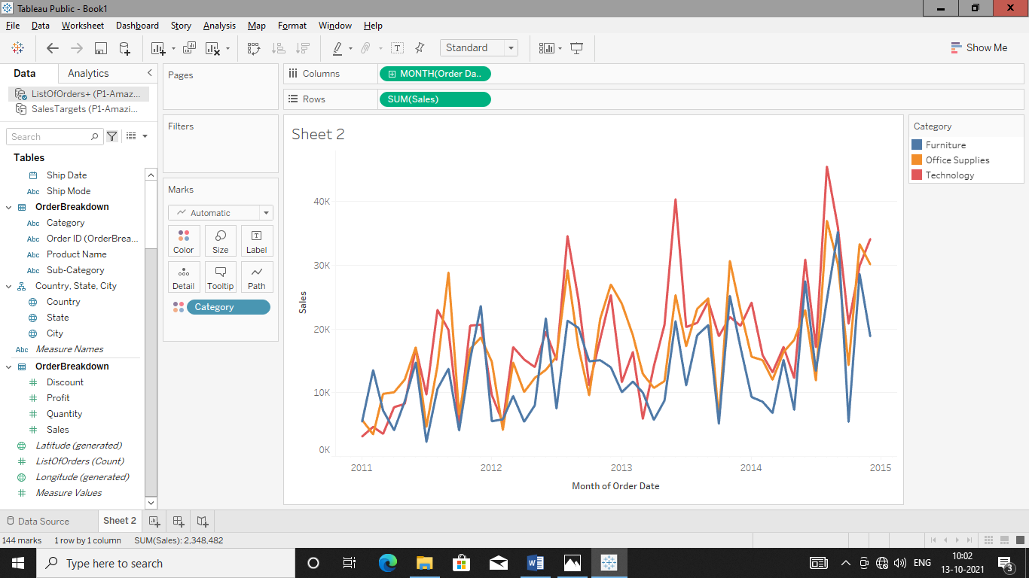

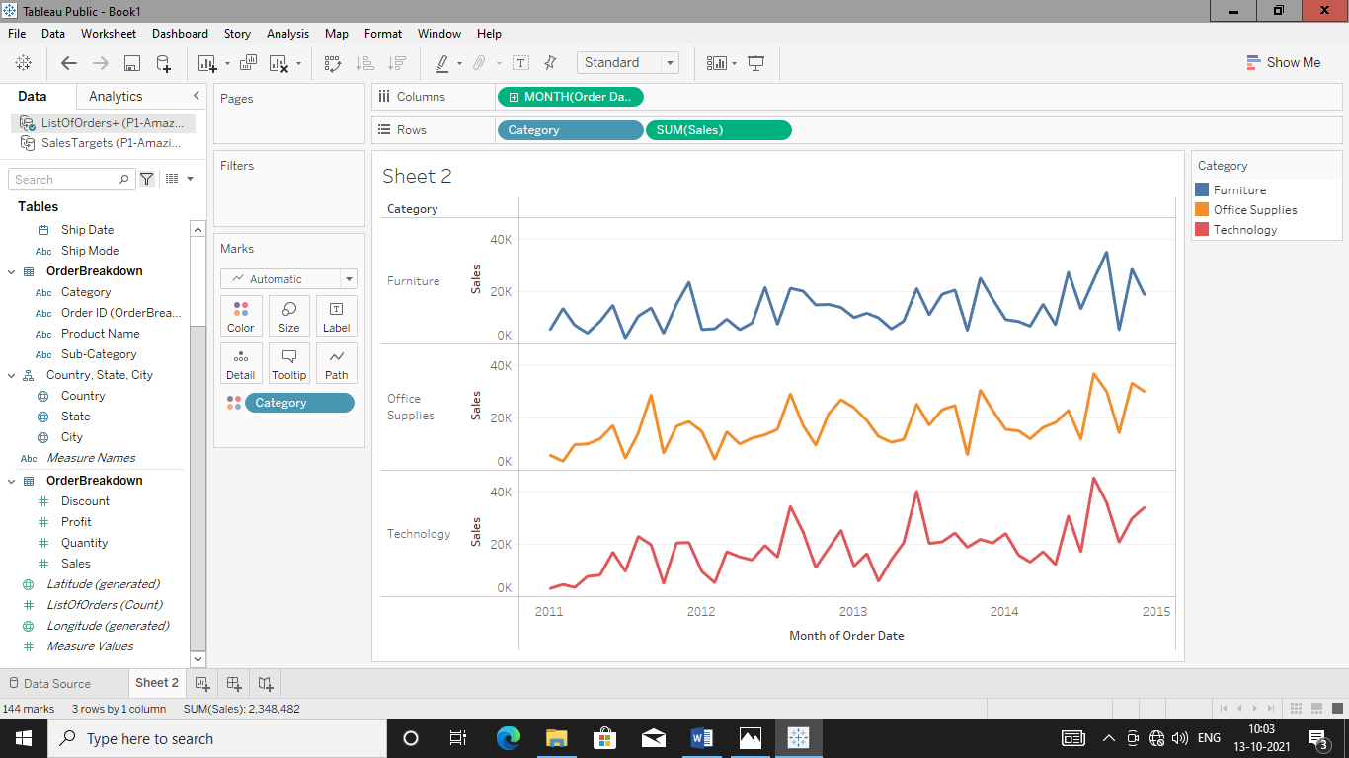

Add target in order to analyse sales in each month of year .

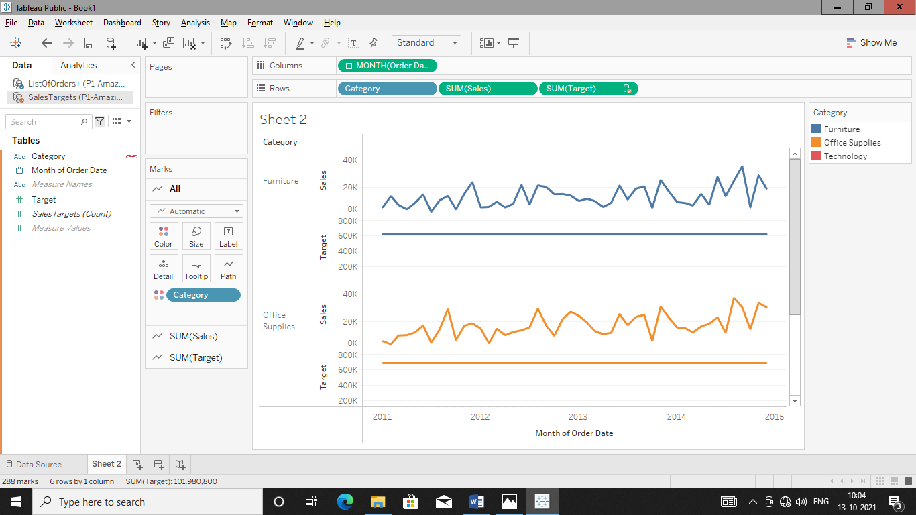

Now chart is not appropriate of target as its one line or aggregated chart so blend the data to get exact analysis.

**Blending The Table:**

Blend “targets” in sales table to match with ‘Month’ of ‘order date’ in ‘ListofOrder+Orderbreakdown’ table.

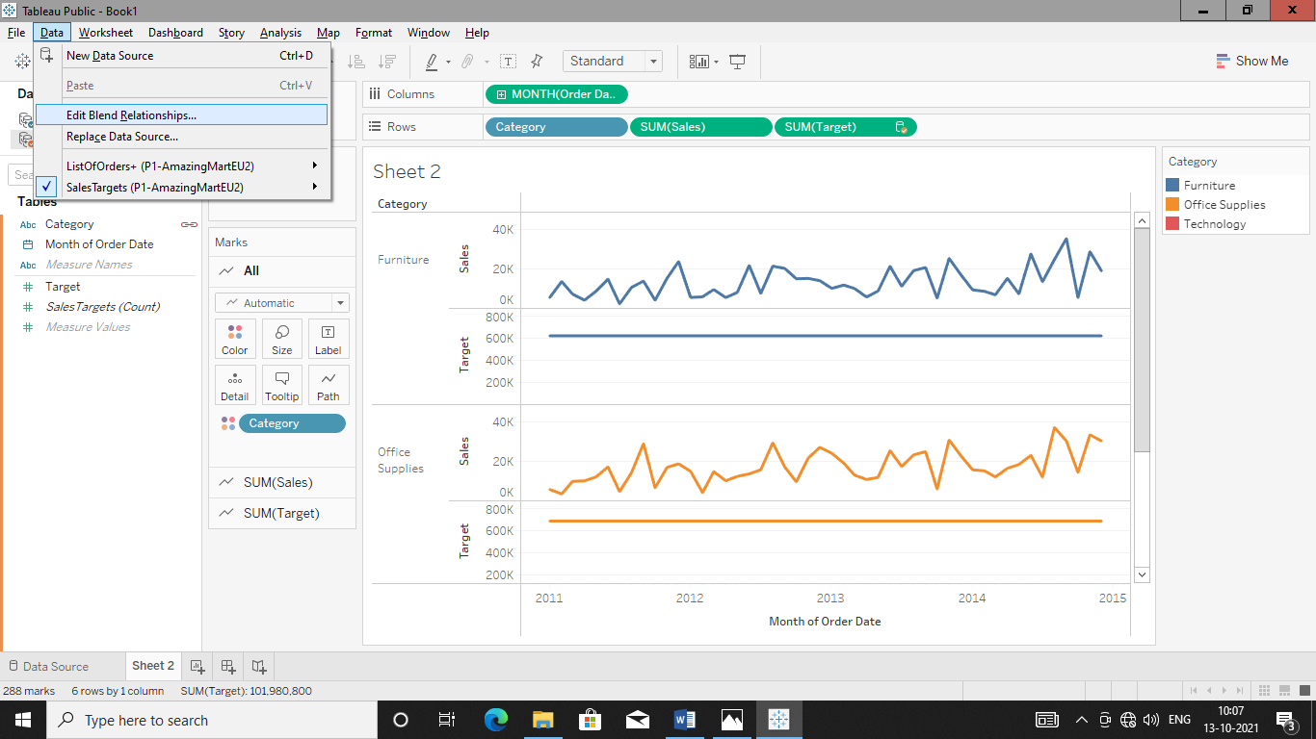

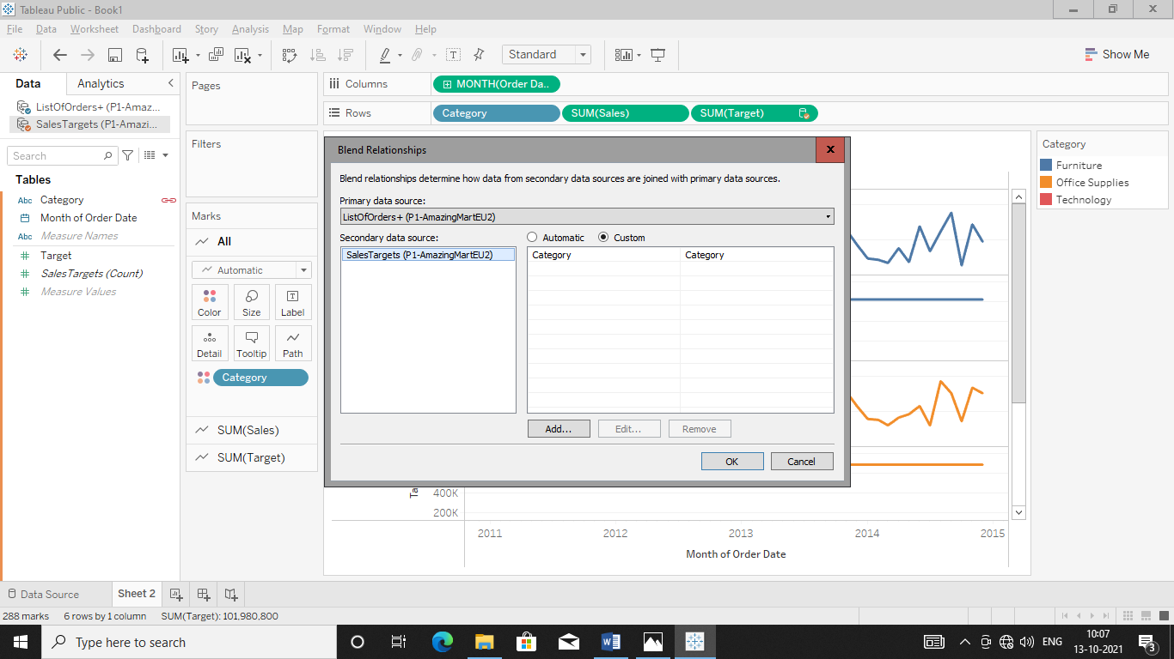

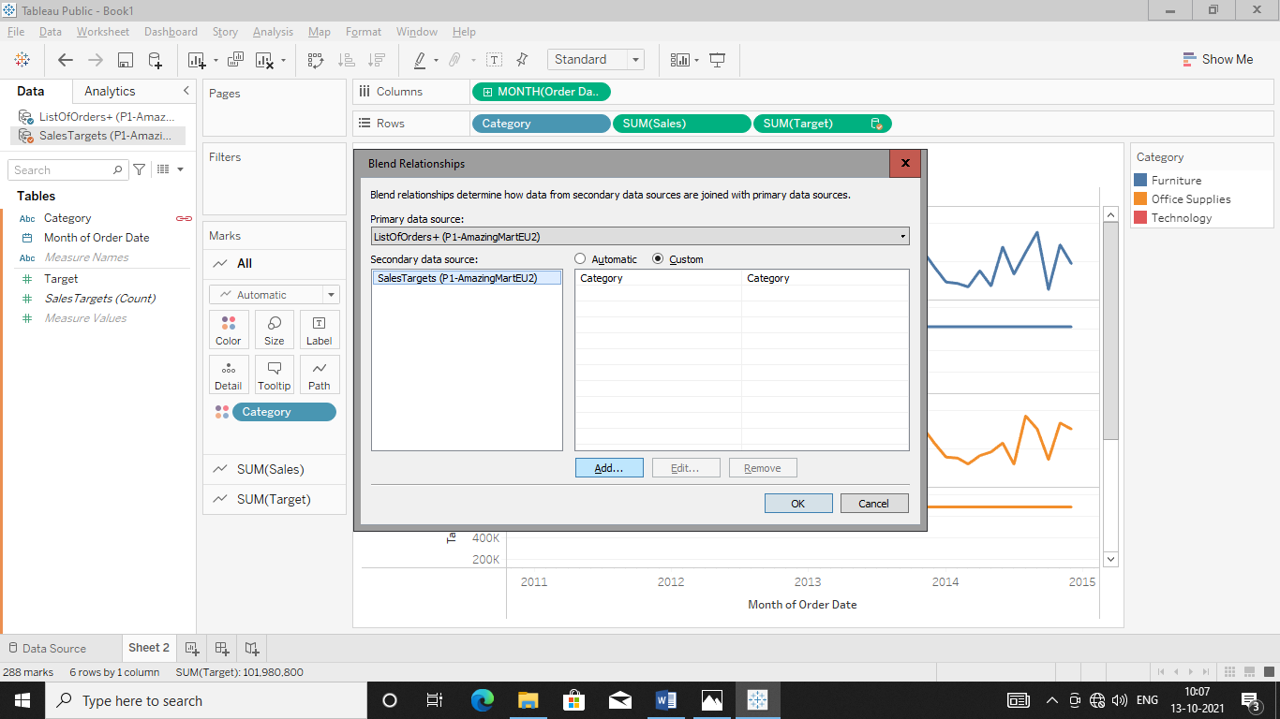

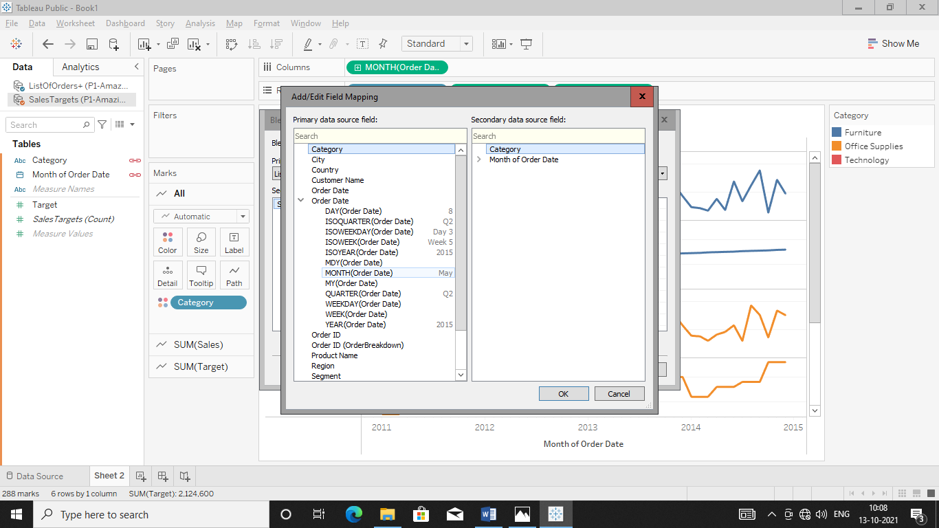

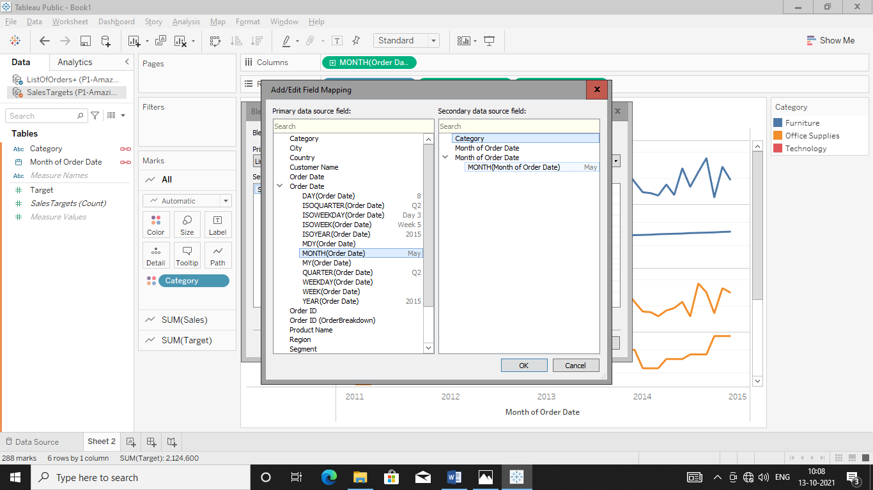

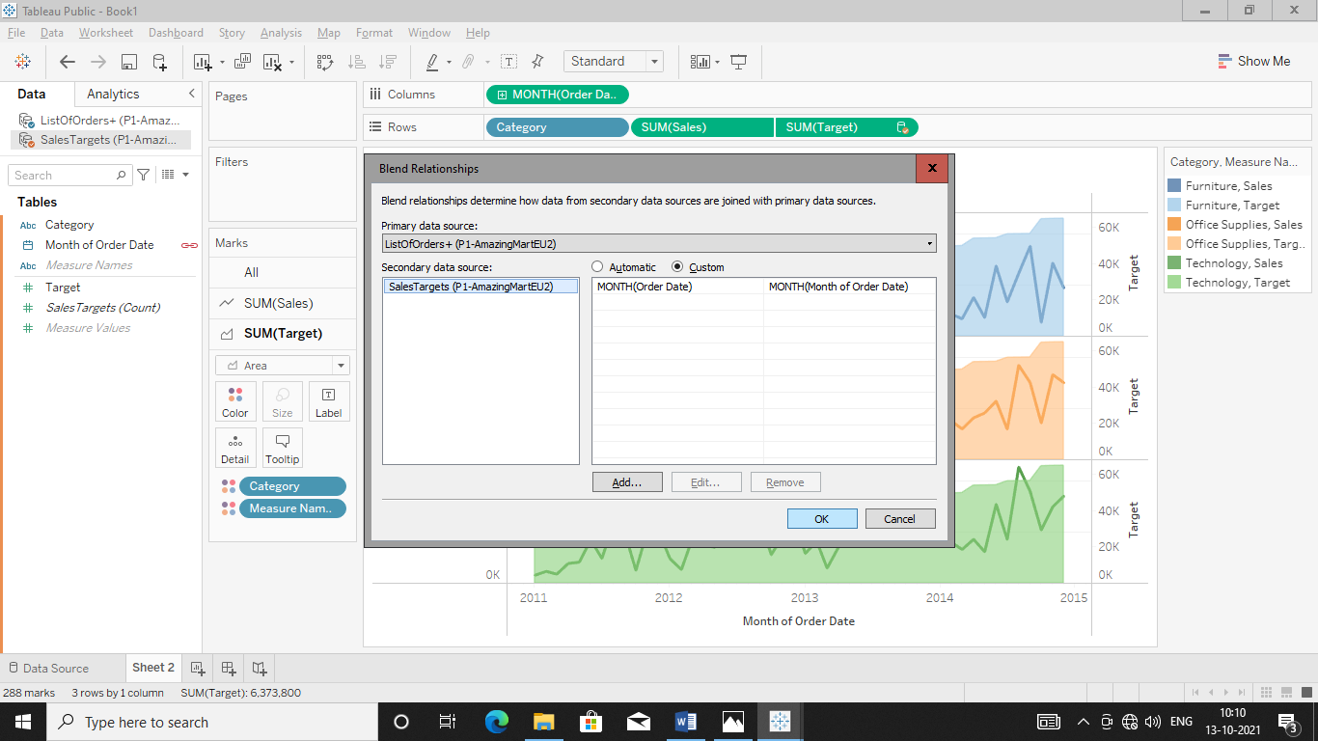 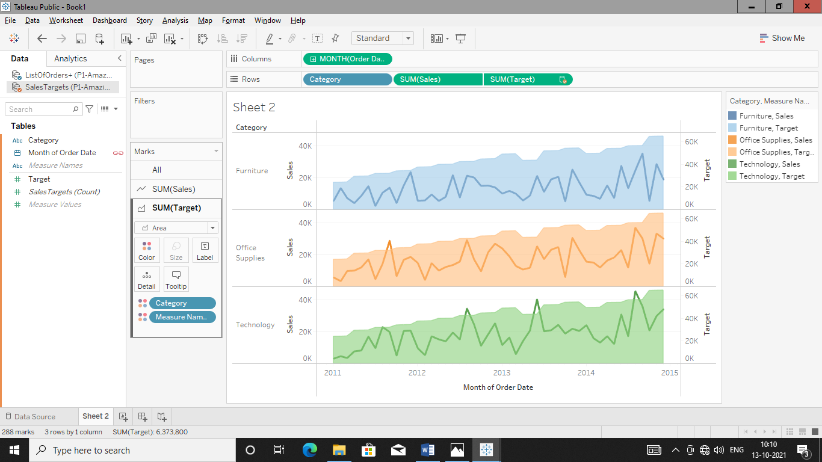

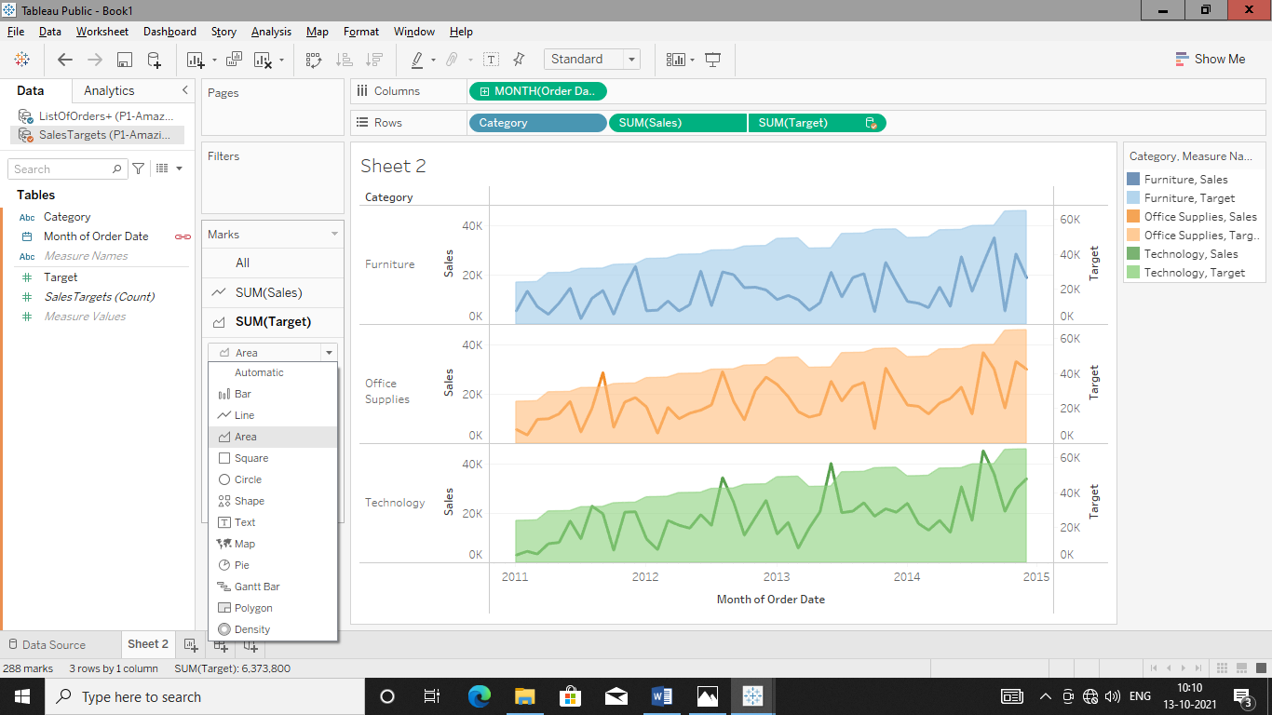

Add Dual Axis in graph in order to get perfectly analyse graph.

