**DAY-07**

**17/10/2021**

**Name**: Harshal Acharya

**Roll No**: 12

**Batch**: B11

**Datasets:** Amazing Mart EU

Charts:

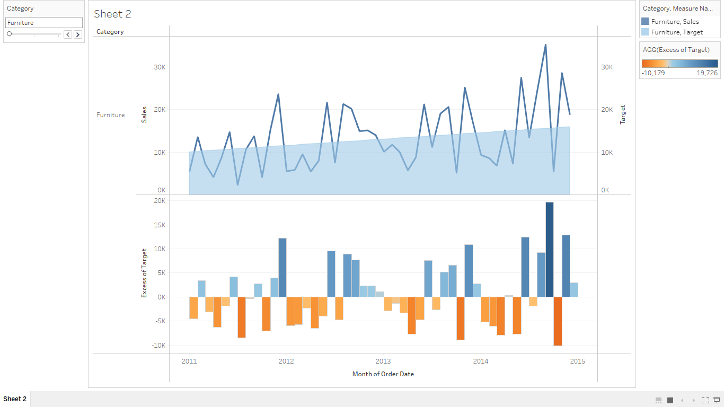

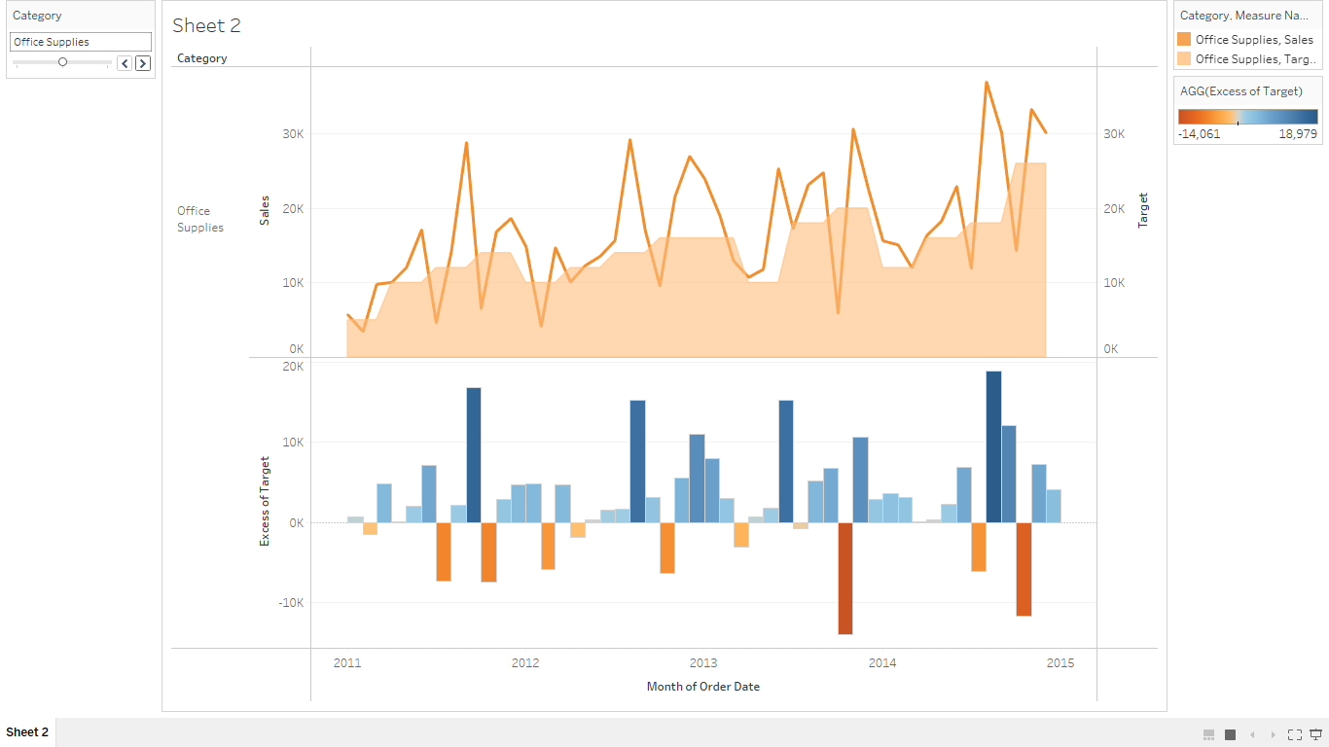

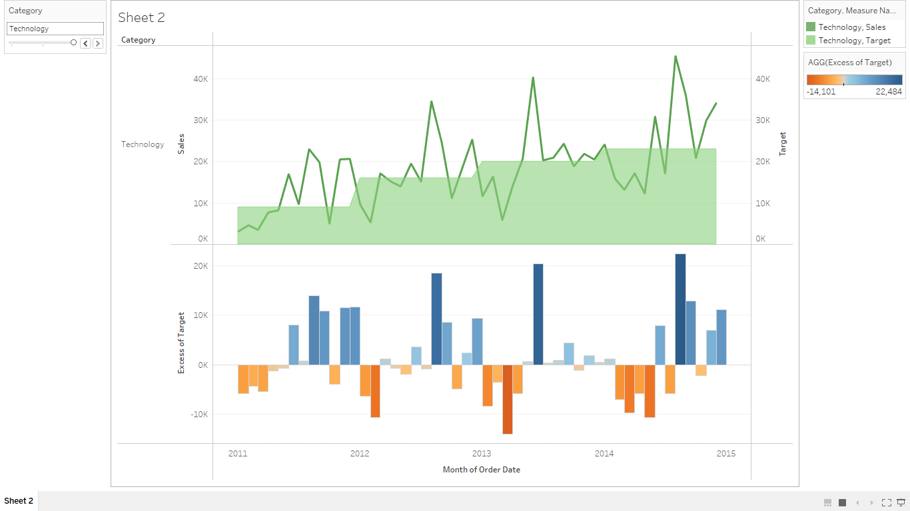

**Dataset:** Personal Vehical Sales Global

Use Of Data Cleanup,Interpreter and Pivot

