**Supporting Documentation**

# Harshal Jaspal

# StudentID 13251450

CS613 (Advanced Concepts In Object-Oriented Programming)

2013-14



Department of Computer Science National University of Ireland, Maynooth Co. Kildare

Ireland

Lecturer: Andrea Ballatore

# 

# 1. System design

Introduction :

The software is developed on Linux of Ubuntu flavor using g++ compiler by considering the needs of a well known reputed Publication known as Entertainment News . The objectice of the software is to design an information system for the entertainment news so that they can do their daily tasks in a systematic and convenient way and can organize their activities efficiently .Following are the entities established in the information system.

Roles:

* Publisher : Is the organization for whom this software is being developed.
* Entertainment News : It can be any member of the organizing committee who owns the company ,he/she is the person with the bank account and is responsible for paying the salaries to the employees , so technically he is the CEO of the company.
* Editor in Chief : He/she is the person who regulates the work load among the employees and can hire and fire employees on the basis of their performance .
* Editors : These employees work under the Editor in Chief and they handle different sections of the newspapers . There are editors working for different sections of the newspaper like
* Kids editor – Deals with the section for the kids
* Movies editor– editor Deals with the section for movies
* Advertisment -editor Deals with the section for advertisement
* Reporters : These are the employees that work under the Editors , there are full time and part time reporters. They are in charge of writing the articles for various sections of the newspaper.

**2. System architecture**

System Overview:

In the given project we are using classes to represent the various roles and functions given in the system requirements .We are using four levels to represent these roles and thereby representing their functions:

1. Entertainment News : As this is the committee member so this class has the privilege to Hire or Fire the journalist and can see the information of journalist, and can pay salary to the employees from the account of the committee which currently has 500000 euros in it . The function used are shown below: Funtions : HireJounalists(); FireJounalists(); JournalistInfo(); deposit();

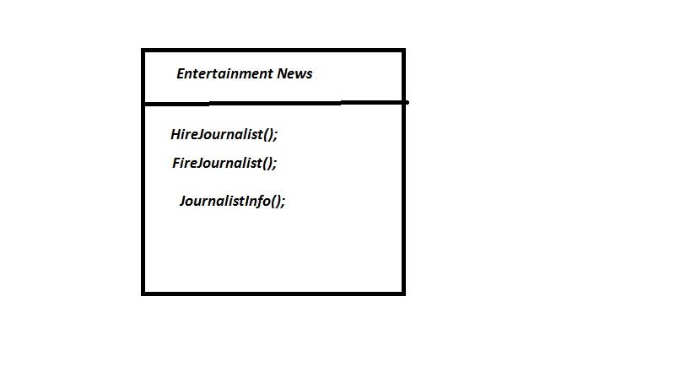

1. Editor-In-Chief : He/she has the authority to hire or fire the Editor and also he can view and approve articles and can view the blog as well .

Funtions :

HireKidsEditor(); FireKidsEditor() ;HireMoviesEditor(); FireMoviesEditor(); HireAdvertismentEditor(),FireAdvertismentEditor(); seeArticle(); ApproveArticle(); seeBlog();

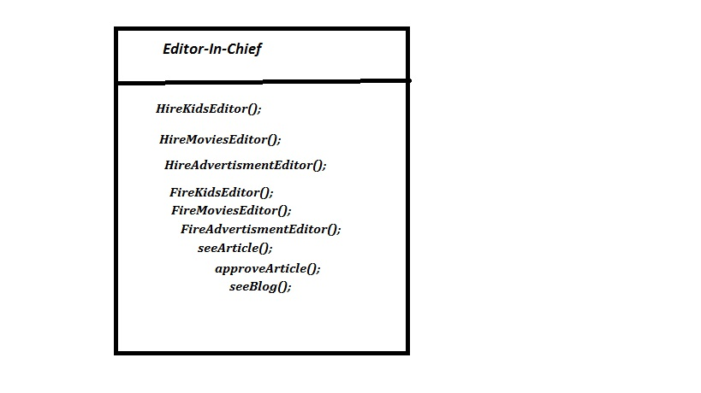

1. Editor :

Editors are responsible for hiring the reporters .he/she also approves the article so that it can be considered for approval by Editor-In-Chief. He can also view article , approve article and can view blog . The functionalities of this class can be defined as Funtions : HireReporter(); FireReporter(); seeArticle(); ApproveArticle(); seeblog();

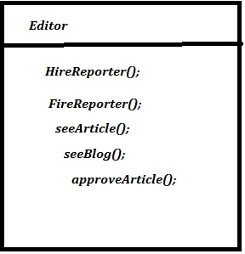

1. Reporters : The reporters are mainly responsible for writing articles on various issues . There are Full time Reporters and Part time Reporters but they both have the same functionality. The Full Time reporters can have the blog but Part Time reporter can not have the blog They are the least ranked employees in the organization.

Reporter Full-Time

Functions : writeArticle(); seeArticle(); seeBlog();

Reporter Part-Time

Functions: writeArticle(); seeArticle();

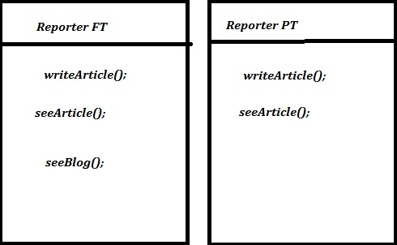

Simplified Diagram:

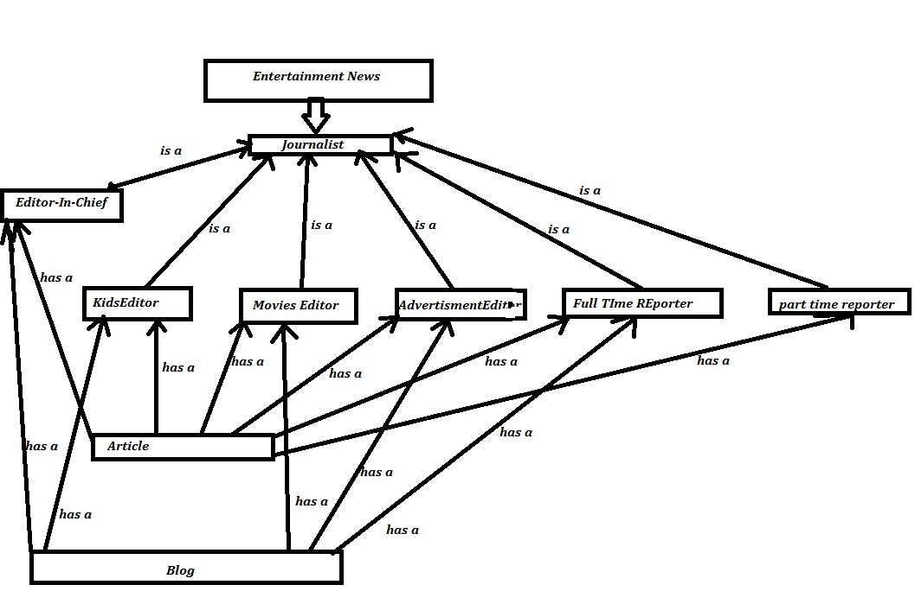

**3. User guide**

The Information System for Entertainment News is designed in such a way that it can be easily used by all the entities without any prolonged delay in the execution of the code .

**User guide for Publisher :**

The credentials for Publisher are

**User Name** : Fame **Password** : harshal

When the Publisher successfully log in the system He/she will get a menu with a welcome greeting

1. Do you want to hire an Editor-In-Chief?
2. Do you want to fire an Editor-In-Chief?
3. Do you want to pay salary ?

. He can pay salary to Editor-In-Chief , Editors and Reporters

**User guide for Editor-In_chief :**

The credentials for Editor-In_chief are

User Name : Navneet Password : jaspal

When the Editor-In-Chief successfully login to the system He/she will get a menu

1. Do you want to hire a Kids Editor?

2) Do you want to hire a Movies Editor?

3) Do you want to Hire an Advertisment Editor?

4) Do you want to fire a Kids Editor ?

5) Do you want to fire a Movies Editor ?

6) Do you want to fire a Advertisment Editor ?

7) Do you want to view and approve article ?

8) View Blog

Editor-In-Chief can use any provided option according to his needs

**User guide for Editors:**

The credentials for Editors are

Kids -Editor

User Name : Kashish Password : judge

Movies-Editor

User Name : Nancy Password : sydney

Advertisment-Editor

User Name : Paramjit Password : judge

When any of the Editor successfully login to the system He/she will get a menu

1. Do you want to hire a Reporter?

2) Do you want to fire a Reporter?

3) Do you want to view and approve Article?

4) Exit

Editors can use any provided option according to his needs

**User guide for Reporters:**

The credentials for Reporters are

**Full Time reporter**

Full Time reporter-1

User Name : Amit Password : sharma

Full Time reporter-2

User Name : Sabina Password : usa

Full Time reporter-3

User Name : Rajdeep Password : bansal

**Part Time reporter**

Part Time reporter-1

User Name : Sahil Password : verma

Part Time reporter-2

User Name : Amarjot Password : judge

When any Full Time successfully login to the system He/she will get a menu

1. Do you want to write an article?

2) Do you want to view an article?

3) Do you want to view the blog?

When any Part Time successfully login to the system He/she will get a menu

1. Do you want to write an article?

2) Do you want to view an article?

3) Do you want to Exit the system?

Reporters can use any provided option according to his needs

**4. OO concepts**

Discuss what OO concepts you used in the system.

The Object Oriented concepts used in this project are as follows:

1. Inheritance
2. File Handling
3. Method Of Over –riding
4. Inheritance:

In [object-oriented programming](http://en.wikipedia.org/wiki/Object-oriented_programming) (OOP), **inheritance** is a way to establish [Is a](http://en.wikipedia.org/wiki/Is-a) relationships between classes or objects. In *classical inheritance* where objects are defined by [classes](http://en.wikipedia.org/wiki/Class_(computer_programming)), classes can inherit attributes and behavior from pre-existing classes called [base classes](http://en.wikipedia.org/wiki/Base_class), *superclasses*, or *parent classes*. The resulting classes are known as *derived classes*, *subclasses*, or*child classes*. The relationships of classes through inheritance give rise to a [hierarchy](http://en.wikipedia.org/wiki/Hierarchy). In [prototype-based programming](http://en.wikipedia.org/wiki/Prototype-based_programming), objects can be defined directly from other objects without the need to define any classes, in which case this feature is called [differential inheritance](http://en.wikipedia.org/wiki/Differential_inheritance).

Inheritance is a mechanism of reusing and extending existing classes without modifying them, thus producing hierarchical relationships between them.

In C++, we have 5 different types of Inheritance. Namely,

* Single Inheritance
* Multiple Inheritance
* Hierarchical Inheritance
* Multilevel Inheritance
* Hybrid Inheritance

1. File handling:

* File. The information / data stored under a specific name on a storage device, is called a file.
* Stream. It refers to a sequence of bytes.
* Text file. It is a file that stores information in ASCII characters. In text files, each line of text is terminated with a special character known as EOL (End of Line) character or delimiter character. When this EOL character is read or written, certain internal translations take place.
* Binary file. It is a file that contains information in the same format as it is held in memory. In binary files, no delimiters are used for a line and no translations occur here.

Opening a file

* OPENING FILE USING CONSTRUCTOR:

ofstream fout(“results”); //output only

ifstream fin(“data”); //input only

* OPENING FILE USING open()

Stream-object.open(“filename”, mode)

ofstream ofile;

ofile.open(“data1”);

ifstream ifile;

ifile.open(“data2”);

1. Method Over-riding:

Method overriding, in object oriented programming, is a language feature that allows a subclass or child class to provide a specific implementation of a method that is already provided by one of its super classes or parent classes. The implementation in the subclass overrides (replaces) the implementation in the super class by providing a method that has same name, same parameters or signature, and same return type as the method in the parent class

**Function overloading** or **method overloading** is a feature found in various [programming languages](http://en.wikipedia.org/wiki/Programming_language) such as [Ada](http://en.wikipedia.org/wiki/Ada_(programming_language)), [C++](http://en.wikipedia.org/wiki/C%2B%2B), [C#](http://en.wikipedia.org/wiki/C_Sharp_(programming_language)), [D](http://en.wikipedia.org/wiki/D_(programming_language)), and [Java](http://en.wikipedia.org/wiki/Java_(programming_language)), that allows creating several [methods](http://en.wikipedia.org/wiki/Subprogram) with the same name which differ from each other in the type of the input and the output of the function. It is simply defined as the ability of one function to perform different tasks.

For example, *doTask()* and *doTask(object O)* are overloaded methods. To call the latter, an [object](http://en.wikipedia.org/wiki/Object_(computer_science)) must be passed as a [parameter](http://en.wikipedia.org/wiki/Parameter_(computer_science)), whereas the former does not require a parameter, and is called with an empty parameter field. A common error would be to assign a default value to the object in the second method, which would result in an *ambiguous call* error, as the compiler wouldn't know which of the two methods to use.

Another appropriate example would be a *Print(object O)* method. In this case one might like the method to be different when printing, for example, text or pictures. The two different methods may be overloaded as *Print(text_object T); Print(image_object P)*. If we write the overloaded print methods for all objects our program will "print", we never have to worry about the type of the object, and the correct [function](http://en.wikipedia.org/wiki/Subroutine) call again, the call is always: *Print(something)*.